## **Objectives**

* Identify the tools for API testing
* Explain how to test Web API Services using Postman

In this hands-on lab, you will learn how to:

* Use Postman to issue Get request to the Web API service
* Use Postman to issue Post request to the Web API service

**Prerequisites**

The following is required to complete this hands-on lab:

* Visual Studio 2017 Community Edition
* Web API 2.x
* SQL Server 2014
* Postman

## **Notes**

Estimated time to complete this lab: **60 minutes.**

**What is Postman?**

Postman is an interactive and automatic tool for verifying the APIs of your project. Postman is a Google Chrome app for interacting with HTTP APIs. It presents you with a friendly GUI for constructing requests and reading responses. It works on the backend, and makes sure that each API is working as intended.

**Step 1:**Download and install **Postman** from [Postman](https://www.postman.com/downloads/)

**Step 2:**Once the Postman is successfully installed, open the Postman. It will look like the image shown below.

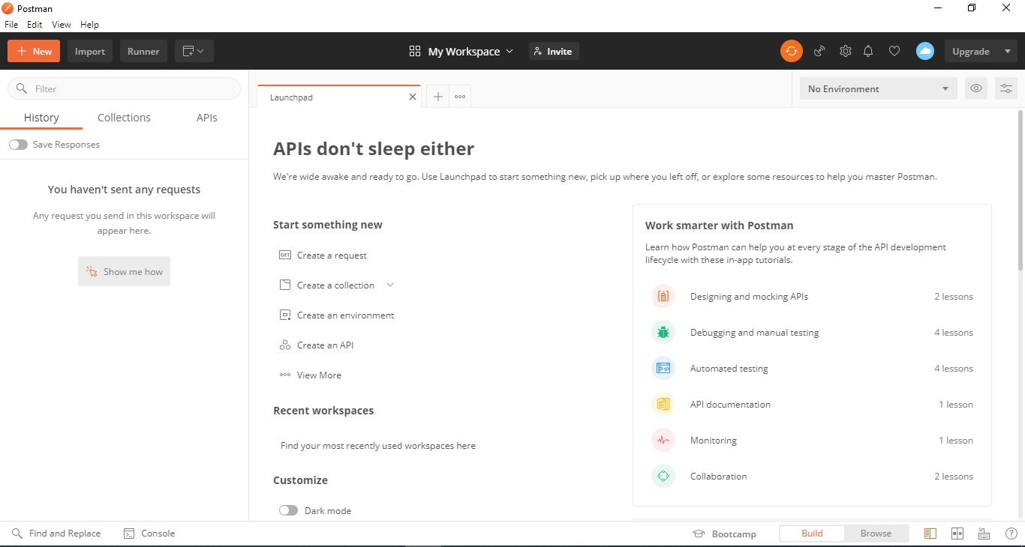

You have been given a Web API service called **BookService** for testing using **Postman**.

**How to set up the project?**

**Step 1: - Execute the DB script provided to create the required table**

Launch SQL Server 2014 Management Studio. Open the **“DBScript.sql”** on it. Execute the script in order to create the Books table.

**Step 2: - Build the project and execute on IIS Express**

Build the project from **Visual Studio 2017 Community Edition**. Afterwards, execute the **BookService** **app** so that you can consume it from Postman.

##### ****GET Request using Postman****

##### Select the HTTP Method as “GET” and enter the URL of your Web API as shown in the below image.

##### 

##### ****POST Request using Postman****

##### Follow the below steps in order to send a POST request to the Web API

##### Step 1

##### Choose the HTTP verb as POST

##### Step 2

##### Set the URI

##### Step 3

Set the Content-Type as **application/json**. To do this click on the Header tab and provide the key value as shown in the below image

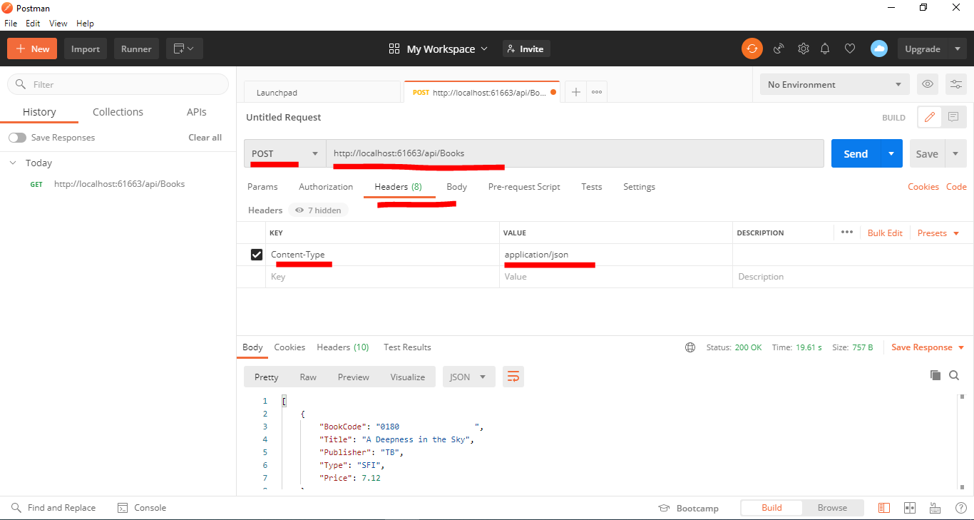

**Step 4**

Next, you need to provide the new book details to add in the JSON format as shown below.

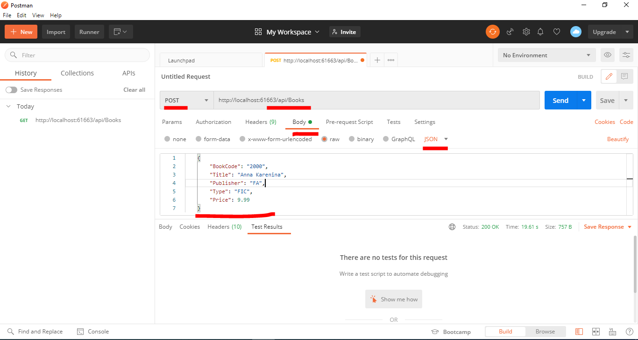

**New Book Details to Add**

{

"BookCode": "6000",

"Title": "Anna Karenina",

"Publisher": "FA",

"Type": "FIC",

"Price": 9.99

}

**Step 5**

Once you provided the JSON value in the request body, click on the send button which will issue a post request to the web API. Observe the response from the Web API and verify the response code. It must be **201 Created.**

