Nikhil Saroop

ST10040092

ADD7311

ASSIGNMENT 2

Question 1

1. **Customer Table**

CREATE TABLE Customer (

Customer_ID NUMBER PRIMARY KEY,

First_Name VARCHAR2(50),

Surname VARCHAR2(50),

Address VARCHAR2(100),

Contact_Number VARCHAR2(15),

Email VARCHAR2(50)

);

1. **Employee Table**

CREATE TABLE Employee (

Employee_ID VARCHAR2(10) PRIMARY KEY,

First_Name VARCHAR2(50),

Surname VARCHAR2(50),

Contact_Number VARCHAR2(15),

Address VARCHAR2(100),

Email VARCHAR2(50)

);

1. **Donator Table**

CREATE TABLE Donator (

Donator_ID NUMBER PRIMARY KEY,

First_Name VARCHAR2(50),

Surname VARCHAR2(50),

Contact_Number VARCHAR2(15),

Email VARCHAR2(50)

);

1. **Donation table**

CREATE TABLE Donation (

Donation_ID NUMBER PRIMARY KEY,

Donator_ID NUMBER REFERENCES Donator(Donator_ID),

Donation VARCHAR2(100),

Price NUMBER(10, 2), -- Store price as a NUMBER for proper calculations

Donation_Date DATE

);

1. **Delivery Table**

CREATE TABLE Delivery (

Delivery_ID NUMBER PRIMARY KEY,

Delivery_Notes VARCHAR2(200),

Dispatch_Date DATE,

Delivery_Date DATE

);

1. **Returns Table**

CREATE TABLE Returns (

Return_ID VARCHAR2(10) PRIMARY KEY,

Return_Date DATE,

Reason VARCHAR2(200),

Customer_ID NUMBER REFERENCES Customer(Customer_ID),

Donation_ID NUMBER REFERENCES Donation(Donation_ID),

Employee_ID VARCHAR2(10) REFERENCES Employee(Employee_ID)

);

1. **Invoice Table**

CREATE TABLE Invoice (

Invoice_Num NUMBER PRIMARY KEY,

Customer_ID NUMBER REFERENCES Customer(Customer_ID),

Invoice_Date DATE,

Employee_ID VARCHAR2(10) REFERENCES Employee(Employee_ID),

Donation_ID NUMBER REFERENCES Donation(Donation_ID),

Delivery_ID NUMBER REFERENCES Delivery(Delivery_ID)

);

**Question 1 Populating Tables**

1. **Customer table**

**-- Insert data into the Customer table**

INSERT INTO Customer (Customer_ID, First_Name, Surname, Address, Contact_Number, Email)

VALUES (11011, 'Jack', 'Smith', '18 Water Rd', '0877277521', 'jsmith@isat.com');

INSERT INTO Customer (Customer_ID, First_Name, Surname, Address, Contact_Number, Email)

VALUES (11012, 'Pat', 'Hendricks', '22 Water Rd', '0863257857', 'ph@mcom.co.za');

INSERT INTO Customer (Customer_ID, First_Name, Surname, Address, Contact_Number, Email)

VALUES (11013, 'Andre', 'Clark', '101 Summer Lane', '0834567891', 'aclark@mcom.co.za');

INSERT INTO Customer (Customer_ID, First_Name, Surname, Address, Contact_Number, Email)

VALUES (11014, 'Kevin', 'Jones', '55 Mountain way', '0612547895', 'kj@isat.co.za');

INSERT INTO Customer (Customer_ID, First_Name, Surname, Address, Contact_Number, Email)

VALUES (11015, 'Lucy', 'Williams', '5 Main Rd', '0827238521', 'lw@mcal.co.za');

1. **Employee Table**

**-- Insert data into the Employee table**

INSERT INTO Employee (Employee_ID, First_Name, Surname, Contact_Number, Address, Email)

VALUES ('emp101', 'Jeff', 'Davis', '0877277521', '10 Main Road', 'jand@isat.com');

INSERT INTO Employee (Employee_ID, First_Name, Surname, Contact_Number, Address, Email)

VALUES ('emp102', 'Kevin', 'Marks', '0837377522', '18 Water Road', 'km@isat.com');

INSERT INTO Employee (Employee_ID, First_Name, Surname, Contact_Number, Address, Email)

VALUES ('emp103', 'Adanya', 'Andrews', '0817117523', '21 Circle Lane', 'aa@isat.com');

INSERT INTO Employee (Employee_ID, First_Name, Surname, Contact_Number, Address, Email)

VALUES ('emp104', 'Adebayo', 'Dryer', '0797215244', '1 Sea Road', 'aryer@isat.com');

INSERT INTO Employee (Employee_ID, First_Name, Surname, Contact_Number, Address, Email)

VALUES ('emp105', 'Xolani', 'Samson', '0827122255', '12 Main Road', 'xosam@isat.com');

1. **Donator Table**

**-- Insert data into the Donator table**

INSERT INTO Donator (Donator_ID, First_Name, Surname, Contact_Number, Email)

VALUES (20111, 'Jeff', 'Watson', '0827172250', 'jwatson@ymail.com');

INSERT INTO Donator (Donator_ID, First_Name, Surname, Contact_Number, Email)

VALUES (20112, 'Stephen', 'Jones', '0837865670', 'joness@ymail.com');

INSERT INTO Donator (Donator_ID, First_Name, Surname, Contact_Number, Email)

VALUES (20113, 'James', 'Joe', '0878978650', 'jj@isat.com');

INSERT INTO Donator (Donator_ID, First_Name, Surname, Contact_Number, Email)

VALUES (20114, 'Kelly', 'Ross', '0826575650', 'kross@gsat.com');

INSERT INTO Donator (Donator_ID, First_Name, Surname, Contact_Number, Email)

VALUES (20115, 'Abraham', 'Clark', '0797656430', 'aclark@ymail.com');

**4. Donation Table**

**-- Insert data into the Donation table**

INSERT INTO Donation (Donation_ID, Donator_ID, Donation, Price, Donation_Date)

VALUES (7111, 20111, 'KIC Fridge', 599, TO_DATE('01-MAY-2024', 'DD-MON-YYYY'));

INSERT INTO Donation (Donation_ID, Donator_ID, Donation, Price, Donation_Date)

VALUES (7112, 20112, 'Samsung 42inch LCD', 1299, TO_DATE('03-MAY-2024', 'DD-MON-YYYY'));

INSERT INTO Donation (Donation_ID, Donator_ID, Donation, Price, Donation_Date)

VALUES (7113, 20113, 'Sharp Microwave', 1599, TO_DATE('03-MAY-2024', 'DD-MON-YYYY'));

INSERT INTO Donation (Donation_ID, Donator_ID, Donation, Price, Donation_Date)

VALUES (7114, 20115, '6 Seat Dining Room Table', 799, TO_DATE('05-MAY-2024', 'DD-MON-YYYY'));

INSERT INTO Donation (Donation_ID, Donator_ID, Donation, Price, Donation_Date)

VALUES (7115, 20114, 'Lazyboy Sofa', 1199, TO_DATE('07-MAY-2024', 'DD-MON-YYYY'));

INSERT INTO Donation (Donation_ID, Donator_ID, Donation, Price, Donation_Date)

VALUES (7116, 20113, 'JVC Surround Sound System', 179, TO_DATE('09-MAY-2024', 'DD-MON-YYYY'));

1. **Delievery Table**

**-- Insert data into the Delivery table**

INSERT INTO Delivery (Delivery_ID, Delivery_Notes, Dispatch_Date, Delivery_Date)

VALUES (511, 'Double packaging requested', TO_DATE('10-MAY-2024', 'DD-MON-YYYY'), TO_DATE('15-MAY-2024', 'DD-MON-YYYY'));

INSERT INTO Delivery (Delivery_ID, Delivery_Notes, Dispatch_Date, Delivery_Date)

VALUES (512, 'Delivery to work address', TO_DATE('12-MAY-2024', 'DD-MON-YYYY'), TO_DATE('15-MAY-2024', 'DD-MON-YYYY'));

INSERT INTO Delivery (Delivery_ID, Delivery_Notes, Dispatch_Date, Delivery_Date)

VALUES (513, 'Signature required', TO_DATE('12-MAY-2024', 'DD-MON-YYYY'), TO_DATE('17-MAY-2024', 'DD-MON-YYYY'));

INSERT INTO Delivery (Delivery_ID, Delivery_Notes, Dispatch_Date, Delivery_Date)

VALUES (514, 'No notes', TO_DATE('12-MAY-2024', 'DD-MON-YYYY'), TO_DATE('15-MAY-2024', 'DD-MON-YYYY'));

INSERT INTO Delivery (Delivery_ID, Delivery_Notes, Dispatch_Date, Delivery_Date)

VALUES (515, 'Birthday present wrapping required', TO_DATE('18-MAY-2024', 'DD-MON-YYYY'), TO_DATE('19-MAY-2024', 'DD-MON-YYYY'));

INSERT INTO Delivery (Delivery_ID, Delivery_Notes, Dispatch_Date, Delivery_Date)

VALUES (516, 'Delivery to work address', TO_DATE('20-MAY-2024', 'DD-MON-YYYY'), TO_DATE('25-MAY-2024', 'DD-MON-YYYY'));

**6. Returns Table**

**-- Insert data into the Returns table**

INSERT INTO Returns (Return_ID, Return_Date, Reason, Customer_ID, Donation_ID, Employee_ID)

VALUES ('ret001', TO_DATE('25-MAY-2024', 'DD-MON-YYYY'), 'Customer not satisfied with product', 11011, 7116, 'emp101');

INSERT INTO Returns (Return_ID, Return_Date, Reason, Customer_ID, Donation_ID, Employee_ID)

VALUES ('ret002', TO_DATE('25-MAY-2024', 'DD-MON-YYYY'), 'Product had broken section', 11013, 7114, 'emp103');

**7. Invoice Table**

**-- Insert data into the Invoice table**

INSERT INTO Invoice (Invoice_Num, Customer_ID, Invoice_Date, Employee_ID, Donation_ID, Delivery_ID)

VALUES (8111, 11011, TO_DATE('15-MAY-2024', 'DD-MON-YYYY'), 'emp103', 7111, 511);

INSERT INTO Invoice (Invoice_Num, Customer_ID, Invoice_Date, Employee_ID, Donation_ID, Delivery_ID)

VALUES (8112, 11013, TO_DATE('15-MAY-2024', 'DD-MON-YYYY'), 'emp101', 7114, 512);

INSERT INTO Invoice (Invoice_Num, Customer_ID, Invoice_Date, Employee_ID, Donation_ID, Delivery_ID)

VALUES (8113, 11012, TO_DATE('17-MAY-2024', 'DD-MON-YYYY'), 'emp101', 7112, 513);

INSERT INTO Invoice (Invoice_Num, Customer_ID, Invoice_Date, Employee_ID, Donation_ID, Delivery_ID)

VALUES (8114, 11015, TO_DATE('17-MAY-2024', 'DD-MON-YYYY'), 'emp102', 7113, 514);

INSERT INTO Invoice (Invoice_Num, Customer_ID, Invoice_Date, Employee_ID, Donation_ID, Delivery_ID)

VALUES (8115, 11011, TO_DATE('17-MAY-2024', 'DD-MON-YYYY'), 'emp102', 7115, 515);

INSERT INTO Invoice (Invoice_Num, Customer_ID, Invoice_Date, Employee_ID, Donation_ID, Delivery_ID)

VALUES (8116, 11015, TO_DATE('18-MAY-2024', 'DD-MON-YYYY'), 'emp103', 7116, 516);

**Showing Tables**

SELECT * FROM Employee;

SELECT * FROM Donator;

SELECT * FROM Donation;

SELECT * FROM Delivery;

SELECT * FROM Returns;

SELECT * FROM Invoice;

1. **Delivery Table**

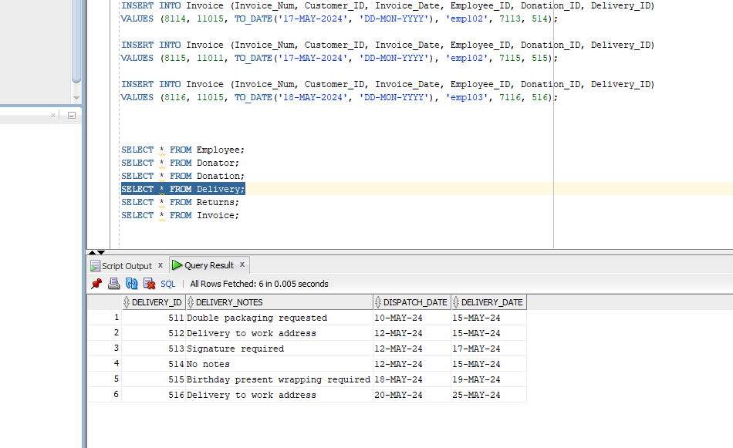

1. **Donator Table**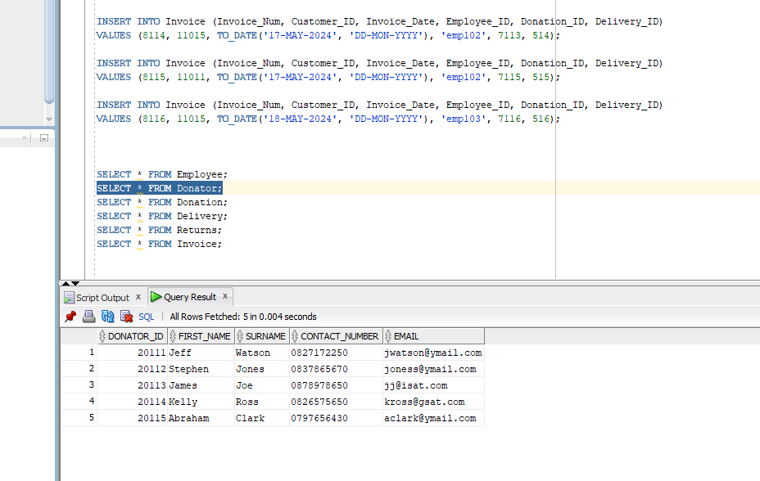
2. **Donation**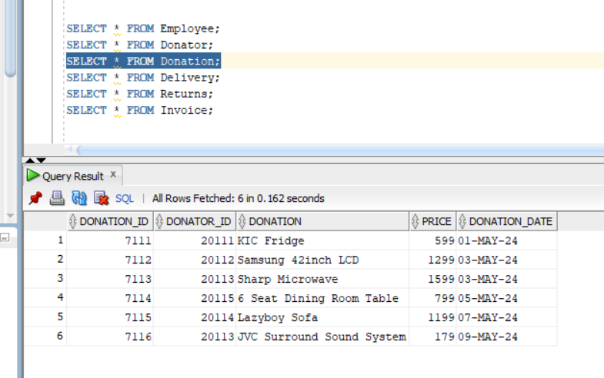
3. **Employee Table**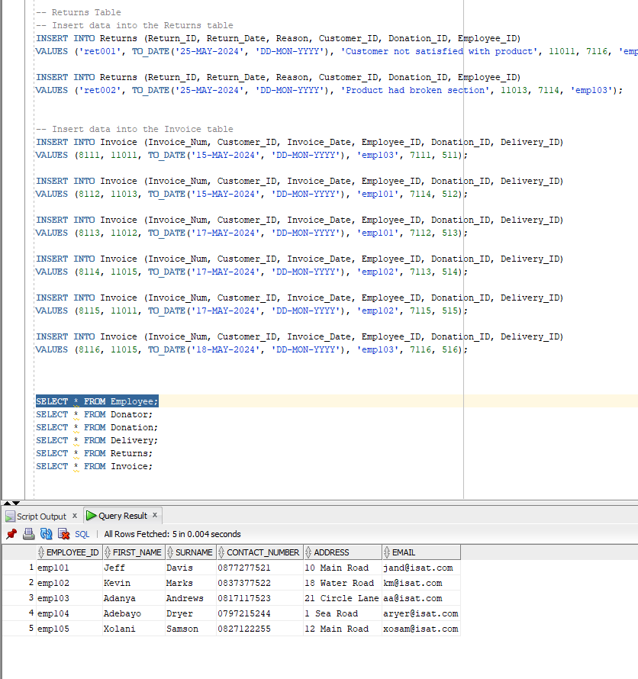
4. **Invoice table**

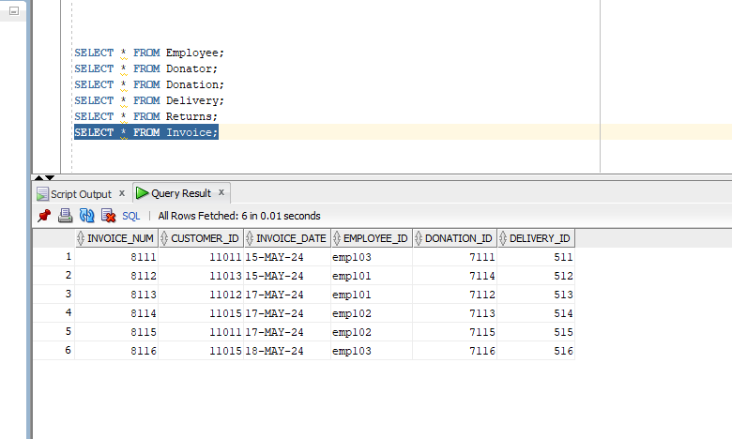

1. **Returns Table**

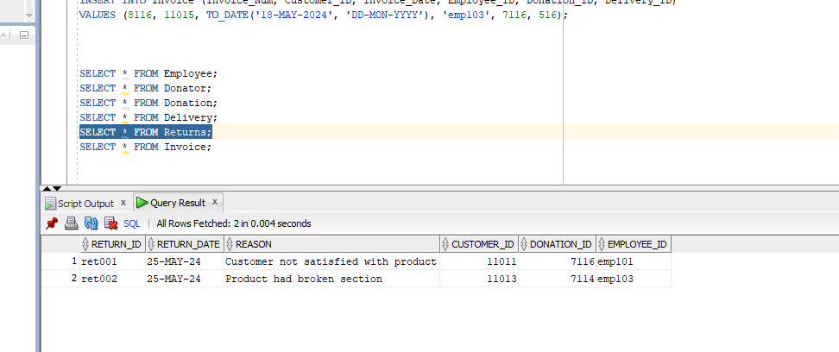

**7. Customer Table**

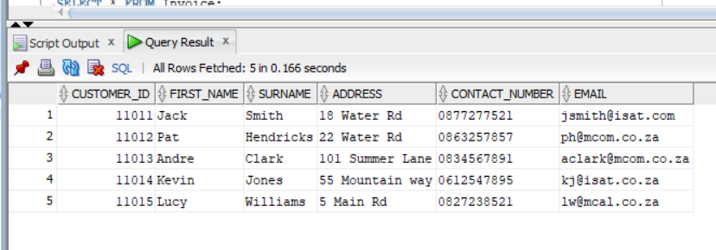

Console OUTPUT

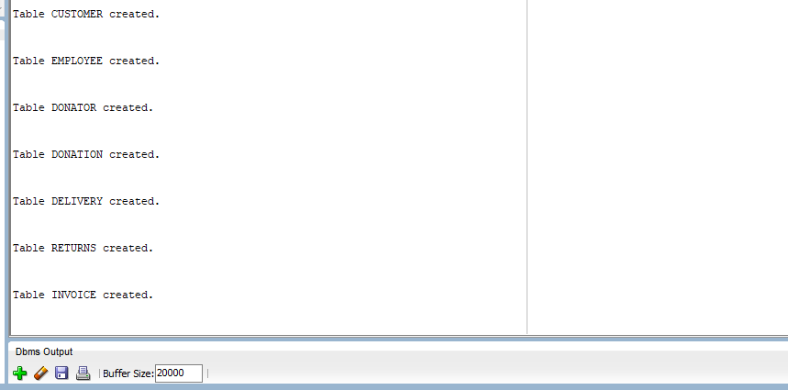

**Question 2**

SELECT

c.First_Name || ', ' || c.Surname AS Customer_Name, -- Concatenating first name and surname with a comma

i.Employee_ID, -- Employee ID from the invoice

d.Delivery_Notes, -- Delivery notes from the delivery table

don.Donation, -- Donation description from the donation table

i.Invoice_Num, -- Invoice number from the invoice table

i.Invoice_Date -- Invoice date to show when filtering

FROM

Invoice i

JOIN

Customer c ON i.Customer_ID = c.Customer_ID -- Join Invoice and Customer tables

JOIN

Delivery d ON i.Delivery_ID = d.Delivery_ID -- Join Invoice and Delivery tables

JOIN

Donation don ON i.Donation_ID = don.Donation_ID -- Join Invoice and Donation tables

WHERE

i.Invoice_Date > TO_DATE('16-MAY-2024', 'DD-MON-YYYY'); -- Filter for invoice dates after 16 May 2024

**OUTPUT**

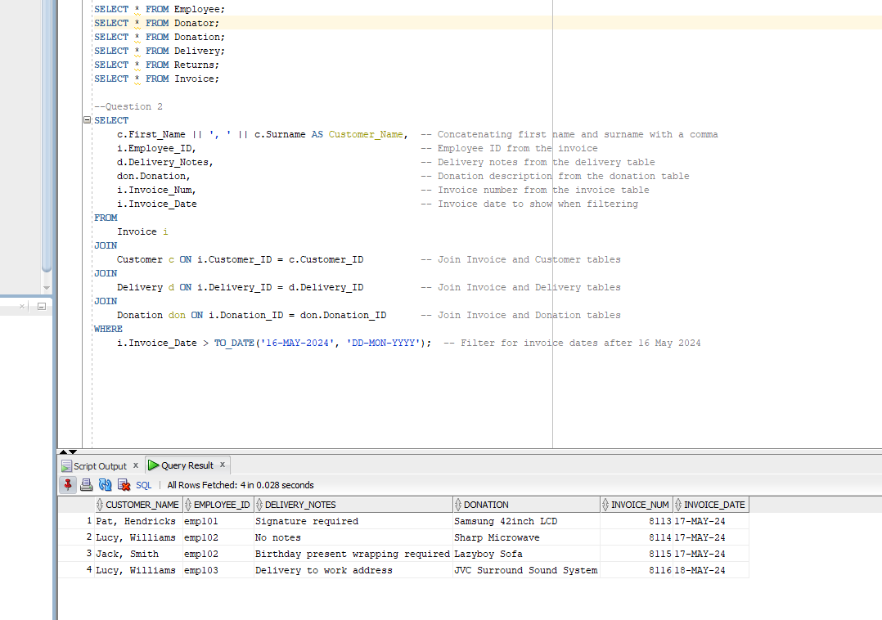

**Question 3**

**Step 1:**

**-- Create the Funding table**

CREATE TABLE Funding (

funding_id NUMBER GENERATED BY DEFAULT AS IDENTITY PRIMARY KEY, -- Auto-generated unique ID

funder VARCHAR2(100), -- Name of the funder

funding_amount NUMBER(10, 2) -- Amount of funding

);

**--The funding_id column uses GENERATED BY DEFAULT AS IDENTITY to automatically generate a unique ID for each inserted record.**

**--The funder column is a VARCHAR2(100) to store the organization's name or person providing the funding.**

**--The funding_amount column is a NUMBER(10, 2) to store the funding amount, allowing up to 10 digits with 2 decimal places for precision (e.g., 50000.00).**

**Step 2: Example Insert Statements**

**-- Insert a new funding record**

INSERT INTO Funding (funder, funding_amount)

VALUES ('United Charity', 50000.00);

**-- Insert another funding record**

INSERT INTO Funding (funder, funding_amount)

VALUES ('Global Aid', 75000.50);

**-- Insert a third record**

INSERT INTO Funding (funder, funding_amount)

VALUES ('Helping Hands Foundation', 25000.00);

--The funding_id is automatically generated and does not need to be included in the INSERT statements.

--Each funder and funding_amount is inserted into the table.

**--Step 3: Query to View the Data**

**-- Query to view all the funding records**

SELECT * FROM Funding;

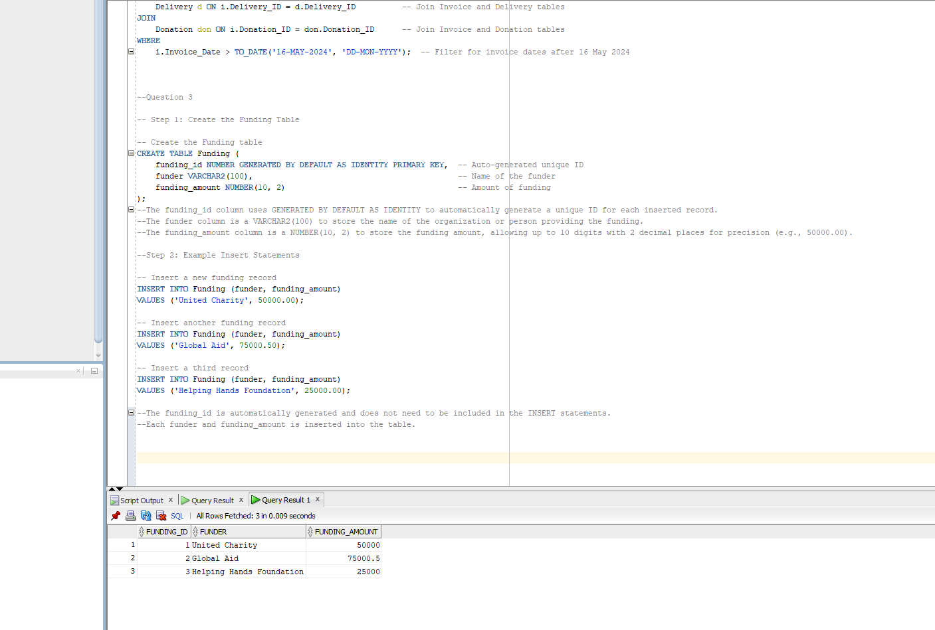

**Question 4**

SET SERVEROUTPUT ON; -- Ensure the output is enabled correctly

BEGIN

-- Cursor to fetch the required data from the Returns, Customer, and Donation tables

FOR r IN (

SELECT

c.First_Name || ', ' || c.Surname AS Customer_Name, -- Concatenate first name and surname

d.Donation, -- Donation description

d.Price, -- Donation price

ret.Reason -- Reason for return

FROM

Returns ret

JOIN

Customer c ON ret.Customer_ID = c.Customer_ID -- Join Returns with Customer

JOIN

Donation d ON ret.Donation_ID = d.Donation_ID -- Join Returns with Donation

)

LOOP

-- Output the results

DBMS_OUTPUT.PUT_LINE('Customer: ' || r.Customer_Name);

DBMS_OUTPUT.PUT_LINE('Donation Purchased: ' || r.Donation);

DBMS_OUTPUT.PUT_LINE('Price: ' || r.Price);

DBMS_OUTPUT.PUT_LINE('Return Reason: ' || r.Reason);

DBMS_OUTPUT.PUT_LINE('-----------------------------');

END LOOP;

END;

/

**--Explanation:**

**--SET SERVEROUTPUT ON: This command ensures that the output from the PL/SQL block is displayed in the console.**

**--Cursor (FOR Loop): The cursor retrieves data from the Returns, Customer, and Donation tables, joining them based on the foreign keys to display the necessary information.**

**--c.First_Name || ', ' || c.Surname AS Customer_Name: This concatenates the customer’s first name and surname with a comma.**

**--d.Donation: The donation purchased by the customer.**

**--d.Price: The price of the donation.**

**--ret.Reason: The reason for the return from the Returns table.**

**--DBMS_OUTPUT.PUT_LINE: This is used to print each piece of information (customer name, donation, price, reason) in a formatted manner.**

**--END LOOP: The loop iterates over each result from the cursor and prints the details.**

**OUTPUT**

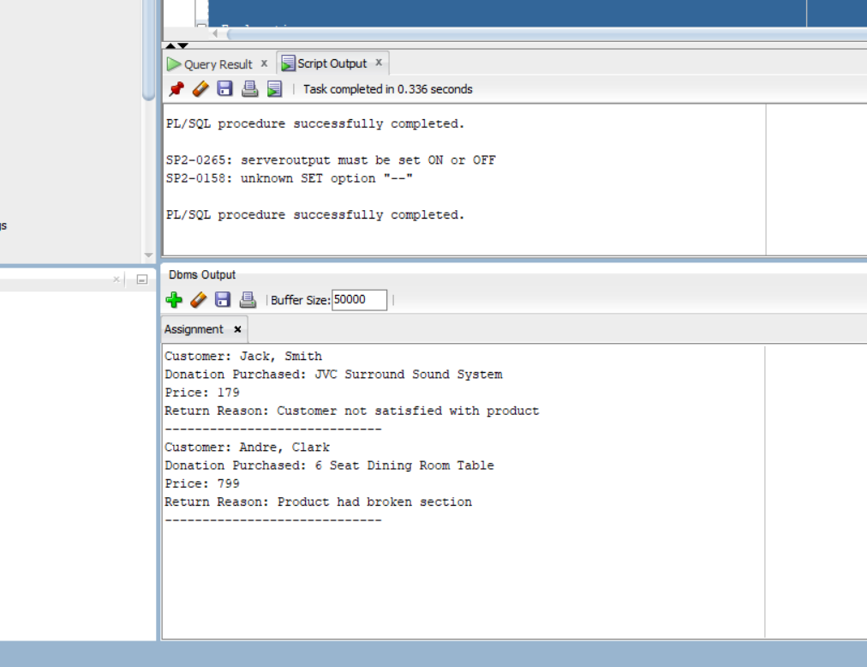

Question 5

SET SERVEROUTPUT ON;

BEGIN

-- Counter to differentiate the first customer for name formatting

DECLARE

v_counter NUMBER := 0; -- Counter variable to track iteration

BEGIN

-- Cursor to fetch the required data from Invoice, Customer, Employee, Donation, and Delivery tables

FOR rec IN (

SELECT

c.First_Name, -- Customer First Name

c.Surname, -- Customer Last Name

e.First_Name || '.' || e.Surname AS Employee_Name, -- Employee name with period

d.Donation, -- Donation description

TO_CHAR(del.Dispatch_Date, 'DD-MON-YY') AS Dispatch_Date, -- Formatted Dispatch Date

TO_CHAR(del.Delivery_Date, 'DD-MON-YY') AS Delivery_Date, -- Formatted Delivery Date

(del.Delivery_Date - del.Dispatch_Date) AS Days_To_Delivery -- Calculating days between dates

FROM

Invoice i

JOIN

Customer c ON i.Customer_ID = c.Customer_ID -- Join with Customer table

JOIN

Employee e ON i.Employee_ID = e.Employee_ID -- Join with Employee table

JOIN

Donation d ON i.Donation_ID = d.Donation_ID -- Join with Donation table

JOIN

Delivery del ON i.Delivery_ID = del.Delivery_ID -- Join with Delivery table

WHERE

i.Customer_ID = 11011 -- Filter for customer ID 11011

)

LOOP

-- Increment the counter

v_counter := v_counter + 1;

-- Conditional formatting for the customer name

IF v_counter = 1 THEN

-- For the first customer, show 'FirstName.LastName'

DBMS_OUTPUT.PUT_LINE('Customer: ' || rec.First_Name || '.' || rec.Surname);

ELSE

-- For subsequent customers, show 'First Initial.LastName'

DBMS_OUTPUT.PUT_LINE('Customer: ' || SUBSTR(rec.First_Name, 1, 1) || '. ' || rec.Surname);

END IF;

-- Output the remaining data

DBMS_OUTPUT.PUT_LINE('Employee: ' || rec.Employee_Name);

DBMS_OUTPUT.PUT_LINE('Donation: ' || rec.Donation);

DBMS_OUTPUT.PUT_LINE('Dispatch Date: ' || rec.Dispatch_Date);

DBMS_OUTPUT.PUT_LINE('Delivery Date: ' || rec.Delivery_Date);

DBMS_OUTPUT.PUT_LINE('Days to Delivery: ' || rec.Days_To_Delivery);

DBMS_OUTPUT.PUT_LINE('-----------------------------------');

END LOOP;

END;

END;

/

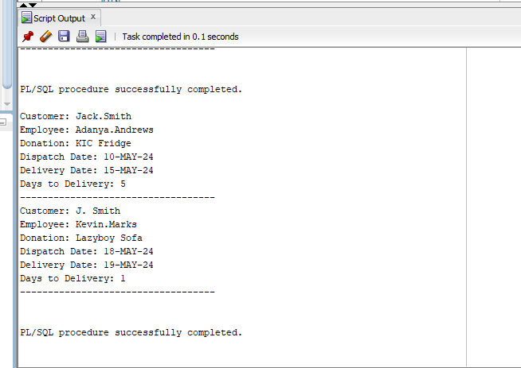

(IIE,2024)

**Question 6**

SET SERVEROUTPUT ON;

BEGIN

-- Cursor to fetch customer names and their total amount spent on donations

FOR rec IN (

SELECT

c.First_Name || ', ' || c.Surname AS Customer_Name, -- Concatenate First Name and Surname

SUM(TO_NUMBER(REPLACE(d.Price, 'R', ''))) AS Total_Spent -- Remove "R" and convert Price to number

FROM

Invoice i

JOIN

Customer c ON i.Customer_ID = c.Customer_ID -- Join Invoice and Customer tables

JOIN

Donation d ON i.Donation_ID = d.Donation_ID -- Join Invoice and Donation tables

GROUP BY

c.First_Name, c.Surname -- Group by Customer to sum the total spent

)

LOOP

-- Output the customer name

DBMS_OUTPUT.PUT_LINE('Customer: ' || rec.Customer_Name);

-- Determine the output based on total spent

IF rec.Total_Spent >= 1500 THEN

-- Display the amount and 3-star rating for totals >= 1500

DBMS_OUTPUT.PUT_LINE('Total Amount Spent: R' || rec.Total_Spent || ' (***)');

ELSE

-- Display the amount only for totals < 1500 (no stars, no brackets)

DBMS_OUTPUT.PUT_LINE ('Total Amount Spent: R' || rec.Total_Spent);

END IF;

DBMS_OUTPUT.PUT_LINE ('-----------------------------------');

END LOOP;

END;

/

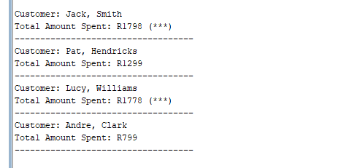

(IIE,2024)

Question 7

Q7.1

SET SERVEROUTPUT ON;

DECLARE

v_customer_email Customer.Email%TYPE; -- Declare variable with the same datatype as Email in Customer table

BEGIN

-- Select the email of the customer with ID 11012

SELECT Email INTO v_customer_email

FROM Customer

WHERE Customer_ID = 11012;

-- Output the customer's email

DBMS_OUTPUT.PUT_LINE('Customer Email: ' || v_customer_email);

END;

/

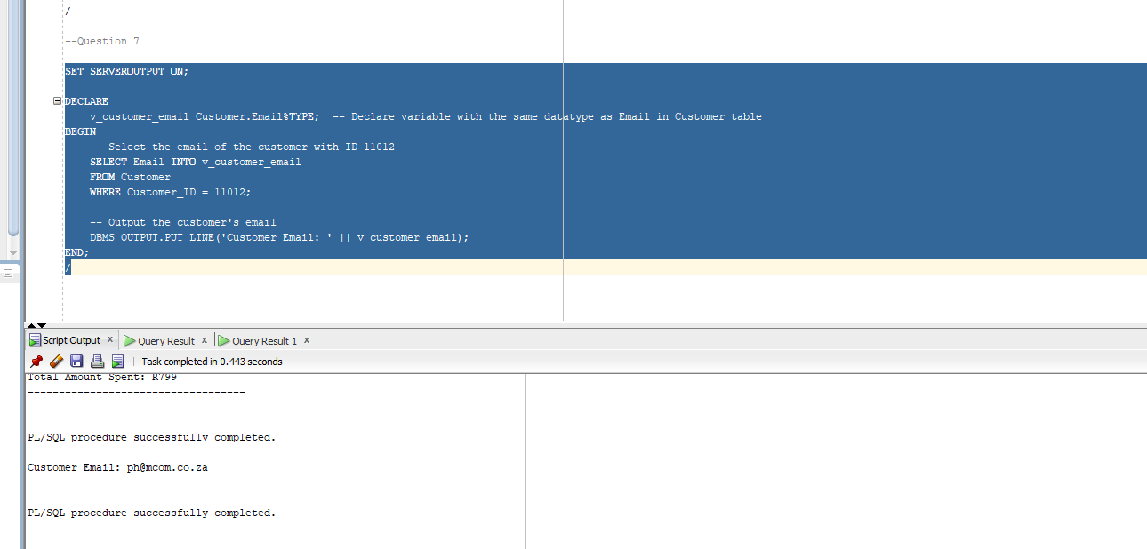

Q7.2

SET SERVEROUTPUT ON;

DECLARE

v_invoice Invoice%ROWTYPE; -- Declare a variable with the same structure as a row in the Invoice table

BEGIN

-- Select the entire row for the invoice of customer with ID 11012

SELECT * INTO v_invoice

FROM Invoice

WHERE Customer_ID = 11012;

-- Output the invoice details

DBMS_OUTPUT.PUT_LINE('Invoice Number: ' || v_invoice.Invoice_Num);

DBMS_OUTPUT.PUT_LINE('Invoice Date: ' || v_invoice.Invoice_Date);

DBMS_OUTPUT.PUT_LINE('Employee ID: ' || v_invoice.Employee_ID);

END;

/

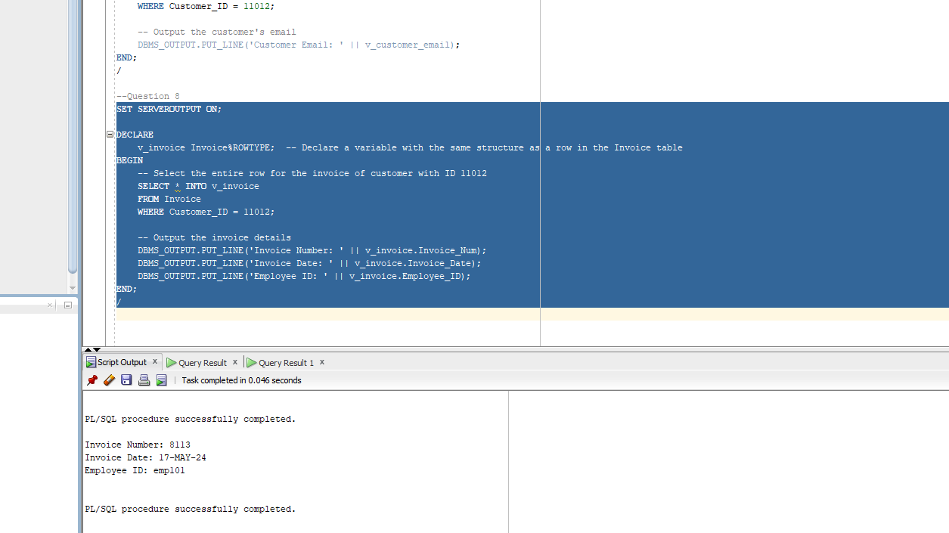

(IIE,2024)

Q7.3

SET SERVEROUTPUT ON;

DECLARE

-- Declare a user-defined exception for low total spending

e_low_spending EXCEPTION;

v_total_spent NUMBER; -- Declare a variable to hold the total amount spent by a customer

BEGIN

-- Select the total amount spent by customer with ID 11012

SELECT SUM(TO_NUMBER(REPLACE(Price, 'R', ''))) INTO v_total_spent

FROM Invoice i

JOIN Donation d ON i.Donation_ID = d.Donation_ID

WHERE i.Customer_ID = 11012;

-- Check if the total amount spent is less than R500

IF v_total_spent < 500 THEN

RAISE e_low_spending; -- Raise the custom exception

END IF;

-- Output the total spent

DBMS_OUTPUT.PUT_LINE('Total Amount Spent: R' || v_total_spent);

EXCEPTION

-- Handle the user-defined exception

WHEN e_low_spending THEN

DBMS_OUTPUT.PUT_LINE('Error: Total amount spent is less than R500.');

END;

/

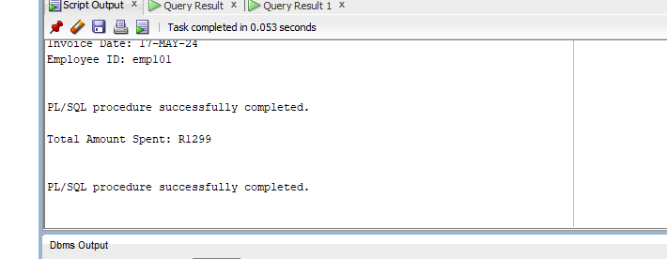

(IIE,2024)

Question 8

SELECT

c.First_Name AS FIRST_NAME, -- Display customer's first name

c.Surname AS SURNAME, -- Display customer's surname

'R' || SUM(TO_NUMBER(REPLACE(d.Price, 'R', ''))) AS AMOUNT, -- Total amount spent by the customer

CASE

WHEN SUM(TO_NUMBER(REPLACE(d.Price, 'R', ''))) >= 1500 THEN '***' -- 3 stars for total >= 1500

WHEN SUM(TO_NUMBER(REPLACE(d.Price, 'R', ''))) BETWEEN 1000 AND 1499 THEN '**' -- 2 stars for total between 1000 and 1499

ELSE '*' -- 1 star for total < 1000

END AS CUSTOMER_RATING -- Star rating based on the total amount spent

FROM

Invoice i

JOIN

Customer c ON i.Customer_ID = c.Customer_ID -- Join Customer and Invoice tables

JOIN

Donation d ON i.Donation_ID = d.Donation_ID -- Join Donation and Invoice tables

GROUP BY

c.First_Name, c.Surname -- Group by Customer's first and last name

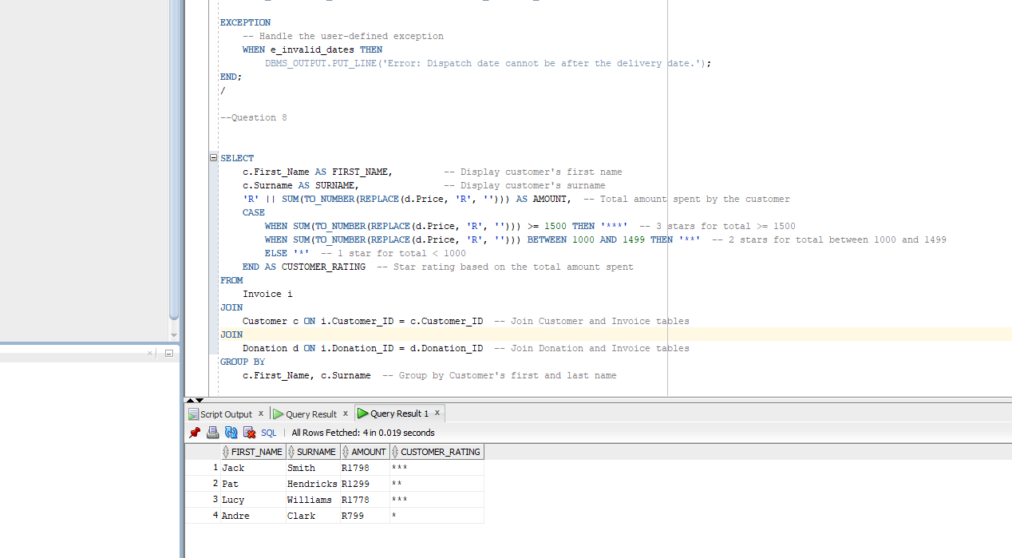

(IIE,2024)

Bibliography

IIE, 2024. Advanced Databases Module Manual. 1st Edition ed. s.l.:The Indipendant Institute of Education.