**Nikhil Saroop**

**POE6212**

**Feedback**

**ST10040092**

**POE**

FEEDBACK FROM LECTURER

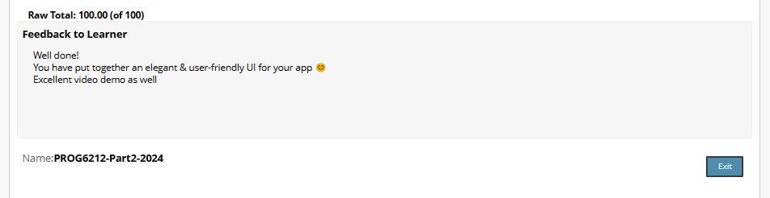

HOW CAN I IMPROVE?

(Sidra, 2023)Focus on crafting an intuitive interface (UI) that improves the user experience (UX ) as you're hoping to enhance your website. Make sure the design is consistent and visually pleasing first. Implement a simple design with intuitive menus to make it simple for users to access important functions like status monitoring, approvals, and claim filings. To make sure that the website works beautifully on desktops, tablets, and smartphones, apply responsive design concepts. Using a color scheme that compliments the objectives your application while retaining visibility can additionally boost user engagement.

(Sidra, 2023)

Ensure simplicity and accessibility of access to your primary concerns and follow UX best practices. For example, to help lecturers and program coordinators browse forms, use clear labels and placeholders in input fields. Be certain that error messages are easy to understand so users can resolve problems rapidly. Integrate confirmation messages or progress indicators to give users feedback and convince them if their activities were effective. Minimizing the variety of steps in the claim submission and approval process will enhance usability and alleviate dissatisfaction

At last, to boost efficiency and engagement, think about adding interactive aspects. For example, to offer further details without overwhelming the user, use tooltips and hover effects. Use technologies like SignalR to enable real-time claim status updates so users don't have to reload sites. Using user testing and feedback gathering you'll likely uncover difficulties while implementing data-driven upgrades. By combining these UX and UI strategies, you may be certain your website is both useful as well as simple to use, which will enhance user satisfaction and efficiency.

(Sidra, 2023)

Bibliography:

Sidra, 2023. 10 Tips How To Improve UI/UX Design of a Web Application [WWW Document]. Sencha.com. URL <https://www.sencha.com/blog/10-tips-how-to-improve-ui-ux-design-of-a-web-application/>

(accessed 21 November 2024).