**Mini Project Report on**



**STOCK VISUALIZATION AND FORECASTING**



**Submitted in partial fulfillment of the requirement for the award of the degree of**

**BACHELOR OF TECHNOLOGY**

**IN**

**COMPUTER SCIENCE & ENGINEERING**

**Submitted by:**

**Student Name**  **University Roll No.**

**NIKHIL SINGH 2016880**

***Under the Mentorship of***

**MS. MEENAKSHI MAINDOLA**

**Assistant Professor**



**Department of Computer Science and Engineering**

**Graphic Era (Deemed to be University)**

**Dehradun, Uttarakhand**

**January 2023**



**CANDIDATE’S DECLARATION**

I hereby certify that the work which is being presented in the project report entitled **“Stock Visualization and Forecasting using Python”** in partial fulfillment of the requirements for the award of the Degree of Bachelor of Technology in Computer Science and Engineeringof the Graphic Era (Deemed to be University), Dehradun shall be carried out by the under the mentorship of **Ms. Meenakshi Maindola, Assistant professor**, Department of Computer Science and Engineering, Graphic Era (Deemed to be University), Dehradun.

Name: Nikhil Singh University Roll no.:2016880 **signature**

**Table of Contents**

|  |  |  |
| --- | --- | --- |
| **Chapter No.** | **Description** | **Page No.** |
| Chapter 1 | Introduction |  |
| Chapter 2 | Literature Survey |  |
| Chapter 3 | Methodology |  |
| Chapter 4 | Result and Discussion |  |
| Chapter 5 | Conclusion and Future Work |  |
|  | References |  |

**Chapter 1**

**Introduction**

Problem statement: To visualize and forecast stocks using python.

* 1. **Introduction**

Investing in stocks represents an ownership interest in a company, along with a claim on its earnings and assets. Stock markets enable companies to be traded publicly and raise capital. The transfer of capital and ownership is traded in a regulated, secure environment. Stock markets promote investment. The raising of capital allows companies to grow their businesses, expand operations and create jobs in the economy. That’s why stock always fluctuates. Forecasting stock market indexes is an important issue for market participants, because even a small improvement in forecast accuracy may lead to better trading decisions than those of other participants.

Forecasting the movement of composite market indexes is a challenging problem from both an academic and practical perspective owing to the complexity of movement. It includes random noise made by various market participants with different points of view, making the movement complex and difficult to predict. In addition, a stock market index is affected by numerous incidents involving individual companies and external incidents, such as political and diplomatic issues.

We proposed a forecasting and visualization technique for a better understanding of stocks using LSTM (deep learning model) in python. Which will help participants to buy or sell stock at the best time for the profits.

* 1. **LSTM**

Long short term memory (LSTM) is a model that increases the memory of recurrent neural networks. Recurrent neural networks hold short term memory in that they allow earlier determining information to be employed in the current neural networks. For immediate tasks, the earlier data is used. We may not possess a list of all of the earlier information for the neural node. In RNNs, LSTMs are very widely used in Neural networks. Video, NLP, geospatial, and time-series modelling problems could benefit from their application to multiple sequence modeling problems.

**Chapter 2**

**Literature Survey**

We survey on the application of neural networks in forecasting stock market prices. Neural networks have the ability to predict market directions more accurately than existing methods because of their capacity to find patterns in nonlinear and chaotic systems. The effectiveness of common market analysis methods including technical analysis, fundamental analysis, and regression is explored and contrasted with that of neural networks.

|  |  |  |  |  |  |
| --- | --- | --- | --- | --- | --- |
| **Sr. No.** | **Name of paper** | **Authors** | **Publication Name** | **Published on** | **Approaches** |
| 1. | “Data visualization and stock market prediction.” | Ashutosh Sharma, Sanket Modak, Eashwaran Sridhar | IRJET | Sep 2019 | Finanical market directly enhanced long-run growth through financial intermediaries. |
| 2. | “News Sensitive stock market prediction”. | Shazia Usmani, Jawwad A shamsi | IEEE | 23 March, 2021 | Financial time series data encompasses dynamic and historical data. |
| 3. | “Stock market prediction performance of neural networks” | Krishna Bhambani,  Tanmay Jain, Dr. Kavita | IEEE | 14 February, 2017 | According to the efficient market hypothesis, stock price cannot be forecasted by investors since market reflects all of the currently available information. |
| 4. | “Machine learning stock market prediction series” | Troy J. Strader, John J. Rozycki | IEEE | 3 July, 2020 | ANN, SVMs, or multi-method GA approaches are some of the most common techniques for tackling the problem of stock market prediction |

**Chapter 3**

**Methodology**

This section presents the approaches and techniques that are related to the proposed system. The goal of this Project is to visualize and predict the stocks.

**3.1** Tools used:

Google Colab, Jupyter Notebook, VS-Code

**3.2** Python library used:

TensorFlow, Keras, NumPy, Pandas, Datetime, Scikit-learn, Matplotlib, Yfinance, Stream lit.

**3.3** Method:

**3.3.1** Model Formation:

Firstly, we have imported all the library and download the Stock data using yfinance fetch method. We are forecasting the Close stock data of each day. The data needs to be scaled so for that we have used MinMaxScaler from sklearn preprocessing. The we used the sequential model for the time series data with the LSTM Layers forming the recurrent neural network.

The model is compiled with Adam optimizer and metric of mean squared error over the 70% of the scaled data. The remaining 30% of the scaled data is used for testing the model.

**3.3.2** Front-end:

We have streamilt for designing the UI of the application. Stream lit is an open-source app framework in Python language. It helps in creating web apps for data science and machine learning in a short time and is compatible with major Python libraries such as scikit-learn, Keras, PyTorch, SymPy(latex), NumPy, pandas, Matplotlib etc.

**3.4 Steps in the model making**

1. Firstly, various libraries such as NumPy, pandas, Scikit-learn, matplotlib, yfinance etc. were imported.
2. The we fetched the data using yfinance API call which takes a ticker i.e., Stock symbol which uniquely represent a stock.
3. Filter the close stock amount from the data frame and plot the close stock amount for the better visualization.
4. Compute the Training data length that is mostly taken as 70% and for Testing data is 30%.
5. Before splitting the data, we have to scale the data for better optimization and prediction using MinMaxScaler from sklearn.
6. Split the data into training and testing i.e., x_train, y_train and x_test, and y_test.
7. Compute the rolling mean of 100 data point and plot is using matplotlib which determines that the data is computed using the recent values of stocks.
8. We can also check the result using 200 data point for computing rolling mean and checking the hinderance.
9. The main part is now to form a model. We will use sequential and LSTM model for building of the model. LSTM works efficiently on the time series data.
10. The model is then compiled on the Adam optimizer and loss metric of mean squared error.
11. The model is ready for making the prediction. We will test the data over the Testing data we have previously filtered.
12. We also check the model RMSE (root mean squared error for checking the model efficiency).
13. Finally model prediction is plotted with the original stock price.

**Chapter 4**

**Result and Discussion**

We visualize all the stocks details along with the comparisons. This is the plot of close price history of the selected stock.

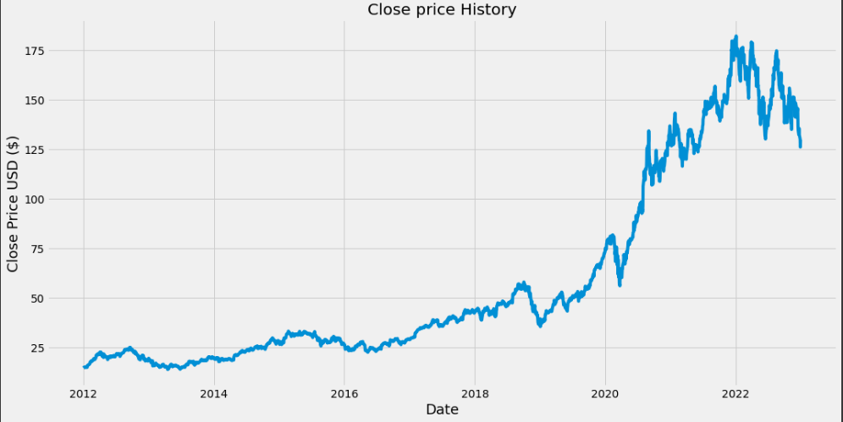

This plot shows the train, validated, predicted data. Orange line in the validated data and yellow line in the predicted data. This show our model is working so good with root mean squared error of 10.551.

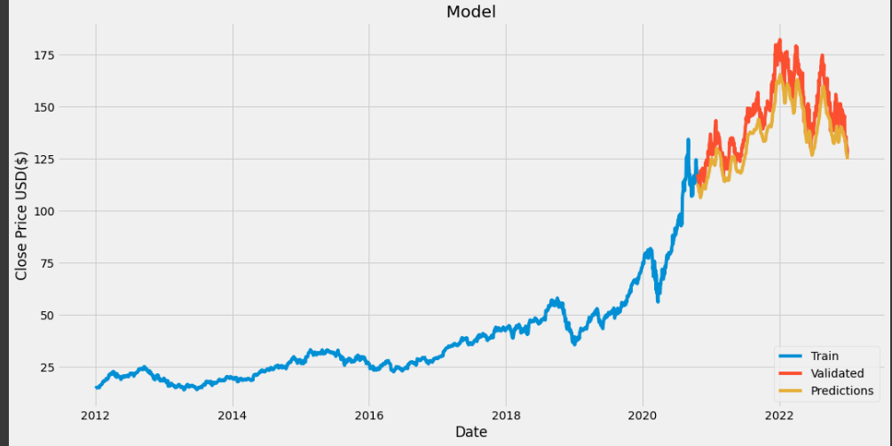

UI of the application.

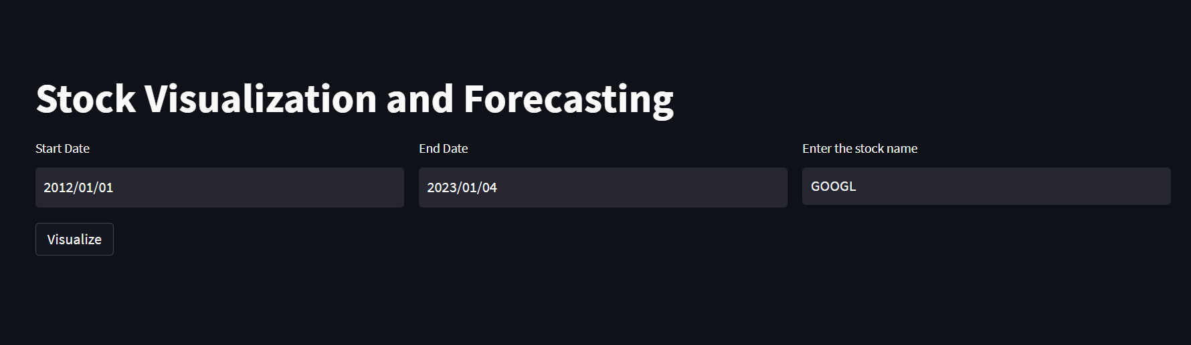

Description of the data frame we fetched using yfinance API.

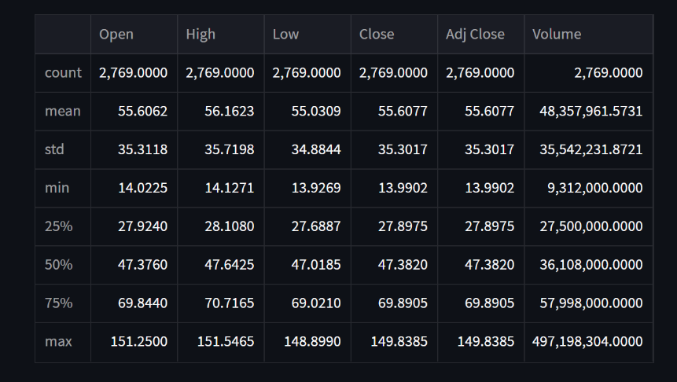

This plot depicts the rolling mean average of 100 days with the original stocks’ values.

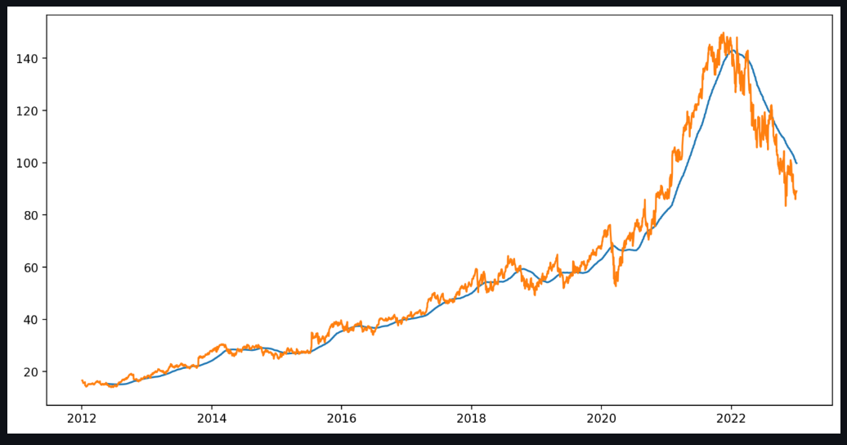

This plot depicts the comparison between 200 days rolling mean average and 100 days rolling mean average with the original stock price values.

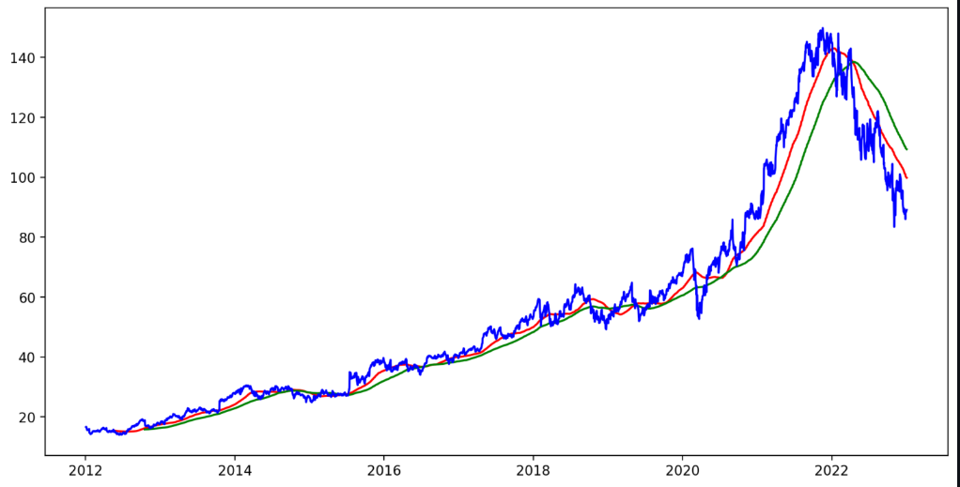

This is the plot of prediction and original stock values.

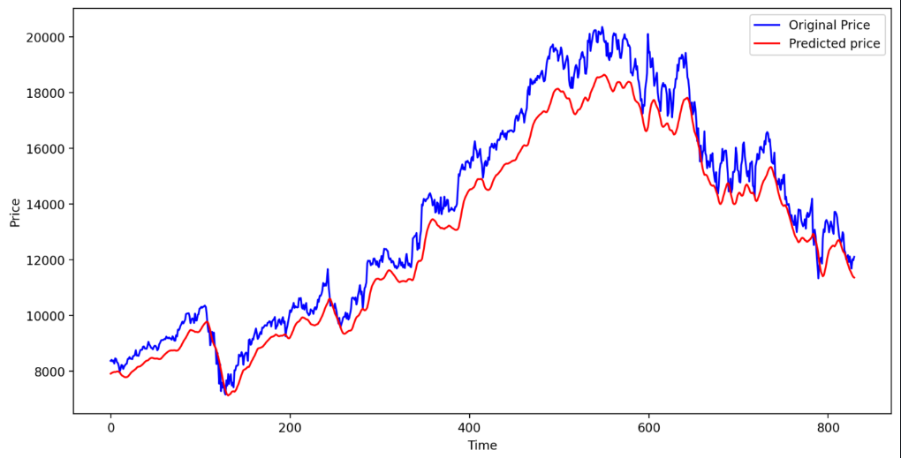

**Chapter 5**

**Conclusion and Future Work**

Stock price prediction is a challenging task, and it is difficult to achieve consistently accurate results. However, despite the inherent difficulties, the development of effective stock price prediction systems has the potential to provide significant benefits, both for individual investors and for the financial industry as a whole.

There are many areas where future work on stock price prediction systems could be focused. One possibility is to continue to improve the accuracy of the predictions, through the use of more advanced machine learning techniques, such as deep learning and reinforcement learning, or by incorporating additional sources of data, such as news articles or social media data.

Another area of focus could be on developing more efficient and scalable prediction systems, in order to make them more practical for use in real-world applications. This could involve optimising the algorithms used for prediction, as well as designing more efficient hardware and software architectures.

In addition, there is also a need for more robust evaluation methods for stock price prediction systems, in order to better understand their strengths and limitations and to identify the most accurate and reliable approaches.

Overall, the field of stock price prediction is an active area of research, and there is still much work to be done in order to improve the accuracy and reliability of these systems.

**References**

[1] “Visualizing and Forecasting Stocks Using Dash” by Sachin Kumar Mishra, Rishabh Thakur, Shantanu Saha3, Chitrangada Chaubey. International Journal of Advanced Research in Science, Communication and Technology (IJARSCT) Volume 2, ISSN (Online) 2581-9429, Issue 1, May 2022.

[2] “Stock price using LSTM and its implementation” by Siddharth M- Published on December 6,2021:<https://www.analyticsvidhya.com/blog/2021/12/stock-price-prediction-using-lstm/> (**Analytic Vidhya**)

[3]“Stock Market Predictions with LSTM in Python” by [Thushan Ganegedara](https://www.datacamp.com/profile/thushv)- Published on January,2020: <https://www.datacamp.com/tutorial/lstm-python-stock-market>

(**Data Camp**)

[4] **“**Predicting stock market index using LSTM” by Hum Nath Bhandari Binod Rimal Nawa Raj Pokhrel Ramchandra Rimal   Keshab R. Dahal Rajendra K.C. Khatri, Received 8 February 2022, revised 2 May 2022, Accepted 2 May 2022, Available online 13 May 2022, Version of Record 19 May 2022.

[5]A. Sharma, D. Bhuriya, and U. Singh, “Survey of Stock Market Prediction Using Machine Learning Approach,” pp. 506–509, 2017.