Name -Nikhil Singhal

Section -K23XR

Reg no. – 12305948

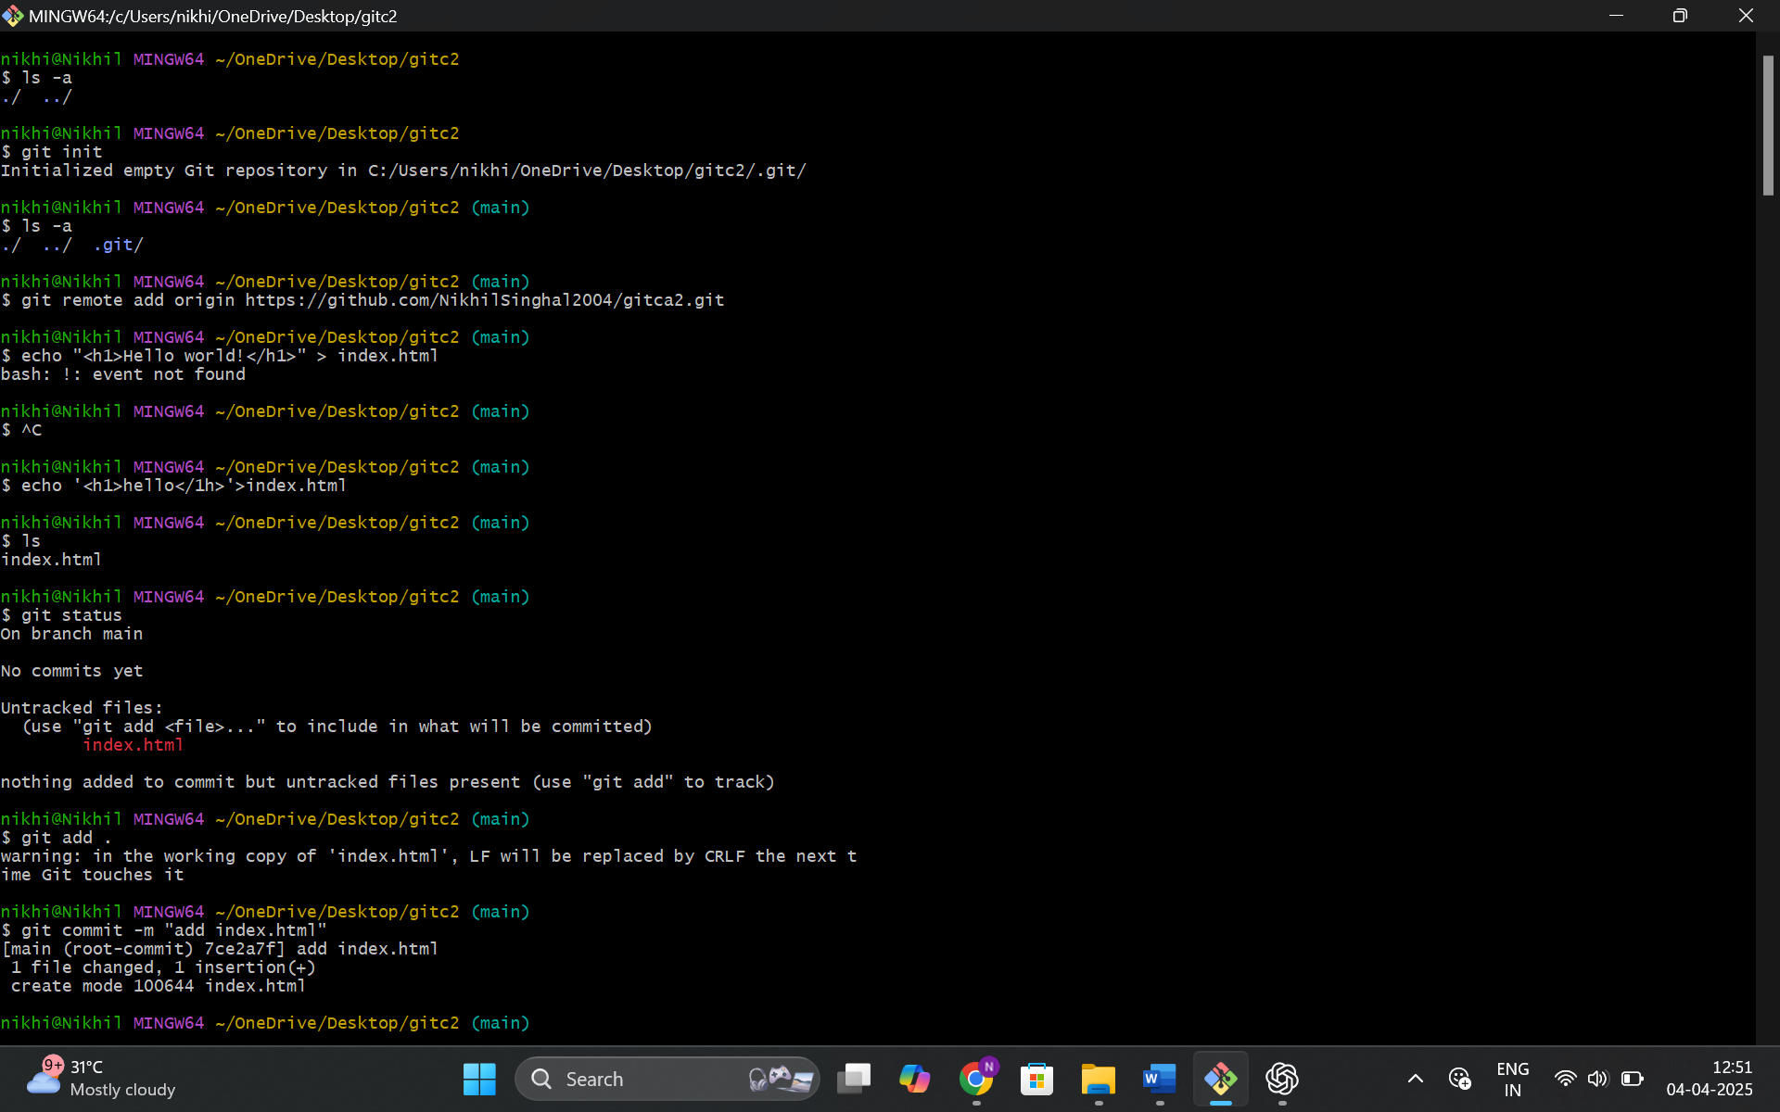

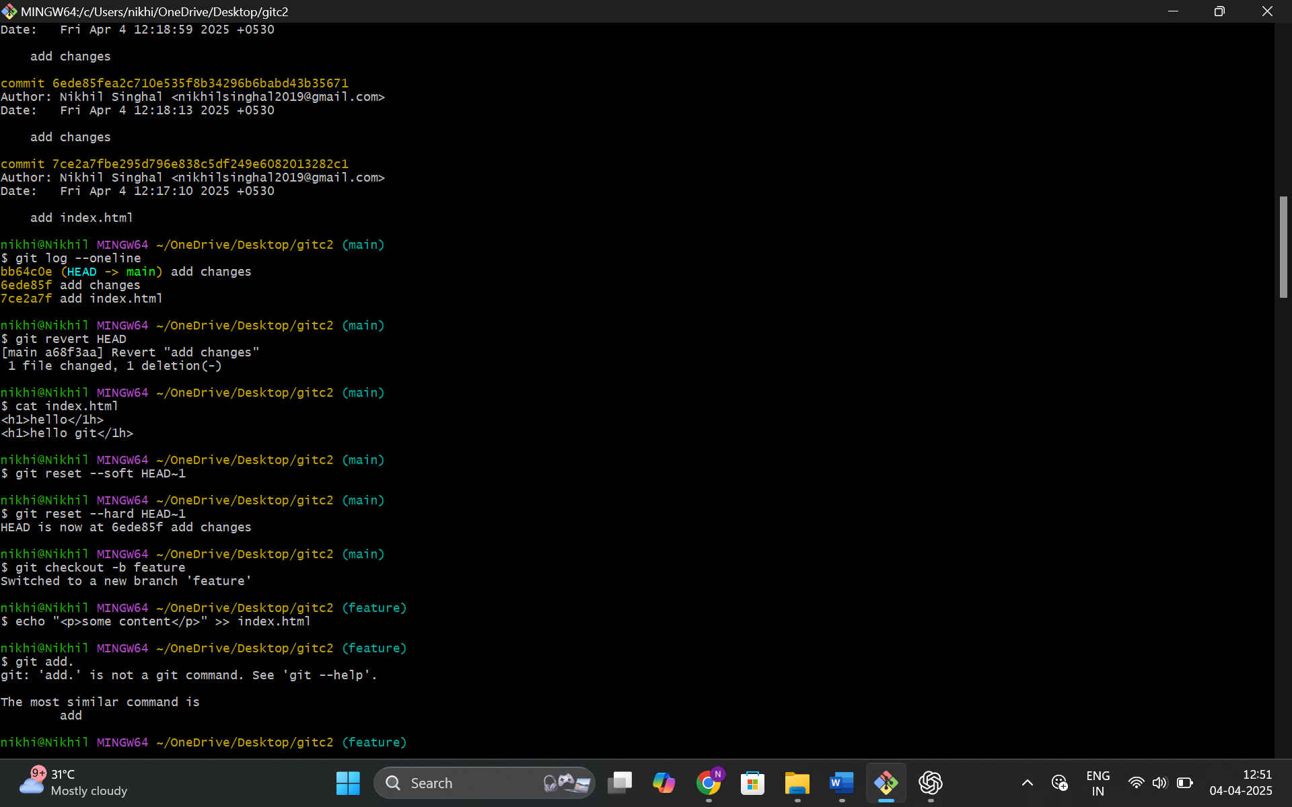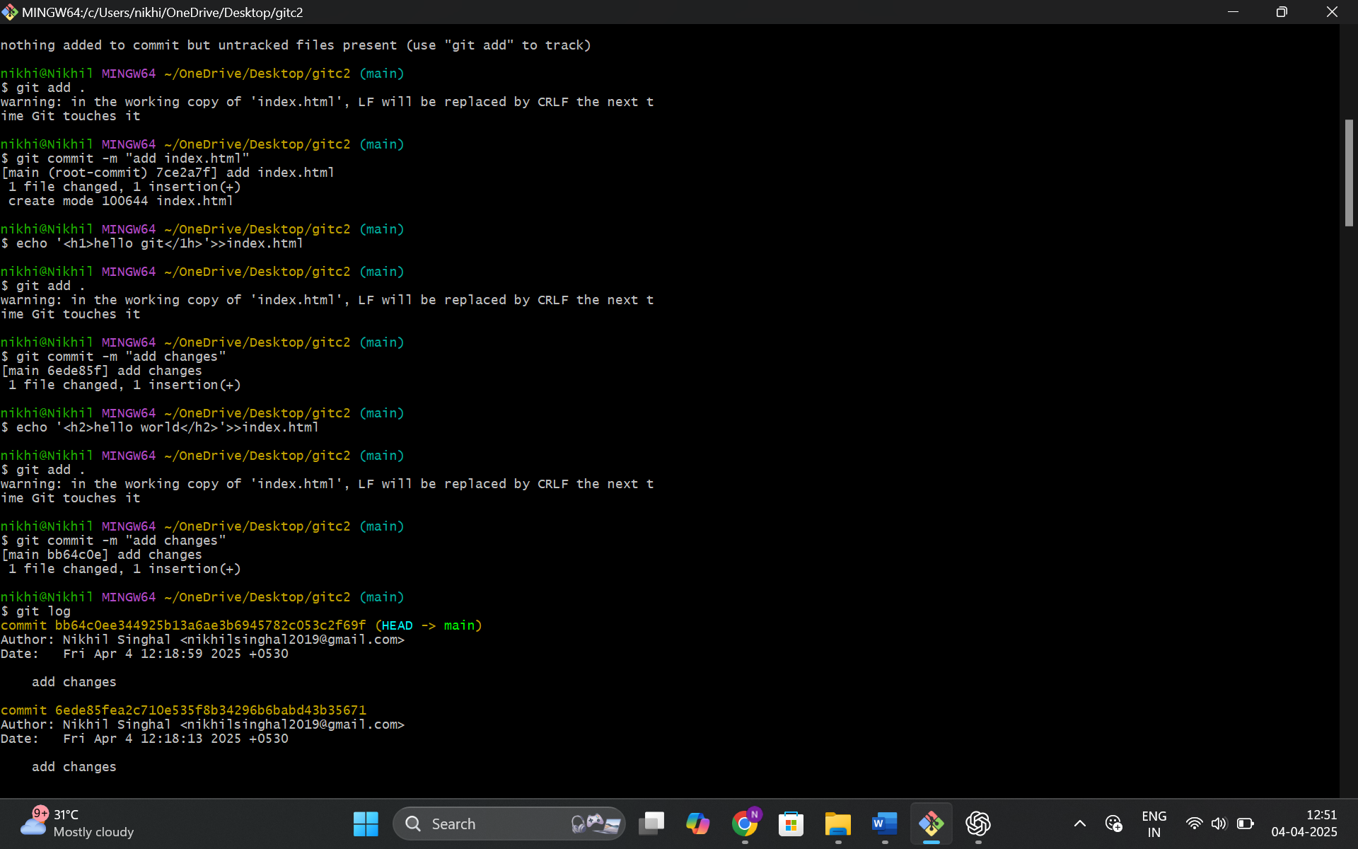

**Head** is a pointer to the current branch's latest commit.  
During soft reset, HEAD moves back, but changes stay.  
In hard reset, HEAD moves and changes are discarded from working directory.

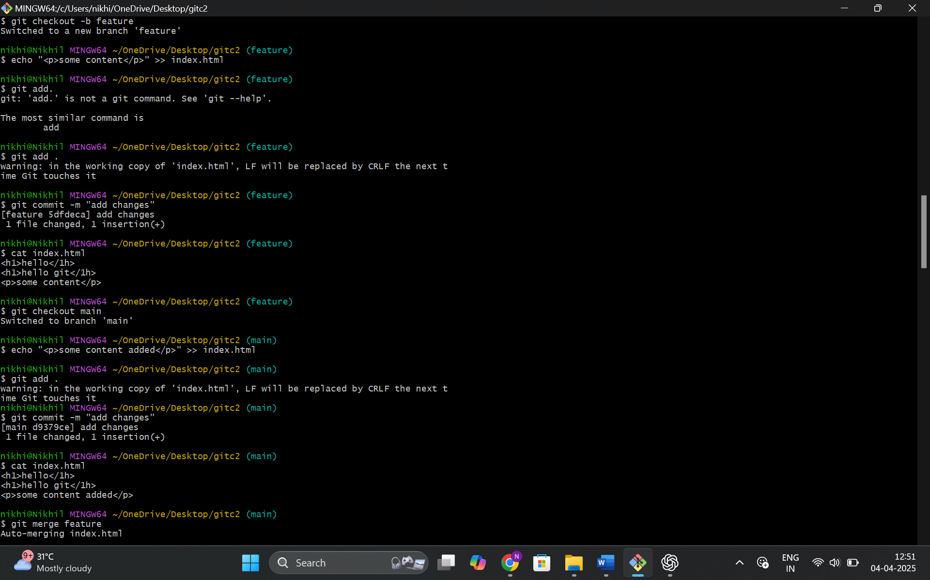

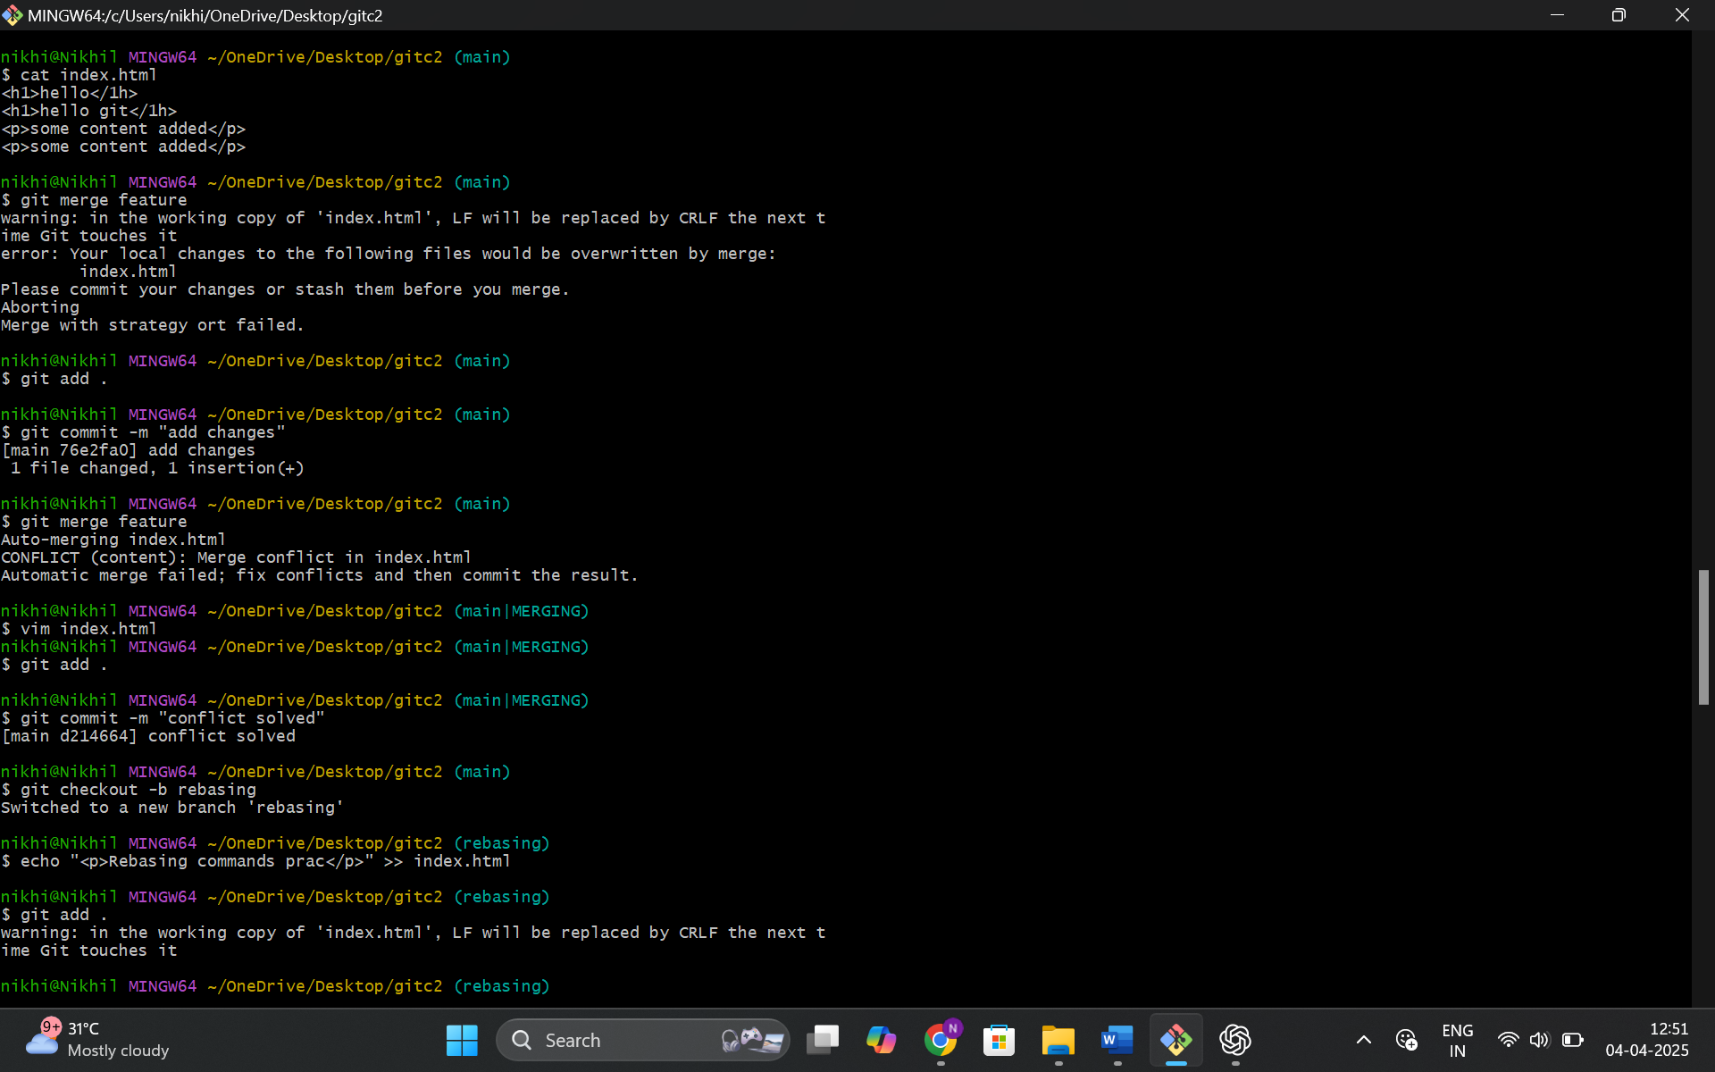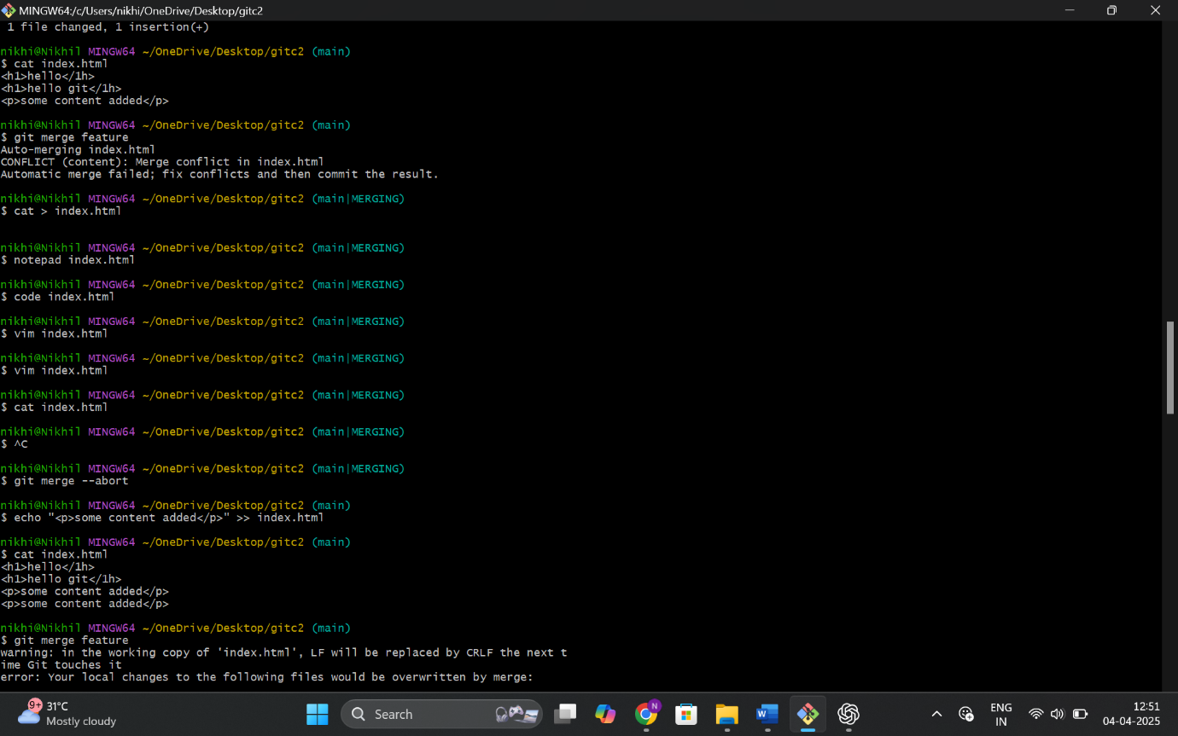

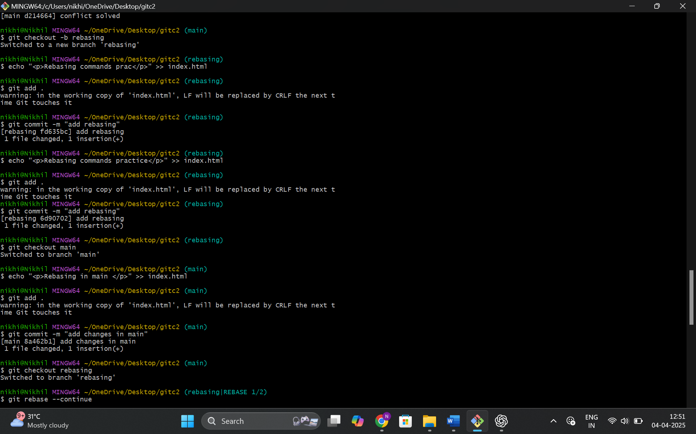

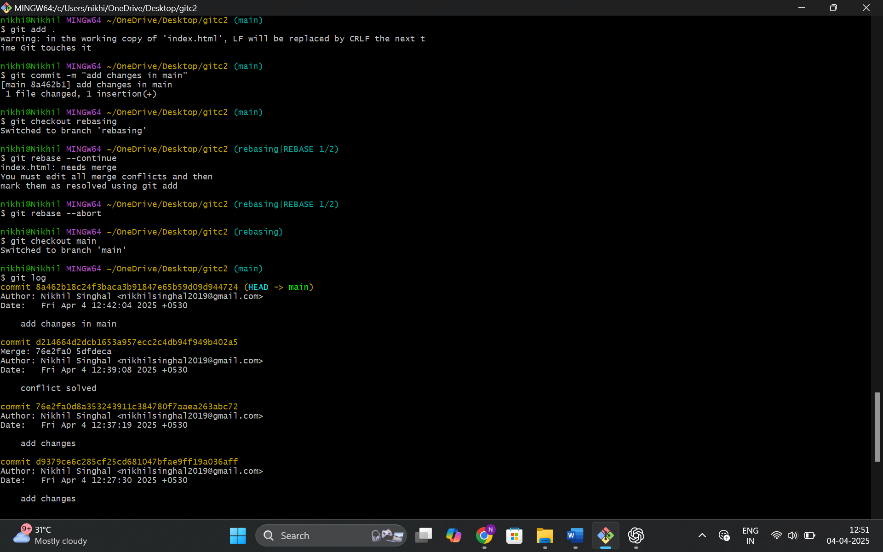

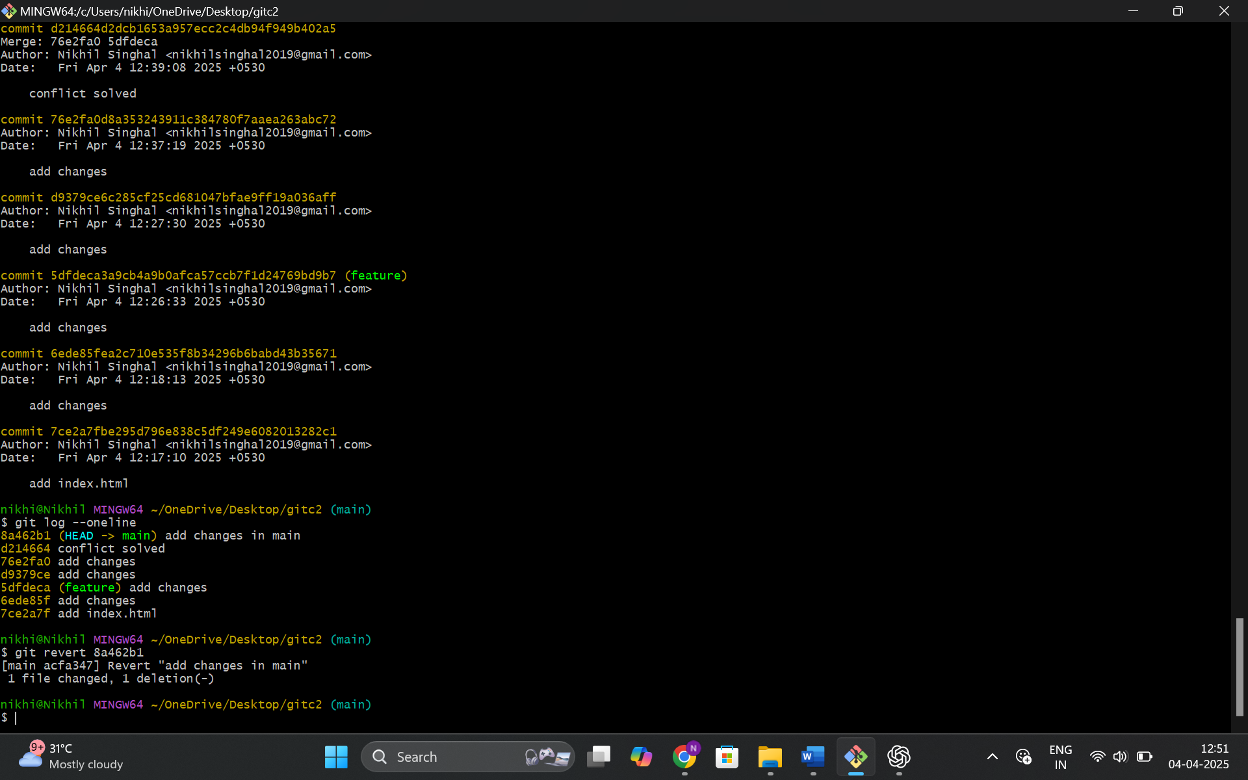

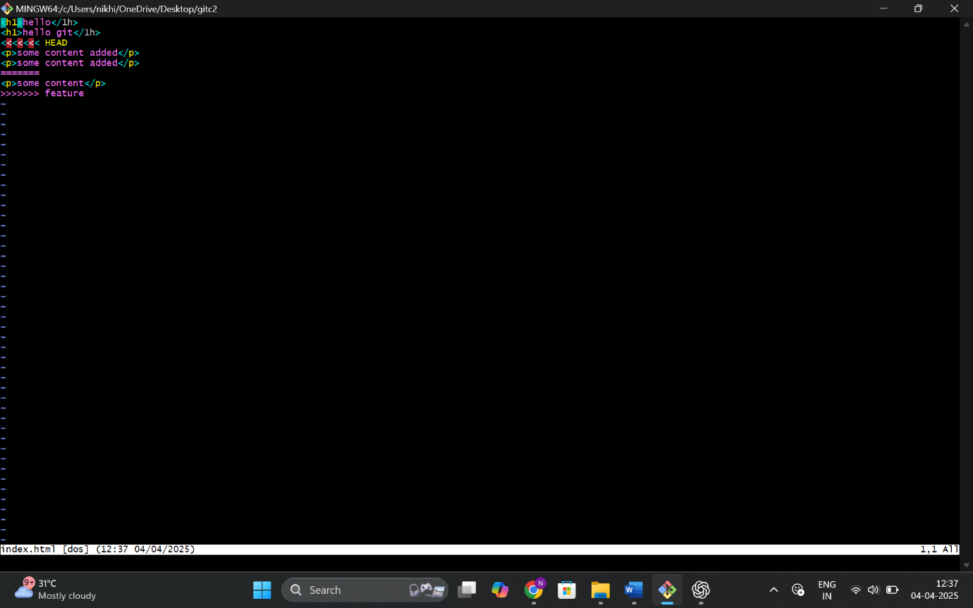

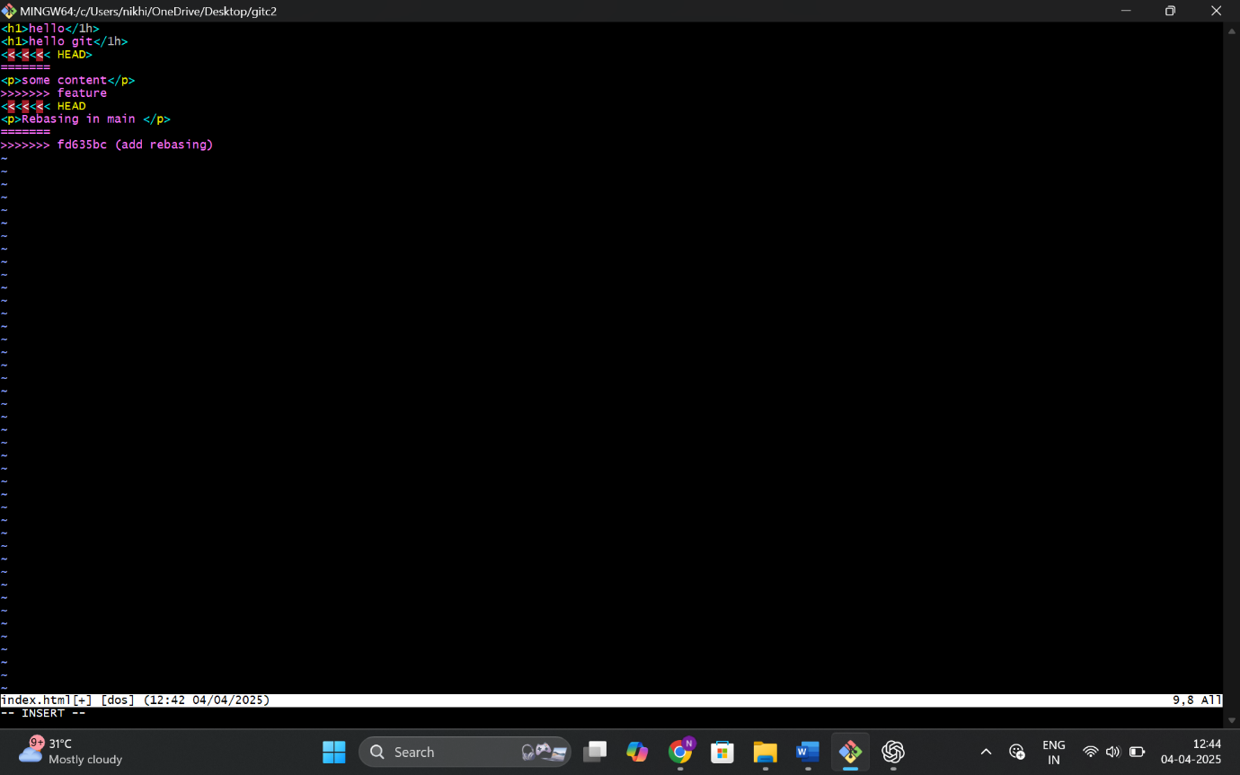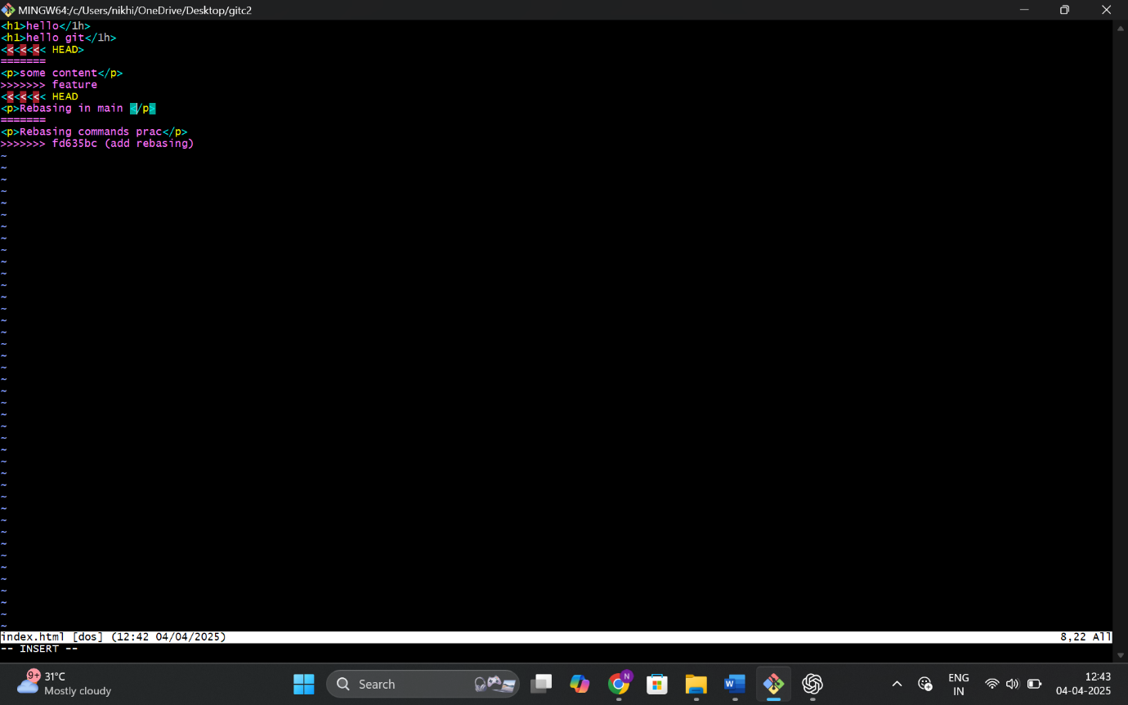

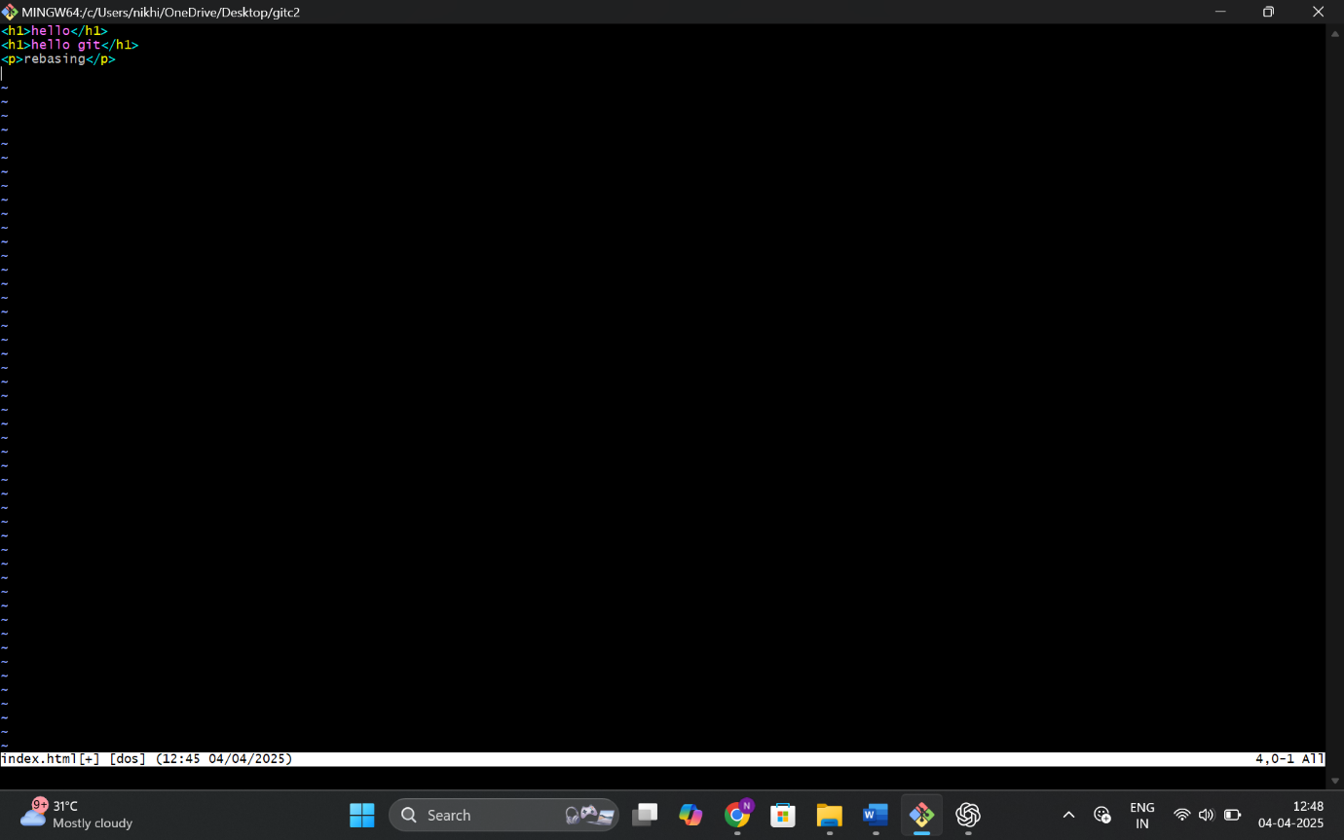

The merge conflict occurred because both branches modified the same part of the file.  
I manually edited the conflicting sections, staged the file, and committed the resolution.

**Merging** creates a merge commit and keeps both histories.  
**Rebasing** rewrites history to make it linear and cleaner.  
Rebasing is good for clarity but should be avoided on public/shared branches.

Reverting creates a new commit to undo the effects of a past commit.  
Reset rewrites history and should be used with caution, especially on shared branches.