Q-1: Write a PHP script to check whether a given number is positive, negative, or zero using if-else.

CODE:-

<?php

$number = -2;

if ($number > 0) {

echo "$number is Positive";

} elseif ($number < 0) {

echo "$number is Negative";

} else {

echo "The number is Zero";

}

?>

OUTPUT:-

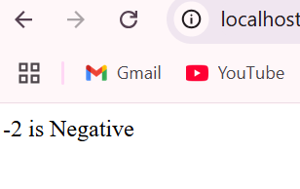

Q-2: Create a PHP program to print the first 10 numbers of the Fibonacci series using a while loop.

CODE:-

<?php

$n = 10;

$a = 0;

$b = 1;

$count = 0;

while ($count < $n) {

echo $a . " ";

$sum = $a + $b;

$a = $b;

$b = $sum;

$count++;

}

?>

OUTPUT-:

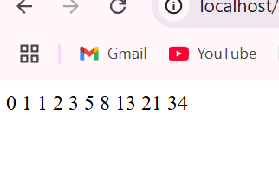

Q-3: Develop a form in HTML and PHP where users can enter their name and email, and after submission, display a welcome message using POST method.

Form.html CODE:-

<!DOCTYPE html>

<html>

<head>

<title>User Form</title>

</head>

<body>

<h2>Enter your details</h2>

<form action="welcome.php" method="POST">

<label for="name">Name:</label><br>

<input type="text" name="name" required><br><br>

<label for="email">Email:</label><br>

<input type="email" name="email" required><br><br>

<input type="submit" value="Submit">

</form>

</body>

</html>

OUTPUT:-

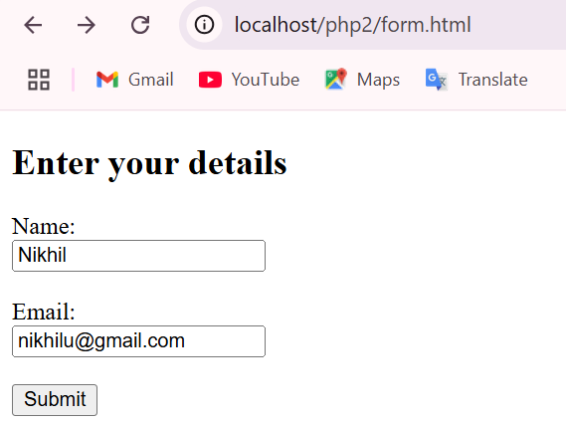

Welcome.php CODE:-

<!DOCTYPE html>

<html>

<head>

<title>Welcome</title>

</head>

<body>

<?php

if ($_SERVER["REQUEST_METHOD"] == "POST") {

$name = htmlspecialchars($_POST['name']);

$email = htmlspecialchars($_POST['email']);

echo "<h2>Welcome, $name!</h2>";

echo "<p>Your email address is: $email</p>";

} else {

echo "<p>No data submitted.</p>";

}

?>

</body>

</html>

OUTPUT:-

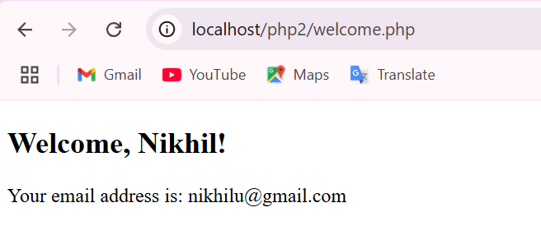

Q-4: Write a PHP program to create an array of 5 student names and display them using a foreach loop.

CODE:-

<!DOCTYPE html>

<html>

<head>

    <title>Student Names</title>

</head>

<body>

    <h2>List of Students:</h2>

    <?php

    $students = array("Aarav", "Bhavna", "Chirag", "Divya", "Eshan");

    foreach ($students as $student) {

        echo $student . "<br>";

    }

    ?>

</body>

</html>

OUTPUT:-

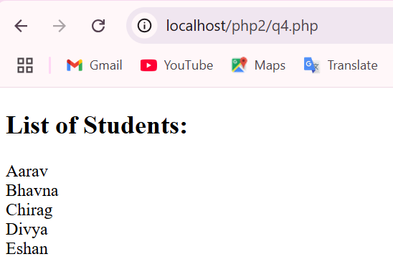

Q-5: Create a PHP script to store a visitor’s name using a session and display a personalized welcome message when they revisit the page.

CODE:-

<?php

session_start();

if ($_SERVER["REQUEST_METHOD"] == "POST" && !empty($_POST['name'])) {

    $_SESSION['visitor_name'] = htmlspecialchars($_POST['name']);

}

$visitorName = isset($_SESSION['visitor_name']) ? $_SESSION['visitor_name'] : '';

?>

<!DOCTYPE html>

<html>

<head>

    <title>Welcome Page</title>

</head>

<body>

    <?php if ($visitorName): ?>

        <h2>Welcome back, <?php echo $visitorName; ?>!</h2>

    <?php else: ?>

        <h2>Enter Your Name</h2>

        <form method="POST" action="">

            <label>Name:</label><br>

            <input type="text" name="name" required><br><br>

            <input type="submit" value="Submit">

        </form>

    <?php endif; ?>

</body>

</html>

OUTPUT:-

