**REALTIME DATA ANALYSIS OF SALES BASED ON TRANSACTIONS**

This project simulates real-time data generation for sales transactions, processes it through Kafka, stores it in DynamoDB, replicates data to S3, and enables querying using AWS Athena after crawling the S3 data using AWS Glue.

horizontal line

# 

# Introduction

This project focuses on the real-time analysis of sales data using a fully automated data pipeline. The system generates simulated sales transaction data, which is streamed through Apache Kafka to Amazon DynamoDB for storage. Kafka is also used to replicate the data from DynamoDB into Amazon S3 for scalable storage.

To manage and organize the data in S3, an AWS Glue crawler is configured to crawl the S3 bucket and automatically create a data catalog. This cataloged data can then be queried using AWS Athena, which provides a powerful SQL-based interface for analytics. The goal of this pipeline is to enable real-time analytics, with the ability to perform complex queries and extract valuable insights into sales patterns, trends, and customer behaviors in a scalable, cost-efficient manner.

By utilizing technologies like Apache Kafka, AWS DynamoDB, S3, Glue, and Athena, this project offers an end-to-end solution for handling, storing, and analyzing large datasets in real-time. It is designed to scale and adapt to high data volumes, making it suitable for any use case that requires real-time data processing and analysis.

## Project Components:

This project leverages several key technologies to build a robust real-time data processing pipeline. Below is an overview of the components involved in the solution:

1. **Real-Time Data Generator**The data generator creates simulated sales transaction data that mimics real-world scenarios. This data includes details such as transaction ID, timestamp, product ID, customer ID, quantity, and total sale value. The generator continuously streams data in real-time for analysis.
2. **Apache Kafka**Kafka serves as the backbone for the data streaming architecture. The generated sales transaction data is sent to a Kafka topic, which acts as the intermediary between the data generator and DynamoDB. Kafka guarantees high throughput, fault tolerance, and scalability, ensuring seamless data movement.
3. **Amazon DynamoDB**Once the sales data is streamed into Kafka, it is written to DynamoDB, a fast and flexible NoSQL database service. DynamoDB is used here for its high availability, scalability, and the ability to handle large volumes of data with minimal operational overhead.
4. **Data Replication to Amazon S3**A separate Kafka topic is configured to replicate data from DynamoDB to an S3 bucket. Amazon S3 provides scalable, durable, and cost-effective storage for the data, enabling further analysis and archiving.
5. **AWS Glue Crawler**AWS Glue is used to create an automated data catalog of the sales transaction data stored in the S3 bucket. The Glue crawler scans the data and creates metadata, making it easily discoverable and queryable.
6. **Amazon Athena**Athena is used to query the data cataloged by AWS Glue. With Athena, you can execute SQL-like queries on the structured data stored in S3 without needing to load it into a traditional relational database. This enables quick and cost-effective data analysis.

### Workflow Overview

The entire data processing pipeline follows a structured flow that facilitates real-time sales transaction analysis. Here's how the different components come together:

1. **Real-Time Data Generation**The real-time data generator simulates sales transaction events. This data includes details such as transaction ID, timestamp, product ID, quantity, total value, and customer information. It is continuously streamed at regular intervals to ensure that the data is constantly being updated.
2. **Kafka Data Streaming**The generated data is sent to an Apache Kafka topic, acting as a message broker. Kafka handles the high-throughput data streaming with fault tolerance and scalability. The data is organized into messages and consumed by downstream services, in this case, DynamoDB.
3. **Data Storage in DynamoDB**The sales transaction data from Kafka is ingested into DynamoDB. As a NoSQL database, DynamoDB is highly scalable and provides low-latency read/write operations, making it a suitable choice for real-time applications. Each sales transaction is stored as an individual record.

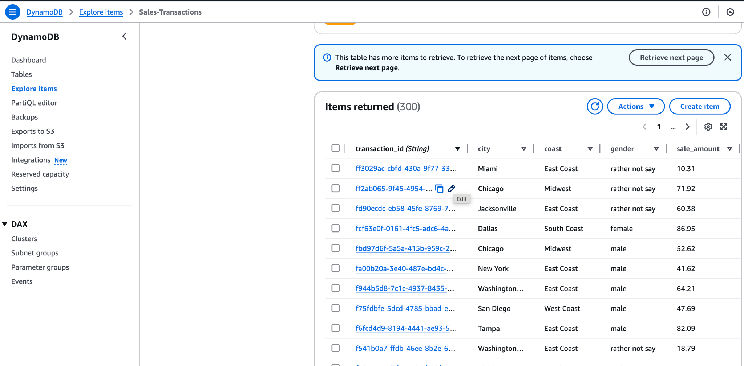

1. **Data Replication to Amazon S3**Another Kafka topic is responsible for replicating the data from DynamoDB into an S3 bucket. This S3 bucket serves as durable and scalable storage for large amounts of transaction data. The S3 replication ensures that the data is safely archived and ready for processing.

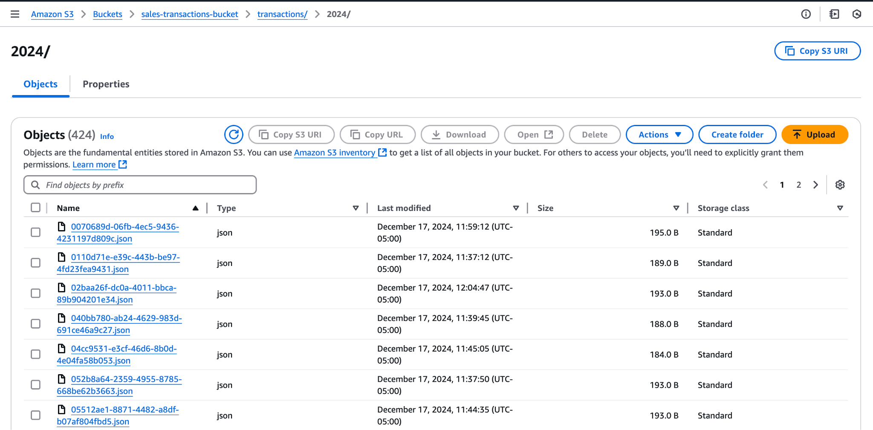

1. **AWS Glue Crawler for Data Cataloging**AWS Glue's crawler service is used to automatically detect and catalog the sales transaction data stored in the S3 bucket. The Glue crawler identifies the structure of the data and creates a metadata catalog, making it accessible for querying in a structured format.

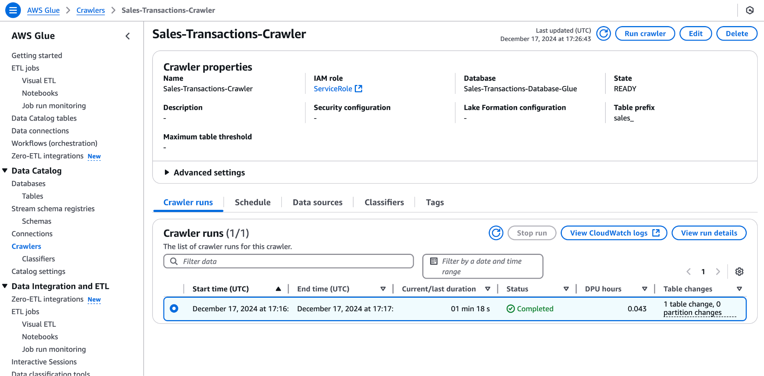

1. **Querying with Amazon Athena**With the data cataloged by Glue, you can now use Amazon Athena to run SQL-like queries directly on the data in S3. Athena allows for serverless querying, meaning you only pay for the queries you run, and it scales automatically with your data volume. This allows quick insights from large datasets with minimal setup.

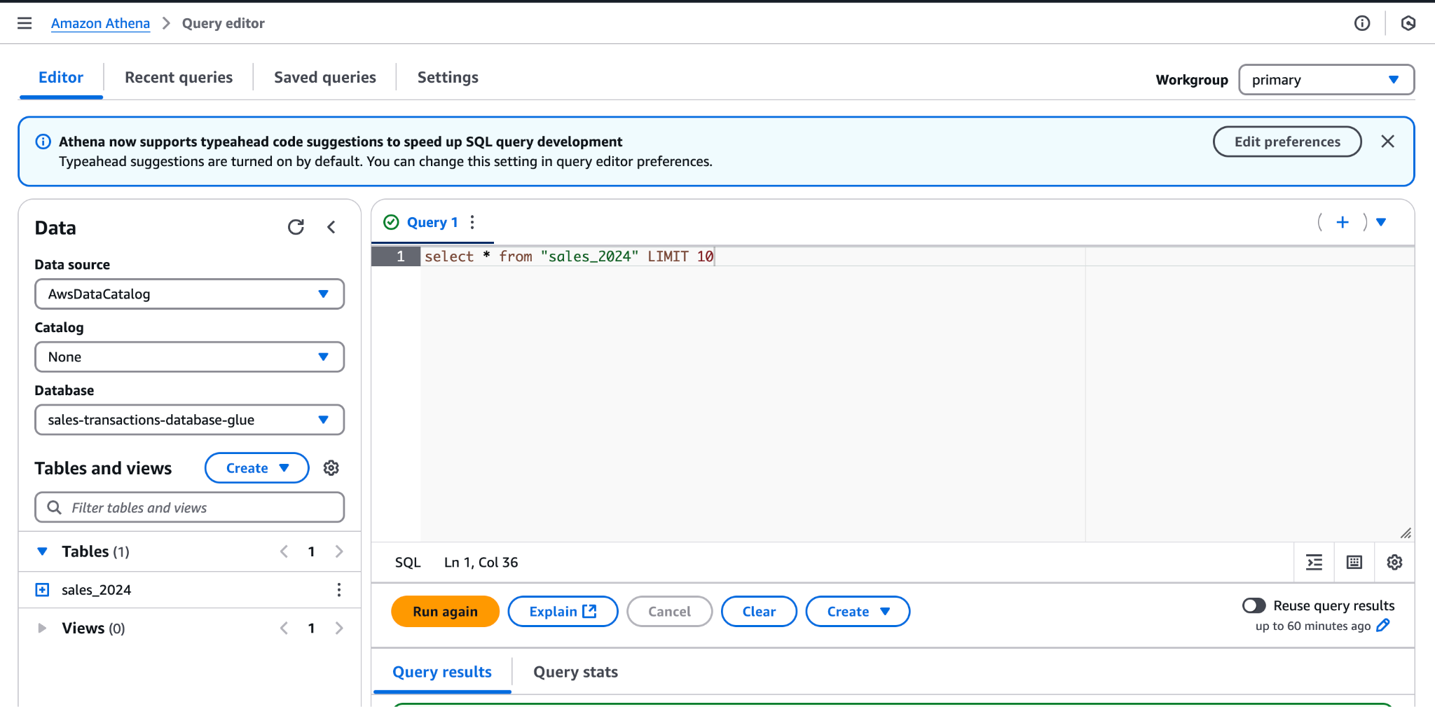

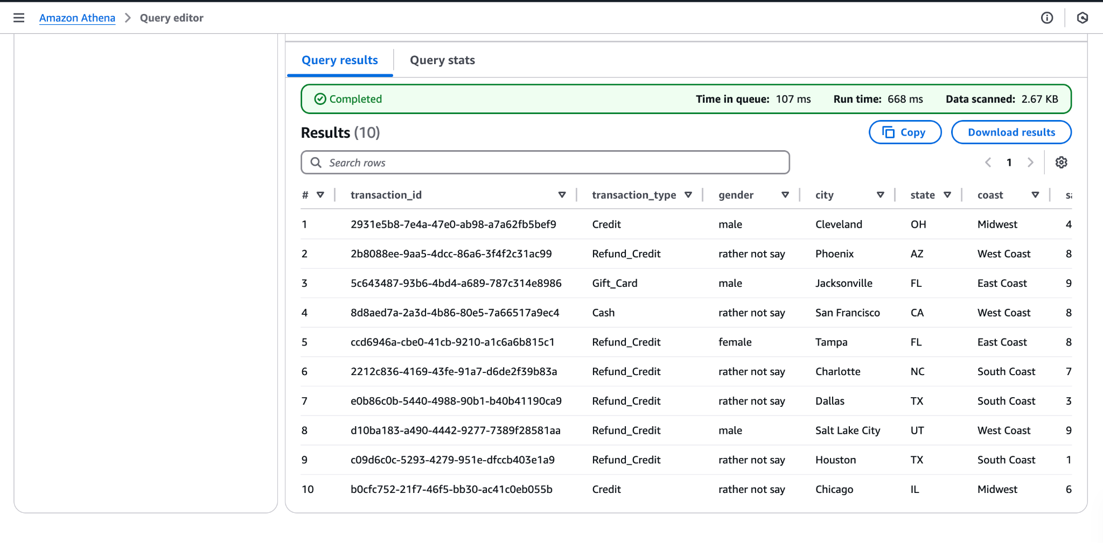

### Technologies Used

This project leverages a variety of modern technologies and services to handle real-time data processing, storage, and analysis. Here’s a breakdown of the key tools and technologies involved:

1. **Amazon Web Services (AWS)**AWS services are used extensively for data storage, processing, and querying:
   * **Amazon DynamoDB**: A NoSQL database used for storing real-time sales transaction data.
   * **Amazon S3**: Object storage used for archiving sales transaction data.
   * **AWS Glue**: A fully managed ETL (Extract, Transform, Load) service, used for crawling and cataloging data in S3.
   * **Amazon Athena**: A serverless interactive query service used to query the cataloged data directly in S3 using standard SQL.
2. **Apache Kafka**Kafka is used for handling real-time data streams. It acts as a message broker, facilitating the transfer of sales data between systems:
   * **Kafka Topics**: Two Kafka topics are used, one for streaming the data into DynamoDB and another for replicating it from DynamoDB to S3.
3. **Python**Python is used for writing the data generation scripts and interacting with AWS services using the boto3 SDK:
   * **boto3**: The AWS SDK for Python, which allows interacting with AWS services like DynamoDB, S3, Glue, and Athena.
4. **Amazon CloudWatch**AWS CloudWatch is used for monitoring and logging. It helps in tracking the state of various AWS services and the real-time performance of the system.

### System Architecture

The architecture of the real-time data analysis system is designed to handle large volumes of sales transaction data with high availability and low latency. Here’s a breakdown of how each component interacts within the system:

1. **Data Generation**
   * A **Real-Time Data Generator** simulates sales transactions and generates data every few seconds. The data includes information like transaction IDs, products sold, quantities, prices, timestamps, and customer information.
   * The generated data is serialized using **Apache Avro** format and sent to **Apache Kafka** for processing.
2. **Kafka Data Flow**
   * **Kafka Producers** are responsible for sending the sales transaction data to a Kafka topic. This data is streamed in real-time to the first Kafka topic.
   * The first Kafka topic sends the data to **Amazon DynamoDB**, which stores the sales transaction data in a NoSQL format, allowing fast reads and writes.
3. **Data Replication to S3**
   * A **second Kafka topic** is used for replicating the sales transaction data stored in DynamoDB to **Amazon S3**. This enables long-term storage and allows data to be queried using SQL.
4. **AWS Glue**
   * **AWS Glue Crawler** scans the data stored in S3 and creates a **Data Catalog**. The catalog organizes the data in a way that makes it easier for **Amazon Athena** to query.
5. **Data Querying**
   * **Amazon Athena** is used for querying the data stored in S3, allowing for complex SQL queries on the sales transaction data. The data is analyzed for various use cases, such as generating sales reports, identifying patterns, and performing analytics.
6. **Monitoring and Logging**
   * **Amazon CloudWatch** monitors the entire data pipeline, including Kafka data flow, DynamoDB operations, and Athena queries. CloudWatch logs help track the performance and health of the system, providing insights into any issues that arise.