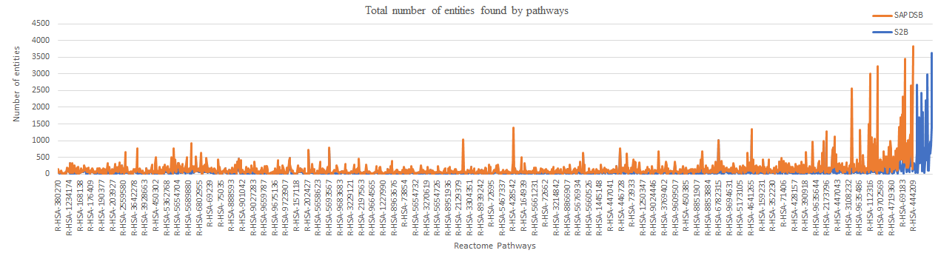

Fig shows the number of protein entities extracted using top 500 genes taken from final rank list predicted by SAPDSB and S2B in ALS-SMA