PROJECT REPORT  BCSE306L · 24BCE2690 · SLOT C1+TC1 | VELLORE INSTITUTE OF TECHNOLOGY  School of Computer Science and Engineering (SCOPE)  BCSE306L · ARTIFICIAL INTELLIGENCE  Digital Assignment — Case Study Report  Interactive  8-Puzzle Problem Solver  using Breadth-First Search  Date of submission [DD Month 2026]  Repository https://github.com/<username>/AI-8Puzzle-Visualizer  Live site https://<username>.github.io/AI-8Puzzle-Visualizer/
  goal state | A browser-based tool that solves the 8-puzzle with a from-scratch BFS and replays every expansion — frontier, explored set and shortest path.
    1 | 2 | 3
    8 |  | 4
    7 | 6 | 5
  SUBMITTED BY  Nikhila Abdul Salam  Reg. No. 24BCE2690  Slot C1+TC1 | SUBMITTED TO  Nagaraja G  Faculty, SCOPE  VIT Vellore
Contents

If the contents list is empty, right-click it in Word and choose Update Field.

Abstract
This report describes a browser-based tool that solves the 8-puzzle with Breadth-First Search (BFS) and shows how the search proceeds. The puzzle is modelled as a state-space search problem in which each board is a state and each move of the blank costs 1. BFS was written from scratch in JavaScript using an array with a head pointer as the FIFO queue, a Map as the visited set, and parent indexes for rebuilding the path. Because BFS expands nodes in the same order it stores them, the program records only a few numbers per expansion and can replay any step, forwards or backwards, after the search has finished. The interface displays the node being expanded, its successors, the frontier, the explored list and live counters, then animates the shortest solution. Thirty automated tests and thirty-nine scripted browser tests pass; in particular, solution lengths for 150 random puzzles match an independently computed table of shortest distances for all 181,440 reachable states. Measurements show the expected exponential growth: a 5-move puzzle expands 20 nodes, while a 30-move puzzle expands 180,974 nodes and stores about 35 MB of data.

1. Introduction and objectives
The 8-puzzle is a 3 × 3 board with eight numbered tiles and one empty square. A tile next to the empty square can slide into it, and the aim is to turn a given initial arrangement into a goal arrangement. The puzzle is small enough to solve on any laptop but large enough that blind trial and error does not work, which is why it is a standard example for search algorithms in AI [1].
This assignment allots one search algorithm to each student by registration number. Registration number 24BCE2690 is allotted Algorithm 1, Breadth-First Search. The objectives were to:
- model the 8-puzzle as a state-space search problem;
- implement BFS without any search library, including repeated-state checking and path reconstruction;
- validate the input and reject unsolvable puzzles before searching;
- visualise the search process and the final solution with interactive controls;
- measure performance honestly and relate it to BFS's theoretical complexity; and
- deploy the result as a static website on GitHub Pages.

2. Scope and requirements
The assignment sheet describes a general website that mentions six algorithms (BFS, DFS, DLS, IDDLS, GBFS and A*), including a comparison of all six on one puzzle. The same sheet, and the later VTOP notice, also state that each student must implement only the algorithm assigned to them. The project follows the second rule. Shared features were adapted so they remain honest for a BFS-only project, as summarised in Table 1.
Table 1. How the website requirements were handled
Requirement | How it is met
Home page (course, title, name, reg. no., introduction, navigation) | Implemented
Manual input of initial and goal state; random solvable puzzle | Implemented, with validation and a solvability check
Algorithm selection; depth limit (DLS); heuristic choice (GBFS, A*) | Selector lists all six, only BFS enabled. Depth limit and heuristics do not apply to BFS
Visualisation of states, successors, solution path, animated blank | Implemented
Real-time search information (frontier, explored, depth, parent, g(n)) | Implemented; h(n) and f(n) do not apply to BFS
Solution summary | Implemented (plus repeats skipped and peak frontier)
Comparison page for six algorithms | Measured BFS runs and a benchmark set; a separate, clearly labelled theoretical table for the six strategies [1]. No results are invented for algorithms that were not run
Algorithm information page | Implemented for BFS
Run, Pause, Resume, Next, Previous, Reset, Speed | Implemented (plus a step scrubber)
README, GitHub repository, GitHub Pages, demo video | README written; repository, deployment and video are completed by the student

The only open question is the rubric line that awards marks for GBFS and A* with heuristics. If the faculty expects every student to implement all six algorithms, that part is not covered by this submission.

3. The 8-puzzle as a search problem

3.1 Problem formulation
Following the standard formulation [1], the problem has the components in Table 2. It is easier to treat the blank as the piece that moves: "blank Up" means the tile above the blank slides down.
Table 2. Problem formulation
Component | Definition in this project
State | A 9-character string read row by row, with 0 for the blank, e.g. 283164705
Initial / goal state | Entered by the user; the default example is 283164705 → 123804765 from the assignment sheet
Actions | Move the blank Up, Down, Left or Right, if it stays on the board (2, 3 or 4 actions)
Transition model | Swap the blank with the neighbouring tile
Goal test | The state string equals the goal string
Path cost | Number of moves; every move costs 1

There are 9! = 362,880 ways to arrange the tiles, but only half of them can reach a particular goal, so every search space here contains 181,440 states [4], [5]. The average number of legal moves per state is about 3 [1].

3.2 Solvability
To decide whether a puzzle can be solved, write the tiles in reading order without the blank and count the inversions, i.e. pairs in which a larger number comes before a smaller one. A left or right move does not change this order. An up or down move makes one tile jump over exactly two others, so the number of inversions changes by −2, 0 or +2. The parity (odd or even) of the count therefore never changes, and an initial state can reach the goal only if both have the same parity [4]. For example, 213804765 has 8 inversions while the goal 123804765 has 7, so the program rejects it with an explanation. The opposite direction also holds on a 3 × 3 board: every state with the same parity is reachable [4]. Our own tests confirmed this, since BFS reached exactly 181,440 states from an unsolvable start.

4. Breadth-First Search

4.1 Working principle
BFS is an uninformed search: it uses only the problem definition, with no estimate of distance to the goal [1]. The idea goes back to Moore's work on finding shortest paths through mazes [3]. It always expands the shallowest unexpanded node. This order comes from keeping the frontier in a FIFO (first-in, first-out) queue. Children join the back of the queue and the node to expand is taken from the front, so every depth-k node leaves the queue before any depth-(k+1) node [1], [2]. The search therefore spreads outwards in layers; the Home page of the website draws depths 0, 1 and 2 for the example puzzle.
Two extra pieces are needed for the 8-puzzle. Different move sequences often reach the same board (for example Up followed by Down returns to the start), so a visited set records every state already generated, and repeated states are skipped. Each stored node also keeps a reference to its parent, so that the path can be rebuilt once the goal is found.

4.2 Algorithm
BFS(start, goal)
nodes <- [ node(start, parent = none, depth = 0) ]
visited <- { start }
if start = goal: return path(start)
head <- 0 // front of the FIFO queue
while head < length(nodes):
current <- nodes[head]; head <- head + 1 // dequeue
for each (state, move) in SUCCESSORS(current): // Up, Down, Left, Right
if state in visited: continue // repeated state
child <- node(state, parent = current, depth = current.depth + 1)
append child to nodes; add state to visited // enqueue
if state = goal: return PATH(child) // early goal test
return failure // frontier empty
The goal test is applied when a node is generated rather than when it is removed from the queue. This "early goal test" is the version of BFS given by Russell and Norvig [1]; it still returns a shortest solution and saves expanding the whole level at the goal's depth.

4.3 Why the solution is the shortest
Let the shortest solution have d moves. Nodes leave the queue in order of non-decreasing depth, so all nodes at depth d−1 are expanded before any node at depth d. The goal is therefore generated while expanding depth d−1, before any longer path can be built. Skipping a repeated state is safe because the copy already stored was reached at the same or a smaller depth. Since every move costs 1, fewest moves also means lowest path cost [1].

4.4 Worked example
Table 3 traces the first six expansions for the example puzzle. Node numbers are the order in which nodes were stored. The successor order Up, Down, Left, Right is fixed in the code.
Table 3. First six expansions for 283164705 → 123804765
Step | Node expanded (depth) | Successors generated | Frontier afterwards
1 | #0 283164705 (0) | Up → #1, Left → #2, Right → #3 | #1 #2 #3
2 | #1 283104765 (1) | Up → #4, Down repeat, Left → #5, Right → #6 | #2 … #6
3 | #2 283164075 (1) | Up → #7, Right repeat | #3 … #7
4 | #3 283164750 (1) | Up → #8, Left repeat | #4 … #8
5 | #4 203184765 (2) | Down repeat, Left → #9, Right → #10 | #5 … #10
6 | #5 283014765 (2) | Up → #11, Down → #12, Right repeat | #6 … #12

The search stops during the 20th expansion, when the goal is generated at depth 5. The path rebuilt from the parent links is: blank Up, Up, Left, Down, Right. The first two moves match the example on the assignment sheet.

5. System design and implementation

5.1 Architecture
The site is a single HTML page with four sections (Home, Solver, Algorithm, Comparison) that are shown or hidden according to the address hash. It uses plain JavaScript loaded as ordinary script tags, so it runs by opening index.html directly and needs no build step or server. Bootstrap 5.3.8 [7] is stored inside the project for the layout grid, navigation bar and form controls. Table 4 lists the responsibility of each file. The search code does not touch the page, and the drawing code never runs the search, which kept both parts easy to test separately.
Table 4. Source files
File | Responsibility
js/puzzle.js | State format, successor function, input validation, inversion count and solvability, random puzzles, heuristic values for the comparison page
js/bfs.js | bfsSolve() – the BFS algorithm and statistics; buildPath(); describeStep() – reads the recorded data for a given step
js/visualization.js | Drawing boards, the sliding-tile board, and the Player class behind Run/Pause/Resume/Next/Previous
js/app.js | Navigation, input handling, running BFS, rendering each step, summary, comparison page and benchmark
css/style.css | Visual theme, board and tile styles, animation, responsive rules
tests/ | Automated tests in Node.js and the memory measurement script

5.2 State representation and successors
A string was chosen for the state because two boards can be compared with ===, a string can be used directly as a Map key, and it is easy to print. The successor function finds the blank, tries the four directions and skips any move that would leave the board:
function getSuccessors(state) {
const blank = state.indexOf('0');
const row = Math.floor(blank / SIZE);
const col = blank % SIZE;
const successors = [];
for (const move of MOVES) { // Up, Down, Left, Right
const newRow = row + move.dRow;
const newCol = col + move.dCol;
if (newRow < 0 || newRow >= SIZE || newCol < 0 || newCol >= SIZE) continue;
const target = newRow * SIZE + newCol;
successors.push({ state: swapTiles(state, blank, target), move: move.name });
}
return successors;
}

5.3 Queue, visited set and parent links
All stored nodes go into one array, nodes, in the order they are created. Each node is { state, parent, move, depth }, where parent is the index of the parent node. An integer head marks the front of the queue: nodes[head] is the next node to expand and head++ removes it. This makes removal constant-time, whereas JavaScript's Array.shift() would move every remaining element. Everything after head is the frontier, and everything before it is the explored list. The visited set is a Map from state to node index; a state is added the moment it is generated, so it can never be queued twice. When the goal is found, buildPath() follows the parent indexes back to node 0 and reverses the list.

5.4 Recording the search for replay
The search runs to completion first and is animated afterwards, so the playback controls cannot interfere with the algorithm. Storing a copy of the frontier for every step would waste a lot of memory on large searches. Instead, the program uses a property of BFS: nodes are expanded in exactly the order they were stored. Step k therefore expands nodes[k], the explored list after it is nodes[0..k], and the frontier is nodes[k+1 .. queueEnd−1]. Only queueEnd and two counters are saved per step. The function describeStep() uses these and the visited map to work out which successors of a step were new, repeated or the goal.

5.5 Statistics
Every figure on screen comes from the actual run. Table 5 gives the exact definitions, because different textbooks count "generated" nodes differently.
Table 5. Definitions of the reported statistics
Statistic | Definition
Nodes generated | The start node plus every successor created by a legal move, including repeats that were skipped
Nodes expanded | Nodes removed from the queue whose successors were generated. The goal is never expanded
Repeats skipped | Generated successors that were already in the visited set
Max search depth | Depth of the deepest node generated
Path cost | Number of moves in the solution
Execution time | performance.now() before and after the search only. Browsers round this timer, typically to 0.1 ms [6]
Memory (approx.) | Stored nodes × 200 bytes. The 200 B figure was measured in the V8 engine (Node.js 22) by forcing garbage collection before and after a search that stored all 181,440 states: the heap grew by 34.5 MB, about 199 B per node

6. Visualisation and user interaction
The Solver page has an input panel on the left (Figure 1) and the visualisation on the right. Input is typed into two 3 × 3 grids, where an empty cell, 0 or _ means the blank. Before searching, the program checks for wrong characters, duplicate or missing tiles and the number of blanks, then applies the parity test. Each problem gets its own message, for example "tile 7 appears 2 times and tile 5 is missing". Generate Random Puzzle either scrambles the goal with 8, 15 or 25 random legal moves, or shuffles all tiles and fixes the parity with one swap; both always produce solvable puzzles.
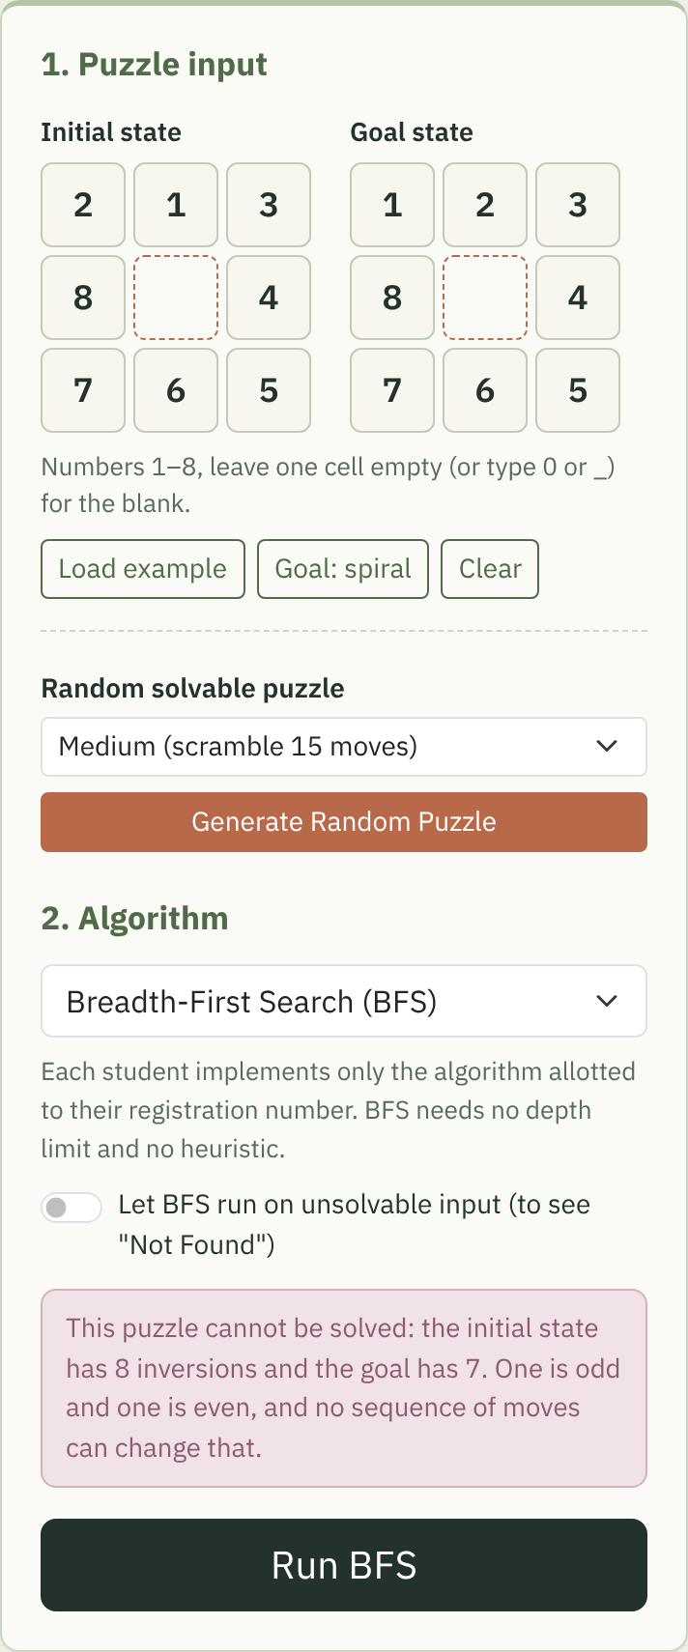
Figure 1. Input panel: initial and goal grids, random puzzle generator, algorithm selector (only BFS is enabled) and the message shown for an unsolvable puzzle.
After Run BFS, the search process view (Figure 2) replays the search one expansion at a time. It shows the node being expanded with its depth and g(n), its parent, and its successors coloured as new (dusty blue), repeated (mauve) or goal (sage green). Below are live counters, the frontier queue with the next node to be expanded outlined, and the explored list. Initial, goal and current states stay visible at the top.
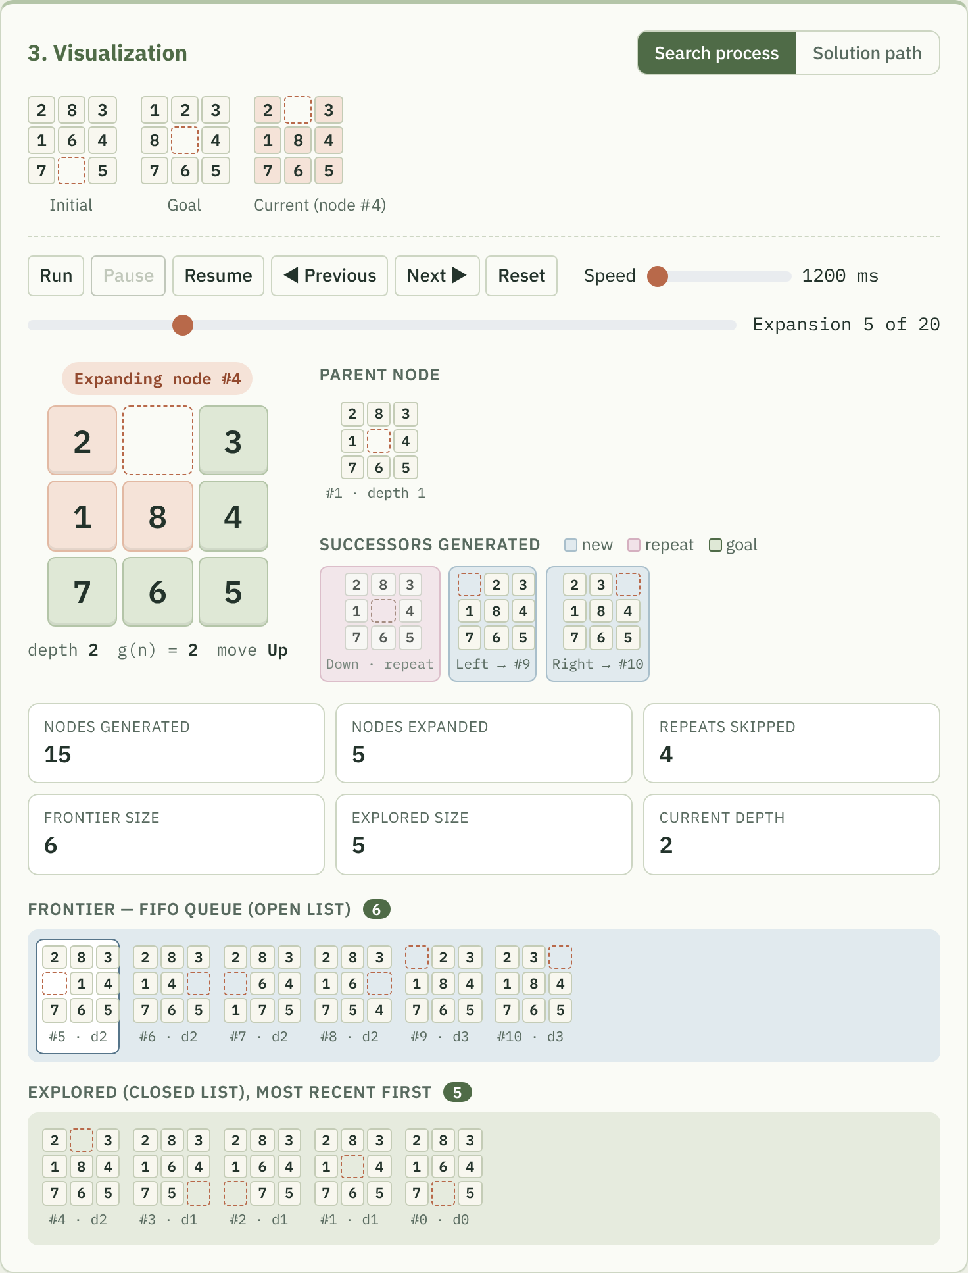
Figure 2. Search process view during the 5th expansion of the example puzzle.
When the replay ends, the view switches to the solution path (Figure 3). The tiles are separate elements positioned with CSS transforms, so when the blank and a tile swap places the tile slides smoothly. The step list on the right follows the "Step 0 ↓ Step 1 ↓ …" format from the assignment sheet and can be clicked to jump to a step.
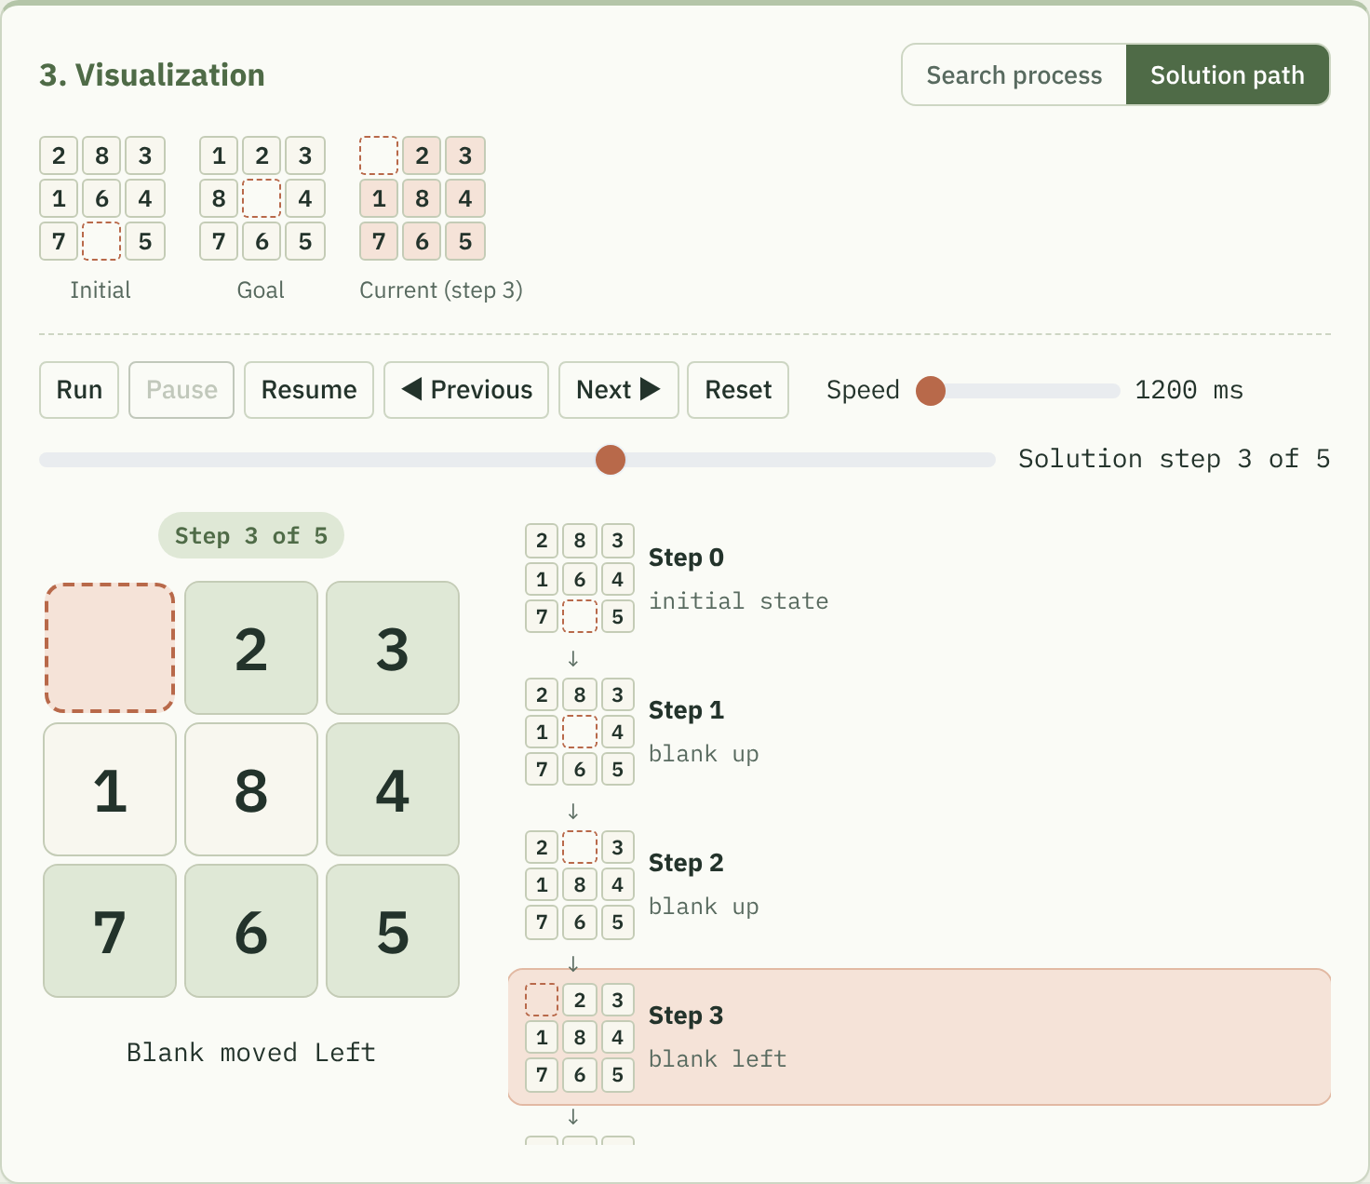
Figure 3. Solution path view at step 3 of 5, with tiles already in their goal position shaded sage green.
Both views share one set of controls: Run, Pause, Resume, Previous, Next and Reset, a speed slider from 1200 ms to 10 ms per step, and a scrubber for jumping to any step. A small Player class keeps the current position and a timer, and buttons are enabled only when they make sense (for example, Resume only when paused in the middle). The summary card (Figure 4) appears after every run. The layout was checked at 1366 px and 390 px wide.
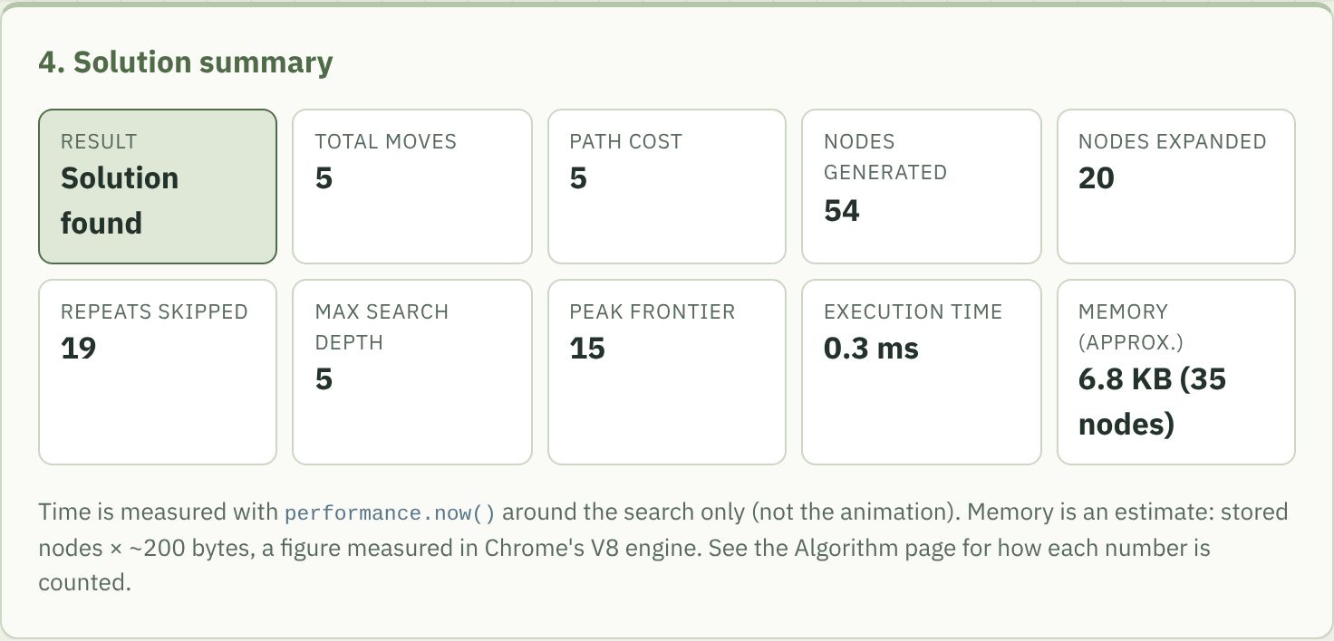
Figure 4. Solution summary for the example puzzle.

7. Testing and results

7.1 Test plan
Testing used two scripts: tests/bfs.test.js, which loads the same puzzle.js and bfs.js files the website uses into Node.js, and a Playwright script that drives the website in headless Chromium. Table 6 summarises the cases. Two checks were written independently of the BFS code so that BFS was not grading itself: a function that confirms each pair of consecutive states differs by one legal blank move, and a brute-force depth-limited search that confirms no shorter path exists.
Table 6. Test cases and results (22 October 2026)
# | Test | Result | Status
1 | Initial = goal | 0 moves, 1 generated, 0 expanded | Pass
2 | One move from goal | 1 move (blank Right) | Pass
3 | Several moves (assignment example) | 5 moves; no 4-move path exists (brute force) | Pass
4–5 | Duplicate tile, missing tile, two blanks, "9", letters, 8 cells | Each rejected with a specific message | Pass
6 | Unsolvable state | Rejected by parity; if forced, BFS stores 181,440 states and reports Not Found | Pass
7 | Random solvable puzzles | 150 generated, all solvable and solved | Pass
8–10 | Reset; Next/Previous; Pause/Resume/Speed | Behave as intended in both views | Pass
11 | Path reconstruction | Every consecutive pair one legal move apart | Pass
12 | Optimality | 150 random puzzles match a separately computed shortest-distance table of all 181,440 states; known 31-move instance solved in 31 | Pass
13 | Responsive layout / GitHub Pages | No horizontal scrolling at 390 px. Real phone, other browsers and the live site still to be checked | Partly pending

In total 30 automated checks and 39 browser checks passed. The full table, including the pending manual checks, is in docs/testing.md in the repository.

7.2 Performance measurements
The comparison page has a fixed benchmark set of eight puzzles whose shortest solutions range from 5 to 30 moves (30 is the largest distance from this goal). Table 7 gives the results. Node counts are exact and the same on any computer; times are the median of three runs in headless Chrome 141 on a cloud Linux machine and will differ on other hardware.
Table 7. BFS benchmark (goal 123804765)
Moves | Generated | Expanded | Stored | Peak frontier | Time (ms) | Memory
5 | 54 | 20 | 35 | 15 | < 0.1 | 6.8 KB
8 | 264 | 97 | 164 | 67 | 0.1 | 32 KB
12 | 2,364 | 867 | 1,404 | 537 | 0.8 | 274 KB
16 | 19,661 | 7,089 | 11,429 | 4,340 | 5.8 | 2.2 MB
20 | 84,207 | 31,125 | 44,633 | 13,508 | 33.6 | 8.5 MB
24 | 297,981 | 111,561 | 132,353 | 24,983 | 178.7 | 25.2 MB
28 | 469,452 | 175,620 | 180,075 | 24,053 | 275.4 | 34.3 MB
30 | 482,469 | 180,974 | 181,382 | 24,983 | 274.1 | 34.6 MB

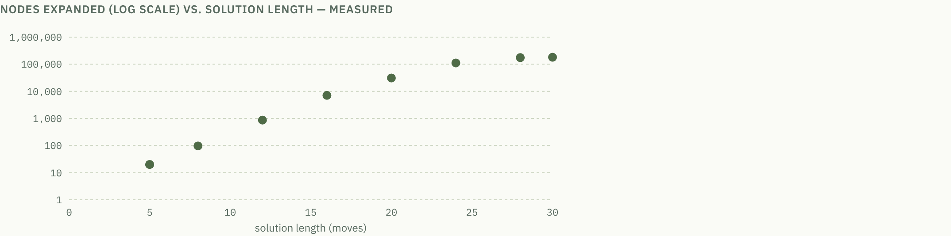
Figure 5. Nodes expanded (log scale) against solution length, as drawn by the comparison page from the measured runs.
Up to about 24 moves the number of expanded nodes grows by roughly 4 to 9 times between consecutive benchmark puzzles, which is the exponential growth predicted by the theory. After that the curve flattens because BFS has nearly run out of new states: at 30 moves it has stored 181,382 of the 181,440 reachable states. Memory follows the number of stored nodes, so the hardest puzzles need about 35 MB.

8. Complexity analysis
Let b be the branching factor and d the depth of the shallowest solution. In the worst case BFS generates 1 + b + b² + … + b^{d} nodes, so its time complexity is O(b^{d}). Every generated node stays in memory, either in the frontier or in the explored set, so space complexity is also O(b^{d}) [1]. BFS is complete when b is finite and a solution exists at finite depth, and optimal when all actions have the same cost [1], [2]. Both conditions hold for the 8-puzzle.
For the 8-puzzle b is 2, 3 or 4 depending on where the blank is, and repeated-state checking caps the work at the 181,440 reachable states. This explains both parts of the measured curve: exponential growth while b^{d} is small compared with the state space, then saturation. It also shows why BFS is usually limited by memory before time. For the hardest instance it finishes in under half a second but holds about 181,000 nodes. The same method would not work for the 15-puzzle, which has about 10¹³ reachable states. That is why informed methods such as A* with the Manhattan-distance heuristic are used for larger puzzles [1]. On the comparison page, both the Manhattan and misplaced-tiles values of the last puzzle are shown next to the true distance found by BFS, and in every case tested they were lower or equal, as an admissible heuristic must be.

9. Limitations and possible improvements
- Only BFS is implemented, as allotted. The comparison with other algorithms is theoretical.
- The search runs on the browser's main thread, so the page pauses for a few hundred milliseconds on the hardest puzzles. Moving bfsSolve() into a Web Worker would keep the page responsive.
- Replaying a search of 100,000+ expansions one step at a time is impractical even at 10 ms per step; the scrubber and the Solution path tab work around this. A "skip to depth" control would help.
- The memory figure is an estimate based on one engine. A real measurement would need browser-specific APIs that are not widely available.
- Run history on the comparison page is lost on reload; it could be saved in the browser's local storage.

10. Conclusion
The project solves the 8-puzzle with a Breadth-First Search written from scratch and makes the algorithm's behaviour visible step by step. Using an array with a head pointer as the queue and a map as the visited set kept the code short. The same structure also allowed a whole search to be replayed without storing copies of the frontier. Testing against an independent table of shortest distances confirmed that the solutions are always optimal, and the measurements reproduced the exponential growth in nodes and memory predicted by O(b^{d}). Building the tool made the main trade-off of BFS clear: it guarantees the shortest answer, but only by remembering everything it has seen.

References
[1] S. Russell and P. Norvig, Artificial Intelligence: A Modern Approach, 4th ed. Hoboken, NJ, USA: Pearson, 2020.
[2] T. H. Cormen, C. E. Leiserson, R. L. Rivest, and C. Stein, Introduction to Algorithms, 4th ed. Cambridge, MA, USA: MIT Press, 2022.
[3] E. F. Moore, "The shortest path through a maze," in Proc. Int. Symp. Theory of Switching, Cambridge, MA, USA: Harvard Univ. Press, 1959, pp. 285–292.
[4] W. W. Johnson and W. E. Story, "Notes on the ‘15’ puzzle," American Journal of Mathematics, vol. 2, no. 4, pp. 397–404, 1879.
[5] A. Reinefeld, "Complete solution of the eight-puzzle and the benefit of node ordering in IDA*," in Proc. 13th Int. Joint Conf. Artificial Intelligence (IJCAI-93), 1993, pp. 248–253.
[6] MDN Web Docs, "Performance: now() method." [Online]. Available: https://developer.mozilla.org/en-US/docs/Web/API/Performance/now (accessed Oct. 22, 2026).
[7] Bootstrap, "Get started with Bootstrap," v5.3. [Online]. Available: https://getbootstrap.com/docs/5.3/getting-started/introduction/ (accessed Oct. 22, 2026).
[8] GitHub Docs, "Creating a GitHub Pages site." [Online]. Available: https://docs.github.com/en/pages/getting-started-with-github-pages/creating-a-github-pages-site (accessed Oct. 22, 2026).
Third-party resources: Bootstrap 5.3.8 (MIT licence) and the Fraunces and IBM Plex fonts (SIL Open Font Licence) are used for the interface. No search or puzzle-solving library is used.

