**Fall 2023: CS5720**

**Neural Networks & Deep Learning - ICP-3**

**NIKHILA AJJU ( 700742196 )**

**Assignment - 3**

1. Create a class Employee and then do the following

• Create a data member to count the number of Employees

• Create a constructor to initialize name, family, salary, department

• Create a function to average salary • Create a Fulltime Employee class and it should inherit the properties of Employee class

• Create the instances of Fulltime Employee class and Employee class and call their member functions

**­ ­**

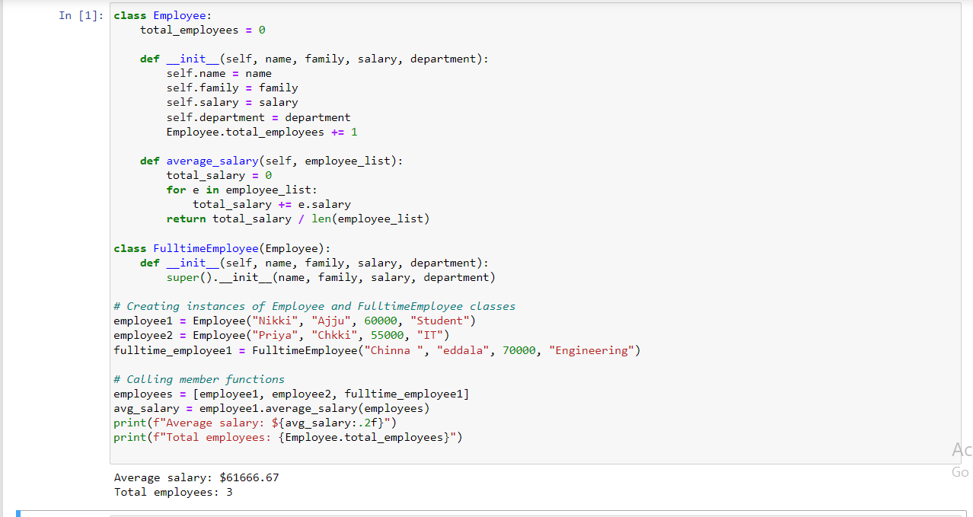

2. Numpy Using NumPy create random vector of size 20 having only float in the range 1-20. Then reshape the array to 4 by 5 Then replace the max in each row by 0 (axis=1) (you can NOT implement it via for loop) .

