**Fall 2023: CS5720**

**Neural Networks & Deep Learning - ICP-1**

**NIKHILA AJJU ( 700742196 )**

**Assignment - 1**

1. **Write a python program for the following: – Input the string “Python” as a list of characters from console, delete at least 2 characters, reverse the resultant string and print it.**

**­ ­**

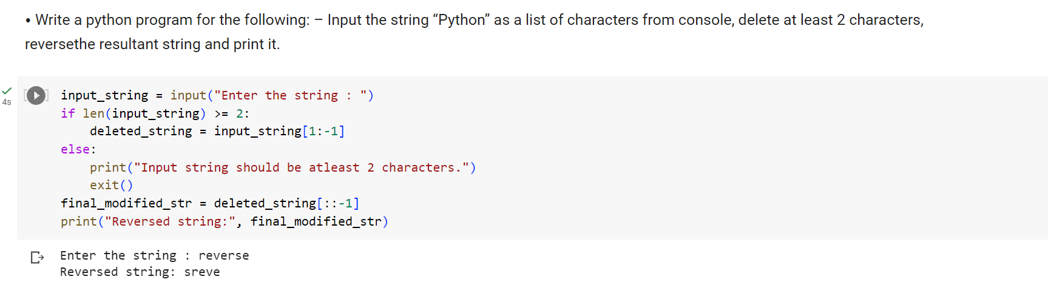

**1.1 Take two numbers from user and perform at least 4 arithmetic operations on them**

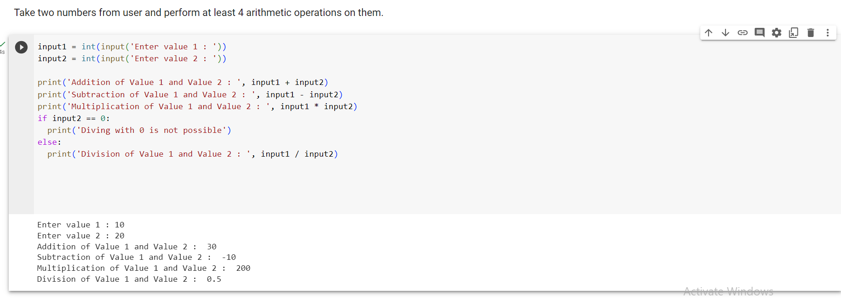

1. **. Write a program that accepts a sentence and replace each occurrence of ‘python’ with ‘pythons’.**

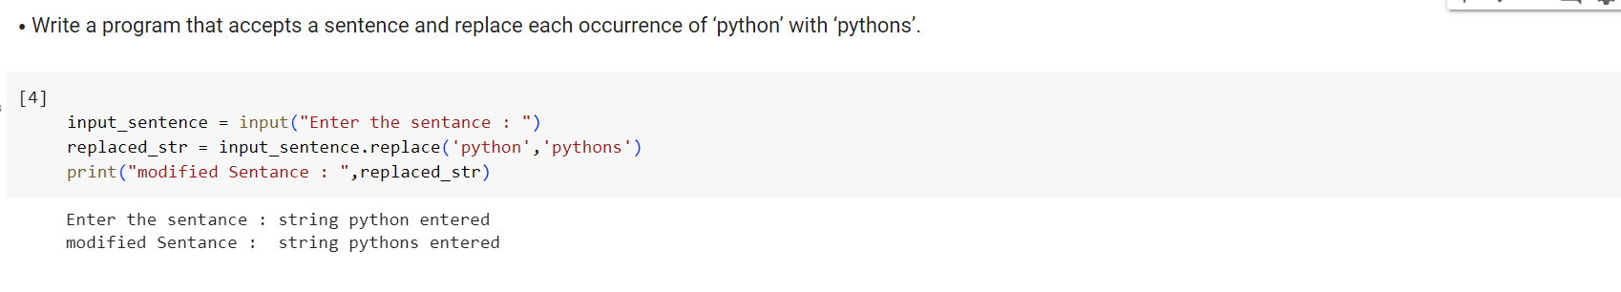

1. **Use the if statement conditions to write a program to print the letter grade based on an input class score. Use the grading scheme we are using in this class.**

