

**School of Computer Science and Engineering**

VIT Chennai

Vandalur - Kelambakkam Road, Chennai – 60127 **Final Review Report**

**Program :** Integrated Mtech

**Course :** Marketing Analytics

**Slot :** D2

**Faculty :** Mrs. Padmavathy

**Component :**  J

**Title : Café Chain Dataset Analysis**

**Team Member: -**

Atul Patel (20MIA1134)

SHASHANK Pandey (20MIA1147)

Gaurav Sharan (20MIA1081)

Pratyansh Soni(20MIA10)

Piyali Saha(20MIA1066)

Jalavadi Shree Nikhila(20MIA1023)

* **Executive summary**

1. The problem at hand involves conducting a comprehensive analysis of a Café Chain's data set for one of its restaurants, with a focus on three main components: Exploratory Analysis, Menu Analysis, and Pricing Analysis.
2. The Exploratory Analysis entails examining trends in consumer behaviour based on different times of the day and days of the week and providing actionable recommendations based on these trends.
3. Additionally, the analysis aims to identify menu items that could potentially be removed from the menu, as well as analyze trends across months to identify patterns and opportunities for improvement.
4. The Menu Analysis component of the analysis involves identifying the most popular combos that can be suggested to the restaurant chain by analyzing frequently occurring sets of menu items in customer orders.
5. Since the restaurant does not currently offer combo meals, the analysis aims to provide recommendations for the best combo meals that could be introduced to enhance customer experience and drive sales.
6. The Pricing Analysis component focuses on identifying pricing changes and evaluating their impact on menu items, using a price analysis chart with four quadrants categorizing the impact as positive or negative.
7. The analysis quantifies the volume increase or decrease in relation to the price changes, providing insights into how pricing strategies can impact sales volume.
8. The overall goal of the analysis is to provide actionable insights and recommendations for optimizing menu offerings, understanding consumer behavior, and implementing effective pricing strategies to enhance the restaurant's performance and profitability.
9. The analysis will provide data-driven insights and recommendations to support decision-making and drive improvements in the restaurant's operations.
10. By leveraging the findings from the analysis, the Café Chain can make informed decisions to optimize their menu, pricing strategies, and overall business performance to meet customer needs, increase sales, and maximize profitability.

* **Problem statement**

**Background**

* The data set provided constitutes the data Of a Café Chain for one Of its restaurants. We need to do a thorough analysis Of the data

and come up with the following analysis:

* Exploratory Analysis
* Menu Analysis
* . Price Analysis

**Exploratory Analysis**

* What kind of trends do you notice in terms of consumer behavior over different times of the day and different days of the week? Can you give concrete recommendations based on the same?
* Are there certain menu items that can be taken off the menu?
* Are there trends across months that you are able to notice?

**Menu Analysis**

* Identify the most popular combos that can be suggested to the restaurant chain after a thorough analysis of the most commonly occurring sets of menu items in the customer orders
* The restaurant doesn't have any combo meals. Can we suggest the best combo meals?

**Pricing Analysis**

* Identify pricing changes and menu items that saw a positive impact and/or negative impact of the price changes.
* Show a price analysis chart with four quadrant price analysis as below along with quantification of the volume increase and decrease

in relation to the price changes

* •Price increased — sales volume decreased in the post period of 2-4 weeks ( take a pre-period window of sales of 1-2 weeks)
* Price increased — Sales volume increased
* price decreased — Sales volume increased
* Price decreased — Sales volume decreased
* **Objectives**

our objective is to find various trends and data insights by doing exploratory data analysis of the café chain dataset, further, we will perform the Menu Analysis where we will going to identify Identify the most popular combos that can be suggested to the restaurant chain after a thorough analysis of the most commonly occurring sets of menu items in the customer orders, what combos can be made, then we will perform pricing Analysis like Menu Analysis and Pricing Analysis.

* **Methodology For Each Objective**

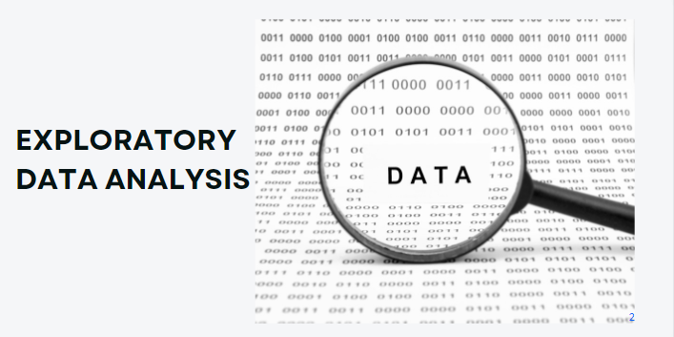

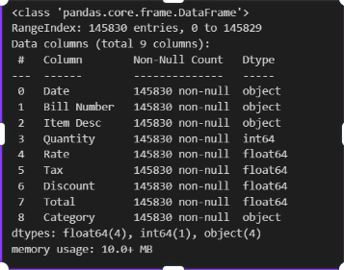

There are a total of 8 categories of items served in the cafe

1. beverage
2. food
3. liquor
4. liquor & tobacco
5. merchandise
6. misc
7. tobacco
8. wines

* Top categories according to Sales value on Monthly Basi

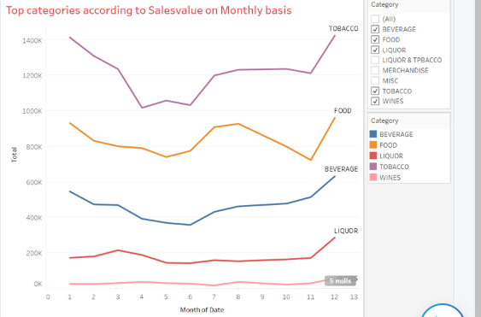

The higher Category sold every month is, Tobacco followed by food then beverage

* Category-wise Sales
* 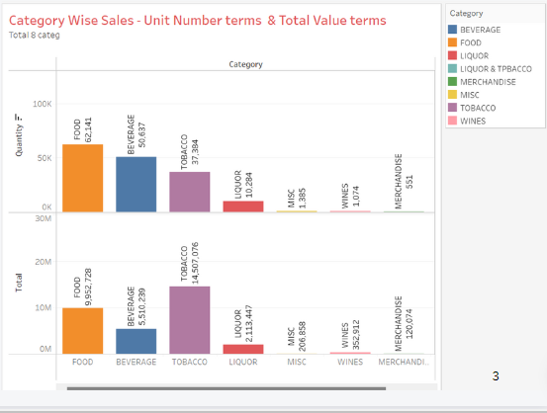
* Highest sales in category unit wise is of food followed by Tobacco and accuse least sales is of liquor and wine
* Highest sales in category in values wise is of tobacco and least is liquor and tobacco
* Most frequent item in Liquor Category is

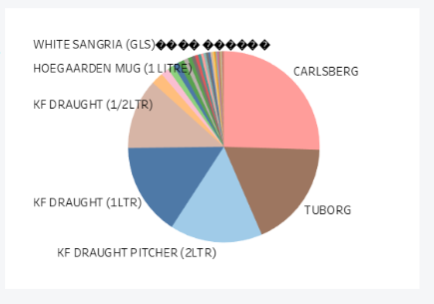

The most frequent item in Liquor Category is

1. Carlsberg ( 5,38,802)

2. Tuborg (3,81,051

3. KF Draught (2 ltr) (3,30,617)

4. Kf draught (1ltr)(3,30,074)

And least is Whiskey (Sm) (525)

followed by Zinzi White (BTL) 882

* Most frequent item in Liquor Category

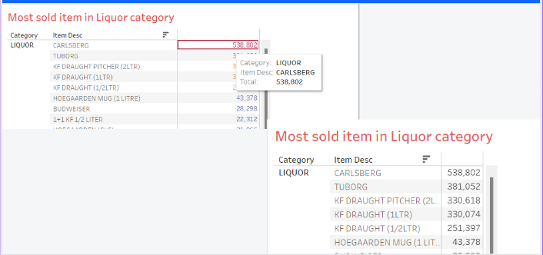

* Most frequent item in Food Category

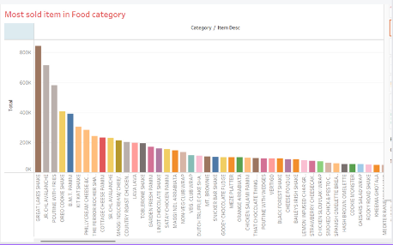

The most frequent item in the Food category is

* Great Lakes Shakes (843,122)
* JR CHL Avalanche(713,566)
* Poutine with Fries (580,284)
* Oreo Cookie shake(405,645)
* And least is B.M.T Panini(391,067)
* followed by Kitkat shake(303,865)

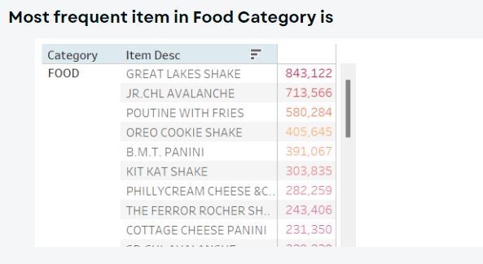

* Most frequent item in Tobacco Category

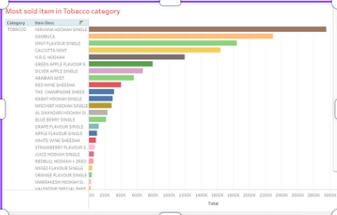

* Most frequent item in the Tobacco category is
* Nirvana Hookah Single (2,953,135)
* Sambuca (2,291,058)
* Mint Flavour Single(1,840,501)
* Calcutta Mint(1,640,860)

And least is N R G Hookah(1,193,015) followed by Green Apples Flavour(793,683)

* ·Most frequent item in Tobacco Category is

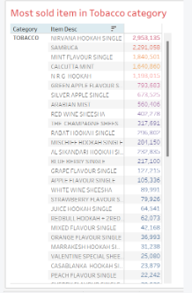

* The most frequent item in Beverage Category is

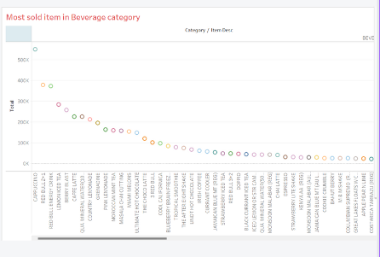

The most frequent itemthe in Beverage category is

* Cappuccino (550,252)
* Red Bull 2+1 (378,632)
* Red Bull Energy Drink (373,016)
* Lemon Iced Tea (282,714)
* And least is Berry Blast(258,198)
* followed by Caffe Latte(224,818)
* Most frequent item in Beverage Category is

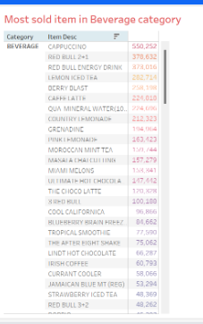

* Graph based on the avg amount of sales and avg amount of tax in the cafe

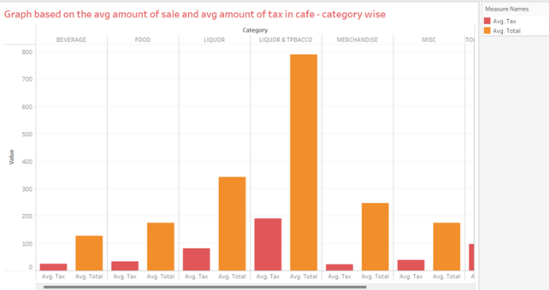

* Top categories according to sales value ona monthly basis

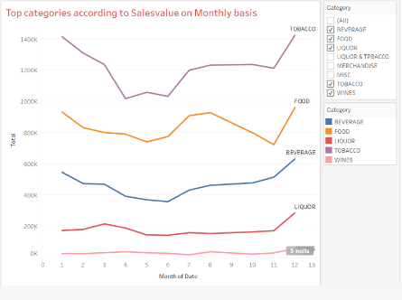

* Sales of products increase from June and peak up in Dec month.
* From Jan till June, sales usually are low for all the products.
* The months of July and August notice a sharp increase in sales for Food and Beverage.
* Liquor and Tobacco show contrasting trends for other months except for December when the sale peaks up for both alike.
* Sales value chart Weekly basis (showing quantity and sales)

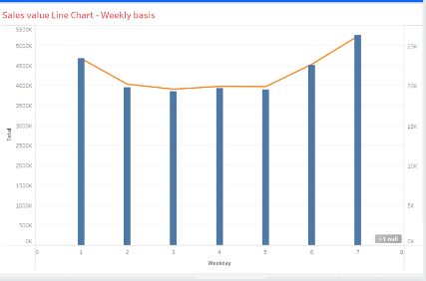

Sales are high on Saturday with a total sales of 5642039 and the number of items sold was 28479 followed by Sunday and Friday and the same for the rest of the days.

* Sales Trend chart Hour of the basis ( showing quantity and sales)

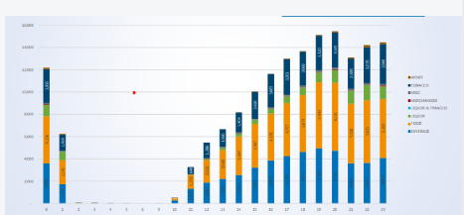

Sales shows steady progress from 11:00 hours onwards. Restaurant makes max sales in the evenings between 19:00-23:00 hours. Peak time is 19:00-20:00 hours .

* Sales value chart monthly basis ( showing quantity and sales)

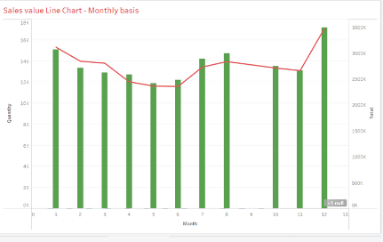

Sales are high in December with a total sales of 3473691 and the number of items sold was 17148 followed by January and August and the same for the rest of the Month .

* Item to be discontinued

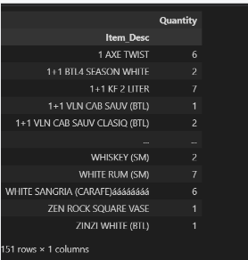

These were the items to be discontinued.

**Menu Analysis**

We have used Market basket analysis ie apriori algorithm to find the best combo

* Suggestion For Best Combo Meals

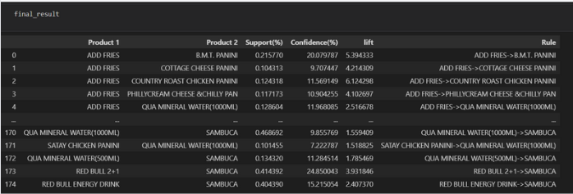

* Suggestion For Best Combo Meals Top 10 item in terms of Quantity sold

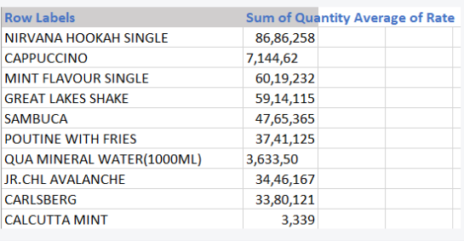

We see that the nirvana hookah single was the highest followed by cappuccino ,mint flavour single .

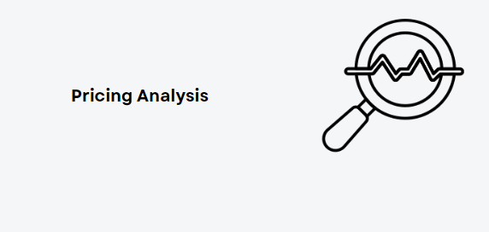

* Linear regression

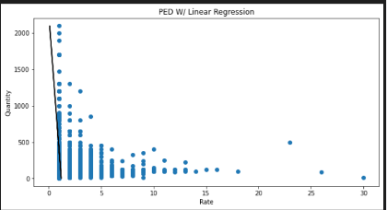

* Our R-squared value is close to 1 for both train and test sets indicating our model is both accurate and precise

Train RMSE 0.469

Train R2 0.013

* RMSE tells us that our model’s predictions are off by 045.–0.50 units of demand on average

Test RMSE 0.491

Test R2 0.01

* each increase in unit Price demand will decrease by coefficient -0.001 .

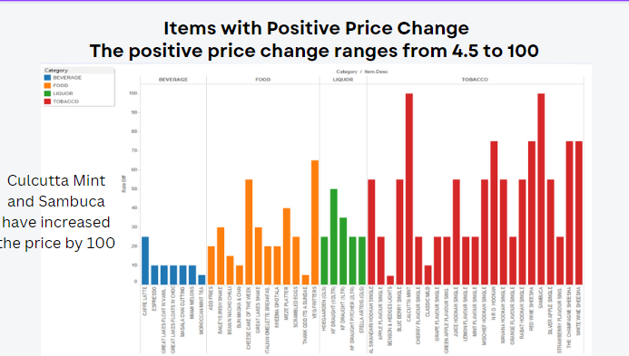

From the above plot we can infer that Calcutta Mint and Sambuca

have increased the price by 100 .

* Items With Negative Price Change

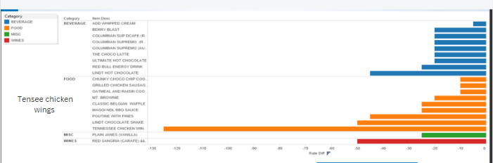

The negative price change ranges from 5 to 12

* Price Change Vs. Sales volume Change

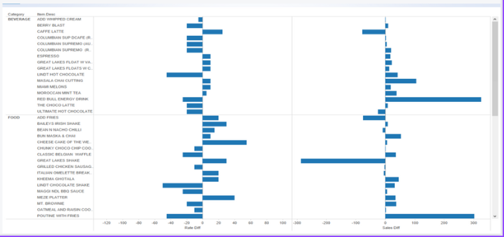

**Findings**

* 1. The Café's top-selling product categories are Tobacco, Food, Beverage, and Liquor.
  2. Most product sales start to increase on Fridays and reach their peak on Saturdays.
  3. The sales of Food, Beverage, Liquor, and Tobacco products are predominantly during the night.
  4. Tobacco and Wine sales are consistent throughout the day but tend to increase during the night.
  5. Product sales typically increase from June and peak in December.

**Final Recommendations To The Company**

1. Adequate resources, inventory, and staff should be readily available to accommodate the peak demand during different times of day and days of the week. Monthly trend analysis can serve as a basis for forecasting quantities for the next fiscal year.
2. It has been observed that Tobacco shows a higher consumption pattern compared to other categories during the month of May. Therefore, increasing promotions for Tobacco can help leverage this trend.
3. Tobacco has shown a brighter consumption pattern in May compared to other categories, indicating an opportunity to increase promotions for Tobacco to capitalize on this trend.
4. Monitoring the sales performance of items in relation to price changes is essential, as some items have experienced a decline in sales after a price increase. This data can be used to strategize the pricing of popular items.