A Novel Approach for Intrusion Detection Using ML and Hyper Parameter Tuning

Abstract—Cardiovascular Intrusion Detection Systems (IDS) is an essential tool for detecting potential threats and attacks in computer networks. Predictive analytics techniques can significantly improve the accuracy of IDS by identifying potential threats and attacks using historical data and identifying patterns. This presentation discusses the various predictive analytics techniques, such as clustering, classification, and anomaly detection, that can be used in IDS. It also explores the popular algorithms used in predictive analytics, such as K-Means Clustering, Decision Trees, and Support Vector Machines. While predictive analytics can improve the effectiveness of IDS, it also presents several challenges that need to be addressed, such as data quality, scalability, diversity of data, the complexity of attacks, and human expertise. Organizations need to invest in the right infrastructure, technology, and human resources to overcome these challenges and improve the effectiveness of their IDS. The presentation concludes by highlighting the importance of understanding predictive analytics techniques and algorithms to choose the best solution for organizations' needs.

Keywords—Artificial Int

Introduction
In today's era, data is considered one of the most valuable assets, and it is critical to protect it from potential cyber threats and attacks. Intrusion Detection System (IDS) is a security solution that helps in detecting potential threats and attacks in real time. IDS monitors network traffic, system activities, and user behavior, and alerts security personnel about any suspicious activity.
With the advancement in technology and the rise in cyber-attacks, predictive analysis has become an essential tool for IDS. The predictive analysis involves using statistical techniques, Machine Learning algorithms, and Artificial Intelligence to analyze historical data and predict future events.
IDS is a critical component of cybersecurity, and predictive analysis can significantly improve its effectiveness. By analyzing historical data and predicting potential threats, IDS can become more proactive and effective in detecting potential threats and attacks. With this project, we aim to provide you with an understanding of how predictive analytics can enhance IDS and help organizations better protect their data and assets.
The purpose of this paper is to provide an overview of the Intrusion Detection System under the predictive analysis domain. We will discuss how predictive analytics can help in improving the accuracy of IDS, various types of IDS, predictive analytics techniques, machine learning algorithms, challenges in implementing IDS under the predictive analysis domain, and the future of IDS In the der predictive analysis domain.

PREDICTIVE ANALYSIS IN IDS
The predictive analysis involves analyzing historical data and predicting future events. In the context of an Intrusion Detection System (IDS), predictive analysis can help in detecting potential threats and attacks before they occur. Predictive analysis in IDS uses statistical techniques, Machine Learning algorithms, and Artificial Intelligence to analyze the data and predict potential threats.
It has many benefits, including improving the accuracy of detecting potential threats, reducing false positives, and reducing response time. By predicting potential threats, security personnel can take proactive measures to prevent attacks, making IDS more effective in protecting against cyber threats.
Predictive analytics is a statistical and data mining technique used to extract information from data and make predictions about future events. In the context of an Intrusion Detection System (IDS), predictive analytics techniques are used to identify potential threats and attacks by analyzing historical data and identifying patterns.

TYPES OF IDS
- Network-based IDS (NIDS):
Network-based IDS (NIDS) monitors network traffic and analyzes network packets to detect potential threats and attacks. NIDS can detect potential threats at the network level, such as suspicious network traffic or unauthorized access attempts.
NIDS has some advantages, such as detecting attacks in real-time, providing a high level of visibility into network traffic, and being able to detect network-level attacks. However, NIDS has some disadvantages, such as being unable to detect attacks on individual systems and being susceptible to false positives.
- Host-based IDS (HIDS):
Host-based IDS (HIDS) monitors the activity of individual hosts or systems to detect potential threats and attacks. HIDS can detect potential threats at the system level, such as suspicious system activities or unauthorized access attempts.

HIDS has some advantages, such as detecting attacks at the system level, being able to monitor all system activities, and being less susceptible to false positives. However, HIDS has some disadvantages, such as being unable to detect network-level attacks and being resource-intensive.

LITERATURE SURVEY

1."A Machine Learning-based Approach for IoT Intrusion Detection using Bot-IoT Dataset" by R. G. Campos et al.
In this paper, the authors propose a machine learning-based approach for detecting intrusions in IoT networks using the Bot-IoT dataset. They evaluate several machine learning algorithms, including Random Forest, Naïve Bayes, and Logistic Regression, to determine which algorithm performs best for intrusion detection. The authors find that the Random Forest algorithm achieves the highest accuracy for detecting both DoS and DDoS attacks.
2."A Comparative Study of Machine Learning Techniques for Bot-IoT Traffic Classification" by R. Y. Mohtar et al.
In this paper, the authors compare the effectiveness of different machine-learning techniques for classifying IoT traffic as either normal or malicious, using the Bot-IoT dataset. They evaluate several classification algorithms, including Decision Trees, Support Vector Machines, and Random Forests. The authors find that the Random Forest algorithm outperforms other algorithms in terms of accuracy, precision, and recall.
3."Machine Learning Techniques for IoT Intrusion Detection: A Comprehensive Review and Comparative Study using Bot-IoT Dataset" by M. T. Siddiqui et al.
In this paper, the authors provide a comprehensive review of machine learning techniques for IoT intrusion detection and evaluate their performance using the Bot-IoT dataset. They compare several machine learning algorithms, including Decision Trees, Support Vector Machines, and Neural Networks. The authors find that the Random Forest algorithm achieves the highest accuracy for intrusion detection on the Bot-IoT dataset.
4."IoT Intrusion Detection using Machine Learning Techniques: A Case Study on Bot-IoT Dataset" by M. S. Hossain et al.
In this paper, the authors present a case study on using machine learning techniques for IoT intrusion detection using the Bot-IoT dataset. They evaluate several machine learning algorithms, including Random Forest, K-Nearest Neighbors, and Support Vector Machines. The authors find that the Random Forest algorithm outperforms other algorithms in terms of accuracy and F-score for intrusion detection on the Bot-IoT dataset.
Overall, these research papers demonstrate the effectiveness of machine learning techniques for intrusion detection on the Bot-IoT dataset. The Random Forest algorithm appears to perform well for this task, achieving high accuracy and F-score for detecting various types of intrusions in IoT networks.

Here are some suggestions:
• Comparison of Ensemble Methods: The four papers all evaluate different machine learning algorithms for intrusion detection, with Random Forest being the most commonly used algorithm. It would be interesting to see a comparison of different ensemble methods, such as Bagging, Boosting, and Stacking, to determine which method works best for intrusion detection on the Bot-IoT dataset.

• Deep Learning Techniques: While the papers evaluate several machine learning algorithms, they do not explore the potential of deep learning techniques, such as Convolutional Neural Networks (CNNs) or Recurrent Neural Networks (RNNs), for intrusion detection on the Bot-IoT dataset. Deep learning has shown promise for similar tasks, such as malware detection, and could potentially improve the accuracy of intrusion detection on the Bot-IoT dataset.

• Multi-Modal Data Fusion: The Bot-IoT dataset includes multiple types of data, such as network traffic data and system call data. It would be interesting to explore the effectiveness of combining these different data modalities using multi-modal data fusion techniques, such as Late Fusion or Early Fusion, for intrusion detection.

• Transfer Learning: One potential issue with intrusion detection on the Bot-IoT dataset is that the dataset is imbalanced, with very few instances of some types of intrusions. Transfer learning techniques, such as Fine-Tuning or Domain Adaptation, could potentially improve the performance of machine learning algorithms by transferring knowledge learned from a related task or dataset to the Bot-IoT dataset.

• These are just a few potential areas where further work could be done using machine learning for intrusion detection on the Bot-IoT dataset. The goal would be to explore new techniques or combine existing ones to improve the accuracy and effectiveness of intrusion detection in IoT networks.

• Explainable AI: Another potential area of research is the development of explainable machine learning models for intrusion detection on the Bot-IoT dataset. This would allow security analysts to understand why a particular intrusion was classified as malicious or benign by the machine learning model. This is particularly important for IoT networks, where the consequences of a false positive or false negative can be severe.

• Dynamic Anomaly Detection: The Bot-IoT dataset consists of a static set of network traffic and system call data. However, in real-world IoT networks, the traffic patterns and system behavior may change over time. Therefore, it would be interesting to explore the effectiveness of dynamic anomaly detection techniques, such as Online Sequential Extreme Learning Machine (OSELM) or Recurrent Neural Networks, for intrusion detection on the Bot-IoT dataset.

• Adversarial Machine Learning: Adversarial machine learning is a growing area of research that explores the vulnerabilities of machine learning models to attacks. It would be interesting to evaluate the vulnerability of intrusion detection models trained on the Bot-IoT dataset to adversarial attacks, such as adding or modifying network traffic to evade detection.

Overall, there are many potential areas of research where machine learning could be used to improve intrusion detection on the Bot-IoT dataset. These include exploring new machine learning techniques, combining existing ones, and addressing specific challenges, such as imbalanced data or dynamic network behavior. The goal of this research would be to improve the accuracy, effectiveness, and explainability of intrusion detection in IoT networks.
.

PREDICTIVE ANALYTICS TECHNIQUES IN IDS

- Clustering is a technique that involves grouping data points into clusters based on their similarity. In IDS, clustering can be used to group similar network traffic and identify patterns that can indicate potential threats or attacks. Clustering can help in identifying new types of attacks that may not be known to the IDS.

- Classification:
Classification is a technique that involves categorizing data into predefined classes. In IDS, classification can be used to identify suspicious activities and label them as normal or malicious. Classification techniques can also be used to identify the type of attack and its severity. Classification can help in reducing false positives and false negatives.

- Anomaly detection:
Anomaly detection is a technique that involves identifying patterns that are outside the norm. In IDS, anomaly detection can be used to detect unusual behavior that may indicate potential threats or attacks. Anomaly detection can help in identifying new types of attacks that may not be known to the IDS.

- K-Means Clustering:
K-Means Clustering is a clustering algorithm that involves grouping data points into K clusters based on their similarity. In IDS, K-Means Clustering can be used to group network traffic into clusters and identify patterns that can indicate potential threats or attacks.

- Decision Trees:
Decision Trees are a classification algorithm that involves creating a tree-like model of decisions and their possible consequences. In IDS, Decision Trees can be used to classify network traffic as normal or malicious based on certain criteria.

- Support Vector Machines (SVM):
Support Vector Machines are a classification algorithm that involves identifying the best boundary that separates data points into different classes. In IDS, SVM can be used to classify network traffic as normal or malicious based on certain criteria.

METHODOLOGY

The methodology used for IDS in the predictive analytics domain typically involves the following steps:

- Data Collection: Collecting data from various sources, such as network traffic, system logs, and application logs, is the first step in the IDS methodology. The quality and quantity of data collected have a significant impact on the accuracy of predictive analytics.

- Data Pre-processing: After collecting the data, it is pre-processed to remove noise and irrelevant information. Data pre-processing techniques such as data cleaning, normalization, and feature selection are applied to ensure that the data is of high quality and relevant to the analysis.

- Feature Engineering: Feature engineering involves identifying the most relevant features or attributes that can contribute to the prediction of potential threats and attacks. This step is critical to improving the accuracy of predictive analytics in IDS.

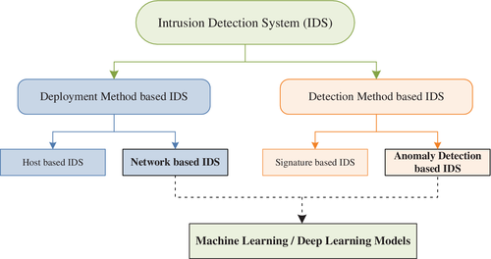

- Model Building: Once the relevant features are identified, various predictive analytics techniques such as clustering, classification, and anomaly detection are applied to build a predictive model. The model is trained on historical data to identify patterns and predict potential threats and attacks.

- Model Evaluation: The effectiveness of the predictive model is evaluated using various metrics such as accuracy, precision, recall, and F1 score. The model may need to be fine-tuned and optimized to improve its accuracy.

- Deployment: After building and evaluating the predictive model, it is deployed in the production environment, where it continuously monitors the network for potential threats and attacks. Any alerts generated by the model are analyzed by human experts and appropriate action is taken to mitigate the threat.

VI. CHALLENGES

Data Quality:

The quality of data used for predictive analytics in IDS is critical for accurate results. Poor quality data can lead to false positives and false negatives, which can impact the effectiveness of IDS. Data cleansing and pre-processing techniques need to be implemented to ensure that the data used for predictive analytics is accurate and reliable.

Scalability:

As the volume of network traffic and data generated by IDS increases, it becomes challenging to scale predictive analytics techniques to handle the large volume of data. High-performance computing infrastructure and parallel processing techniques need to be implemented to ensure that predictive analytics can handle the increasing volume of data.

Diversity of Data:

IDS generates data from various sources, such as network traffic, system logs, and application logs. The diversity of data sources can make it challenging to develop a unified predictive analytics model. Predictive analytics techniques need to be flexible enough to handle the diversity of data sources and adapt to changes in data patterns.

- Complexity of Attacks:

The increasing complexity of attacks, such as advanced persistent threats (APTs), can make it challenging to detect potential threats and attacks using traditional predictive analytics techniques. Advanced predictive analytics techniques, such as machine learning, deep learning, and artificial intelligence, need to be implemented to identify and respond to complex attacks.

- Human Expertise:

The effectiveness of predictive analytics in IDS is dependent on the expertise of human analysts. Human expertise is critical for data interpretation, model selection, and anomaly detection. Organizations need to invest in training and hiring experts in predictive analytics to ensure that IDS is effective in detecting potential threats and attacks.

VII.RESULTS

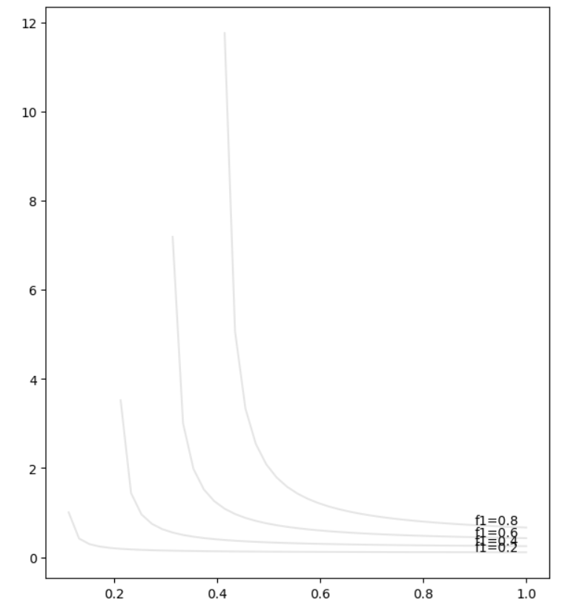

F1-Score

The accuracy the of the base model in XG Boost is 0.61. We need to tune our model by Hyperparameter Tuning to get better accuracy.

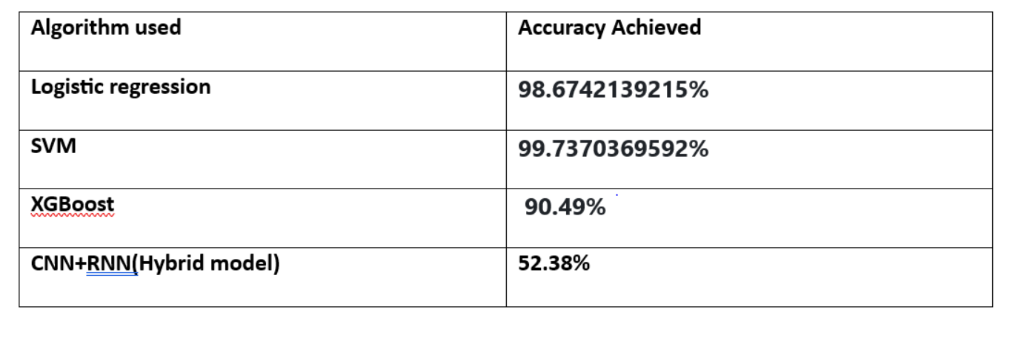

Accuracy Table After Comparing From Model Proposed In literature Survey

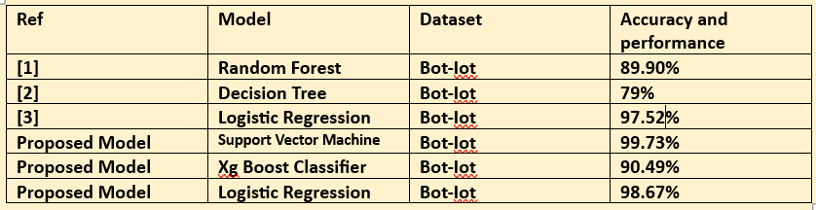

So after hyperparameter tuning, Accuracy has increased from 61.75% to 90.49%.
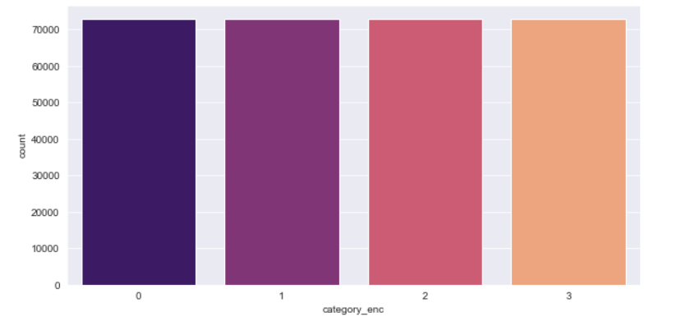

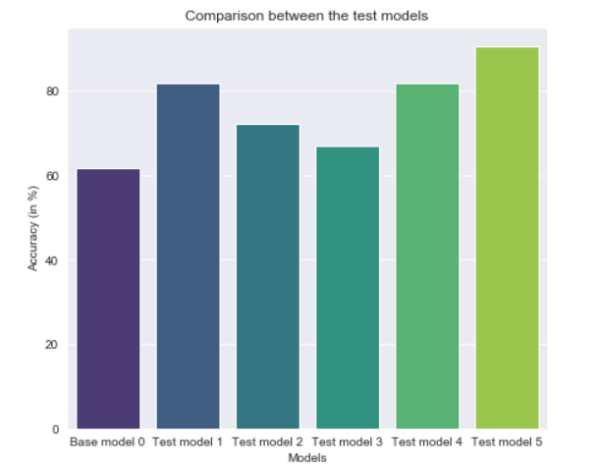

Classification report of tuned model :

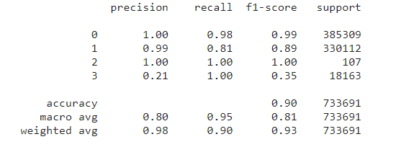

Inferences from the report:
- Recall of the model is 0.90, i.e. 90% of the predicted values were true(1).
- Precision of the model is 0.98, i.e. 98% of the predicted true values were correct.
- F1-Score is also pretty high, 0.93 which means the precision and recall of our model are high.

CLASSIFICATION REPORT OF BASE MODEL

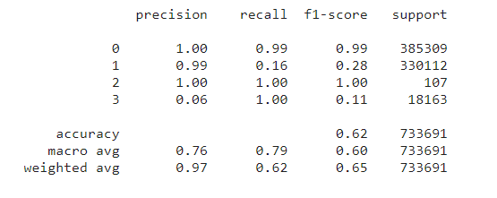

Inferences from the report:
- Recall of the model is 0.62, i.e. 62% of the predicted values were true(1).
- Precision of the model is 0.97, i.e. 97% of the predicted true values were correct.
- F1 score is not very high, 0.65 this is due to low recall.

References
The template will number citations consecutively within brackets [1]. The sentence punctuation follows the bracket [2]. Refer simply to the reference number, as in [3]—do not use “Ref. [3]” or “reference [3]” except at the beginning of a sentence: “Reference [3] was the first ...”

[1] ."A Machine Learning-based Approach for IoT Intrusion Detection using Bot-IoT Dataset" by R. G. Campos et al.
[2] "A Comparative Study of Machine Learning Techniques for Bot-IoT Traffic Classification" by R. Y. Mohtar et al.
[3] "Machine Learning Techniques for IoT Intrusion Detection: A Comprehensive Review and Comparative Study using Bot-IoT Dataset" by M. T. Siddiqui et al.
.[4] ."IoT Intrusion Detection using Machine Learning Techniques: A Case Study on Bot-IoT Dataset" by M. S. Hossain et al
.

IEEE conference templates contain guidance text for composing and formatting conference papers. Please ensure that all template text is removed from your conference paper before submission to the conference. Failure to remove template text from your paper may result in your paper not being published.

