**Course Registration App**

**Description:** It’s an app to enroll for courses. It contains 4 pages:

**Index page**: displays form to be filled by students containing details of his/her name, email, Level of education- Graduate/Under graduate, Semester- Spring/Summer/Fall, Career option- Computer Science/Law. Once student fills all details on click on submit, courses page is loaded.

**Display courses page:** displays all courses available depending upon the data provided by student in index page. Course details include course name, location of class, meeting dates, instructors, MOOCS link for the course, pre-requisites, course description, credit hours and reviews by previous students. It also displays course image and enroll button. Clicking on either would redirect to course registration page.

**Course registration page:** displays totals seats and remaining seats for the course student chose to enroll. On clicking enroll student would be enrolled into the course. If the course seats are full then it displays an alert saying no more seats are available to enroll.

**Registration success page:** displays registration success message along with updated remaining seats of the course.

**Detailed explanation with screenshots:**

* **Index page**:

Screenshot of this page in various devices is shown below:

Laptop view:

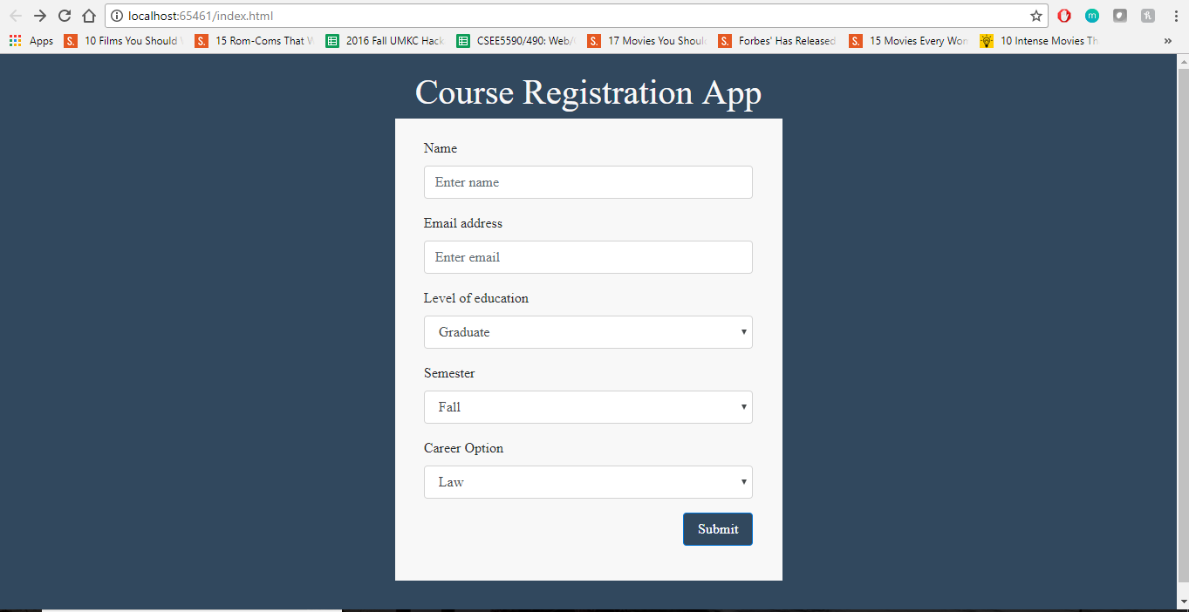

Mobile view:

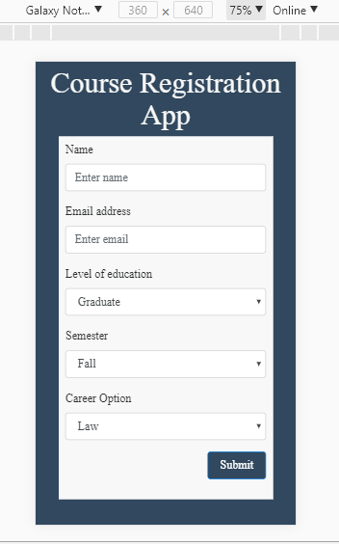

Responsive view:

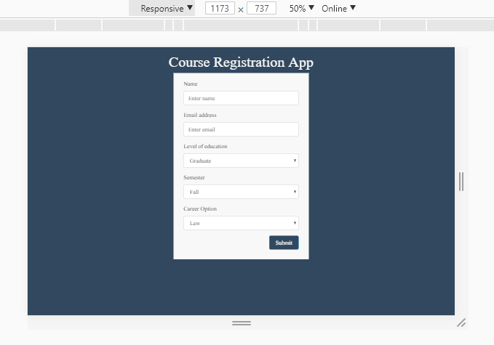

This page contains a form whose code is shown below:

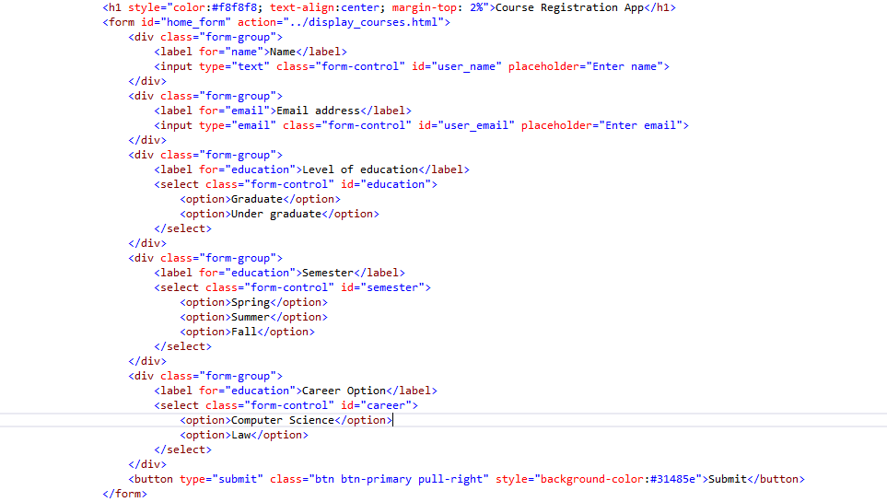

Upon submit button click, data filled by user is saved in local storage and redirected to display courses page. Code is shown below:

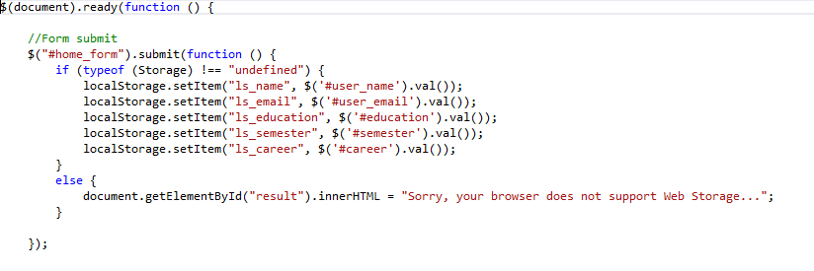

Also, all courses details are stored in local storage. Code is below:

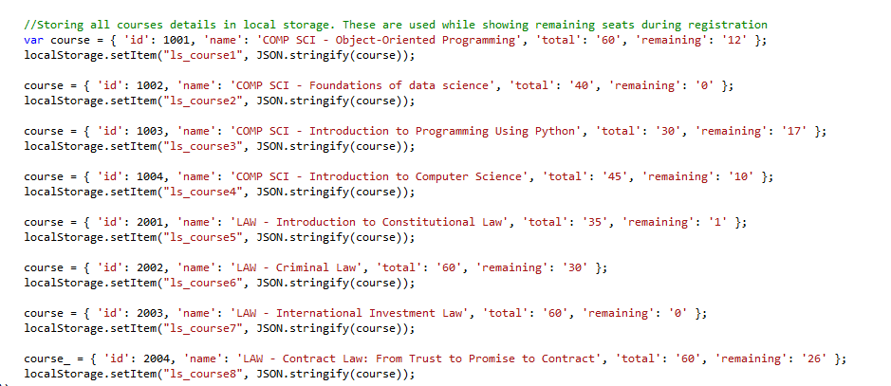

* **Display courses page**:

Screenshot of this page in various devices is shown below:

Laptop view:

*User input:*

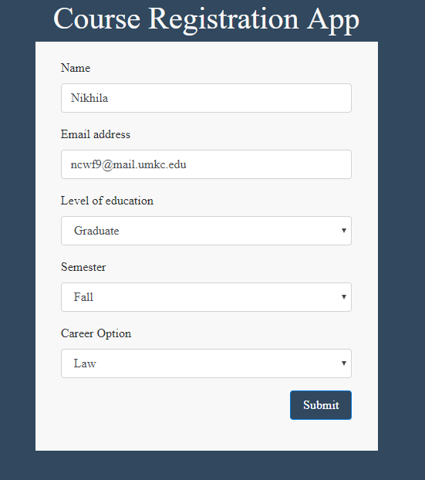

*Display courses page displaying law courses:*

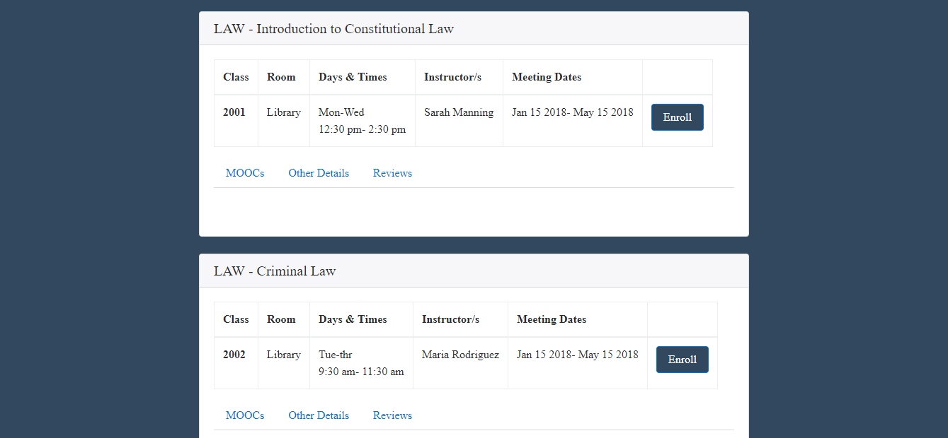

Responsive view:

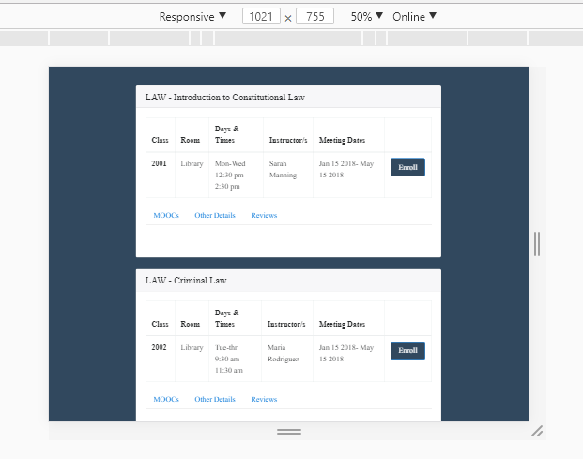

MOOCS link tab showing MOOCS link for the course. Upon clicking the link user is redirected to online course page:

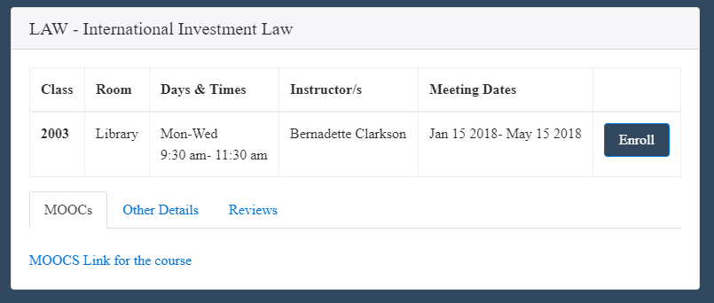

Other details tab showing course url and description:

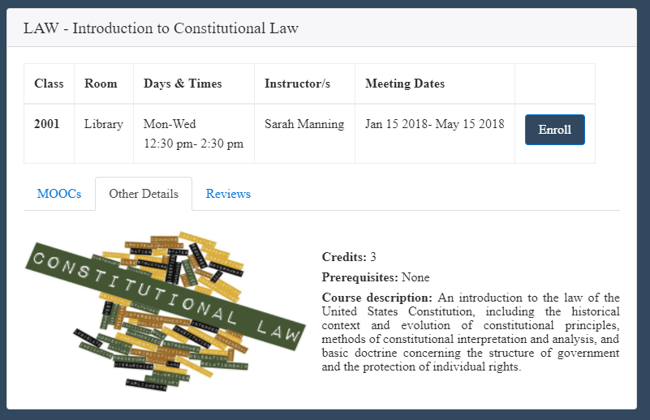

Reviews tab showing previous students reviews:

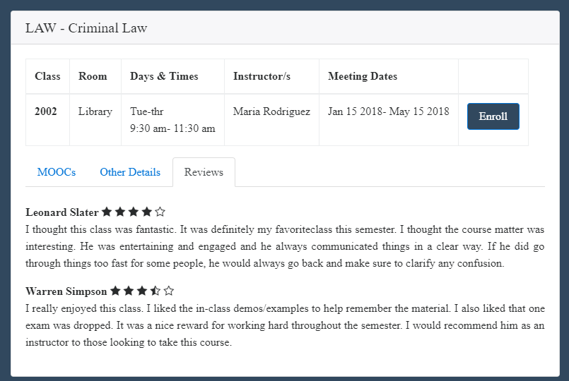

Courses are displayed using bootstrap 4 cards:

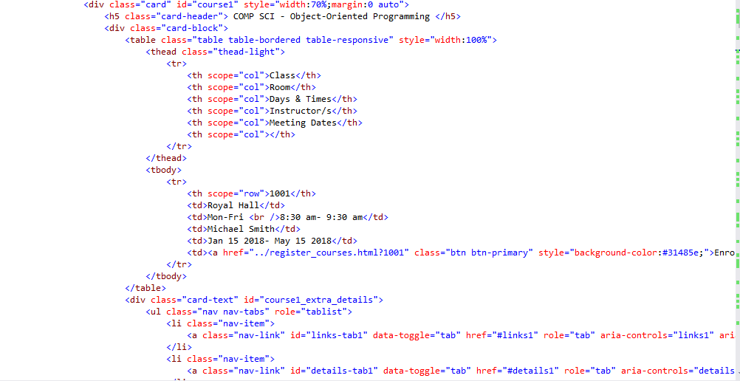

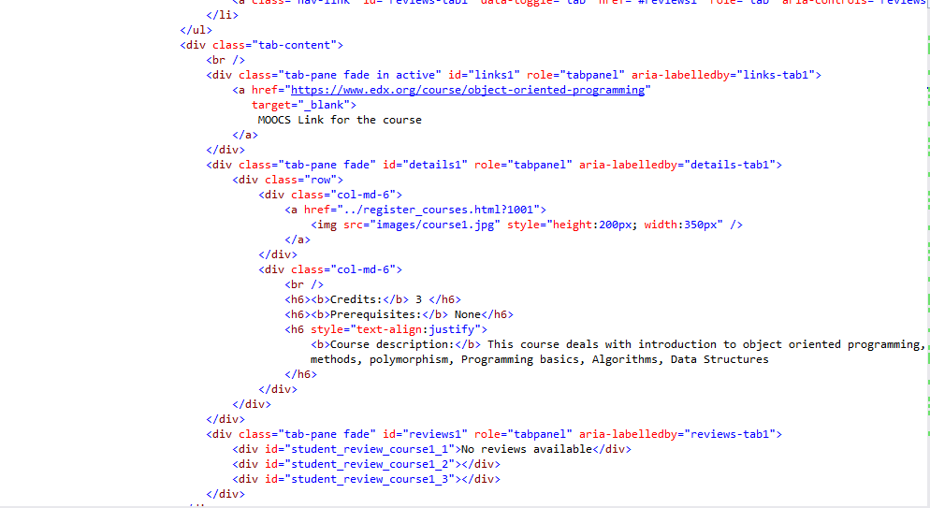

Courses are displayed using user’s input through the following code:

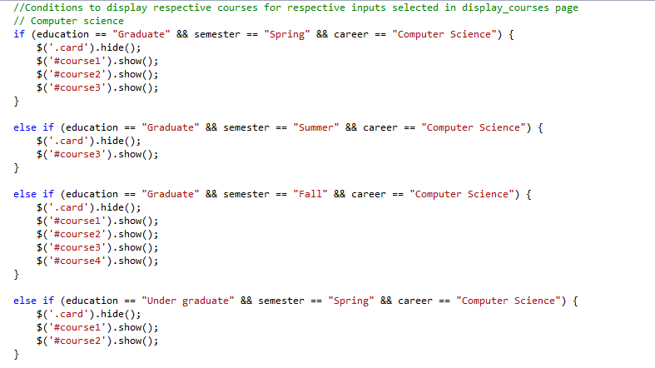

* **Register courses page:** This page displays total and remaining seats for the course.

Screenshots are below:

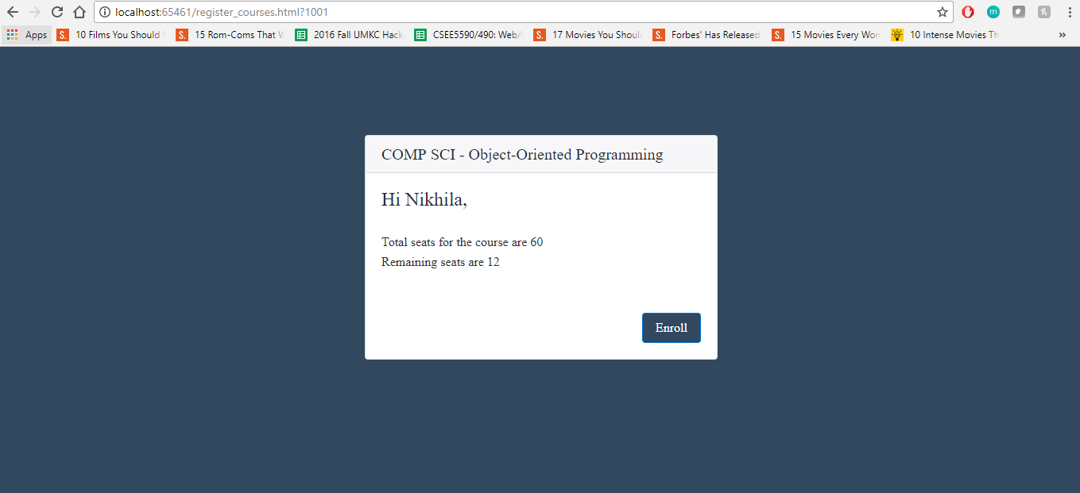

Responsive view:

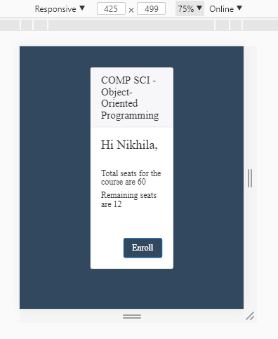

Depending on user’s input course details are obtained from local storage and displayed:

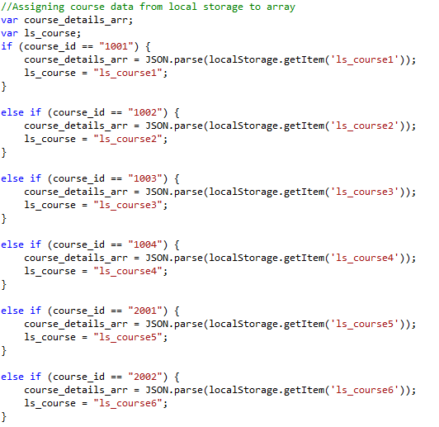

Values are then assigned to display. If remaining seats are 0, alert is shown. Upon click on enroll button remaining seats are reduced by 1. Code for this is below:

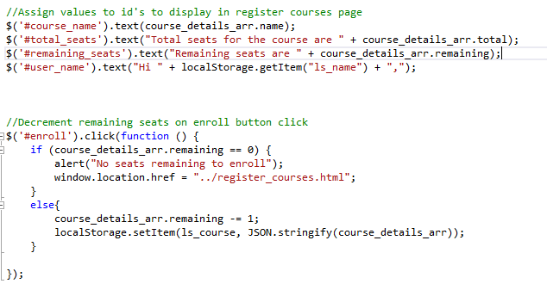

Html view:

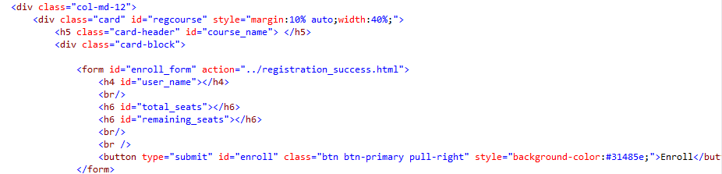

Alert shown upon enroll click for the course having 0 seats:

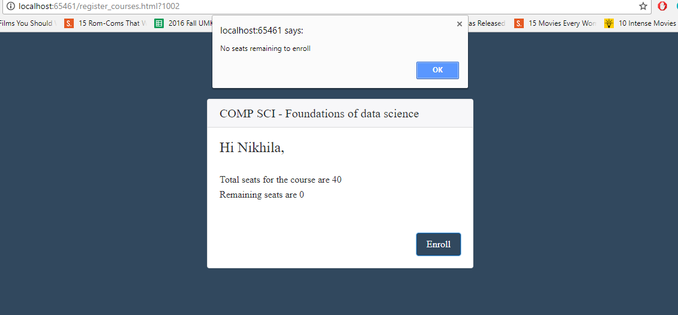

* **Registration success page:**

Upon enroll button click in the registration page, user is redirected to the success page:

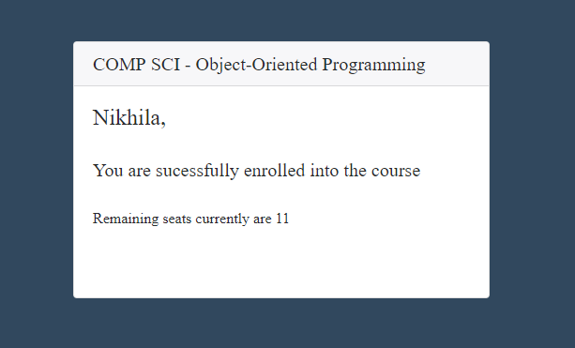

Responsive view:

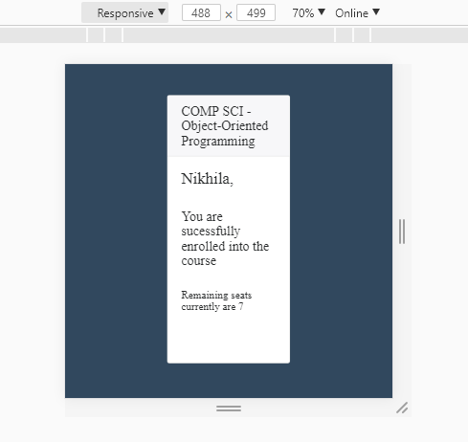

Html page is below:

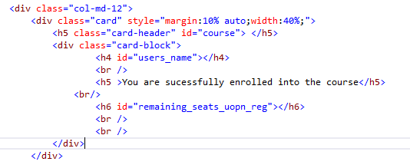

These values are assigned in javascript file shown below:

