**Lab 5**

**Step Counter**

**Description:** It’s an app that counts steps.

**Detailed explanation with screenshots:**

Screenshots of the pages are shown below:

Home page:

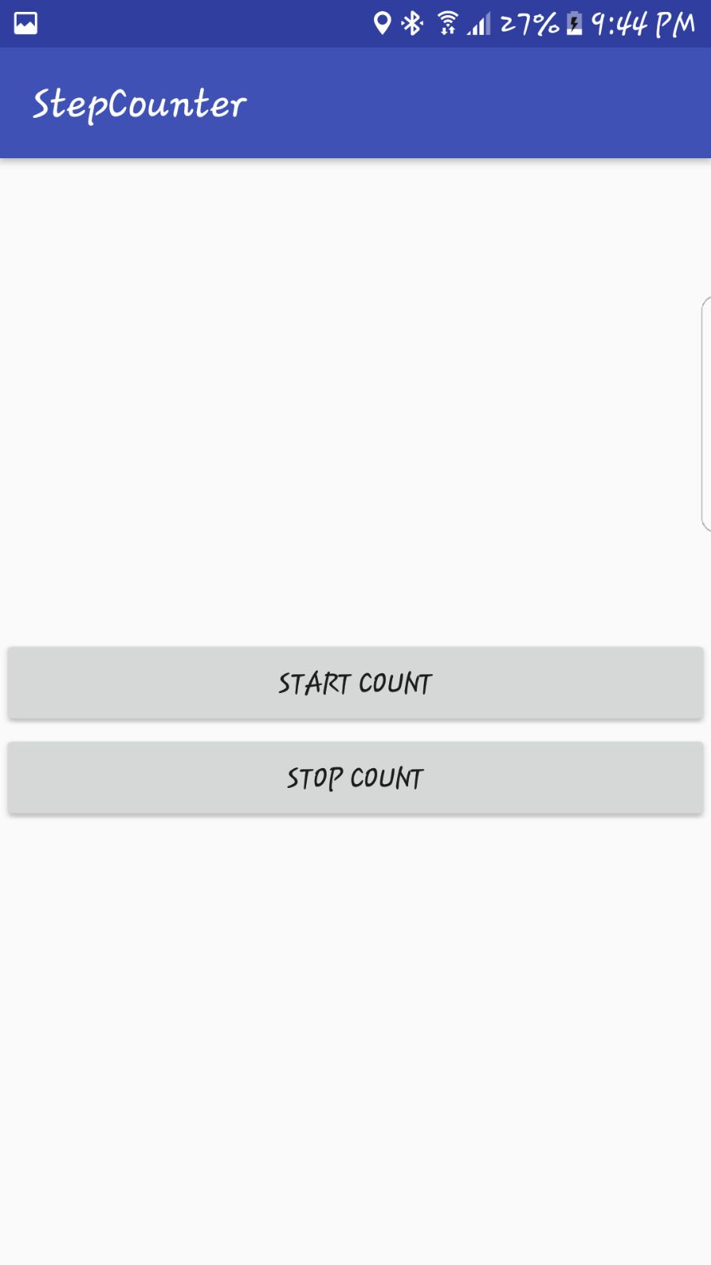

Upon starting the app and taking 2 steps:

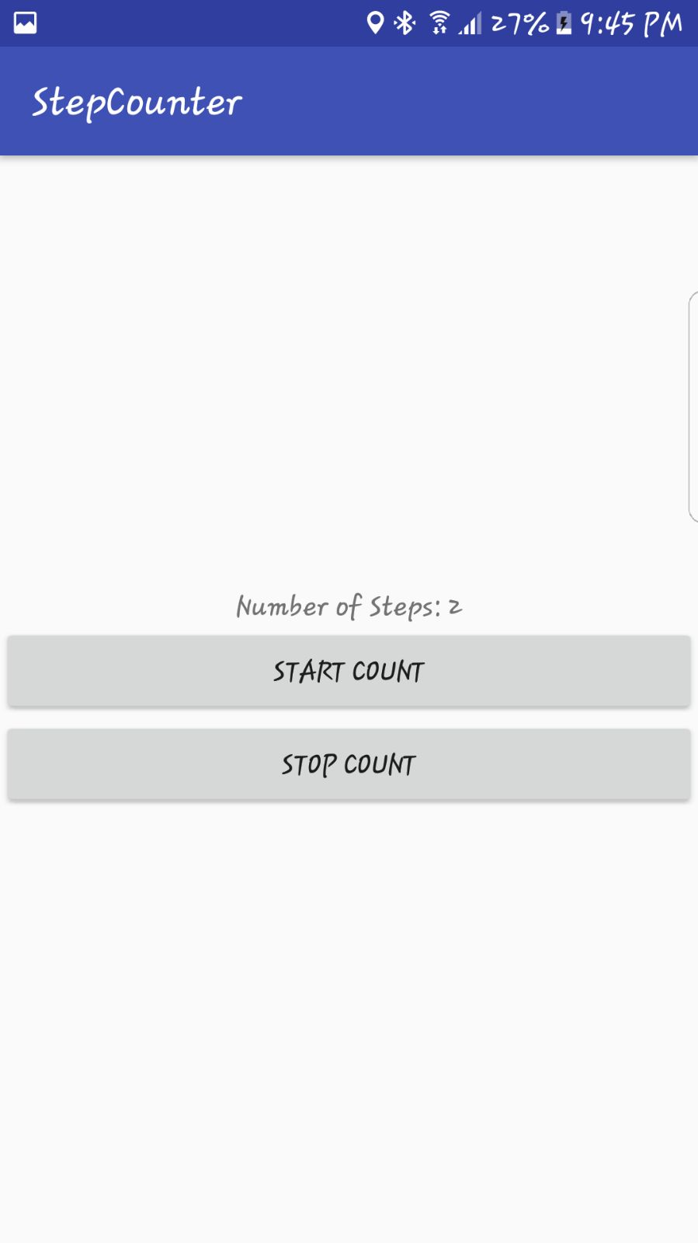

After taking few more steps:

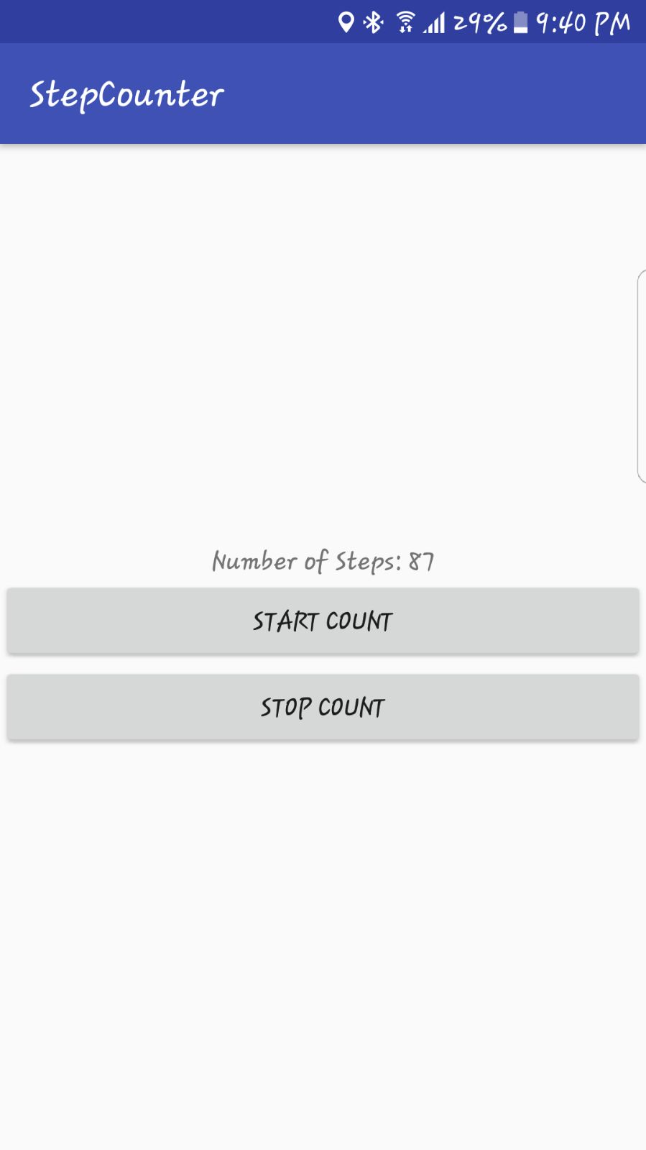

Code:

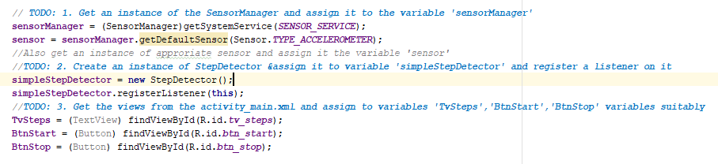

**Facial Features Recognizer**

**Description:** It’s an app that recognizes eyes and smile

**Detailed explanation with screenshots:**

Screenshots of the pages are shown below:



