**Q. Import data sets HH_SAMPLE_POWER_CONSUMPTION_GRID _A.csv into R Studio**

**Download the zip file from moodle Topic “Visualisation” → “Examples” and extract to a local folder**

**library(readr)**

**consumption <- read_delim("C:/PATH_TO_FILE/HH_SAMPLE_POWER_CONSU MPTION_GRID_A.csv", ";", na = "empty", trim_ws = TRUE)**

1. library(readr)
2. consumption<-read_delim("C:/Users/Nikhila Mariam Biju/Desktop/datamining/New folder/HH_SAMPLE_POWER_CONSUMPTION_GRID_A.csv",";",na="empty",trim_ws = TRUE)

Parsed with column specification:

cols(

GRID_IDENT = col_character(),

MONTH_BILLING = col_character(),

SWITCHING_REASON = col_character(),

DECLARATION_CONSUMP_CUST = col_double(),

DECLARATION_CONSUMP_GRID = col_double(),

CORRECTIVE_VALUE = col_double(),

DAYS_INVOICED = col_double(),

CONSUMPTION_INVOICED = col_double(),

READ_OUT_CAT = col_character(),

BILLING_TYPE = col_character()

)

1. summary(consumption)

- Gives an overall summary about the columns of the consumption table with length, class, mode and other information. A screenshot for the one is shown below

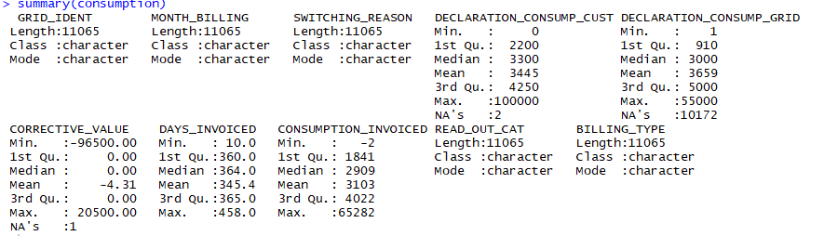

**Q. Create a new table or tibble with the name hh_spc: – month_billing = MONTH_BILLING – swt_reason = SWITCHING_REASON – cust_decl_kwh = DECLARATION_CONSUMP_CUST – grid_decl_kwh = DECLARATION_CONSUMP_CUST + CORRECTIVE_VALUE – bill = BILLING_TYPE – inv_kwh_365 = CONSUMPTION_INVOICED * 365 / DAYS_INVOICED • Use round function to cut decimals**

1. library(tibble) :

Used to load all the packages related to the data frame.

1. hh_spc<-tibble( month_billing = consumption$MONTH_BILLING,swt_reason = consumption$SWITCHING_REASON,cust_decl_kwh=consumption$DECLARATION_CONSUMP_CUST,grid_decl_kwh=consumption$DECLARATION_CONSUMP_GRID+consumption$CORRECTIVE_VALUE,bill=consumption$BILLING_TYPE,inv_kwh_365=consumption$CONSUMPTION_INVOICED*365/consumption$DAYS_INVOICED)

**Q.** **Limit the selection to: – inv_kwh_365 < 10000 – cust_decl_kwh < 7500 – cust_decl_kwh > 0**

1. library(dplyr):

This library is used to provide filter and other data manipulation operations that be used with the table hh_spc.

1. hh_spc<-filter(hh_spc,inv_kwh_365<10000,cust_decl_kwh<7500,cust_decl_kwh > 0)

* It returns modified data sets depending on the conditions that is applied to the data sets.
* Here, filter function when applied to table hh_spc returns the results of colums inv_kwh with the values less than 10000, cust_decl with a value greater than 0 and lesser than 7500

**Order by month_billing**

1. hh_spc <- arrange(hh_spc, month_billing)

Arrange Function here arranges the table hh_spc in the order sequence of month_billing

**Q. Plot a sample of 400 of these point & including smoothing function – Compare customers’ declared consumption and (invoiced) 365 day consumption – Separate switching reason by color – Use se = FALSE for the smoothing**

1. library(ggplot2)

Loads the packages that are required for plotting

1. ggplot(data = sample_n(tbl=hh_spc, size=400),aes(x = cust_decl_kwh,y = inv_kwh_365,color = swt_reason)) + geom_point() + geom_smooth(se = FALSE) + xlim(0,10000) + ylim(0,10000)

* geom_smooth() smooth the plots over the points against cust_decl_kwh and inv_kwh_365
* xlim, ylim are the cartesion coordinate points

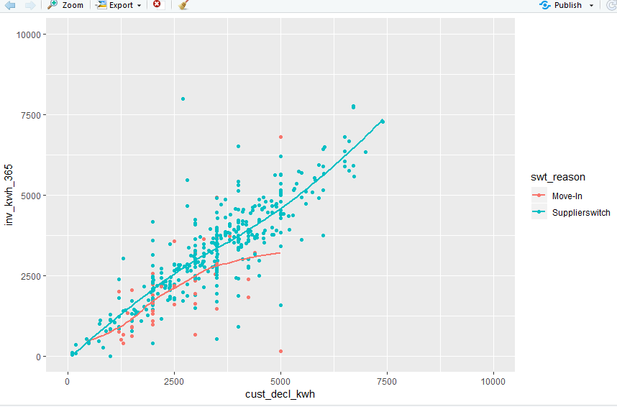

* Observation: People who conduct a supplierswitch can estimate their power demand much more precise than people who move in
* Because each time it can viewed that the variation of power demand in move-in occurs frequently

**Q. Create a boxplot with switching reason and 365 day consumption by using a 10% sample. (Hint: If it does not work change x and y attributes)**

1. ggplot(data = sample_frac(tbl=hh_spc, size=0.1),aes(x = swt_reason, y = inv_kwh_365)) +geom_boxplot()

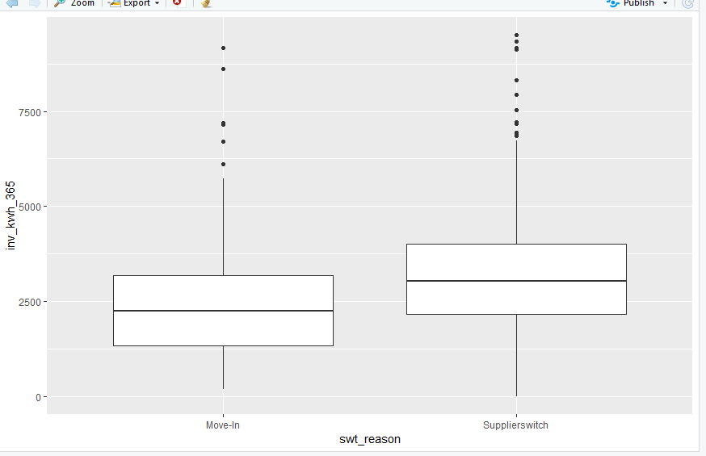

* Observation: People who conduct a supplierswitch use more power than people who have just moved in