Assignment_4

Nikhila Reddy

2024-03-16

library(caret)

## Loading required package: ggplot2

## Loading required package: lattice

#install.packages("factoextra")  
library(factoextra)

## Warning: package 'factoextra' was built under R version 4.3.3

## Welcome! Want to learn more? See two factoextra-related books at https://goo.gl/ve3WBa

library(dplyr)

##   
## Attaching package: 'dplyr'

## The following objects are masked from 'package:stats':  
##   
## filter, lag

## The following objects are masked from 'package:base':  
##   
## intersect, setdiff, setequal, union

library(ggplot2)  
library(tidyverse)

## Warning: package 'tidyverse' was built under R version 4.3.3

## Warning: package 'readr' was built under R version 4.3.3

## Warning: package 'forcats' was built under R version 4.3.3

## ── Attaching core tidyverse packages ──────────────────────── tidyverse 2.0.0 ──  
## ✔ forcats 1.0.0 ✔ stringr 1.5.1  
## ✔ lubridate 1.9.3 ✔ tibble 3.2.1  
## ✔ purrr 1.0.2 ✔ tidyr 1.3.1  
## ✔ readr 2.1.5   
## ── Conflicts ────────────────────────────────────────── tidyverse_conflicts() ──  
## ✖ dplyr::filter() masks stats::filter()  
## ✖ dplyr::lag() masks stats::lag()  
## ✖ purrr::lift() masks caret::lift()  
## ℹ Use the conflicted package (<http://conflicted.r-lib.org/>) to force all conflicts to become errors

#install.packages("cowplot")  
library(cowplot)

## Warning: package 'cowplot' was built under R version 4.3.3

##   
## Attaching package: 'cowplot'

## The following object is masked from 'package:lubridate':  
##   
## stamp

library(readr)  
#install.packages("flexclust")  
library(flexclust)

## Warning: package 'flexclust' was built under R version 4.3.3

## Loading required package: grid

## Loading required package: modeltools

## Loading required package: stats4

#install.packages("cluster")  
library(cluster)

#install.packages("NbClust")  
library(NbClust)

Pharmaceuticals <- read.csv("C:\\Users\\Nikhi\\Downloads\\Pharmaceuticals.csv")  
###to read the given dataset  
View(Pharmaceuticals)  
###to view the given dataset.  
head(Pharmaceuticals)

## Symbol Name Market_Cap Beta PE_Ratio ROE ROA Asset_Turnover  
## 1 ABT Abbott Laboratories 68.44 0.32 24.7 26.4 11.8 0.7  
## 2 AGN Allergan, Inc. 7.58 0.41 82.5 12.9 5.5 0.9  
## 3 AHM Amersham plc 6.30 0.46 20.7 14.9 7.8 0.9  
## 4 AZN AstraZeneca PLC 67.63 0.52 21.5 27.4 15.4 0.9  
## 5 AVE Aventis 47.16 0.32 20.1 21.8 7.5 0.6  
## 6 BAY Bayer AG 16.90 1.11 27.9 3.9 1.4 0.6  
## Leverage Rev_Growth Net_Profit_Margin Median_Recommendation Location Exchange  
## 1 0.42 7.54 16.1 Moderate Buy US NYSE  
## 2 0.60 9.16 5.5 Moderate Buy CANADA NYSE  
## 3 0.27 7.05 11.2 Strong Buy UK NYSE  
## 4 0.00 15.00 18.0 Moderate Sell UK NYSE  
## 5 0.34 26.81 12.9 Moderate Buy FRANCE NYSE  
## 6 0.00 -3.17 2.6 Hold GERMANY NYSE

###To retrieve the initial observations from the provided dataset.  
str(Pharmaceuticals)

## 'data.frame': 21 obs. of 14 variables:  
## $ Symbol : chr "ABT" "AGN" "AHM" "AZN" ...  
## $ Name : chr "Abbott Laboratories" "Allergan, Inc." "Amersham plc" "AstraZeneca PLC" ...  
## $ Market_Cap : num 68.44 7.58 6.3 67.63 47.16 ...  
## $ Beta : num 0.32 0.41 0.46 0.52 0.32 1.11 0.5 0.85 1.08 0.18 ...  
## $ PE_Ratio : num 24.7 82.5 20.7 21.5 20.1 27.9 13.9 26 3.6 27.9 ...  
## $ ROE : num 26.4 12.9 14.9 27.4 21.8 3.9 34.8 24.1 15.1 31 ...  
## $ ROA : num 11.8 5.5 7.8 15.4 7.5 1.4 15.1 4.3 5.1 13.5 ...  
## $ Asset_Turnover : num 0.7 0.9 0.9 0.9 0.6 0.6 0.9 0.6 0.3 0.6 ...  
## $ Leverage : num 0.42 0.6 0.27 0 0.34 0 0.57 3.51 1.07 0.53 ...  
## $ Rev_Growth : num 7.54 9.16 7.05 15 26.81 ...  
## $ Net_Profit_Margin : num 16.1 5.5 11.2 18 12.9 2.6 20.6 7.5 13.3 23.4 ...  
## $ Median_Recommendation: chr "Moderate Buy" "Moderate Buy" "Strong Buy" "Moderate Sell" ...  
## $ Location : chr "US" "CANADA" "UK" "UK" ...  
## $ Exchange : chr "NYSE" "NYSE" "NYSE" "NYSE" ...

###To examine the format of the provided dataset.  
summary(Pharmaceuticals)

## Symbol Name Market_Cap Beta   
## Length:21 Length:21 Min. : 0.41 Min. :0.1800   
## Class :character Class :character 1st Qu.: 6.30 1st Qu.:0.3500   
## Mode :character Mode :character Median : 48.19 Median :0.4600   
## Mean : 57.65 Mean :0.5257   
## 3rd Qu.: 73.84 3rd Qu.:0.6500   
## Max. :199.47 Max. :1.1100   
## PE_Ratio ROE ROA Asset_Turnover Leverage   
## Min. : 3.60 Min. : 3.9 Min. : 1.40 Min. :0.3 Min. :0.0000   
## 1st Qu.:18.90 1st Qu.:14.9 1st Qu.: 5.70 1st Qu.:0.6 1st Qu.:0.1600   
## Median :21.50 Median :22.6 Median :11.20 Median :0.6 Median :0.3400   
## Mean :25.46 Mean :25.8 Mean :10.51 Mean :0.7 Mean :0.5857   
## 3rd Qu.:27.90 3rd Qu.:31.0 3rd Qu.:15.00 3rd Qu.:0.9 3rd Qu.:0.6000   
## Max. :82.50 Max. :62.9 Max. :20.30 Max. :1.1 Max. :3.5100   
## Rev_Growth Net_Profit_Margin Median_Recommendation Location   
## Min. :-3.17 Min. : 2.6 Length:21 Length:21   
## 1st Qu.: 6.38 1st Qu.:11.2 Class :character Class :character   
## Median : 9.37 Median :16.1 Mode :character Mode :character   
## Mean :13.37 Mean :15.7   
## 3rd Qu.:21.87 3rd Qu.:21.1   
## Max. :34.21 Max. :25.5   
## Exchange   
## Length:21   
## Class :character   
## Mode :character   
##   
##   
##

###To examine an overview of the provided dataset.  
dim(Pharmaceuticals)

## [1] 21 14

###To determine the number of rows and columns present in the provided dataset.  
colMeans(is.na(Pharmaceuticals))

## Symbol Name Market_Cap   
## 0 0 0   
## Beta PE_Ratio ROE   
## 0 0 0   
## ROA Asset_Turnover Leverage   
## 0 0 0   
## Rev_Growth Net_Profit_Margin Median_Recommendation   
## 0 0 0   
## Location Exchange   
## 0 0

row.names(Pharmaceuticals) <- Pharmaceuticals[,2]  
Pharmaceuticals <- Pharmaceuticals[,-2]

FIRST QUESTION:

a.Use only the numerical variables (1 to 9) to cluster the 21 firms. Justify the various choices made in conducting the cluster analysis, such as weights for different variables, the specific clustering algorithm(s) used, the number of clusters formed, and so on.

Pharmaceuticals1 <- Pharmaceuticals[,-c(1,11:13)]  
###with exception of "Symbol" and the last three non-numerical variables.

NORMALIZING AND CLUSTERING THE DATA

Here, I have calculated the difference between each observation, and it’s important to modify the data beforehand because the default Euclidean distance measure is sensitive to scale.

norm.Pharmaceuticals1 <- scale(Pharmaceuticals1)  
###the data is normalized.  
distance <- get_dist(norm.Pharmaceuticals1)  
fviz_dist(distance)

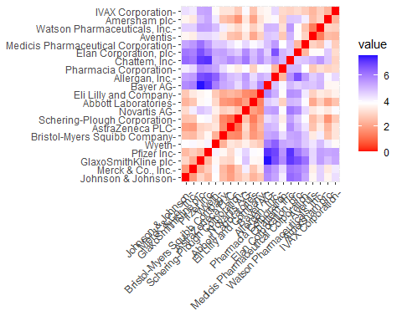

###to measure and plot distance for the given dataset.

The graph illustrates the change in color intensity as distance increases. As expected, the diagonal line shows a value of zero, indicating the distance between two observations.

#To find the Optimal K value

The Elbow chart and the Silhouette Method are the best techniques for deciding the number of clusters in a k-means model when there are no external factors. The Elbow chart shows that increasing the number of clusters leads to less variation within each cluster, while the Silhouette Method measures how connected an object's cluster is to others.

WSS <- fviz_nbclust(norm.Pharmaceuticals1, kmeans, method = "wss")  
Silhouette <- fviz_nbclust(norm.Pharmaceuticals1, kmeans, method = "silhouette")  
plot_grid(WSS, Silhouette)

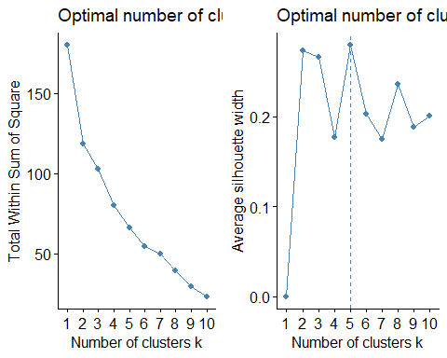

###we used elbow chart and silhouette methods.  
set.seed(123)  
Kmeans.Pharmaceuticals.Optimalno <- kmeans(norm.Pharmaceuticals1, centers = 5, nstart = 50)  
Kmeans.Pharmaceuticals.Optimalno$centers

## Market_Cap Beta PE_Ratio ROE ROA Asset_Turnover  
## 1 -0.03142211 -0.4360989 -0.31724852 0.1950459 0.4083915 0.1729746  
## 2 -0.87051511 1.3409869 -0.05284434 -0.6184015 -1.1928478 -0.4612656  
## 3 -0.43925134 -0.4701800 2.70002464 -0.8349525 -0.9234951 0.2306328  
## 4 1.69558112 -0.1780563 -0.19845823 1.2349879 1.3503431 1.1531640  
## 5 -0.76022489 0.2796041 -0.47742380 -0.7438022 -0.8107428 -1.2684804  
## Leverage Rev_Growth Net_Profit_Margin  
## 1 -0.27449312 -0.7041516 0.556954446  
## 2 1.36644699 -0.6912914 -1.320000179  
## 3 -0.14170336 -0.1168459 -1.416514761  
## 4 -0.46807818 0.4671788 0.591242521  
## 5 0.06308085 1.5180158 -0.006893899

Kmeans.Pharmaceuticals.Optimalno$size

## [1] 8 3 2 4 4

Kmeans.Pharmaceuticals.Optimalno$withinss

## [1] 21.879320 15.595925 2.803505 9.284424 12.791257

fviz_cluster(Kmeans.Pharmaceuticals.Optimalno, data = norm.Pharmaceuticals1)

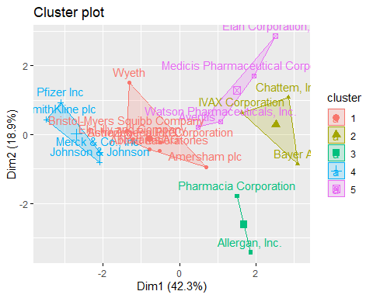

Based on the data, we can classify five clusters based on their proximity to the centroids. Cluster 4 exhibits a high Market Capital, while Cluster 2 shows a high Beta, and Cluster 5 has a low Asset Turnover. We can also determine the size of each cluster, with Cluster 1 having the highest number of enterprises, while Cluster 3 contains only two. The sum of squared distances within each cluster provides insights into data dispersion: Cluster 1 (21.9) shows less uniformity compared to Cluster 3 (2.8). Through visualizing the output of the algorithm, we can observe the division of the data into these five distinct groups.

SECOND QUESTION:

b.Interpret the clusters with respect to the numerical variables used in forming the clusters

###Employing k-means with k=3 to create clusters.  
set.seed(123)  
Kmeans.Pharmaceuticals <- kmeans(norm.Pharmaceuticals1, centers =3, nstart = 50)  
Kmeans.Pharmaceuticals$centers

## Market_Cap Beta PE_Ratio ROE ROA Asset_Turnover  
## 1 -0.6125361 0.2698666 1.3143935 -0.9609057 -1.0174553 0.2306328  
## 2 0.6733825 -0.3586419 -0.2763512 0.6565978 0.8344159 0.4612656  
## 3 -0.8261772 0.4775991 -0.3696184 -0.5631589 -0.8514589 -0.9994088  
## Leverage Rev_Growth Net_Profit_Margin  
## 1 -0.3592866 -0.5757385 -1.3784169  
## 2 -0.3331068 -0.2902163 0.6823310  
## 3 0.8502201 0.9158889 -0.3319956

Kmeans.Pharmaceuticals$size

## [1] 4 11 6

Kmeans.Pharmaceuticals$withinss

## [1] 20.54199 43.30886 32.14336

fviz_cluster(Kmeans.Pharmaceuticals, data = norm.Pharmaceuticals1)

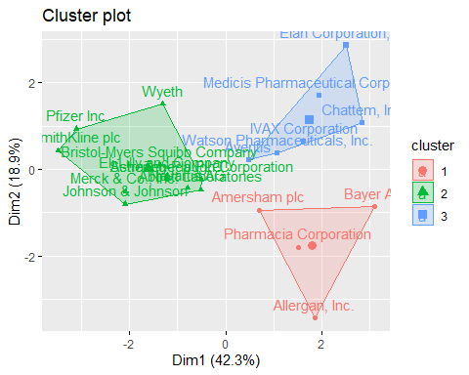

This simplifies the process of identifying and handling the clusters within the analysis. Currently, there are 4 data points allocated to cluster 1, 11 data points assigned to cluster 2, and 6 data points designated to cluster 3.

clusplot(norm.Pharmaceuticals1, Kmeans.Pharmaceuticals$cluster, color = TRUE, shade = TRUE, labels = 2,,lines= TRUE)

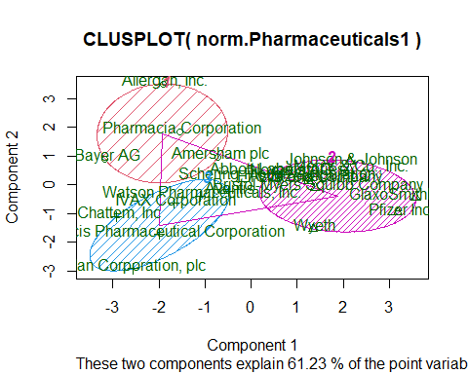

Based on the second graphic, firms in cluster 1 exhibit a low Net Profit Margin and a high Price/Earnings ratio, while those in cluster 2 demonstrate low Asset Turnover and Return on Asset (ROA), yet high Leverage and Estimated Revenue Growth. Cluster 3 did not exhibit any notable characteristics across the parameters we examined.

THIRD QUESTION

1. Is there a pattern in the clusters with respect to the numerical variables (10 to 12)? (those not used in forming the clusters)

* By examining the three final categorical variables, namely Median_Recommendation, Location, and Stock Exchange, I aim to identify any patterns in the dataset. I prefer to utilize bar charts to visually represent how firms are distributed across clusters.

###dataset is partitioned for last 3 variables.  
Pharmaceuticals3 <- Pharmaceuticals %>% select(c(11,12,13)) %>%  
 mutate(Cluster = Kmeans.Pharmaceuticals$cluster)

Median_Rec <- ggplot(Pharmaceuticals3, mapping = aes(factor(Cluster), fill=Median_Recommendation)) +  
geom_bar(position = 'dodge') +  
labs(x='Clusters', y='Frequency')  
Location <- ggplot(Pharmaceuticals3, mapping = aes(factor(Cluster), fill=Location)) +  
geom_bar(position = 'dodge') +  
labs(x='Clusters', y='Frequency')  
Exchange <- ggplot(Pharmaceuticals3, mapping = aes(factor(Cluster), fill=Exchange)) +  
geom_bar(position = 'dodge') +  
labs(x='Clusters', y='Frequency')  
plot_grid(Median_Rec,Location,Exchange)

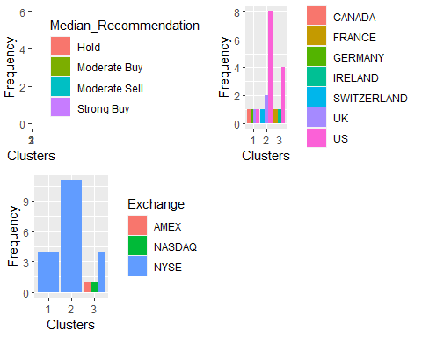

The graph clearly shows that most of the companies in cluster 3 are situated in the United States and all of them have a ‘hold’ recommendation for their shares. They are all listed on the New York Stock Exchange. In cluster 2, we opt for ‘Moderate Buy’ shares, which include only two companies with stocks listed on other exchanges or indexes (AMEX and NASDAQ). Cluster 1 reveals that the four firms are situated in four different countries, and their stocks are traded on the NYSE.

FOURTH QUESTION:

d.Provide an appropriate name for each cluster using any or all of the variables in the dataset.

Here, we can gather all the provided data from the dataset and identify the three distinct groups among the 21 pharmaceutical companies.

Cluster 1 is termed as ‘overvalued international firms’ due to the subsequent factors: international presence, trading on NYSE, low Net Profit Margin, and high Price/Earnings ratio. These companies operate across multiple continents while raising funds on the world’s largest stock exchange (NYSE). They possess high market valuations that surpass their current earnings levels. To prevent a potential collapse in their stock prices, they must invest and enhance their earnings to meet investor expectations.

Cluster 2 is classified as a ‘growing and leveraged firm’ because of the following attributes: ‘Moderate buy’ ratings, low asset turnover and ROA, high leverage, and anticipated revenue growth. Despite their current low profitability and significant debt, they seem to be highly valued by investors who are willing to await future growth.

Cluster 3 is labeled as a ‘mature US firm’ as it is based in the United States, listed on the NYSE, and holds ‘Hold’ ratings.