Assignment 1 FML

Nikhila Reddy

2024-02-02

#I have assigned variable “supermarket_sales” to the supermarket_sales dataset

supermarket_sales <- read.csv("C:\\Users\\Nikhi\\Downloads\\archive (2)\\supermarket_sales - Sheet1.csv")  
View(supermarket_sales)

mode(supermarket_sales$Quantity)

## [1] "numeric"

median(supermarket_sales$Unit.price)

## [1] 55.23

mean(supermarket_sales$Unit.price)

## [1] 55.67213

max(supermarket_sales$Unit.price)

## [1] 99.96

sd(supermarket_sales$Unit.price)

## [1] 26.49463

These values represent descriptive statistics for a selection of quantitave variables. The above mentioned values determines mode, median, standard deviation, maximum for the quatitative variables.

str(supermarket_sales$Payment)

## chr [1:1000] "Ewallet" "Cash" "Credit card" "Ewallet" "Ewallet" "Ewallet" ...

These values represent categorical descriptive analysis of variables.

I Summarized descriptive statistics for a selection of quantitative and categorical variables. / Whereas categorical is “Branch” And quantitative is “Unit.price”

summary(supermarket_sales$Branch)

## Length Class Mode   
## 1000 character character

summary(supermarket_sales$Unit.price)

## Min. 1st Qu. Median Mean 3rd Qu. Max.   
## 10.08 32.88 55.23 55.67 77.94 99.96

I have transformed the Unit.price to a new amount by raising it.

increased_Unit.price <- sqrt(supermarket_sales$Unit.price)  
new_price <- (supermarket_sales$Unit.price - increased_Unit.price)

I generated a scatter plot correlating “Rating” with “Unit.price”

x <-supermarket_sales$Rating  
y <-supermarket_sales$Unit.price  
plot(x,y, main="scatterplot", xlab = "Rating" , ylab = "Unit.price")

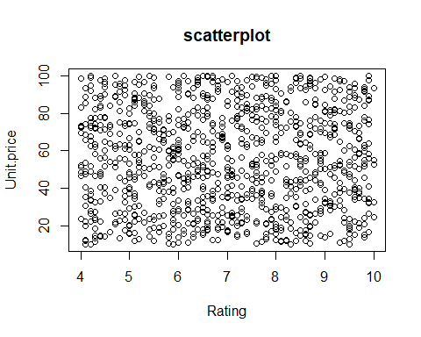

The below graphical representation is a histogram.

hist(supermarket_sales$Unit.price)

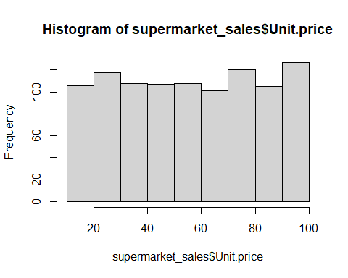

The above graphical representation is a histogram

This dataset is imported from : https://www.kaggle.com/datasets/aungpyaeap/supermarket-sales