**17.VEHICLE REGISTRATION SYSTEM**

USECASE DIAGRAM

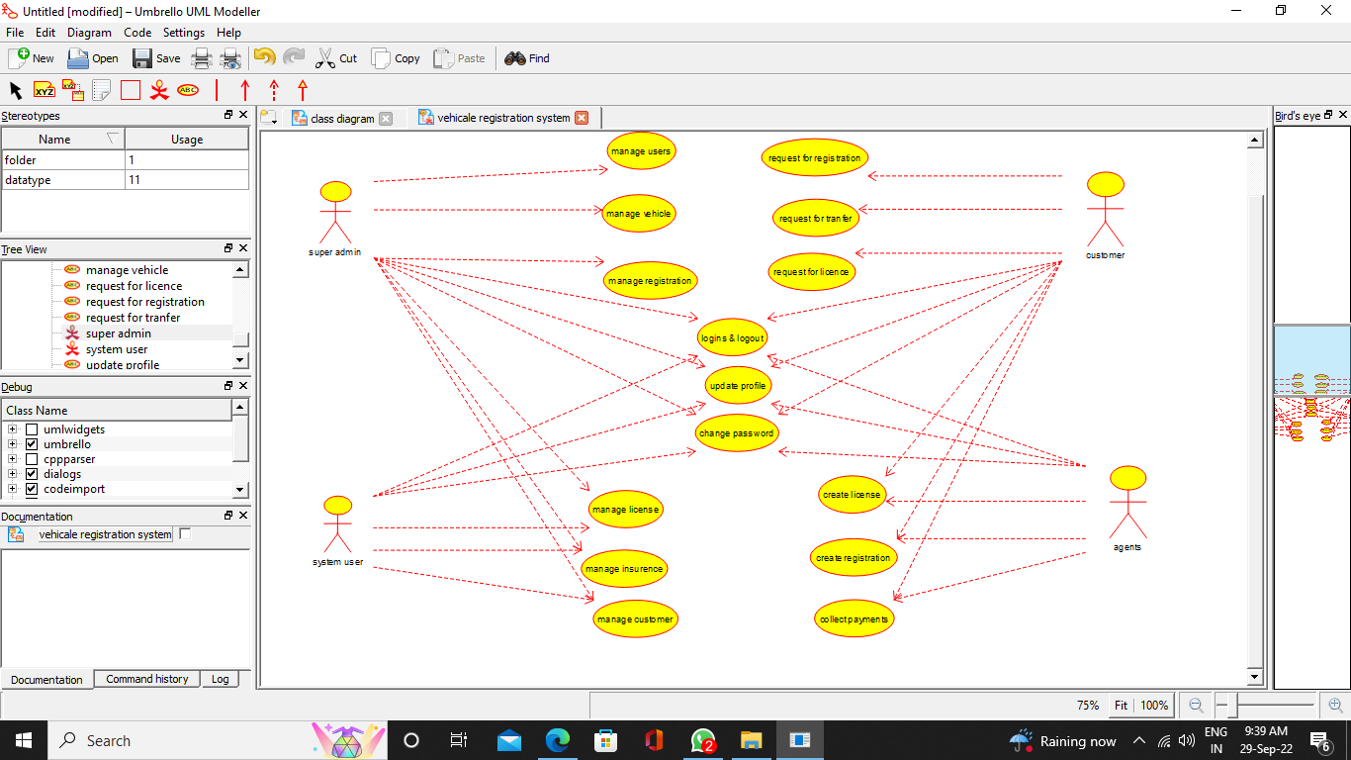

CLASS DIAGRAM

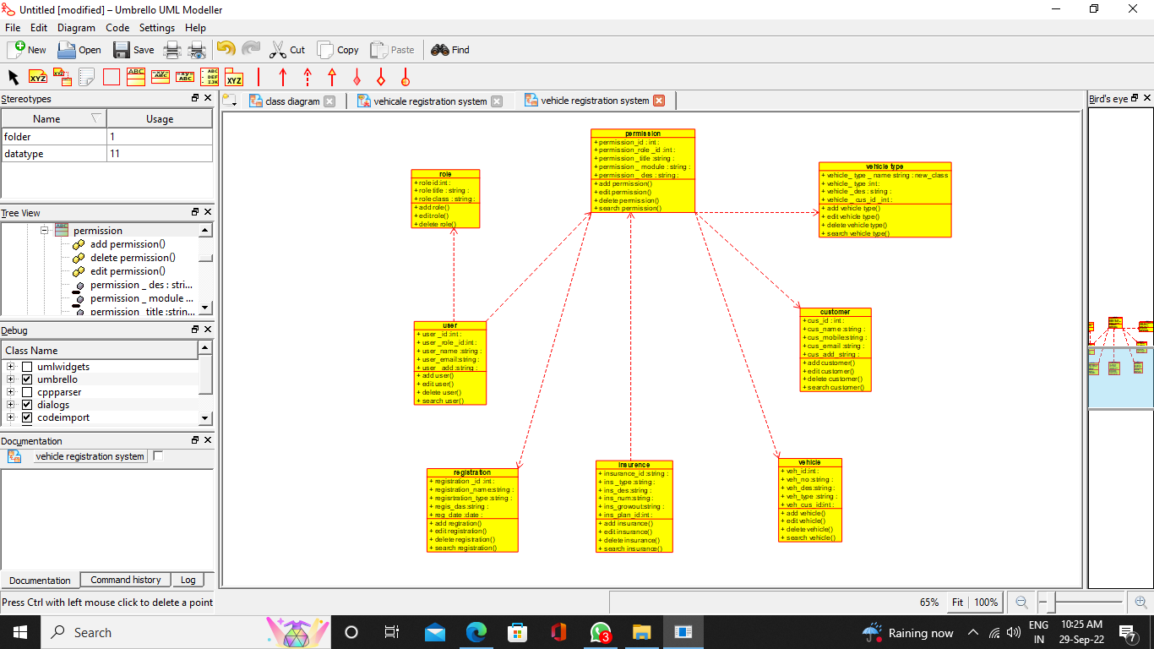

ACTIVITY DIAGRAM

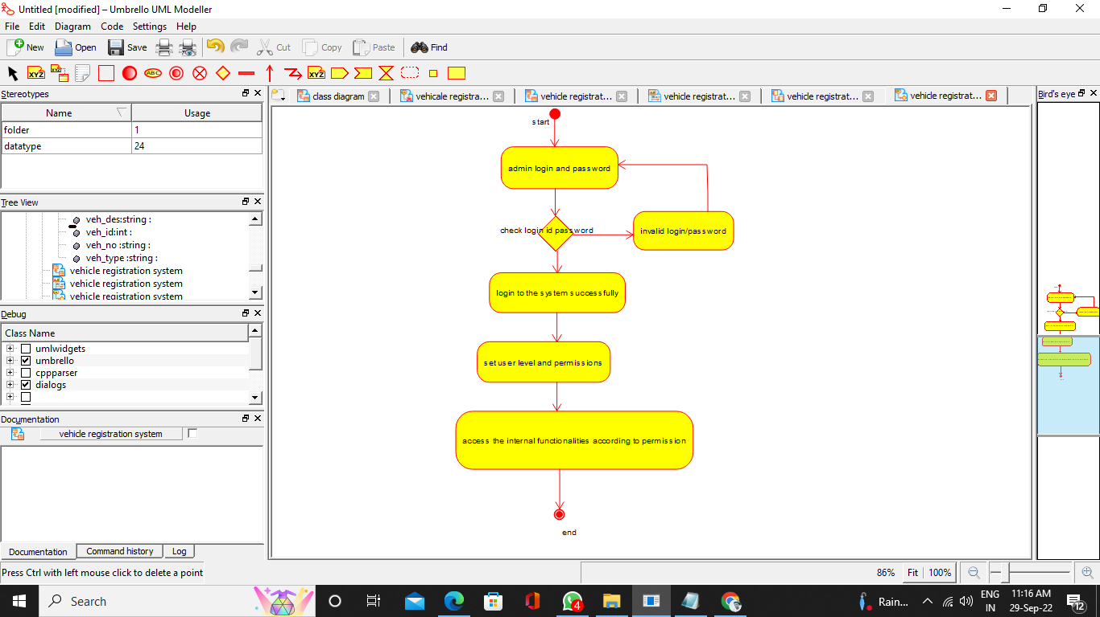

SEQUENCE DIAGRAM

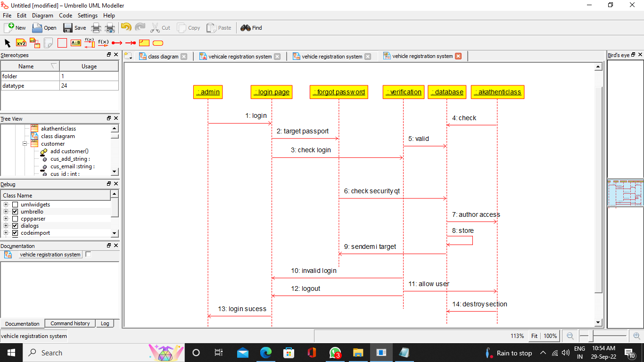

COLLABORATION DIAGRAM

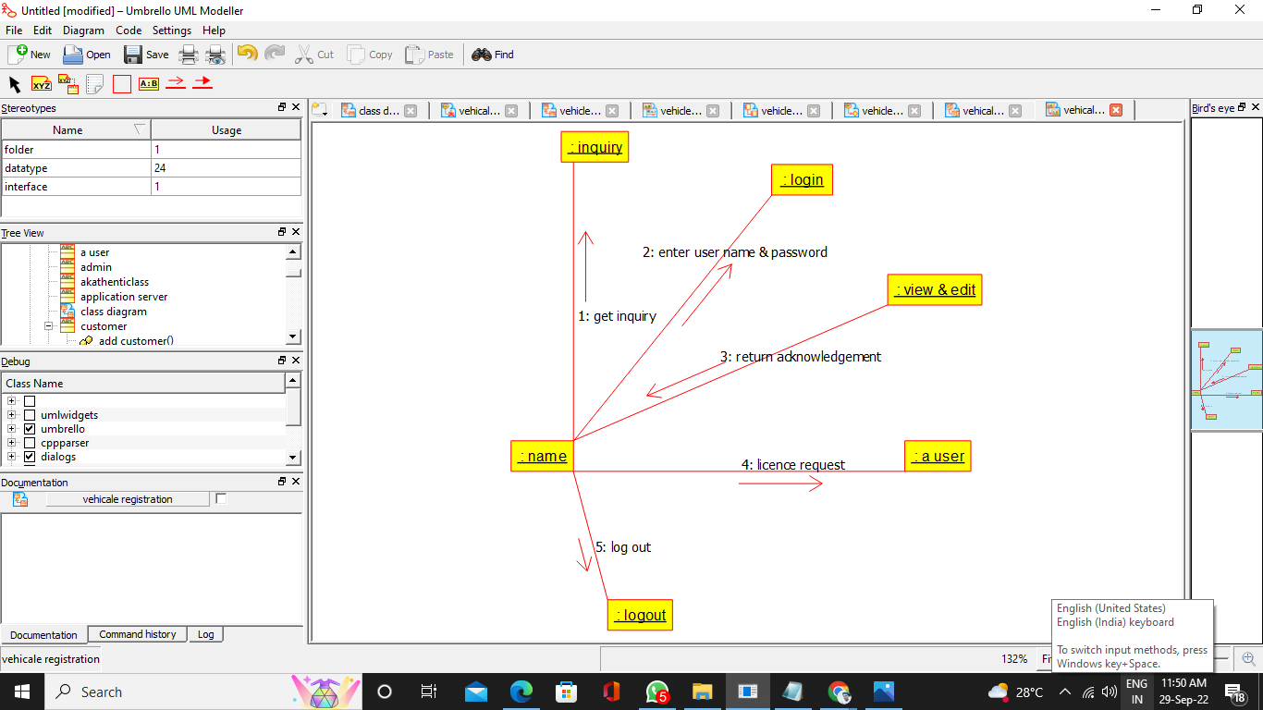

COMPONENT DIAGRAM

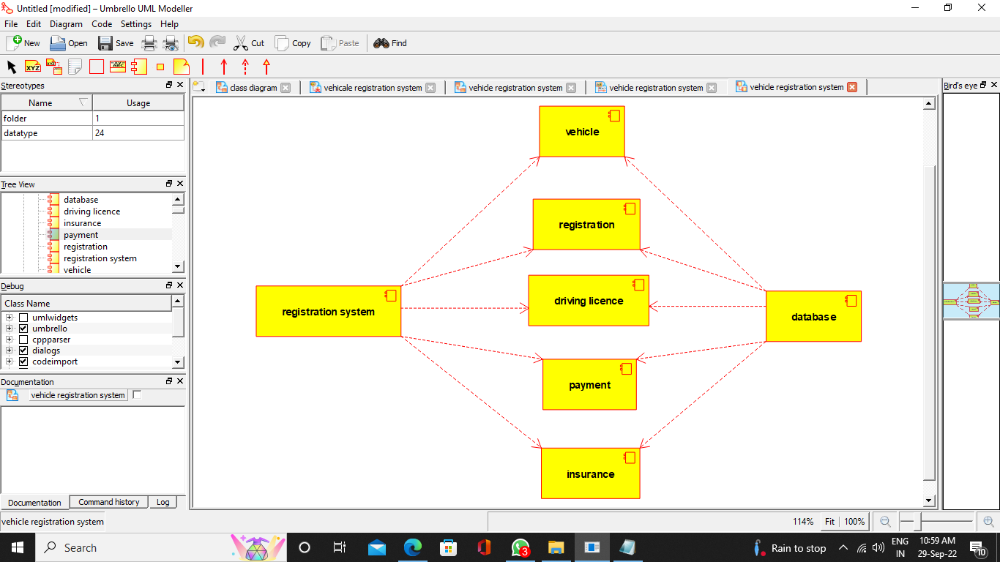

DEPLOYMENT DIAGRAM

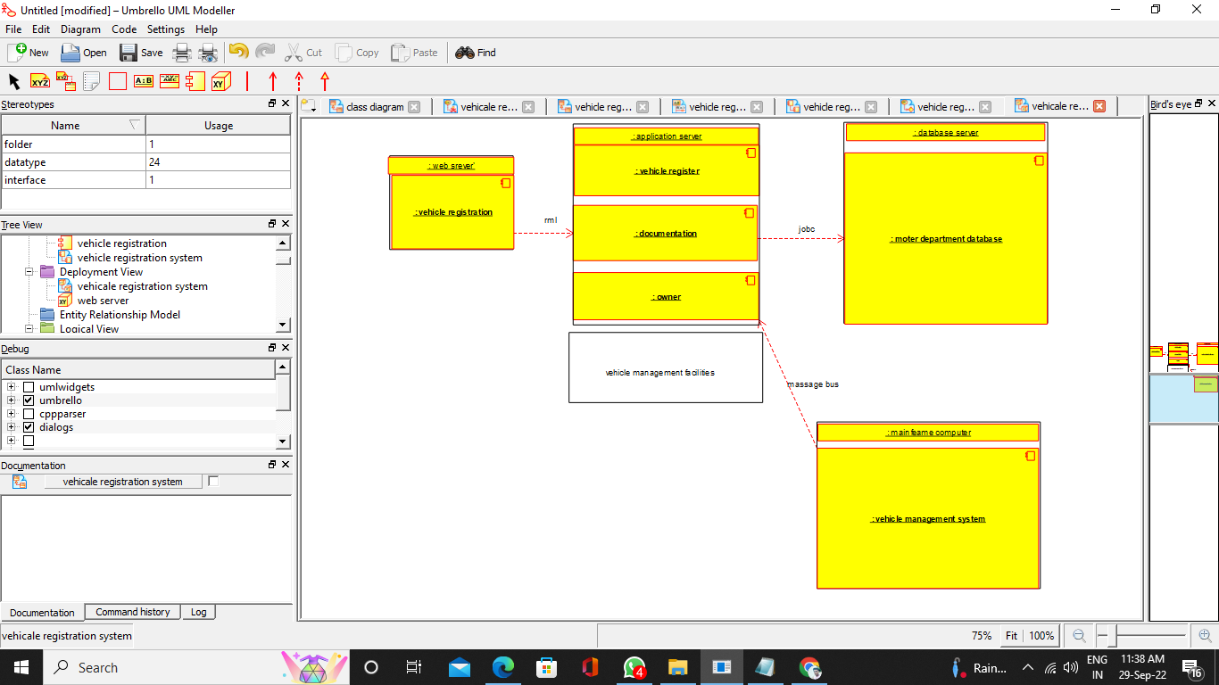

PROGRAM CODE

/**

* Class customer

*/

public class customer {

//

// Fields

//

public void cus_id_int;

public void cus_name_string;

public void cus_mobile_string;

public void cus_email_string;

public void cus_add_string;

//

// Constructors

//

public customer () { };

//

// Methods

//

//

// Accessor methods

//

/**

* Set the value of cus_id_int

* @param newVar the new value of cus_id_int

*/

public void setCus_id_int (void newVar) {

cus_id_int = newVar;

}

/**

* Get the value of cus_id_int

* @return the value of cus_id_int

*/

public void getCus_id_int () {

return cus_id_int;

}

/**

* Set the value of cus_name_string

* @param newVar the new value of cus_name_string

*/

public void setCus_name_string (void newVar) {

cus_name_string = newVar;

}

/**

* Get the value of cus_name_string

* @return the value of cus_name_string

*/

public void getCus_name_string () {

return cus_name_string;

}

/**

* Set the value of cus_mobile_string

* @param newVar the new value of cus_mobile_string

*/

public void setCus_mobile_string (void newVar) {

cus_mobile_string = newVar;

}

/**

* Get the value of cus_mobile_string

* @return the value of cus_mobile_string

*/

public void getCus_mobile_string () {

return cus_mobile_string;

}

/**

* Set the value of cus_email_string

* @param newVar the new value of cus_email_string

*/

public void setCus_email_string (void newVar) {

cus_email_string = newVar;

}

/**

* Get the value of cus_email_string

* @return the value of cus_email_string

*/

public void getCus_email_string () {

return cus_email_string;

}

/**

* Set the value of cus_add_string

* @param newVar the new value of cus_add_string

*/

public void setCus_add_string (void newVar) {

cus_add_string = newVar;

}

/**

* Get the value of cus_add_string

* @return the value of cus_add_string

*/

public void getCus_add_string () {

return cus_add_string;

}

//

// Other methods

//

/**

*/

public void add_customer()

{

}

/**

*/

public void edit_customer()

{

}

/**

*/

public void delete_customer()

{

}

/**

*/

public void search_customer()

{

}

}

/**

* Class insurence

*/

public class insurence {

//

// Fields

//

public void insurance_id_string;

public void ins__type_string;

public void ins_des_string;

public void ins_num_string;

public void ins_growout_string;

public void ins_plan_id_int;

//

// Constructors

//

public insurence () { };

//

// Methods

//

//

// Accessor methods

//

/**

* Set the value of insurance_id_string

* @param newVar the new value of insurance_id_string

*/

public void setInsurance_id_string (void newVar) {

insurance_id_string = newVar;

}

/**

* Get the value of insurance_id_string

* @return the value of insurance_id_string

*/

public void getInsurance_id_string () {

return insurance_id_string;

}

/**

* Set the value of ins__type_string

* @param newVar the new value of ins__type_string

*/

public void setIns__type_string (void newVar) {

ins__type_string = newVar;

}

/**

* Get the value of ins__type_string

* @return the value of ins__type_string

*/

public void getIns__type_string () {

return ins__type_string;

}

/**

* Set the value of ins_des_string

* @param newVar the new value of ins_des_string

*/

public void setIns_des_string (void newVar) {

ins_des_string = newVar;

}

/**

* Get the value of ins_des_string

* @return the value of ins_des_string

*/

public void getIns_des_string () {

return ins_des_string;

}

/**

* Set the value of ins_num_string

* @param newVar the new value of ins_num_string

*/

public void setIns_num_string (void newVar) {

ins_num_string = newVar;

}

/**

* Get the value of ins_num_string

* @return the value of ins_num_string

*/

public void getIns_num_string () {

return ins_num_string;

}

/**

* Set the value of ins_growout_string

* @param newVar the new value of ins_growout_string

*/

public void setIns_growout_string (void newVar) {

ins_growout_string = newVar;

}

/**

* Get the value of ins_growout_string

* @return the value of ins_growout_string

*/

public void getIns_growout_string () {

return ins_growout_string;

}

/**

* Set the value of ins_plan_id_int

* @param newVar the new value of ins_plan_id_int

*/

public void setIns_plan_id_int (void newVar) {

ins_plan_id_int = newVar;

}

/**

* Get the value of ins_plan_id_int

* @return the value of ins_plan_id_int

*/

public void getIns_plan_id_int () {

return ins_plan_id_int;

}

//

// Other methods

//

/**

*/

public void add_insurance()

{

}

/**

*/

public void edit_insurance()

{

}

/**

*/

public void delete_insurance()

{

}

/**

*/

public void search_insurance()

{

}

}

/**

* Class permission

*/

public class permission {

//

// Fields

//

public void permission_id_int;

public void permission_role__id_int;

public void permission__title_string;

public void permission___module_string;

public void permission___des_string;

//

// Constructors

//

public permission () { };

//

// Methods

//

//

// Accessor methods

//

/**

* Set the value of permission_id_int

* @param newVar the new value of permission_id_int

*/

public void setPermission_id_int (void newVar) {

permission_id_int = newVar;

}

/**

* Get the value of permission_id_int

* @return the value of permission_id_int

*/

public void getPermission_id_int () {

return permission_id_int;

}

/**

* Set the value of permission_role__id_int

* @param newVar the new value of permission_role__id_int

*/

public void setPermission_role__id_int (void newVar) {

permission_role__id_int = newVar;

}

/**

* Get the value of permission_role__id_int

* @return the value of permission_role__id_int

*/

public void getPermission_role__id_int () {

return permission_role__id_int;

}

/**

* Set the value of permission__title_string

* @param newVar the new value of permission__title_string

*/

public void setPermission__title_string (void newVar) {

permission__title_string = newVar;

}

/**

* Get the value of permission__title_string

* @return the value of permission__title_string

*/

public void getPermission__title_string () {

return permission__title_string;

}

/**

* Set the value of permission___module_string

* @param newVar the new value of permission___module_string

*/

public void setPermission___module_string (void newVar) {

permission___module_string = newVar;

}

/**

* Get the value of permission___module_string

* @return the value of permission___module_string

*/

public void getPermission___module_string () {

return permission___module_string;

}

/**

* Set the value of permission___des_string

* @param newVar the new value of permission___des_string

*/

public void setPermission___des_string (void newVar) {

permission___des_string = newVar;

}

/**

* Get the value of permission___des_string

* @return the value of permission___des_string

*/

public void getPermission___des_string () {

return permission___des_string;

}

//

// Other methods

//

/**

*/

public void add_permission()

{

}

/**

*/

public void edit_permission()

{

}

/**

*/

public void delete_permission()

{

}

/**

*/

public void search_permission()

{

}

}

/**

* Class registration

*/

public class registration {

//

// Fields

//

public void registration__id_int;

public void registration_name_string;

public void regisrtration_type_string;

public void regis_das_string;

public void reg_date_date;

//

// Constructors

//

public registration () { };

//

// Methods

//

//

// Accessor methods

//

/**

* Set the value of registration__id_int

* @param newVar the new value of registration__id_int

*/

public void setRegistration__id_int (void newVar) {

registration__id_int = newVar;

}

/**

* Get the value of registration__id_int

* @return the value of registration__id_int

*/

public void getRegistration__id_int () {

return registration__id_int;

}

/**

* Set the value of registration_name_string

* @param newVar the new value of registration_name_string

*/

public void setRegistration_name_string (void newVar) {

registration_name_string = newVar;

}

/**

* Get the value of registration_name_string

* @return the value of registration_name_string

*/

public void getRegistration_name_string () {

return registration_name_string;

}

/**

* Set the value of regisrtration_type_string

* @param newVar the new value of regisrtration_type_string

*/

public void setRegisrtration_type_string (void newVar) {

regisrtration_type_string = newVar;

}

/**

* Get the value of regisrtration_type_string

* @return the value of regisrtration_type_string

*/

public void getRegisrtration_type_string () {

return regisrtration_type_string;

}

/**

* Set the value of regis_das_string

* @param newVar the new value of regis_das_string

*/

public void setRegis_das_string (void newVar) {

regis_das_string = newVar;

}

/**

* Get the value of regis_das_string

* @return the value of regis_das_string

*/

public void getRegis_das_string () {

return regis_das_string;

}

/**

* Set the value of reg_date_date

* @param newVar the new value of reg_date_date

*/

public void setReg_date_date (void newVar) {

reg_date_date = newVar;

}

/**

* Get the value of reg_date_date

* @return the value of reg_date_date

*/

public void getReg_date_date () {

return reg_date_date;

}

//

// Other methods

//

/**

*/

public void add_regtration()

{

}

/**

*/

public void edit_registration()

{

}

/**

*/

public void delete_registration()

{

}

/**

*/

public void search_registration()

{

}

}

/**

* Class role

*/

public class role {

//

// Fields

//

public void role_id_int;

public void role_title_string;

public void role_class_string;

//

// Constructors

//

public role () { };

//

// Methods

//

//

// Accessor methods

//

/**

* Set the value of role_id_int

* @param newVar the new value of role_id_int

*/

public void setRole_id_int (void newVar) {

role_id_int = newVar;

}

/**

* Get the value of role_id_int

* @return the value of role_id_int

*/

public void getRole_id_int () {

return role_id_int;

}

/**

* Set the value of role_title_string

* @param newVar the new value of role_title_string

*/

public void setRole_title_string (void newVar) {

role_title_string = newVar;

}

/**

* Get the value of role_title_string

* @return the value of role_title_string

*/

public void getRole_title_string () {

return role_title_string;

}

/**

* Set the value of role_class_string

* @param newVar the new value of role_class_string

*/

public void setRole_class_string (void newVar) {

role_class_string = newVar;

}

/**

* Get the value of role_class_string

* @return the value of role_class_string

*/

public void getRole_class_string () {

return role_class_string;

}

//

// Other methods

//

/**

*/

public void add_role()

{

}

/**

*/

public void edit_role()

{

}

/**

*/

public void delete_role()

{

}

}

/**

* Class user

*/

public class user {

//

// Fields

//

public void user__id_int;

public void user__role__id_int;

public void user_name_string;

public void user_email_string;

public void user__add_string;

//

// Constructors

//

public user () { };

//

// Methods

//

//

// Accessor methods

//

/**

* Set the value of user__id_int

* @param newVar the new value of user__id_int

*/

public void setUser__id_int (void newVar) {

user__id_int = newVar;

}

/**

* Get the value of user__id_int

* @return the value of user__id_int

*/

public void getUser__id_int () {

return user__id_int;

}

/**

* Set the value of user__role__id_int

* @param newVar the new value of user__role__id_int

*/

public void setUser__role__id_int (void newVar) {

user__role__id_int = newVar;

}

/**

* Get the value of user__role__id_int

* @return the value of user__role__id_int

*/

public void getUser__role__id_int () {

return user__role__id_int;

}

/**

* Set the value of user_name_string

* @param newVar the new value of user_name_string

*/

public void setUser_name_string (void newVar) {

user_name_string = newVar;

}

/**

* Get the value of user_name_string

* @return the value of user_name_string

*/

public void getUser_name_string () {

return user_name_string;

}

/**

* Set the value of user_email_string

* @param newVar the new value of user_email_string

*/

public void setUser_email_string (void newVar) {

user_email_string = newVar;

}

/**

* Get the value of user_email_string

* @return the value of user_email_string

*/

public void getUser_email_string () {

return user_email_string;

}

/**

* Set the value of user__add_string

* @param newVar the new value of user__add_string

*/

public void setUser__add_string (void newVar) {

user__add_string = newVar;

}

/**

* Get the value of user__add_string

* @return the value of user__add_string

*/

public void getUser__add_string () {

return user__add_string;

}

//

// Other methods

//

/**

*/

public void add_user()

{

}

/**

*/

public void edit_user()

{

}

/**

*/

public void delete_user()

{

}

/**

*/

public void search_user()

{

}

}

/**

* Class vehicle_type

*/

public class vehicle_type {

//

// Fields

//

public new_class vehicle__type___name_string;

public void vehicle__type_int;

public void vehicle__des_string;

public void vehicle___cus_id__int;

//

// Constructors

//

public vehicle_type () { };

//

// Methods

//

//

// Accessor methods

//

/**

* Set the value of vehicle__type___name_string

* @param newVar the new value of vehicle__type___name_string

*/

public void setVehicle__type___name_string (new_class newVar) {

vehicle__type___name_string = newVar;

}

/**

* Get the value of vehicle__type___name_string

* @return the value of vehicle__type___name_string

*/

public new_class getVehicle__type___name_string () {

return vehicle__type___name_string;

}

/**

* Set the value of vehicle__type_int

* @param newVar the new value of vehicle__type_int

*/

public void setVehicle__type_int (void newVar) {

vehicle__type_int = newVar;

}

/**

* Get the value of vehicle__type_int

* @return the value of vehicle__type_int

*/

public void getVehicle__type_int () {

return vehicle__type_int;

}

/**

* Set the value of vehicle__des_string

* @param newVar the new value of vehicle__des_string

*/

public void setVehicle__des_string (void newVar) {

vehicle__des_string = newVar;

}

/**

* Get the value of vehicle__des_string

* @return the value of vehicle__des_string

*/

public void getVehicle__des_string () {

return vehicle__des_string;

}

/**

* Set the value of vehicle___cus_id__int

* @param newVar the new value of vehicle___cus_id__int

*/

public void setVehicle___cus_id__int (void newVar) {

vehicle___cus_id__int = newVar;

}

/**

* Get the value of vehicle___cus_id__int

* @return the value of vehicle___cus_id__int

*/

public void getVehicle___cus_id__int () {

return vehicle___cus_id__int;

}

//

// Other methods

//

/**

*/

public void add_vehicle_type()

{

}

/**

*/

public void edit_vehicle_type()

{

}

/**

*/

public void delete_vehicle_type()

{

}

/**

*/

public void search_vehicle_type()

{

}

}