**6.E-TICKETING**

Usecase diagram

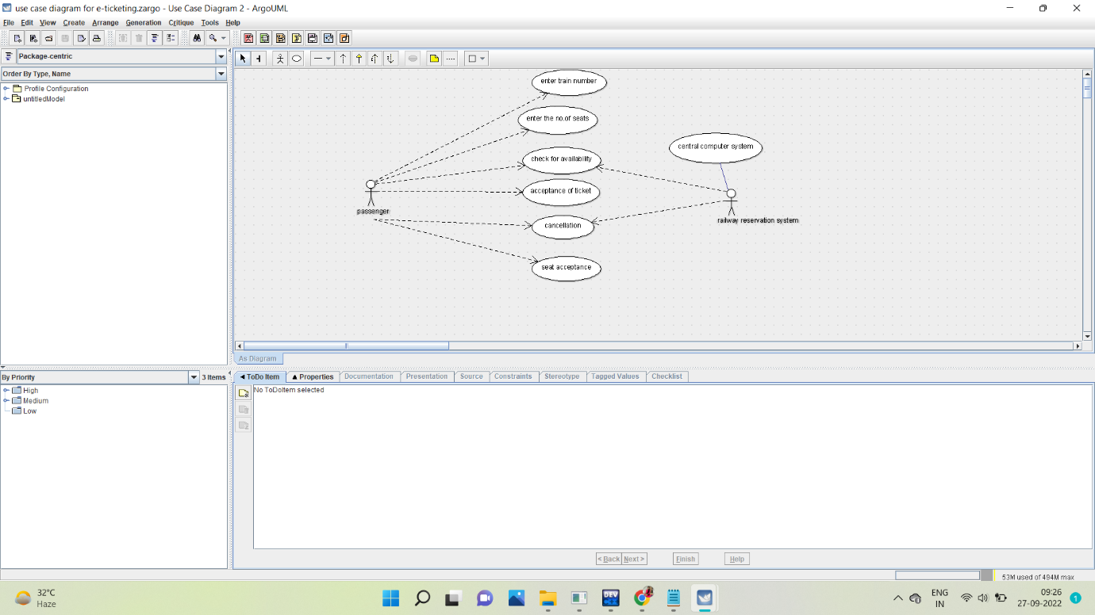

Class diagram

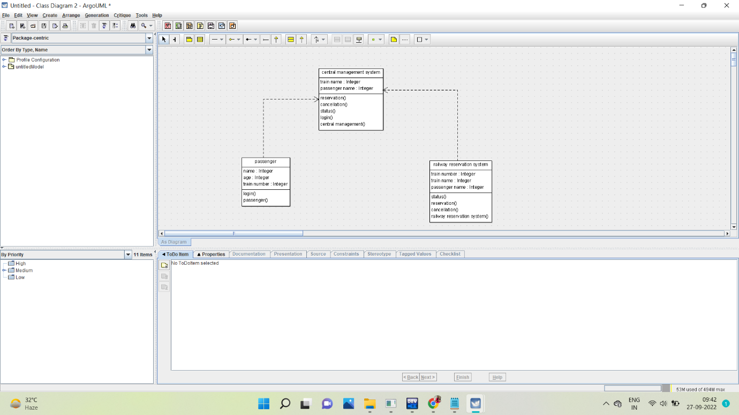

Activity diagram

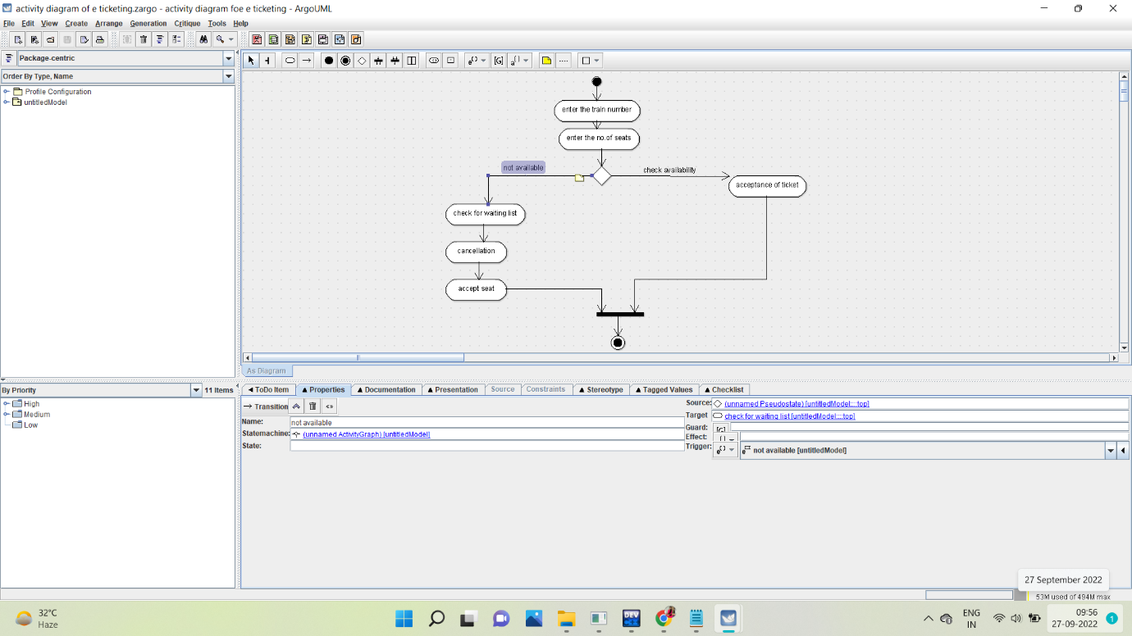

Sequence diagram

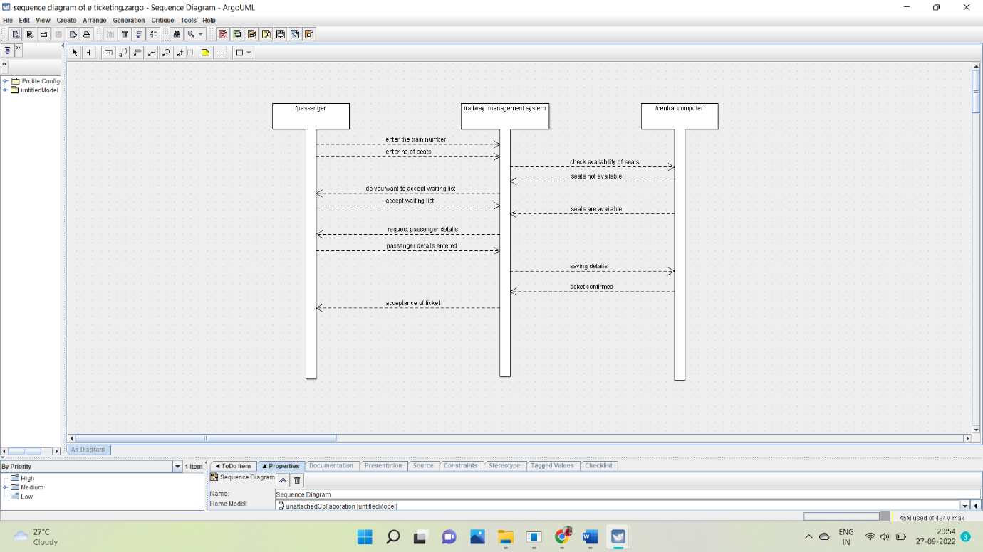

Collaboration diagram

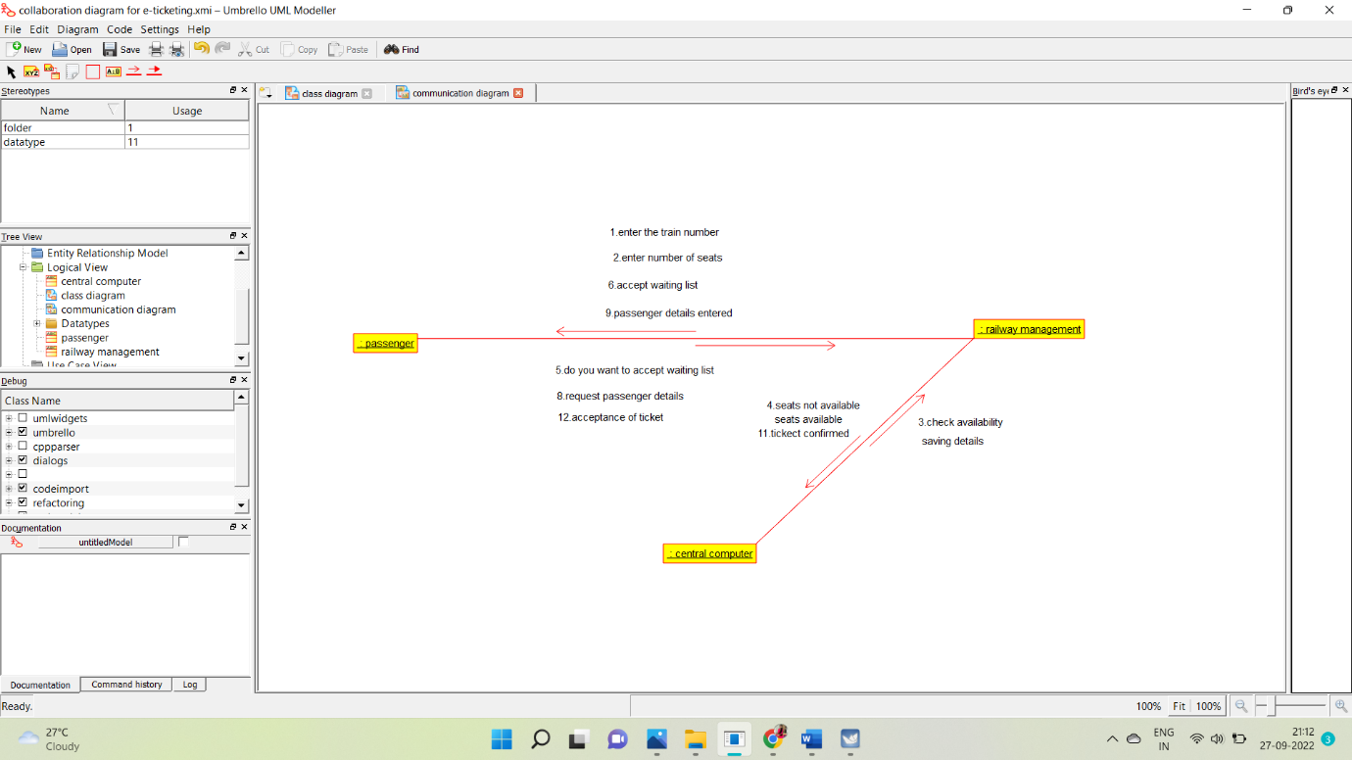

Statechart diagram

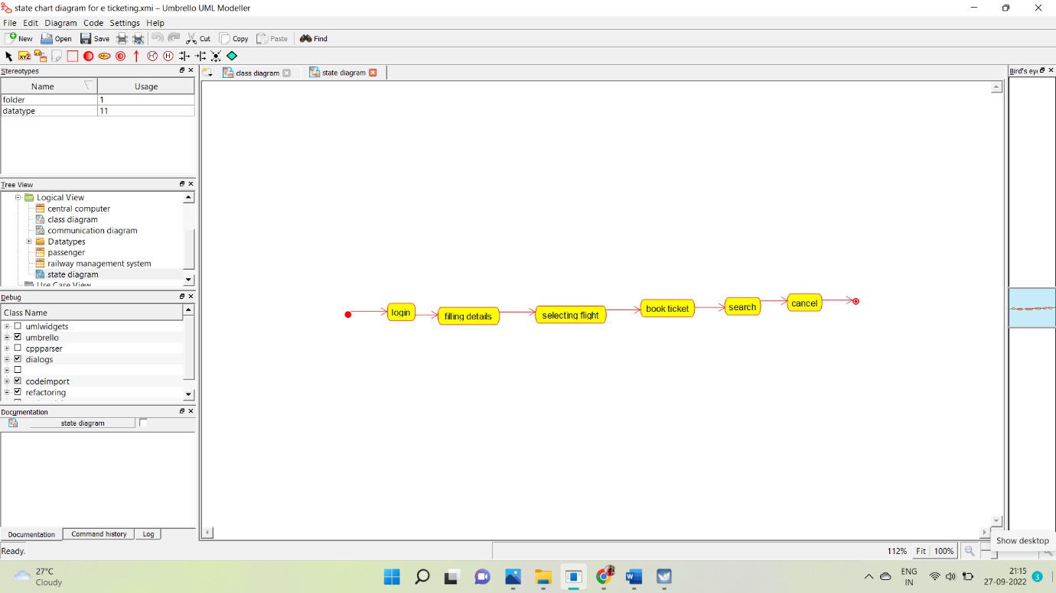

Component diagram

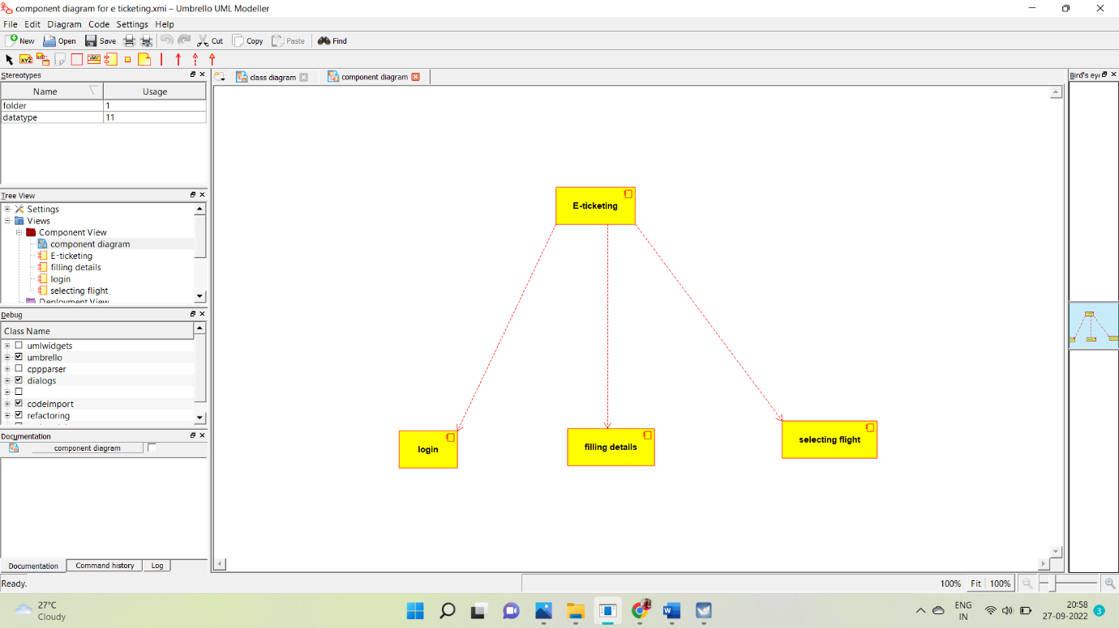

Deployment diagram

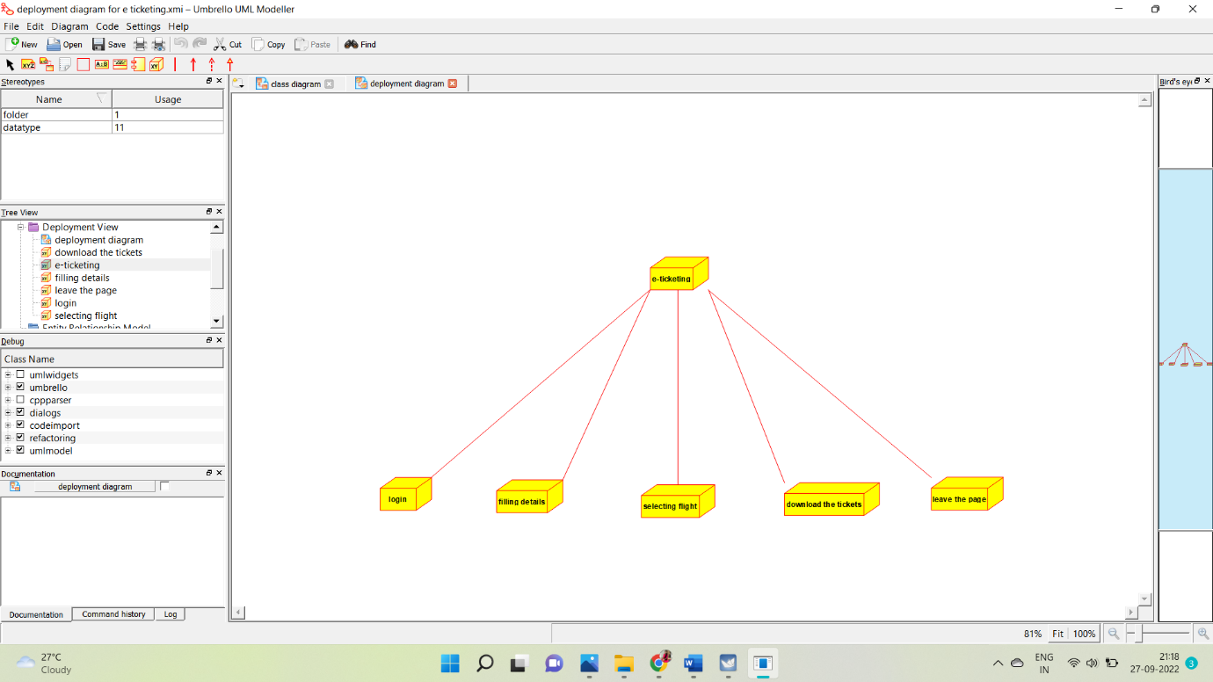

**PROGRAM:**

**PASSENGER:**

Public class passenger

{

Public integer passenger passenger name;

Public integer passenger passenger age;

Public integer train no;

Public void passenger()

{

}

Public void new operation()

{

}

}

**CENTRAL MANAGEMENT SYSTEM:**

Public class central management

{

Public integer train name;

Public integer passenger name;

Public void reservation()

{

}

Public void cancellation()

{

}

Public void status()

{

}

Public void login()

{

}

Private void management()

{

}

}

**RAILWAY RESERVATION SYSTEM:**

Public class railway reservation system

{

Public integer trainno;

Public integer train name;

Public integer passenger name;

Public void status()

{

}

Public void reservation()

{

}

Public void cancellation()

{

}

Public void railway reservation system()

{

}

}