**8.SOFTWARE PERSONNEL MANAGEMENT SYSTEM**

**USECASE DIAGRAM**

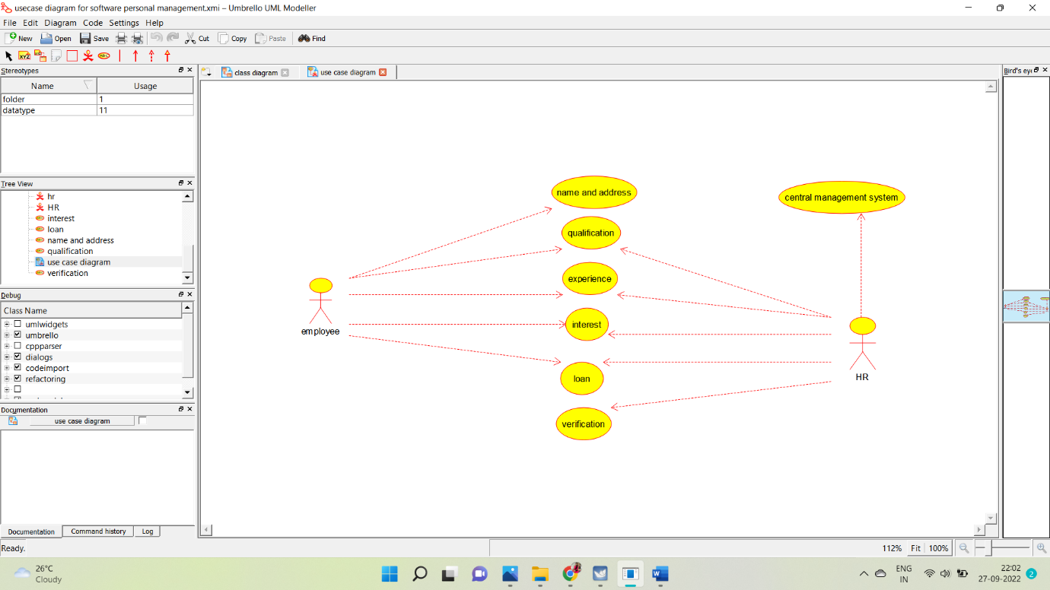

**CLASS DIAGRAM:**

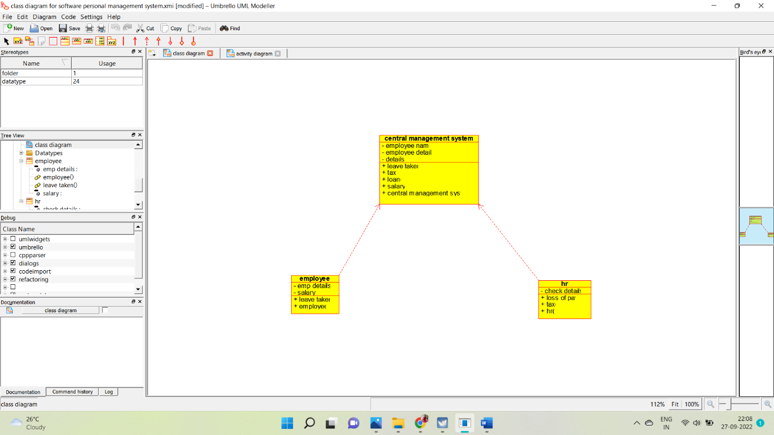

**ACTIVITY DIAGRAM:**

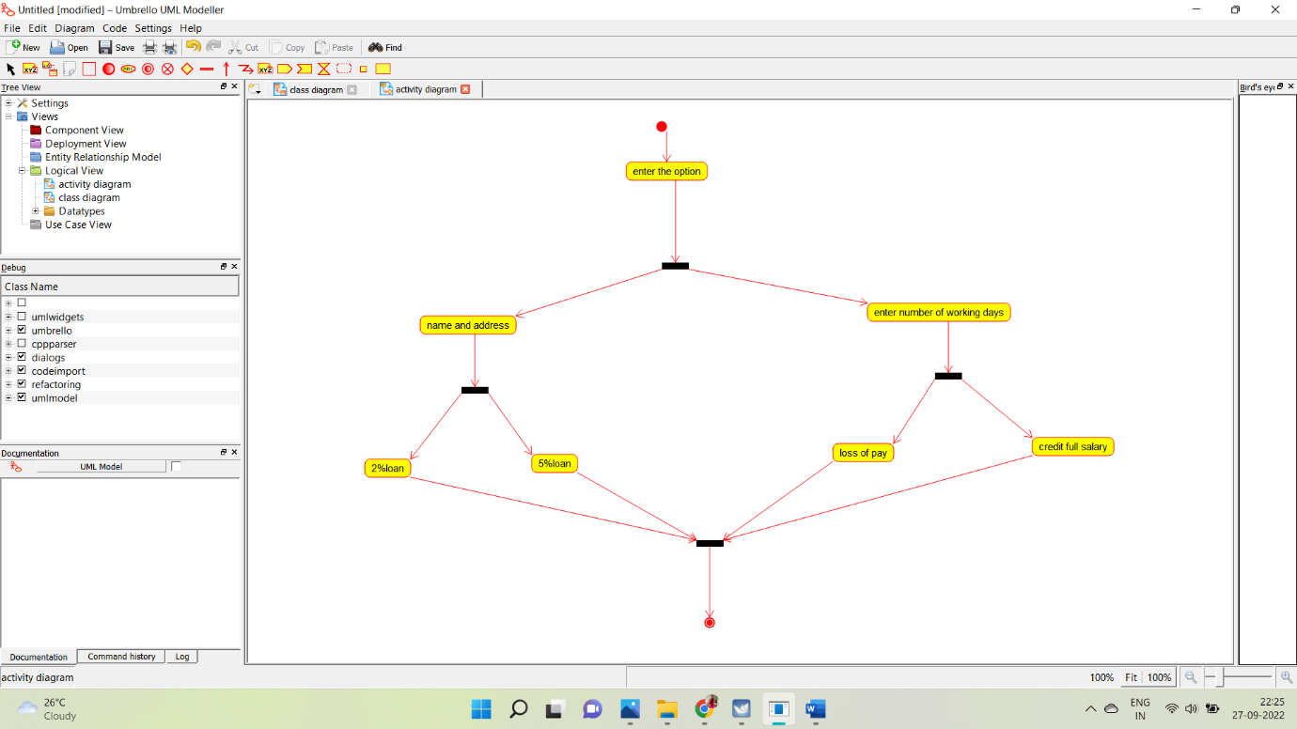

**SEQUENCE DIAGRAM:**

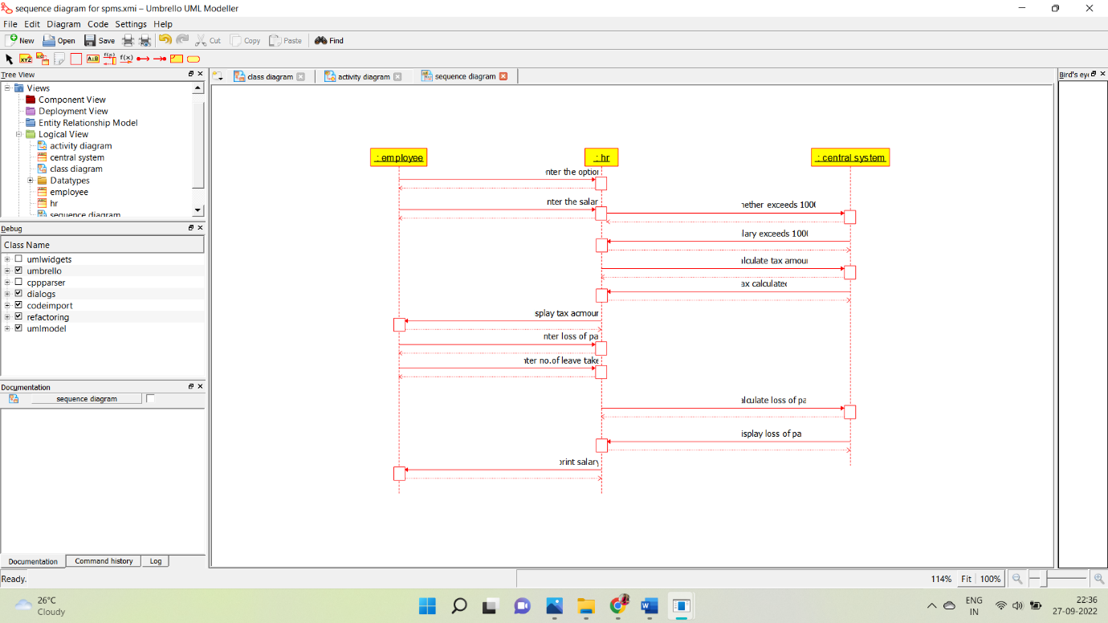

**COLLABORATION DIAGRAM:**

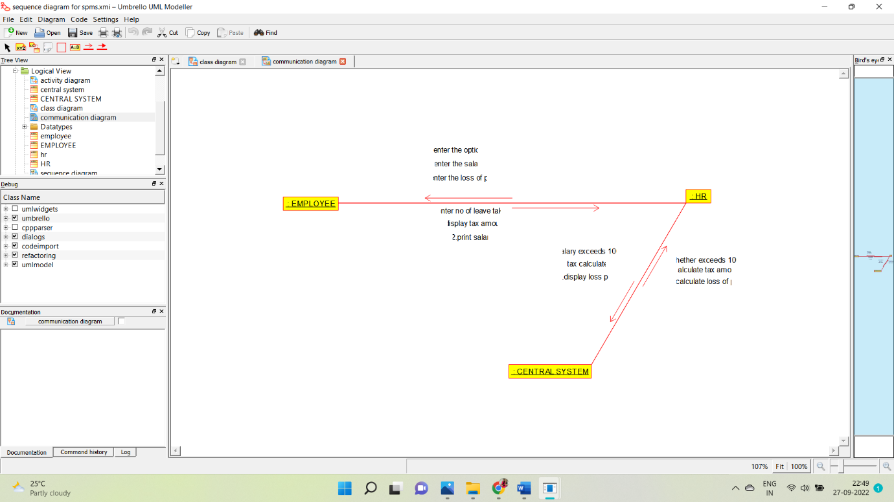

**STATE CHART DIAGRAM:**

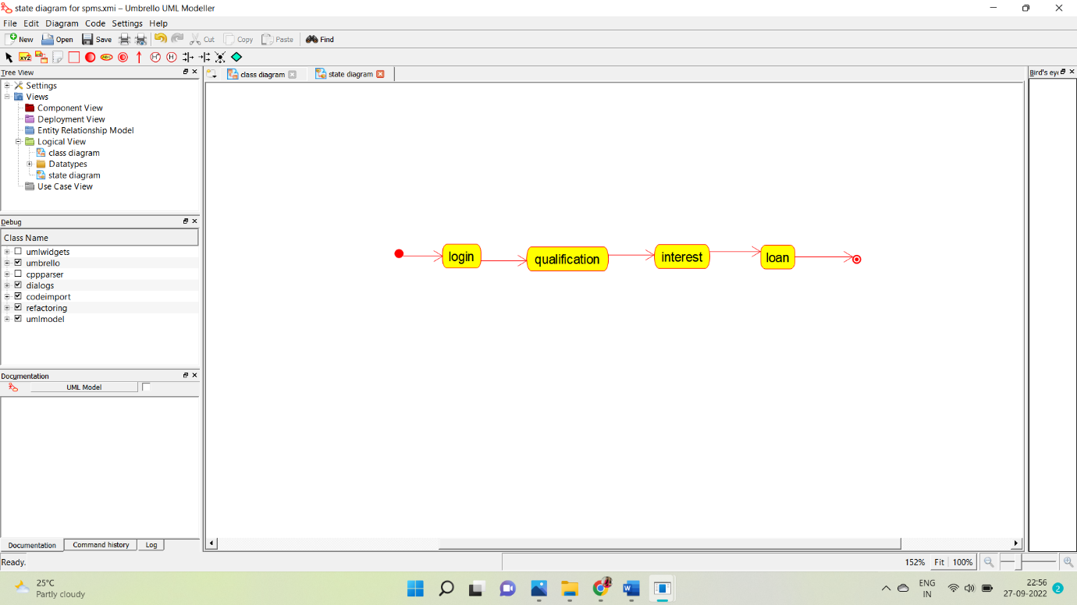

**COMPONENT DIAGRAM:**

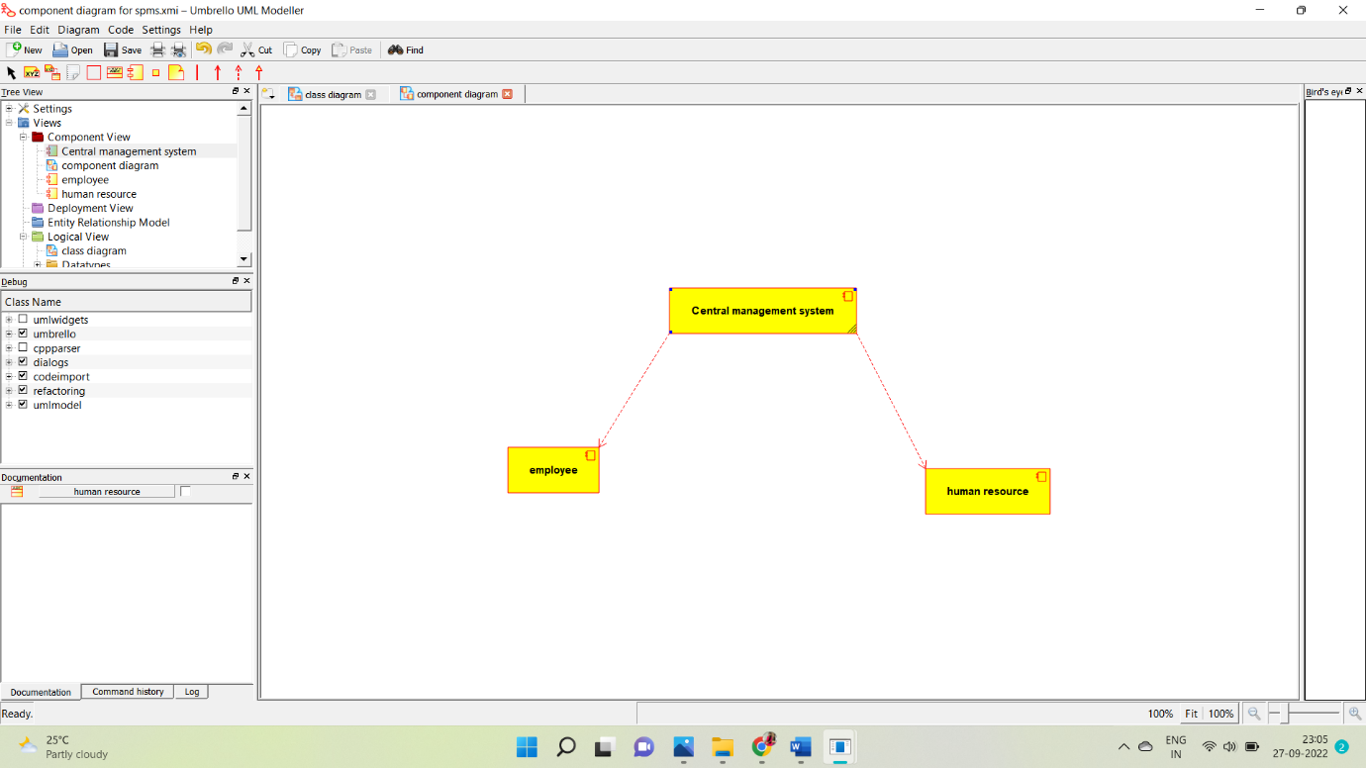

**DEPLOYMENT:**

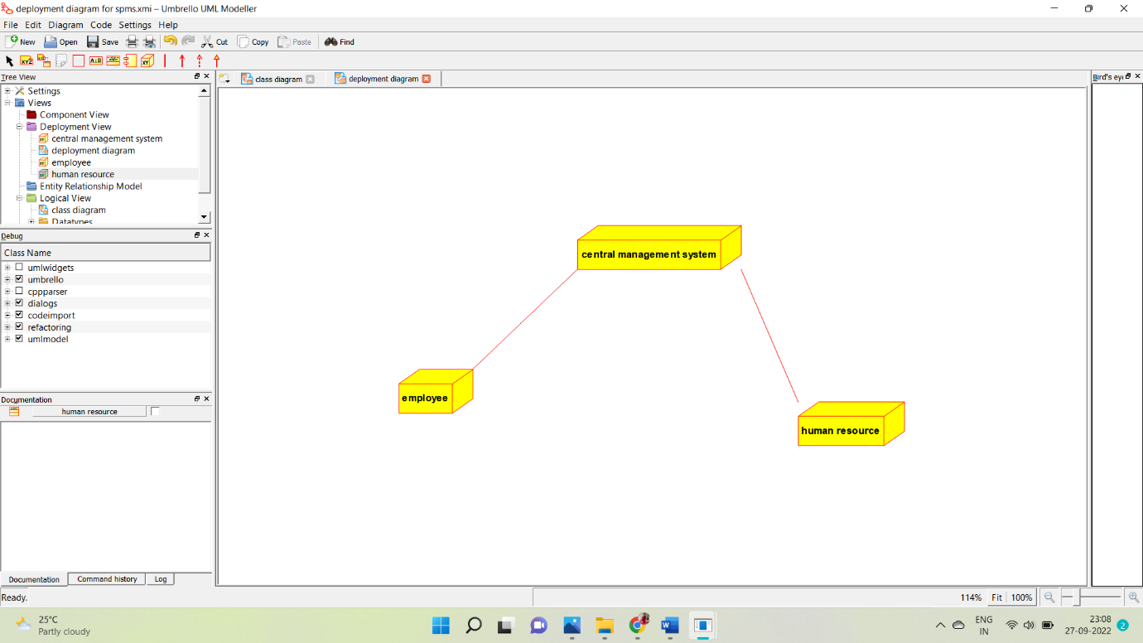

**PROGRAM CODING:**

**EMPLOYEE:**

Public class employee

{

Public integer employee details;

Public integer salary;

Public void leave taken()

{

}

Public void employee()

{

}

}

**HUMAN RESOURCES:**

Public class HR

{

Public integer check details;

Public void loss of pay()

{

}

Public void tax()

{

}

Public void HR()

{

}

}

**CENTRAL MANAGEMENT SYSTEM:**

Public class central management system

{

Public integer employee name;

Public integer employee no;

Public integer details;

Public void leave taken()

{

}

Public void tax()

{

}

Public void loan()

{

}

Public void salary()

{

}

}