**9.E-BOOK MANAGEMENT SYSTEM**

USECASE DIAGRAM

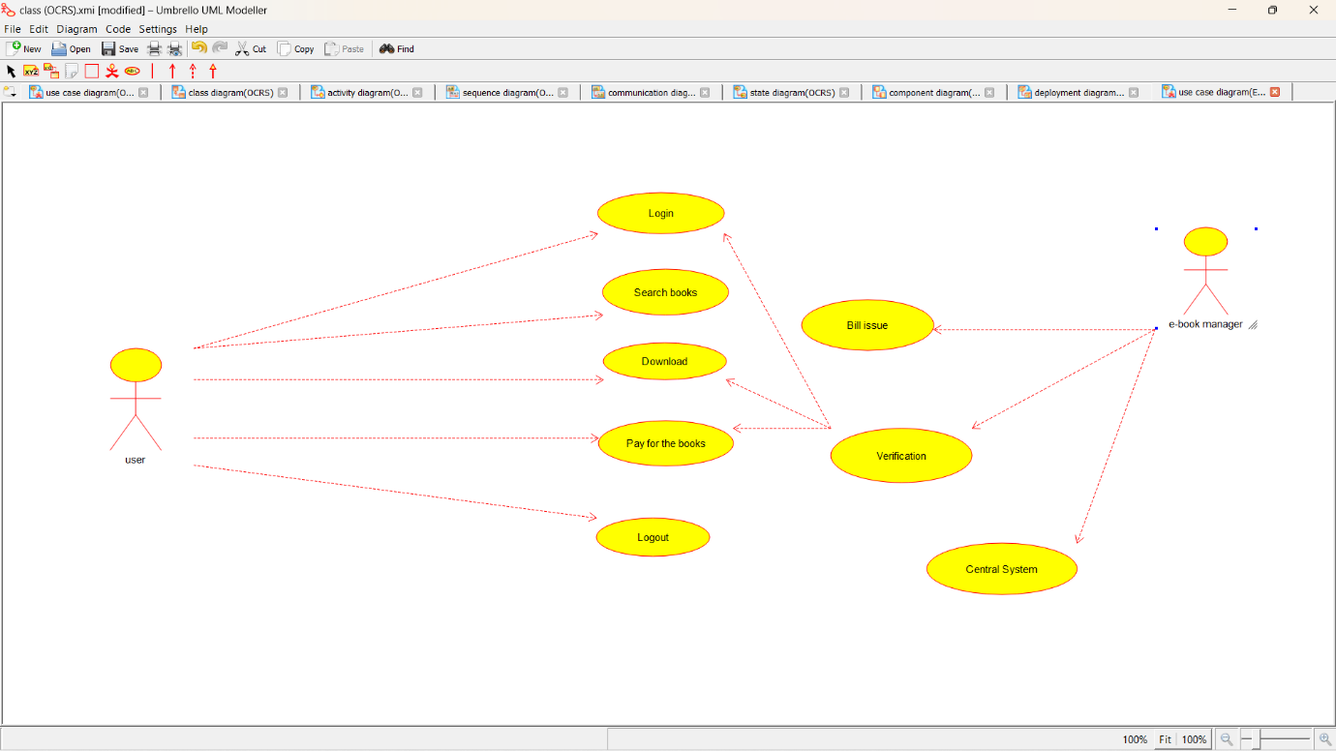

CLASS DIAGRAM

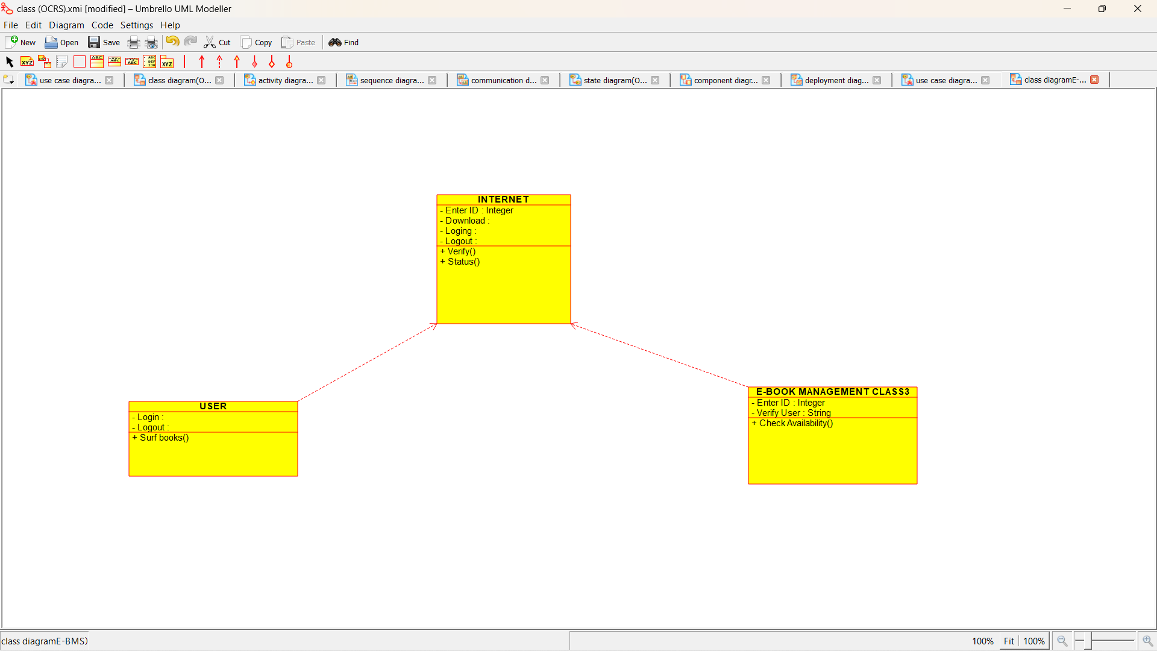

ACTIVITY DIAGRAM

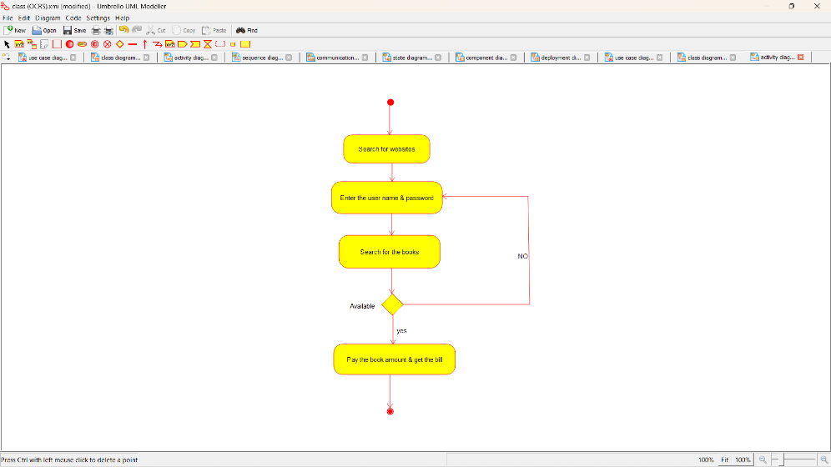

SEQUENCE DIAGRAM

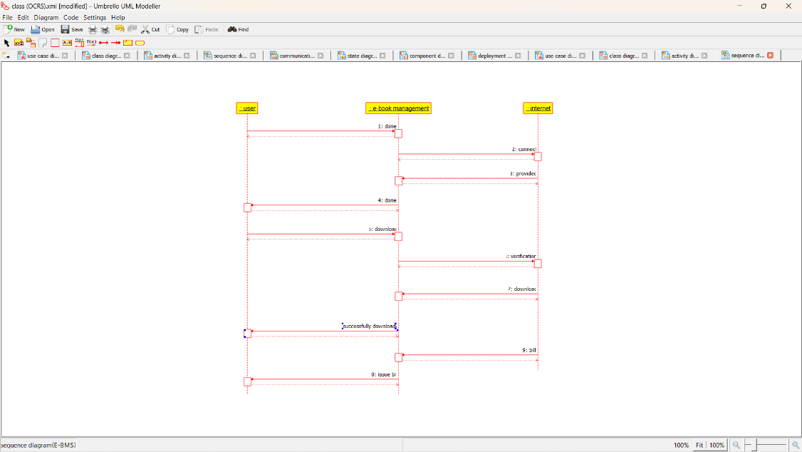

COLLABORATION DIAGRAM

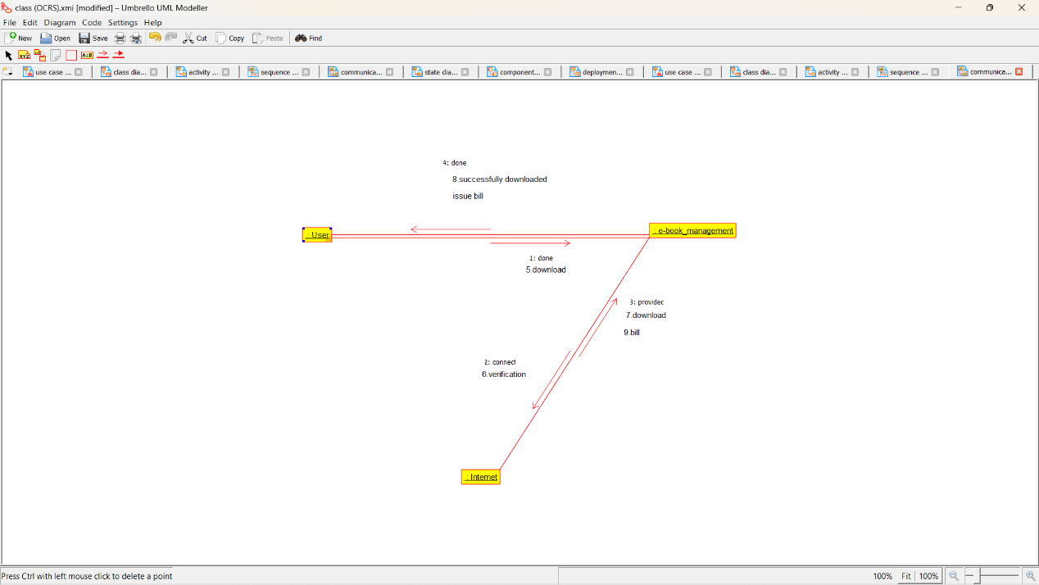

STATECHART DIAGRAM

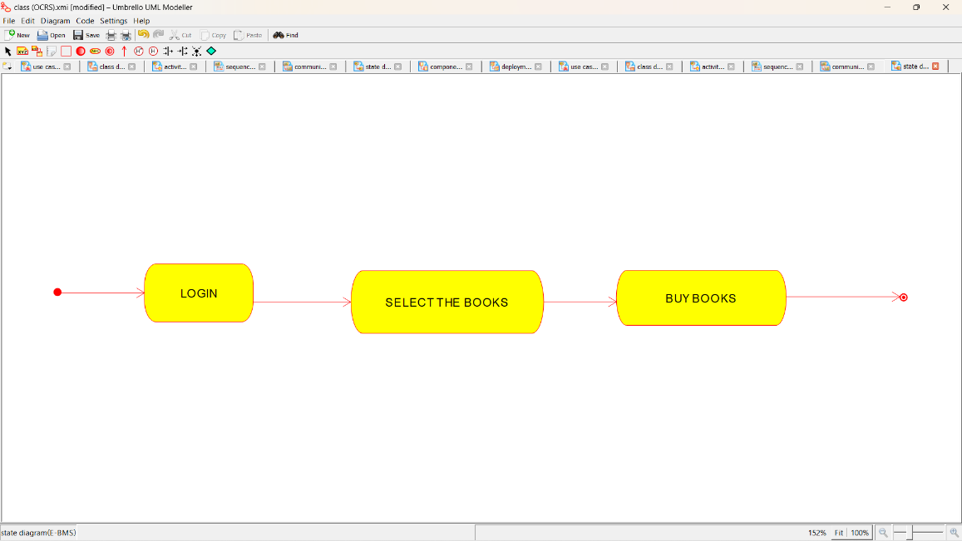

COMPONENT DIAGRAM

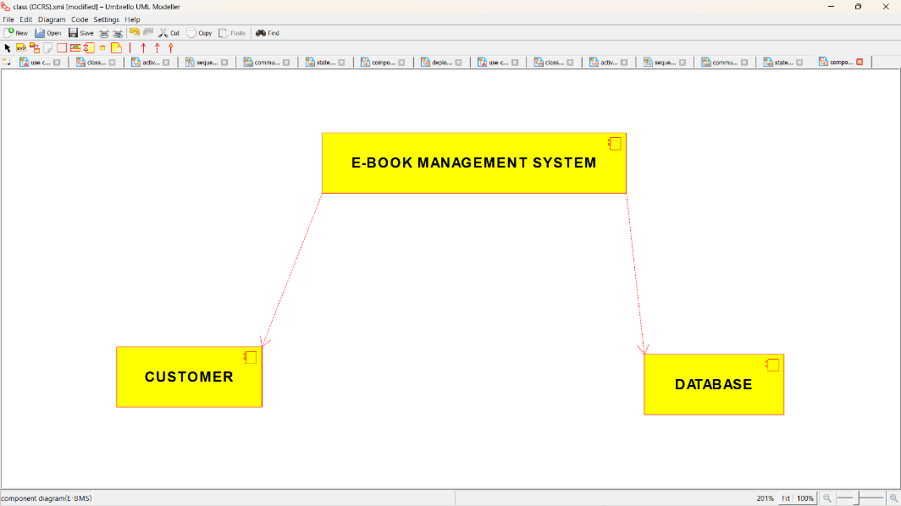

DEPLOYMENT DIAGRAM

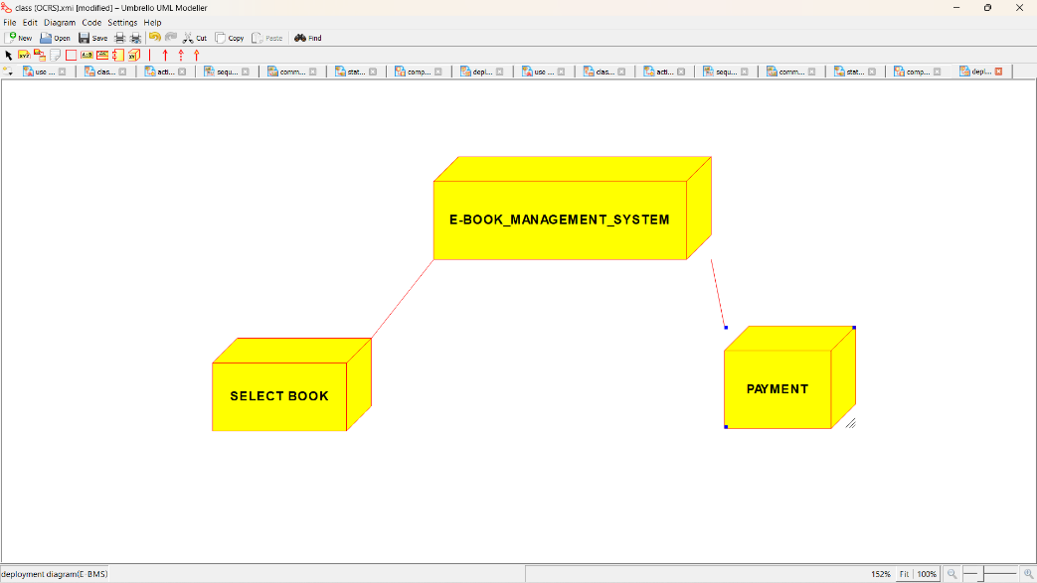

*PROGRAM CODING:*

/**

* Class E_BOOK_MANAGEMENT_CLASS3

*/

public class E_BOOK_MANAGEMENT_CLASS3 {

//

// Fields

//

private Integer Enter_ID;

private String Verify_User;

//

// Constructors

//

public E_BOOK_MANAGEMENT_CLASS3 () { };

//

// Methods

//

//

// Accessor methods

//

/**

* Set the value of Enter_ID

* @param newVar the new value of Enter_ID

*/

private void setEnter_ID (Integer newVar) {

Enter_ID = newVar;

}

/**

* Get the value of Enter_ID

* @return the value of Enter_ID

*/

private Integer getEnter_ID () {

return Enter_ID;

}

/**

* Set the value of Verify_User

* @param newVar the new value of Verify_User

*/

private void setVerify_User (String newVar) {

Verify_User = newVar;

}

/**

* Get the value of Verify_User

* @return the value of Verify_User

*/

private String getVerify_User () {

return Verify_User;

}

//

// Other methods

//

/**

*/

public void Check_Availability()

{

}

}

/**

* Class INTERNET

*/

public class INTERNET {

//

// Fields

//

private Integer Enter_ID;

private void Download;

private void Loging;

private void Logout;

//

// Constructors

//

public INTERNET () { };

//

// Methods

//

//

// Accessor methods

//

/**

* Set the value of Enter_ID

* @param newVar the new value of Enter_ID

*/

private void setEnter_ID (Integer newVar) {

Enter_ID = newVar;

}

/**

* Get the value of Enter_ID

* @return the value of Enter_ID

*/

private Integer getEnter_ID () {

return Enter_ID;

}

/**

* Set the value of Download

* @param newVar the new value of Download

*/

private void setDownload (void newVar) {

Download = newVar;

}

/**

* Get the value of Download

* @return the value of Download

*/

private void getDownload () {

return Download;

}

/**

* Set the value of Loging

* @param newVar the new value of Loging

*/

private void setLoging (void newVar) {

Loging = newVar;

}

/**

* Get the value of Loging

* @return the value of Loging

*/

private void getLoging () {

return Loging;

}

/**

* Set the value of Logout

* @param newVar the new value of Logout

*/

private void setLogout (void newVar) {

Logout = newVar;

}

/**

* Get the value of Logout

* @return the value of Logout

*/

private void getLogout () {

return Logout;

}

//

// Other methods

//

/**

*/

public void Verify()

{

}

/**

*/

public void Status()

{

}

}

/**

* Class USER

*/

public class USER

//

// Fields

//

private void Login;

private void Logout;

//

// Constructors

//

public USER () { };

//

// Methods

//

//

// Accessor methods

//

/**

* Set the value of Login

* @param newVar the new value of Login

*/

private void setLogin (void newVar) {

Login = newVar;

}

/**

* Get the value of Login

* @return the value of Login

*/

private void getLogin () {

return Login;

}

/**

* Set the value of Logout

* @param newVar the new value of Logout

*/

private void setLogout (void newVar) {

Logout = newVar;

}

/**

* Get the value of Logout

* @return the value of Logout

*/

private void getLogout () {

return Logout;

}

//

// Other methods

//

/**

*/

public void Surf_books()

{

}

}