Ex:No:02 | BOOK BANK REGISTRATION SYSTEM
Date: | BOOK BANK REGISTRATION SYSTEM

AIM:
To draw the diagrams [usecase, activity, sequence, collaboration, class, statechart,
collaboration, component, deployment, package ] for the Book bank registration system.

SOFTWARE REQUIREMENTS SPECIFICATION

SL.NO | SOFTWARE REQUIREMENTS SPECIFICATION
1.0 | Hardware Requirements
1.1 | Software Requirements
1.2 | Problem Analysis and Project Plan
1.3 | Project Description
1.4 | Reference

HARDWARE REQUIREMENTS:
Intel Pentium Processor I3/I5

​SOFTWARE REQUIREMENTS:
Rational rose /Argo UML/ Umbrello Tool

​PROBLEM ANALYSIS AND PROJECT PLAN
To simplify the process of applying passport, software has been created by designing through rational rose tool. Initially the applicant login the passport automation system and submits his details. These details are stored in the database and verification process done by the passport administrator, regional administrator and police the passport is issued to the applicant.

PROJECT DESCRIPTION:
This software is designed for the verification of the details of the student by the central computer. The details regarding the student will be provided to the central computer through the administrator in the book bank and the computer will verify the details of student and provide approval to the office. Then the books that are needed by the student will issue from the office to the him.

REFERENCES:
IEEE Software Requirement Specification format.

USE CASE DIAGRAM:
This diagram will contain the actors, use cases which are given below
Actors: Student, book bank admin.

Use case: Student details, register, verify student id, return previous books, request of books, issue of books, check of book availability

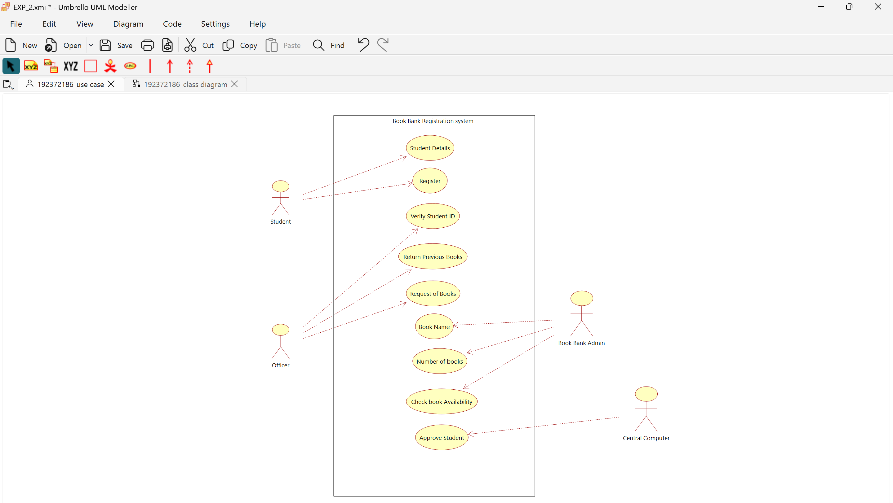

CLASS DIAGRAM:
This diagram consists of the following classes, attributes and their operations.

CLASSES | ATTRIBTES | OPERATIONS
Computer | Student record, Book list | Enter issue(), Check availability()
Stud | Student details | Request for books(), Register()
Admin | Student details, Book list | Verify student id(), Issue books()

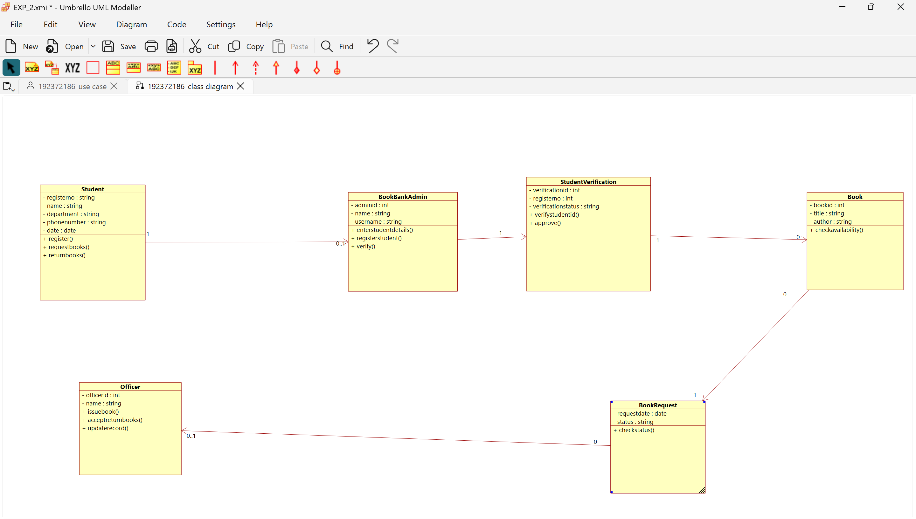

ACTIVITY DIAGRAM:
This diagram will have the activities as Start point, End point, Decision boxes as given below: Activities: Verify id, return books, request for books, enter book issue details in
system, issue books
Decision box: Check availability of books whether it is present or not.

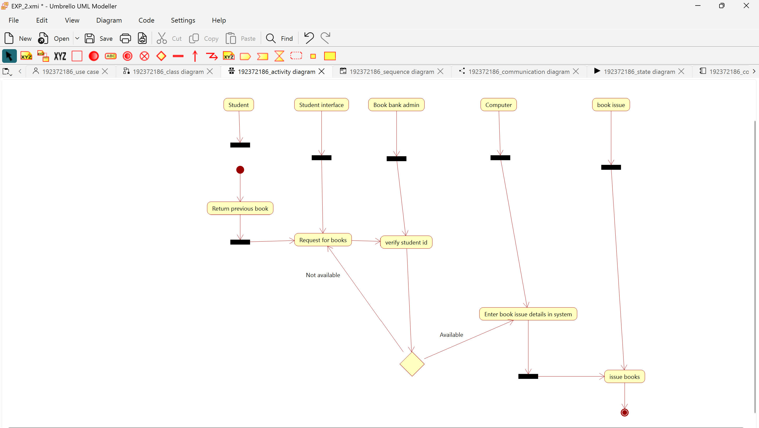

SEQUENCE DIAGRAM:
This diagram consists of the objects, messages and return messages.
Object: Stud, admin, computer

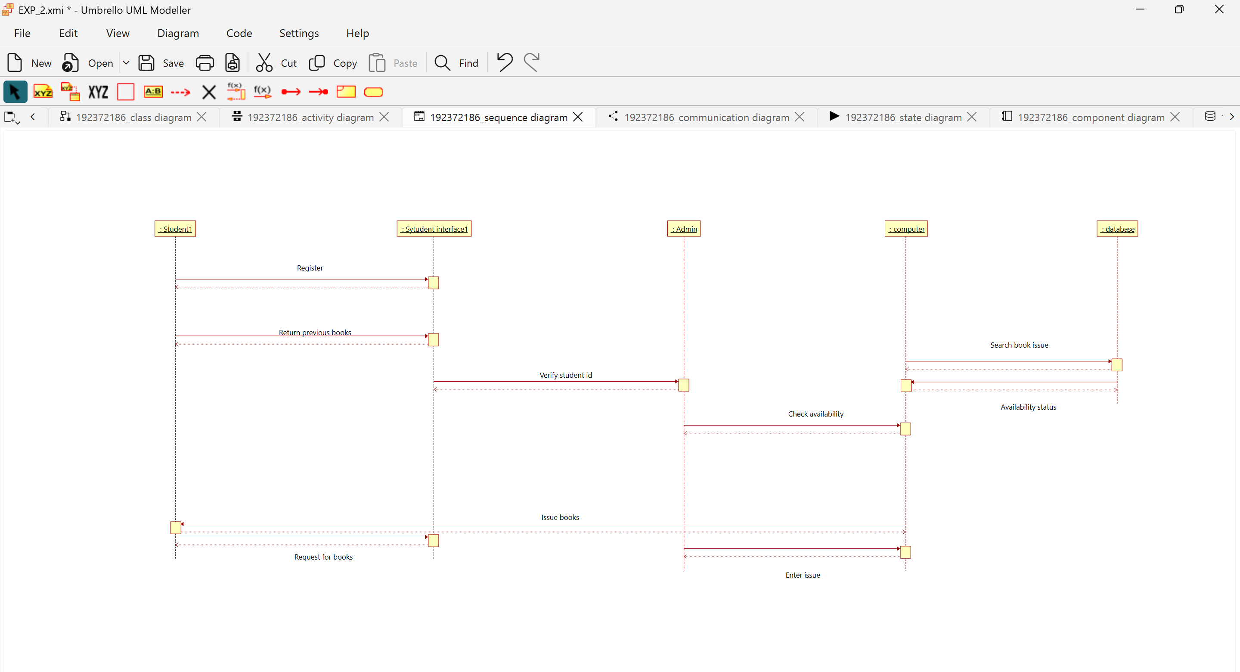

COLLABORATION DIAGRAM:
This diagram contains the objects and actors. This will be obtained by the completion of the sequence diagram and pressing the F5 key.

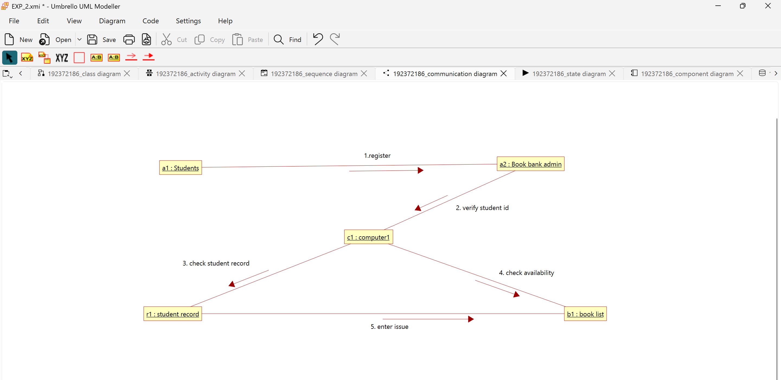

STATE CHART DIAGRAM
The purpose of state chart diagram is to understand the algorithm involved in performing a method. It is also called as state diagram. A state is represented as a round box, which may contain one or more compartments. An initial state is represented as small dot. An final state is represented as circle surrounding a small dot.

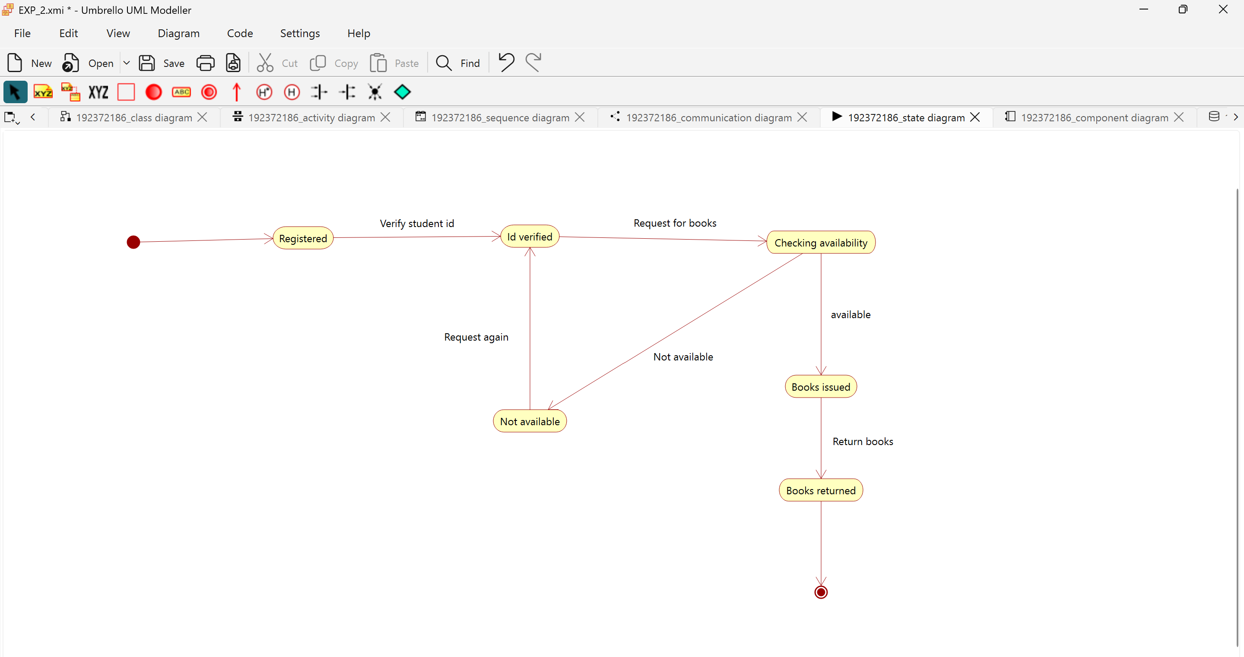

COMPONENT DIAGRAM
The component diagram's main purpose is to show the structural relationships between the components of a system. It is represented by boxed figure. Dependencies are represented by communication association

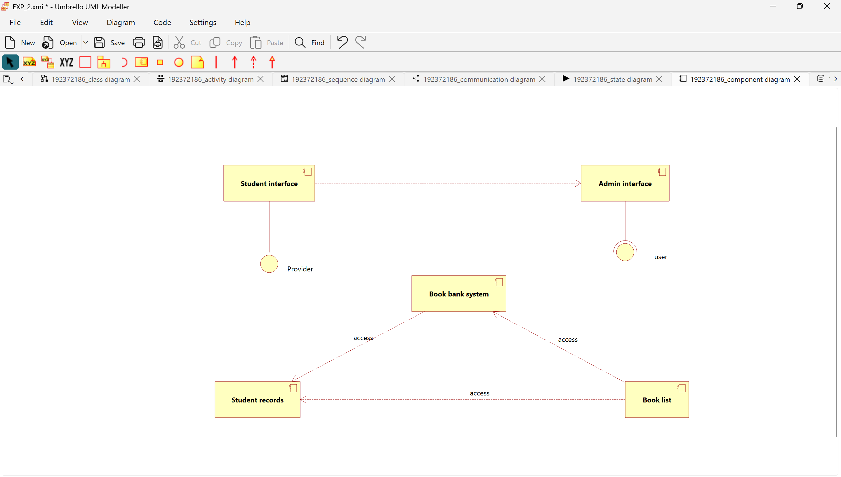

DEPLOYMENT DIAGRAM
A deployment diagram in the unified modeling language serves to model the physical deployment of artifacts on deployment targets. Deployment diagrams show "the allocation of artifacts to nodes according to the Deployments defined between them. It is represented by 3-dimentional box. Dependencies are represented by communication association

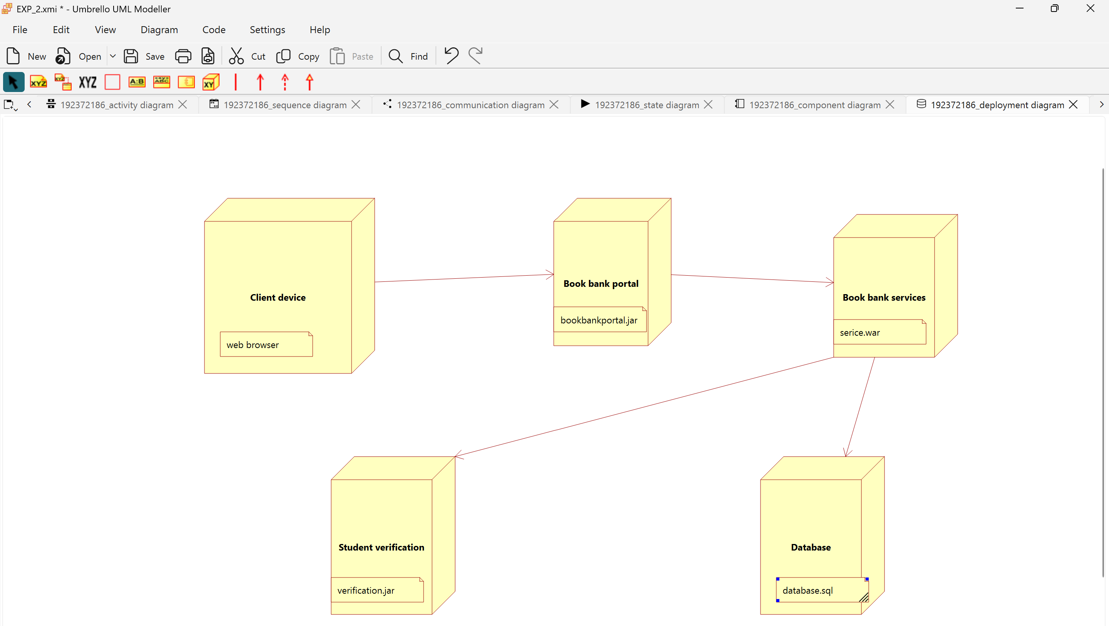

PACKAGE DIAGRAM:
A package diagram in unified modeling language that depicts the dependencies between the packages that make up a model. A Package Diagram (PD) shows a grouping of elements in the OO model, and is a Cradle extension to UML. PDs can be used to show groups of classes in Class Diagrams (CDs), groups of components or processes in Component Diagrams (CPDs), or groups of processors in Deployment Diagrams (DPDs).
There are three types of layer. They are
- User interface layer

- Domain layer

- Technical services layer

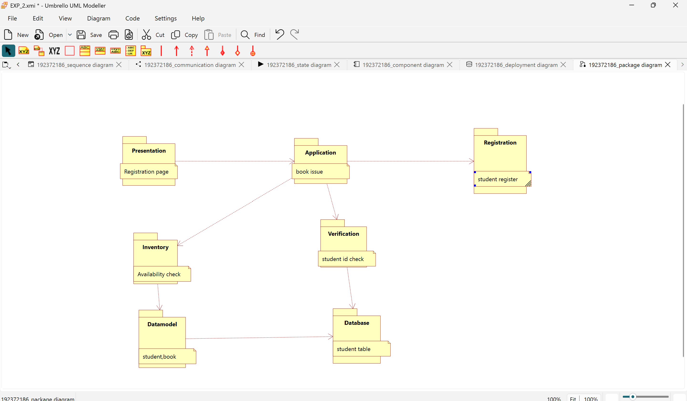

PROGRAM CODING: ADMIN:
Public class admin
{
Public integer student details; Public integer book list;
Public void verify stud id()
{
}
Public void check for availability()
{
}
Public void issue books()
{
}
Public void order for new author()

{
}
Public void maintains stud details()
{
}
}
STUDENT:
Public class stud
{
Public integer studdetails;
Public void request for books()
{
}
Public void register()
{
}
COMPUTER:
Public class computer
{
Public integer stud record; Public integer booklist;
Public void maintain stud rec()
{
}
Public void enter issue()
{
}

Public void order new author()
{
}
Public void check availability()
{
}
}

RESULT:
Thus the diagrams [use case, activity, sequence, collaboration, class, collaboration, component, deployment, package ] for the Book bank registration system has been designed, executed and output is verified.

