DevOps Assessment – Continuous Integration with GitHub Actions
(MSE-1 AI Powered CI/CD Containerizatin)

Name : Nikhil
Roll No. : 202401100200213
Branch : CSE-C

- GitHub repository URL

https://github.com/Nikhilbaisoya09/github-skills-challenge

- Pull request URL used to validate the workflows

https://github.com/Nikhilbaisoya09/github-skills-challenge/pull/1

- Screenshot showing the GitHub Actions workflows

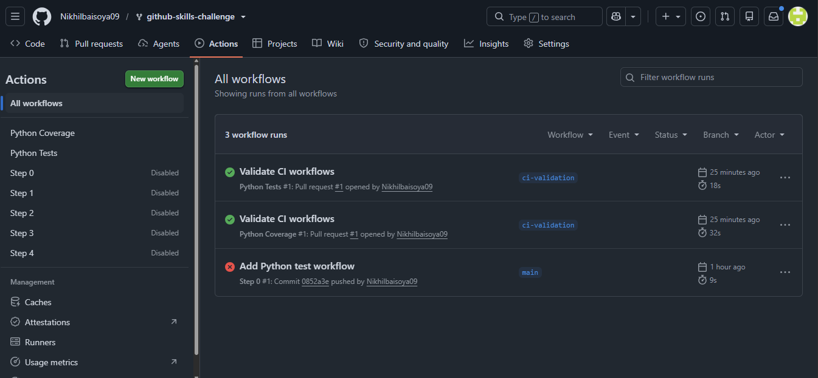

- Screenshot showing a successful test workflow execution
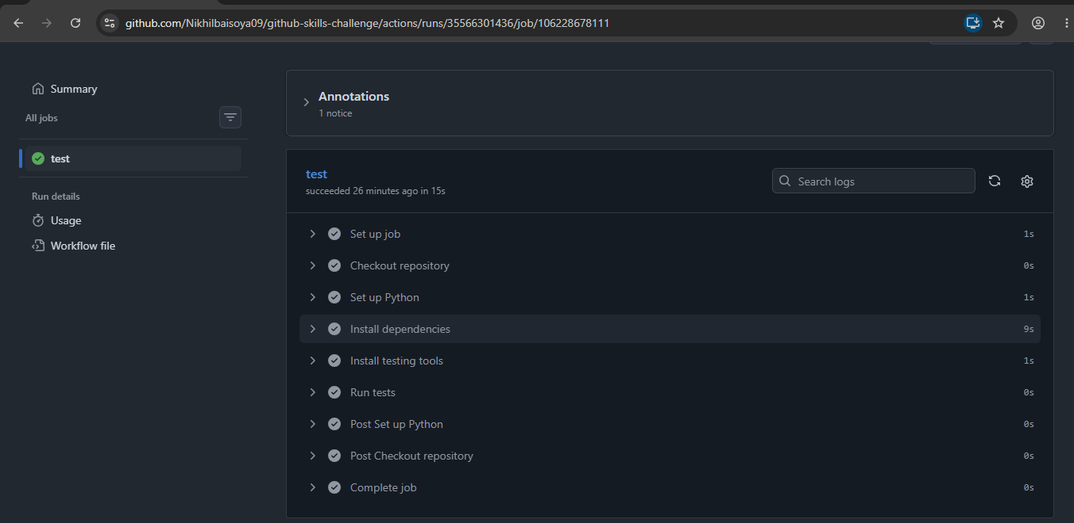
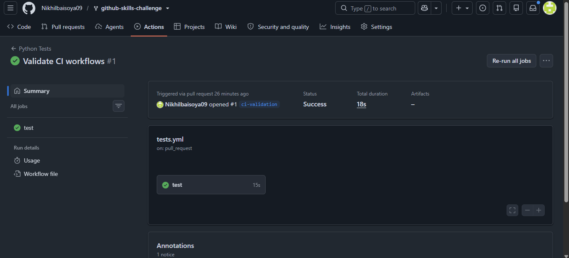
- Screenshot showing the coverage result/comment on the pull request
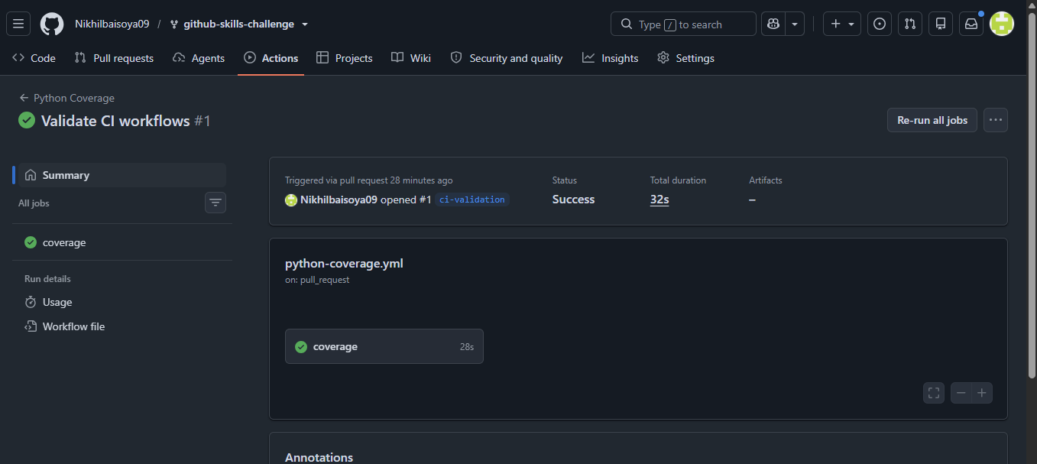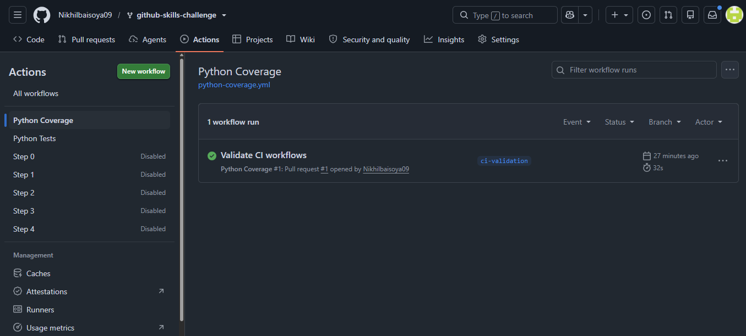

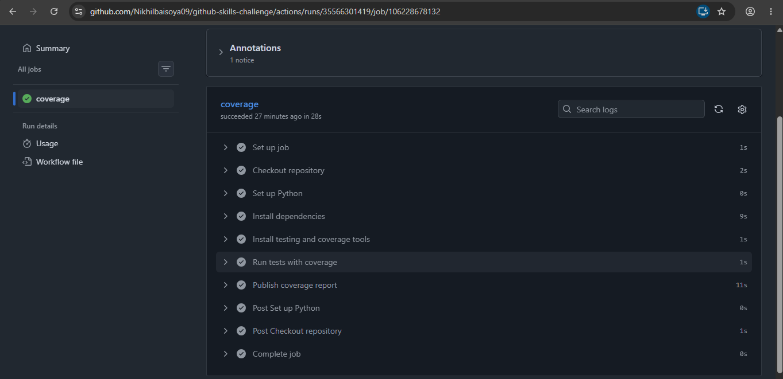

- Screenshot showing the final repository/workflow files
