Company Name: Adobe

Easy Question 1

Code:
class Solution {
public:
string reverseWordsRec(const string& s, int start = 0)
{
int n = s.size();
while (start < n && s[start] == '.')
{
start++;
}
if (start == n) return "";
int end = start;
while (end < n && s[end] != '.') {
end++;
}
string currentWord = s.substr(start, end - start);
string rest = reverseWordsRec(s, end);

if (rest.empty()) {
return currentWord;
} else {
return rest + "." + currentWord;
}
}
string reverseWords(string s) {
return reverseWordsRec(s, 0);
}
};

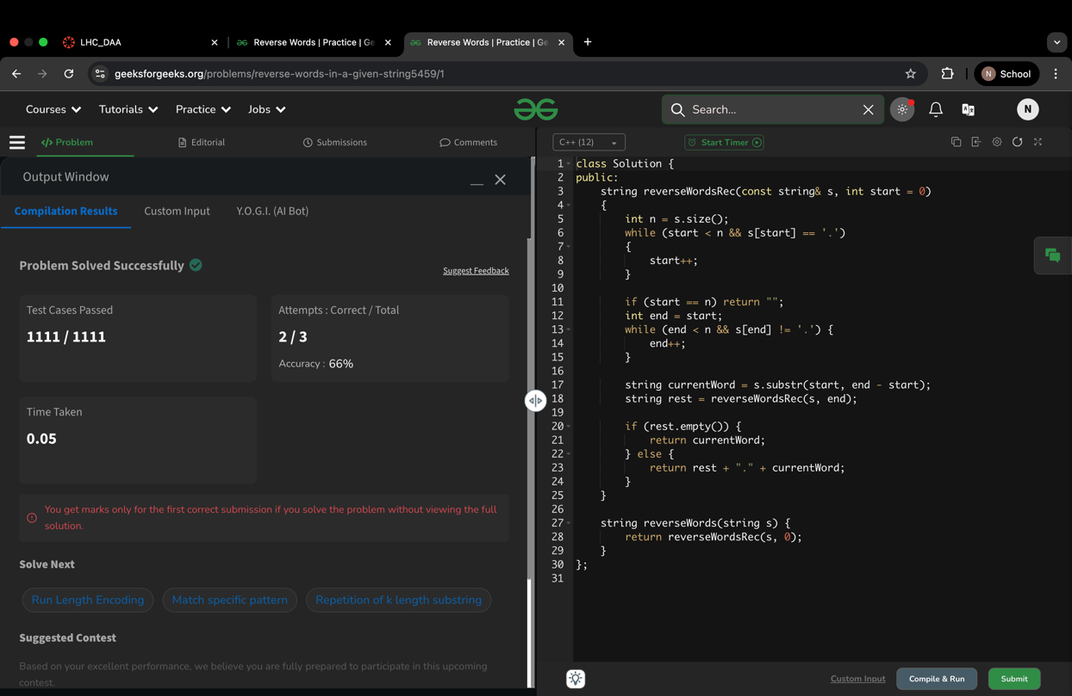
Output:

Easy Question 2
Code:
class Solution {
public:
bool hasPathSum(Node* root, int targetSum) {
if (root == nullptr) {
return false;
}

if (!root->left && !root->right) {
return targetSum == root->data;
}

return hasPathSum(root->left, targetSum - root->data) ||
hasPathSum(root->right, targetSum - root->data);
}
};

Output:
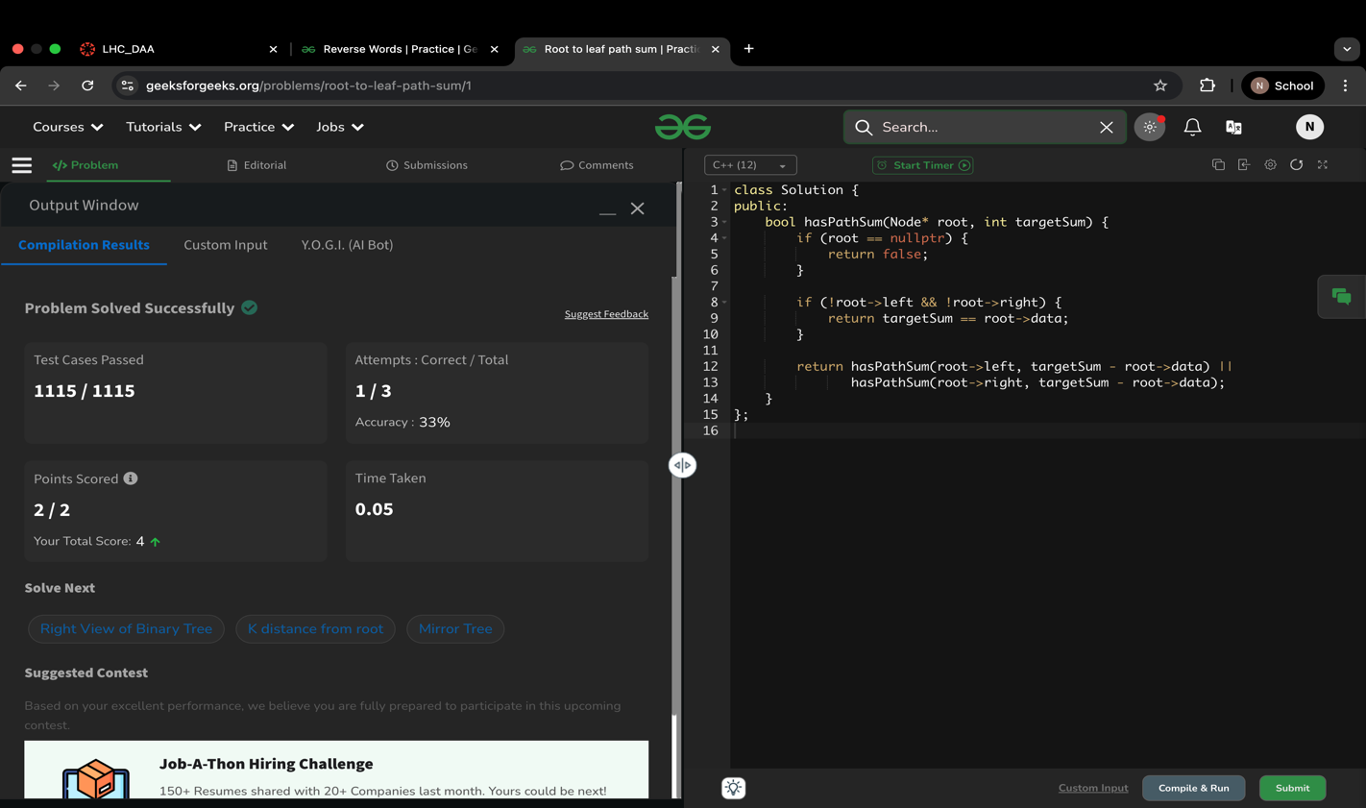

Easy Question 3
Code:
class Solution {
public:
bool isBSTUtil(Node* node, int minValue, int maxValue) {
if (node == nullptr) {
return true;
}
if (node->data <= minValue || node->data >= maxValue) {
return false;
}
return isBSTUtil(node->left, minValue, node->data) &&
isBSTUtil(node->right, node->data, maxValue);
}
bool isBST(Node* root) {
const int MIN_VALUE = 0;
const int MAX_VALUE = 1000000001;
return isBSTUtil(root, MIN_VALUE, MAX_VALUE);
}
};
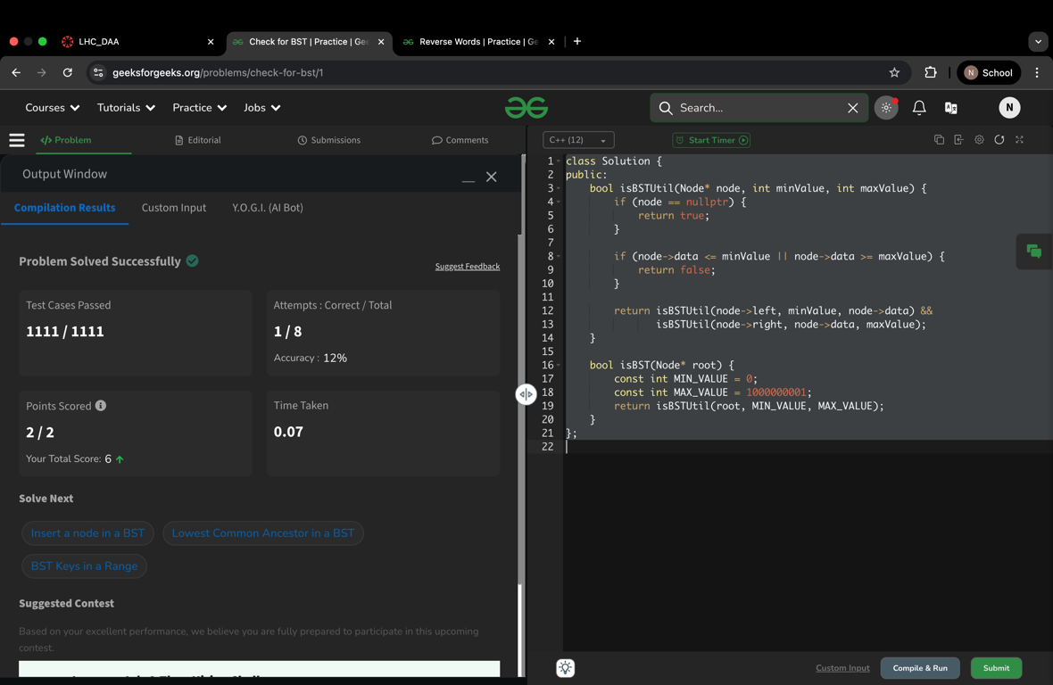
Output:

Easy Question 4
Code:
class Solution
{
public:
int search(vector<int>& arr, int key)
{
int low = 0, high = arr.size() - 1;
while (low <= high)
{
int mid = low + (high - low) / 2;
if (arr[mid] == key)
return mid;
if (arr[low] <= arr[mid])
{
if (arr[low] <= key && key < arr[mid])
high = mid - 1;
else
low = mid + 1;
}
else {
if (arr[mid] < key && key <= arr[high])
low = mid + 1;
else
high = mid - 1;
}
}
return -1;
}
};

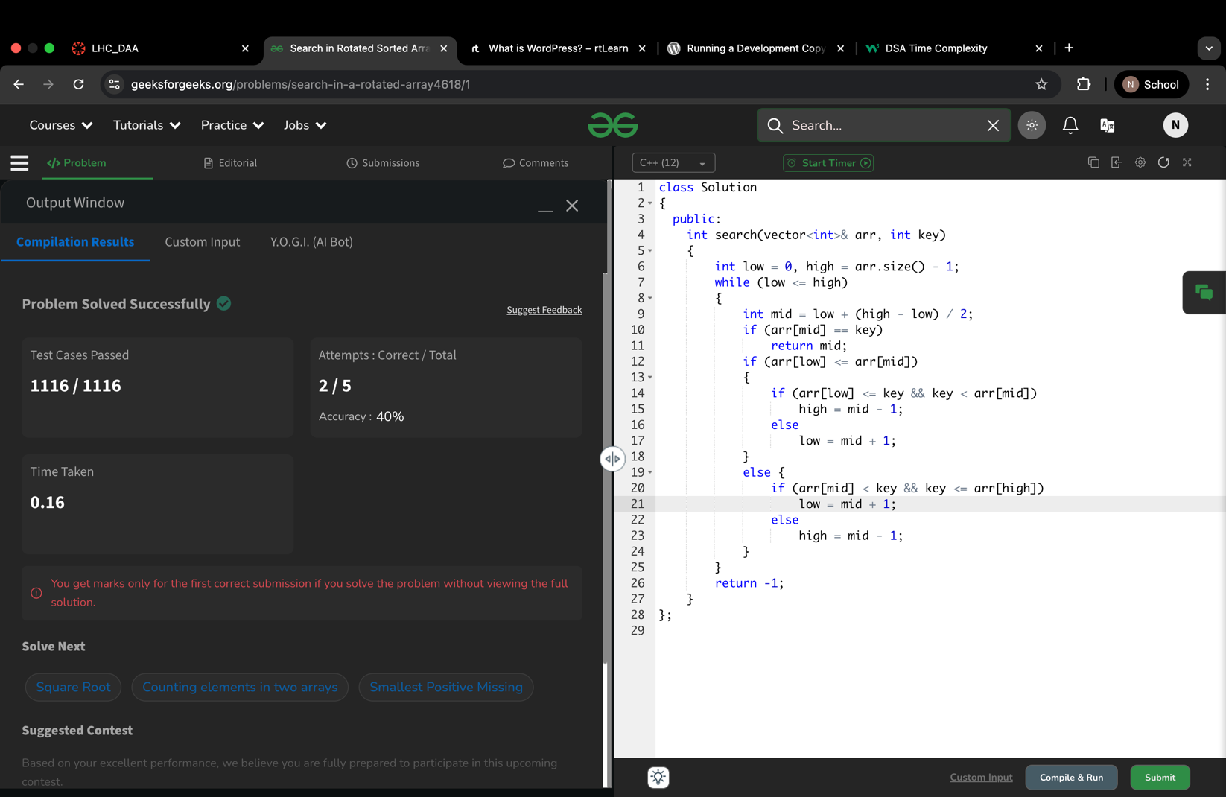
Output:

Easy Question 5
Code:
class Solution {
public:
Node* reverseList(Node* head) {
Node* prev = NULL;
Node* curr = head;
Node* next = NULL;

while (curr != NULL) {
next = curr->next;
curr->next = prev;
prev = curr;
curr = next;
}
return prev;
}
};
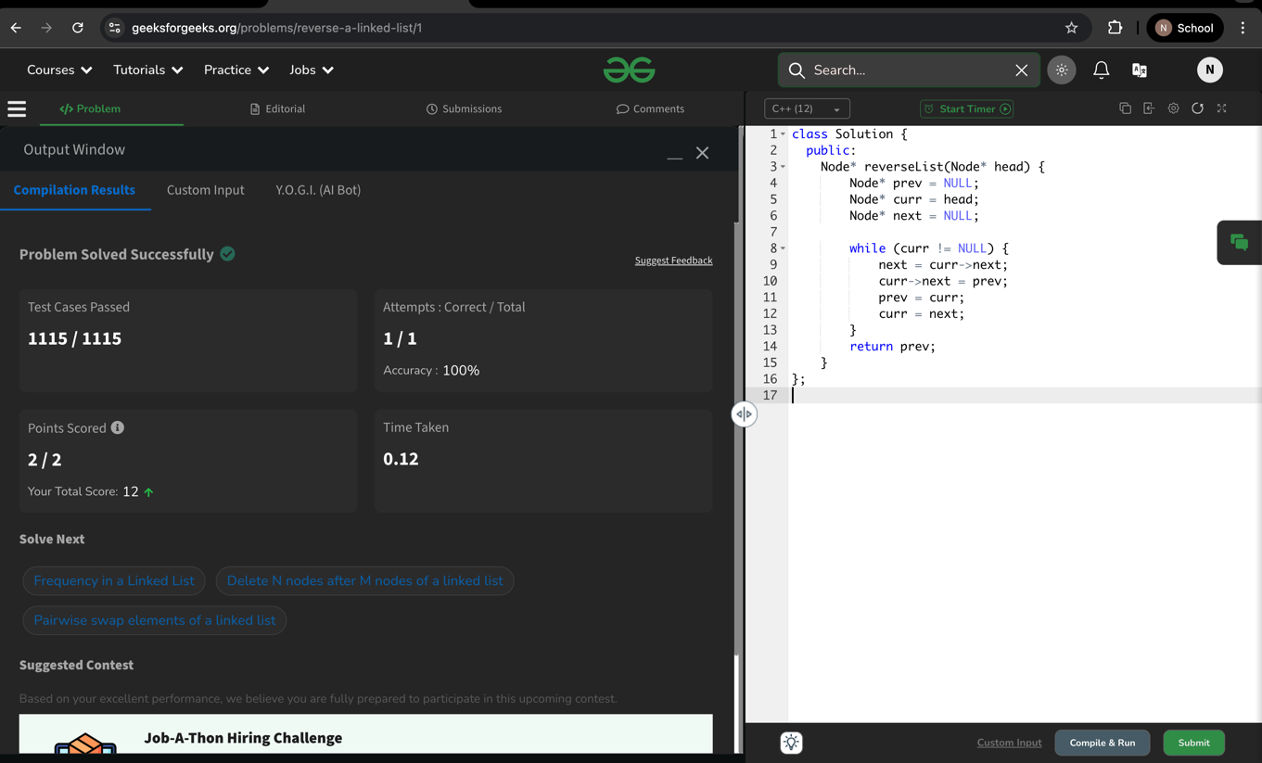
Output:

Easy Question 6
Code:
class Solution {
public:
vector<int> findSpiral(Node* root) {
vector<int> result;
if (!root) return result;
stack<Node*> s1;
stack<Node*> s2;
s1.push(root);
while (!s1.empty() || !s2.empty()) {
while (!s1.empty()) {
Node* curr = s1.top();
s1.pop();
result.push_back(curr->data);
if (curr->right) s2.push(curr->right);
if (curr->left) s2.push(curr->left);
}
while (!s2.empty()) {
Node* curr = s2.top();
s2.pop();
result.push_back(curr->data);
if (curr->left) s1.push(curr->left);
if (curr->right) s1.push(curr->right);
}
}
return result;
}
};

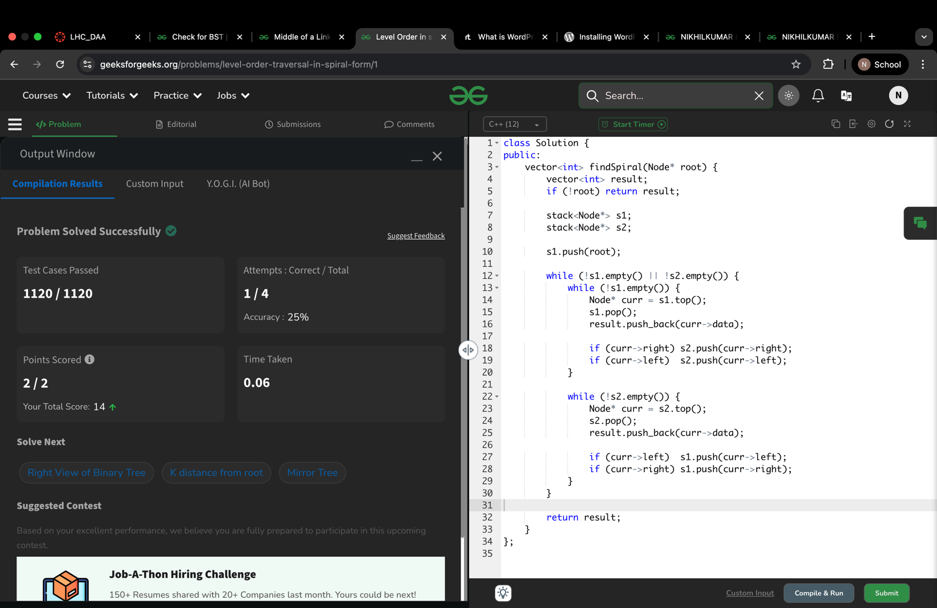
OUTPUT:

