- Insertion Sort

Code:
#include <iostream>
#include <vector>
using namespace std;
void Print_Array(vector<int> Array)
{
for (int i = 0; i < Array.size(); i++)
{
cout << Array[i] << " ";
}
cout << endl;
}
void Insertion_Sort(vector<int> &Array)
{
for (int i = 1; i < Array.size(); i++)
{
int key = Array[i];
int j = i - 1;
while (j >= 0 && Array[j] > key)
{
Array[j + 1] = Array[j];
j--;
}
Array[j + 1] = key;
}
}
int main()
{
vector<int> Array = {12, 45, 57, 78, 89, 62, 7, 49, 21, 23};
cout << "Array Before Sorting :- " << endl;
Print_Array(Array);
Insertion_Sort(Array);
cout << "Array After Sorting :- " << endl;
Print_Array(Array);
return 0;
}

Output:
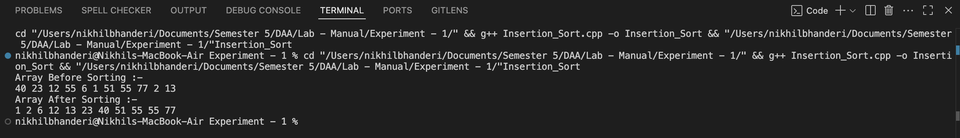

Time Complexity: O(n)
Space Complexity: O(1)

- Bubble Sort
Code:
#include <iostream>
#include <vector>
using namespace std;

void Print_Array(vector<int> Array)
{
for (int i = 0; i < Array.size(); i++)
{
cout << Array[i] << " ";
}
cout << endl;
}

void Swap(int &x, int &y)
{
int temp = x;
x = y;
y = temp;
}

void Bubble_Sort(vector<int> &Array)
{
int size = Array.size();

for (int i = 0; i < size - 1; i++)
{
bool Swapped = false;

for (int j = 0; j < size - i - 1; j++)
{
if (Array[j] > Array[j + 1])

{
Swap(Array[j], Array[j + 1]);
Swapped = true;
}
}
if (Swapped == false)
{
break;
}
}
return;
}

int main()
{
vector<int> Array = {11,4,54,24,35,22,55,65,33,15,76,63};
cout << "Array Before Sorting :- " << endl;

Print_Array(Array);
Bubble_Sort(Array);

cout << "Array After Sorting :- " << endl;
Print_Array(Array);

return 0;
}

Output:
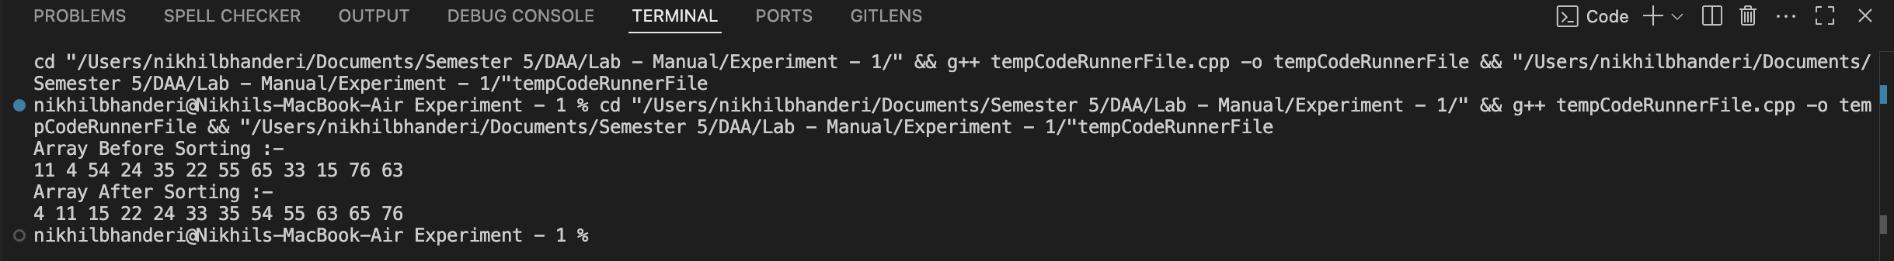

Time Complexity:O(n²)
Space Complexity:O(1)

- Selection Sort
Code:
#include <iostream>
#include <vector>
using namespace std;
void Print_Array(vector<int> Array){
for (int i = 0; i < Array.size(); i++){
cout << Array[i] << " ";
}
cout << endl;
}
void Swap(int &x, int &y){
int temp = x;
x = y;
y = temp;
}
void Selection_Sort(vector<int> &Array){
for (int i = 0; i < Array.size(); i++){
int min_index = i;
for (int j = i + 1; j < Array.size(); j++){
if (Array[j] < Array[min_index]){
min_index = j;
}
}
Swap(Array[i], Array[min_index]);
}
return;
}
int main()
{
vector<int> Array = {22,4,5,3,32,4,34,54,23,87,22,54};
cout << "Array Before Sorting :- " << endl;
Print_Array(Array);
Selection_Sort(Array);
cout << "Array After Sorting :- " << endl;
Print_Array(Array);
return 0;
}

Output:
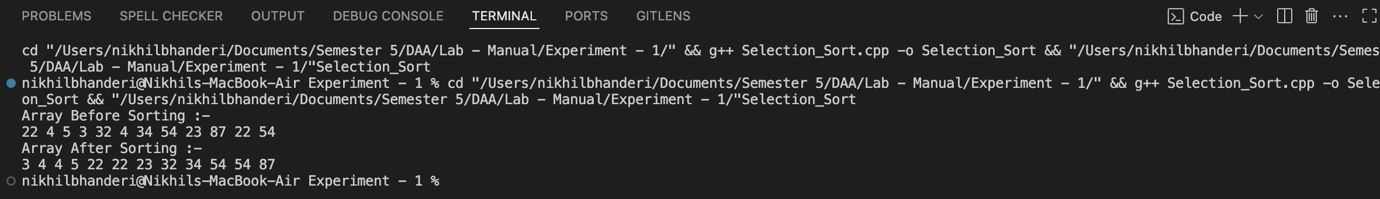

Time Complexity: O(n²)
Space Complexity: O(1)

- Counting Sort
Code:
#include <iostream>
#include <vector>
using namespace std;
void Print_Array(vector<int> Array)
{
for (int i = 0; i < Array.size(); i++)
{
cout << Array[i] << " ";
}
cout << endl;
}
int Find_Max(vector<int> Array)
{
int max_num = Array[0];
for (int i = 1; i < Array.size(); i++)
{
if (Array[i] > max_num)
{
max_num = Array[i];
}
}
return max_num;
}
void Counting_Sort(vector<int> &Array)
{
int max_num = Find_Max(Array);
vector<int> count(max_num + 1, 0);

for (int i = 0; i < Array.size(); i++)
{
count[Array[i]]++;
}
int index = 0;
for (int i = 0; i <= max_num; i++){
while (count[i] > 0){
Array[index++] = i;
count[i]--;
}
}
return;
}
int main()
{
vector<int> Array = {11,3,35,55,76,34,24,2,42,67,45};
cout << "Array Before Sorting :- " << endl;
Print_Array(Array);
Counting_Sort(Array);
cout << "Array After Sorting :- " << endl;
Print_Array(Array);
return 0;
}

Output:
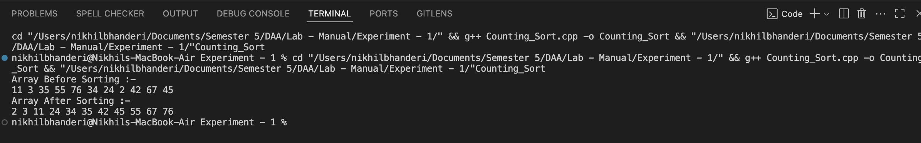

Time Complexity: O(n + k)
Space Complexity: O(k + n)

