- Linear Serch

Code:
#include <iostream>
#include <vector>
using namespace std;

int Linear_Search(vector<int> Array, int key)
{
for (int i = 0; i < Array.size(); i++)
{
if (Array[i] == key)
{
return i;
}
}
return -1;
}

void Print_Array(vector<int> Array)
{
for (int i = 0; i < Array.size(); i++)
{
cout << Array[i] << " ";
}
cout << endl;
}
void Input_Array(vector<int> &Array)
{
for (int i = 0; i < Array.size(); i++)
{
cout << "Enter Element at index " << i << " : ";
cin >> Array[i];
}
}
int main()
{
int size;
int key;
while (true)
{
cout << "Enter The Size of the Array :- " << endl;
cin >> size;
if (size >= 1)
{
break;
}
cout << "Invalid Size. Size must be a Positive Integer." << endl;
}
vector<int> Array(size, 0);
cout << "Enter The Element for the Array:- " << endl;
Input_Array(Array);
cout << "Your Input Array Is :- " << endl;
Print_Array(Array);
cout << "Enter the Key to Search In Array :- ";
cin >> key;
int ans = Linear_Search(Array, key);
if (ans != -1)
{
cout << key << " Found at Index - " << ans << " of Array." << endl;
}
else
{
cout << "Key is not exists in Array.";
}
return 0;
}

Output:
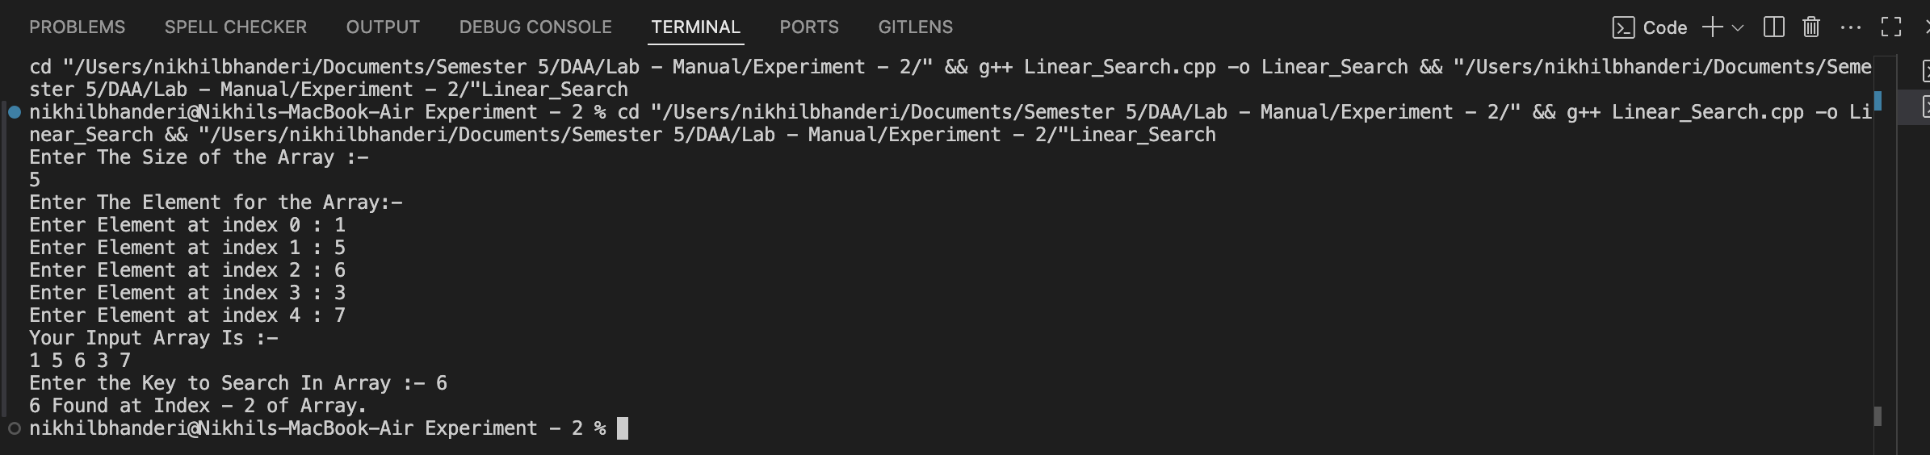

Time Complexity: O(n)
Space Complexity: O(1)

- Binary Search
Code:
#include <iostream>
#include <vector>
#include <algorithm>
using namespace std;
int Binary_Search(vector<int> Array, int left, int right, int key)
{
while (left <= right){
int mid = left + (right - left) / 2;
if (key == Array[mid]){
return mid;
}
if (key < Array[mid]){
right = mid - 1;
}
else
{
left = mid + 1;
}
}
return -1;
}
void Print_Array(vector<int> Array)
{
for (int i = 0; i < Array.size(); i++)
{
cout << Array[i] << " ";
}
cout << endl;
}

void Input_Array(vector<int> &Array)
{
for (int i = 0; i < Array.size(); i++)
{
cout << "Enter Element at index " << i << " : ";
cin >> Array[i];
}
}
int main()
{
int size;
int key;

while (true)
{
cout << "Enter The Size of the Array :- " << endl;
cin >> size;
if (size >= 1)
{
break;
}
cout << "Invalid Size. Size must be a Positive Integer." << endl;
}
vector<int> Array(size, 0);
cout << "Enter The Element for the Array:- " << endl;
Input_Array(Array);
sort(Array.begin(), Array.end());
cout << "Your Input Array Is :- " << endl;
Print_Array(Array);
cout << "Enter the Key to Search In Array :- ";
cin >> key;
int ans = Binary_Search(Array, 0, size, key);
if (ans != -1)
{
cout << key << " Found at Index - " << ans << " of Array." << endl;
}
else
{
cout << "Key is not exists in Array.";
}
return 0;
}

Output:
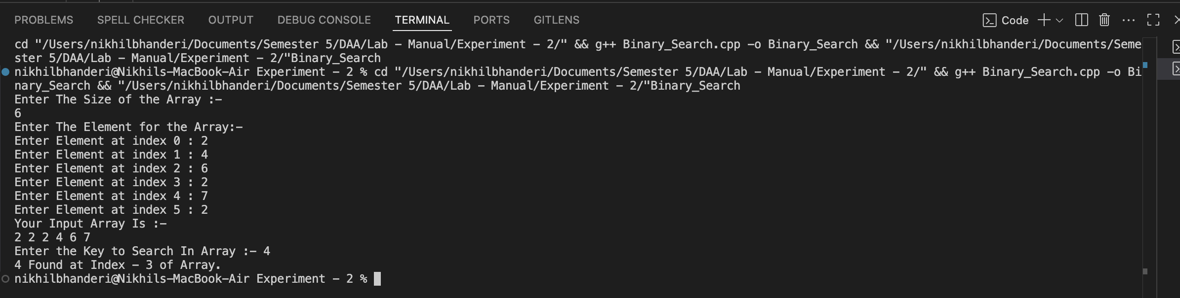

Time Complexity:O(log n)
Space Complexity:O(1)

