**MILESTONE 4**

**Table of Contents**

Milestone 4: 3

# Milestone 4:

Milestone 4- <https://github.com/Nikhilesh-cherukuri/Datamining-project/tree/segmentation>

Here segmentation process has been done based on the bathroom images that are annotated in milestone 3. Based on the txt details and .npy file the present segmentation process has been executed. In order to execute the segmentation process it is important to install all required libraries in the python software environment.

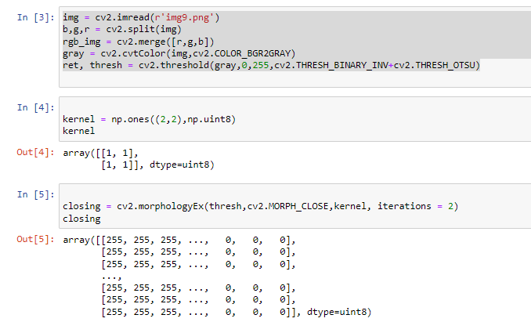

**Figure 1: Image Array creation**

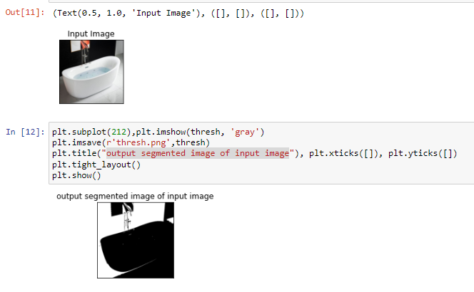

**Figure 2: Image 1 segmentation**

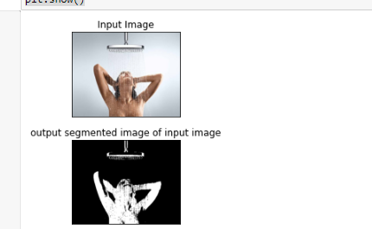

**Figure 3: Image 2 segmentation**

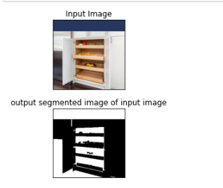

**Figure 4: Image 3 segmentation**

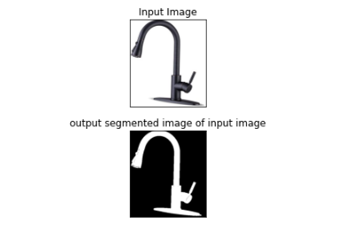

**Figure 5: Image 4 segmentation**

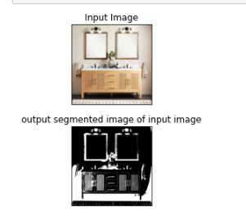

**Figure 6: Image 5 segmentation**

One of the principal occupations in PC vision is picture division. Due to the necessity for low-level spatial data, this assignment is more difficult than other vision-related undertakings. Division and be are the two principal classifications of picture division. The panoptic division is the name for the mix of these two essential exercises. In this review, we will take a gander at the improvement of CNN-based semantic and case division work. Have likewise examined the preparation points of interest of a few best-in-class models and depicted similar compositional parts of probably the most state-of-the-art models to offer a piece of unmistakable information on the hyper-boundary tuning of those models. Also, we looked at how well those models performed across different datasets. At long last, we have shown a couple of instances of state-of-the-art panoptic division models.

# 