# Backup Data from the database

**Overview:**

This guide explains how to export data from the PostgreSQL database named **andromeda** using standard PostgreSQL tools and SQL queries.

**1. Prerequisites**

Before exporting data, ensure:

* PostgreSQL is installed on your machine.
* You have access credentials (host, port number, username, password).
* You have permission to read the database/tables.

**2. Connecting to the Database in pgAdmin**

1. Open **pgAdmin**.
2. In the left panel, right-click on **"Servers"** → **Create** → **Server**.
3. Set connection parameters:
   * **Name**: e.g., Andromeda DB
   * **Host**: e.g., localhost or IP address
   * **Port**: usually 5432
   * **Username** and **Password**: your PostgreSQL login
4. Click **Save**
5. 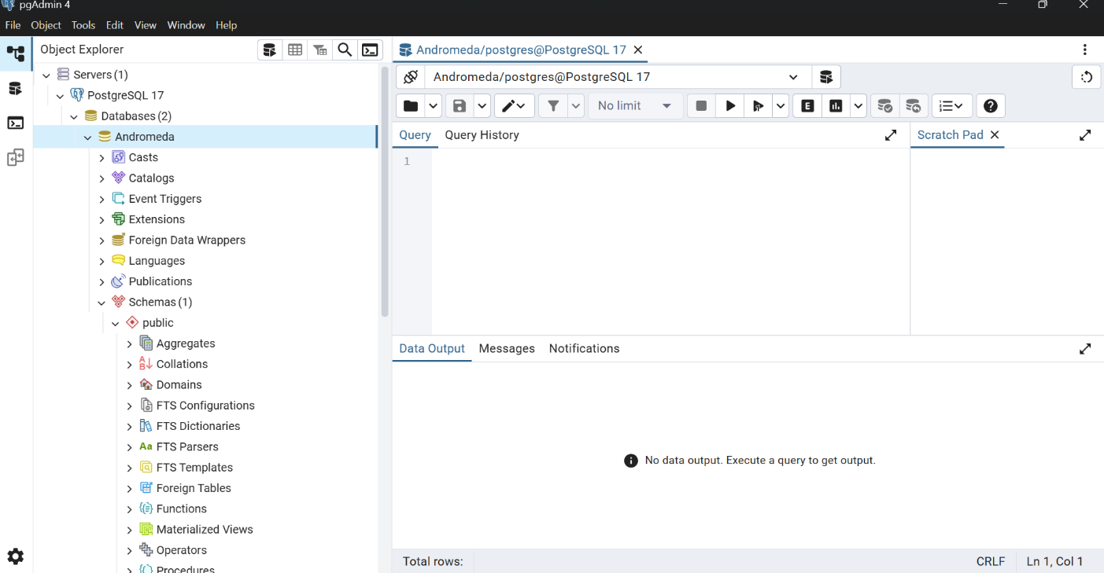You should now see the database andromeda listed under your server.

**3. Exporting Table Data to CSV**

**Export via Table View**

1. Navigate to:  
   Servers > [Your Server] > Databases > andromeda > Schemas > public > Tables
2. Right-click the table you want to export → **View/Edit Data** → **All Rows**
3. Once the data loads:
   * Click the **"Download as CSV"** button (usually a disk icon or in the toolbar above the grid).
   * Choose the save location on your local computer.

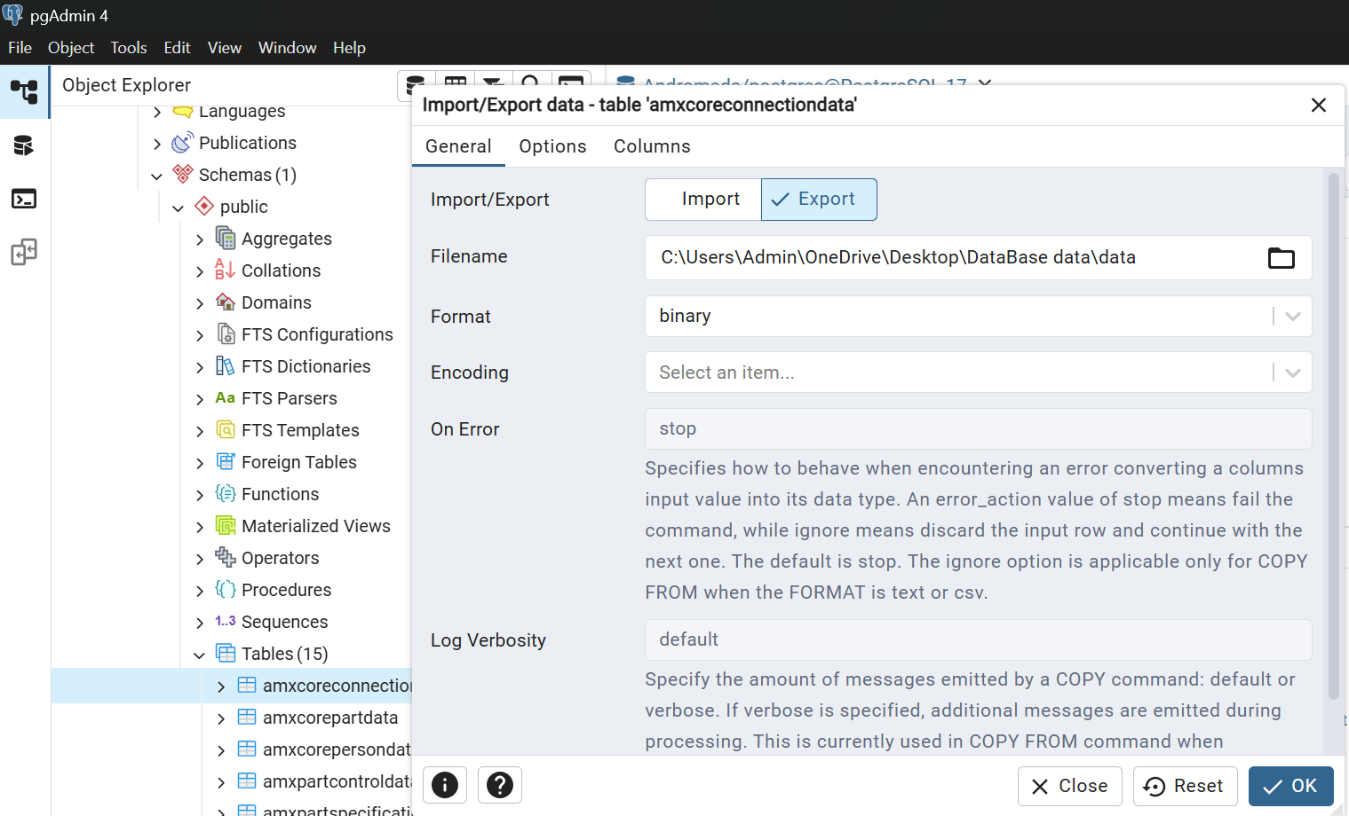That’s it — your table is now saved as a .csv file.

**4. Exporting with SQL in the Query Tool**

If you want to export filtered or custom data:

1. Right-click the andromeda database → **Query Tool**
2. Run a query like:

SELECT * FROM users WHERE created at >= '2025-09-21';

1. Once the results show up:
   * Right-click the result grid.
   * Select **"Save As CSV"**.
   * Choose your file location and filename.

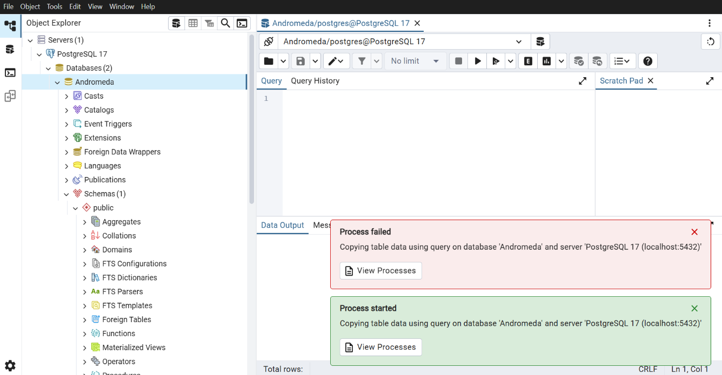

**5. Exporting without any Queries:**

If you want to export filtered or custom data:

1. Right-click the andromeda database → **Backup**
2. It opens a custom box with required fields like Filename, Format, Encoding type.
3. Once the custom dialog box shows up:
   * Choose your file location and filename.
   * Keep the Format as custom.
   * It looks like this after enter your required fields.
   * Click on “**Backup”.**
   * 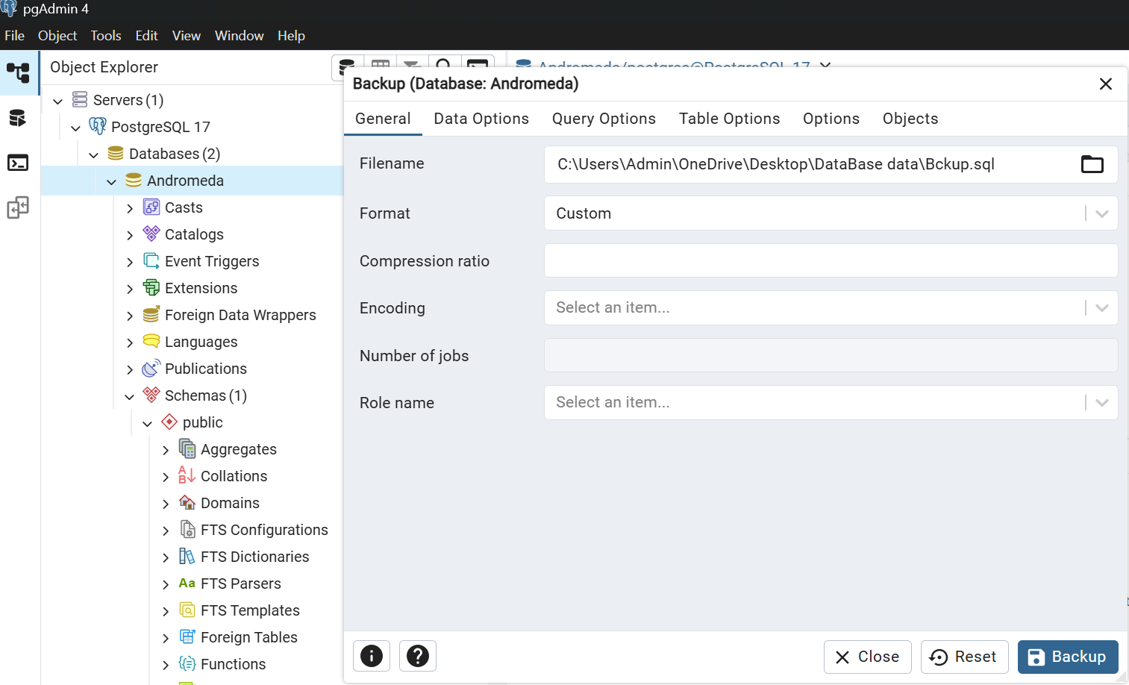After that you may see the Process of your data.
   * 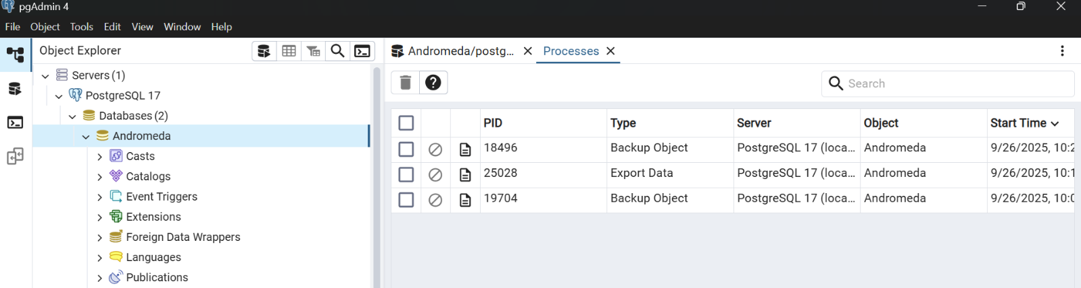Click on the View process you can see the process of your database is backup in with the details.
   * Here you can notice that the process details of your database exporting details and you can notice that the process and the details of the process.

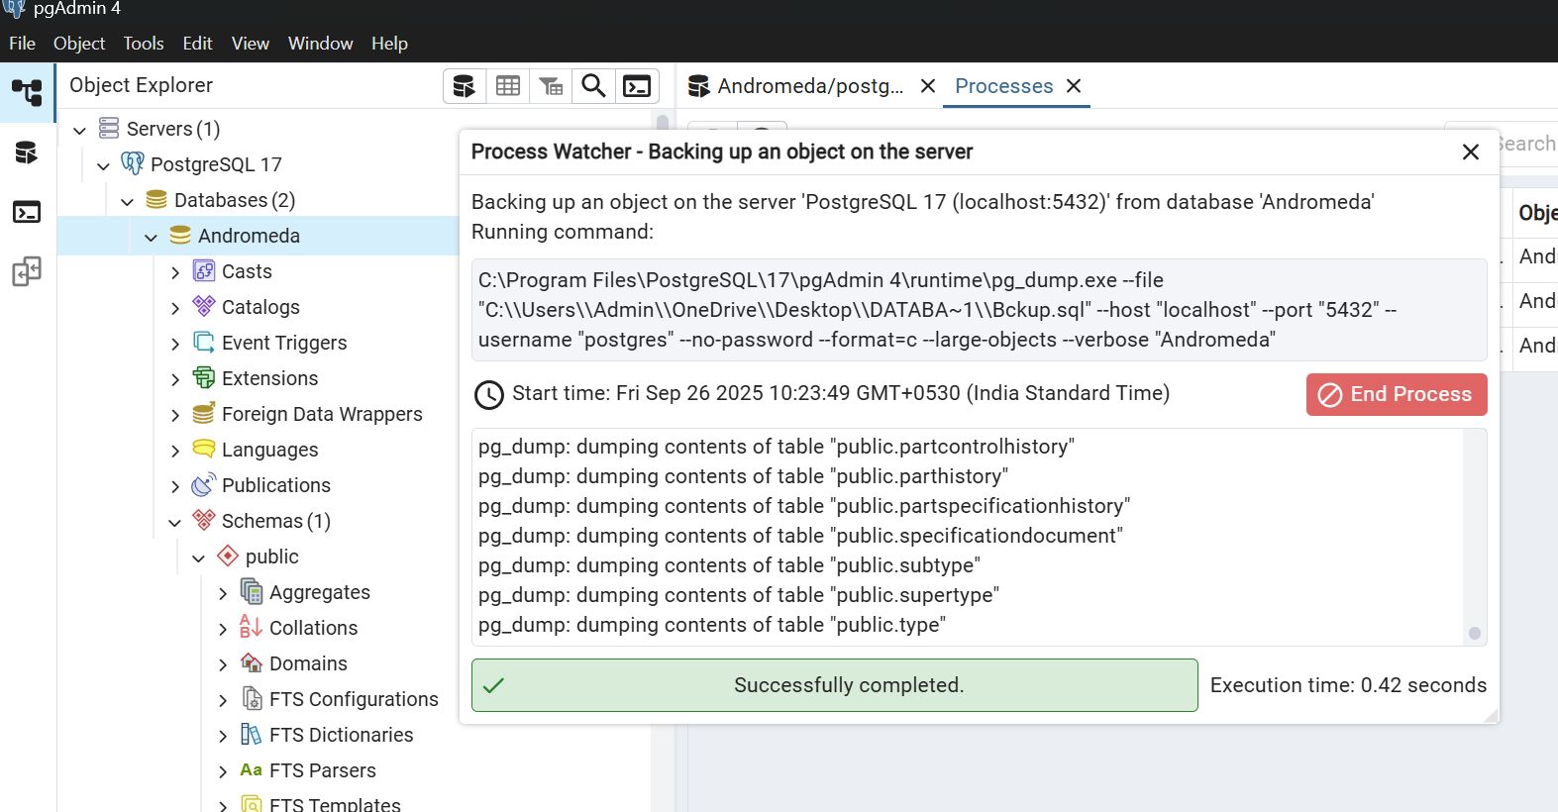

1. **Importing the Database data;**

If you want to import the exported database data:

1. In the left panel, right-click on **"Databases"** → **Create** → **“Database”**.
2. 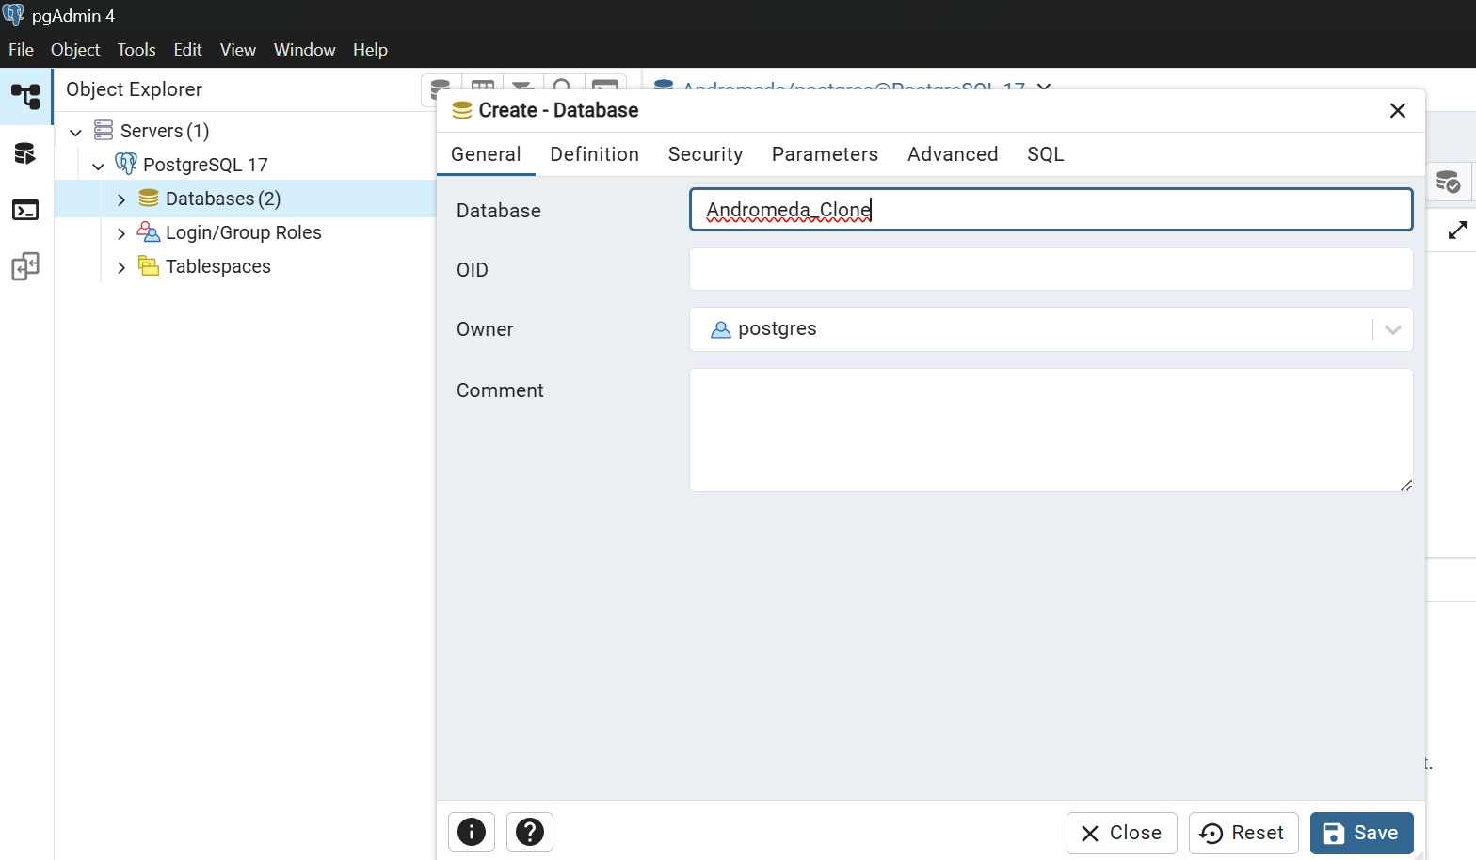Click on the database it opens a custom page like this .
3. Click on save, it will create your new database.
4. Check all the schemas and required data for your database.

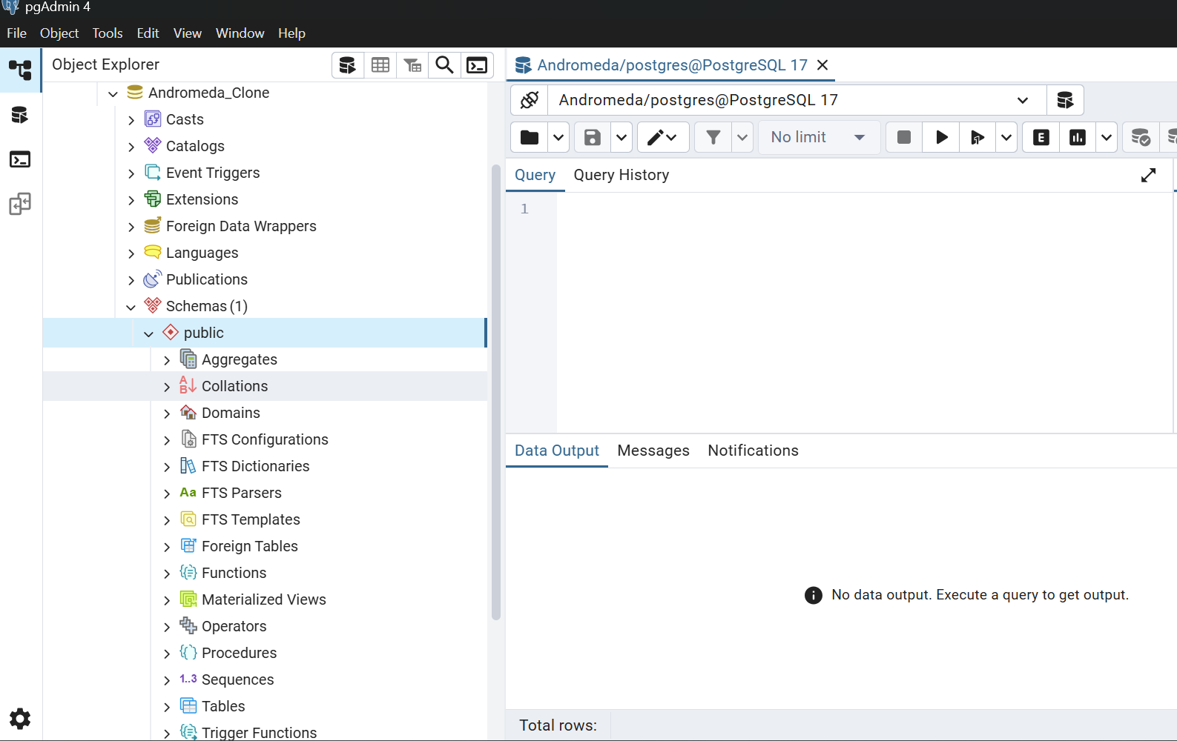

* Now Right Click on your Database e.g.: Andromeda_Clone.
* 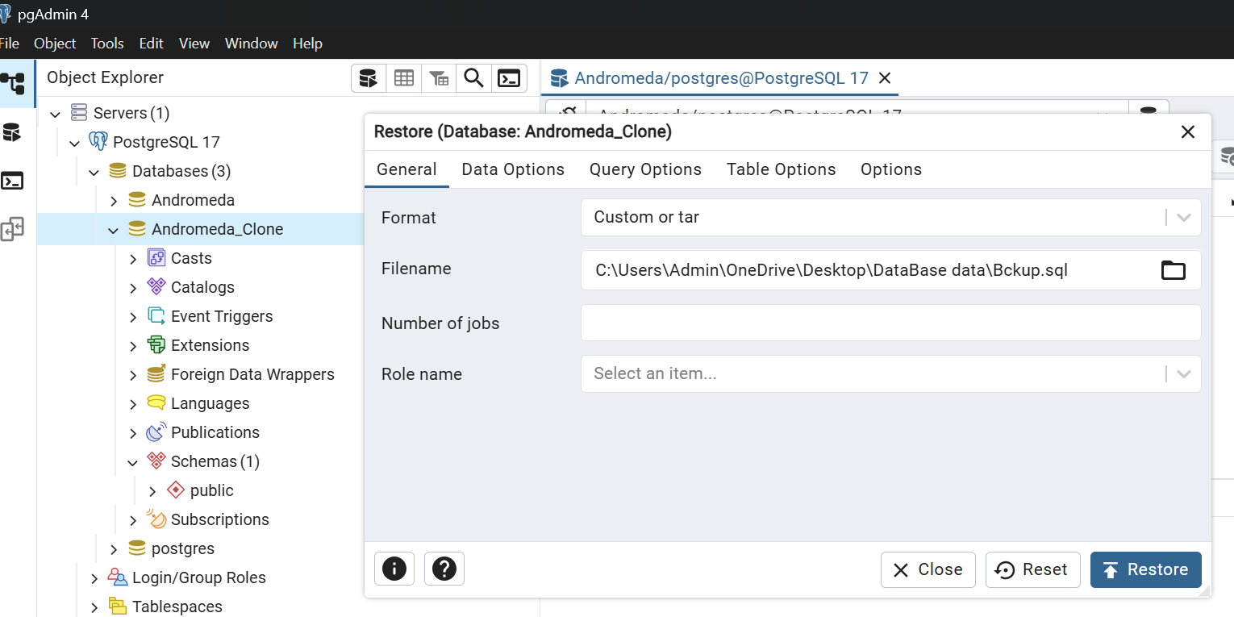Click on Restore it opens a custom page like this
* Give your filepath in the Filename make the Format as custom as we make the backup data with custom format only.
* After all the required fields are entered then click on the button **Restore.**
* Once we click on the restore button it will restore all the data which you are backed.
* Check all the data is present or not and the tables and the schemas in the database what you are backed for backup.

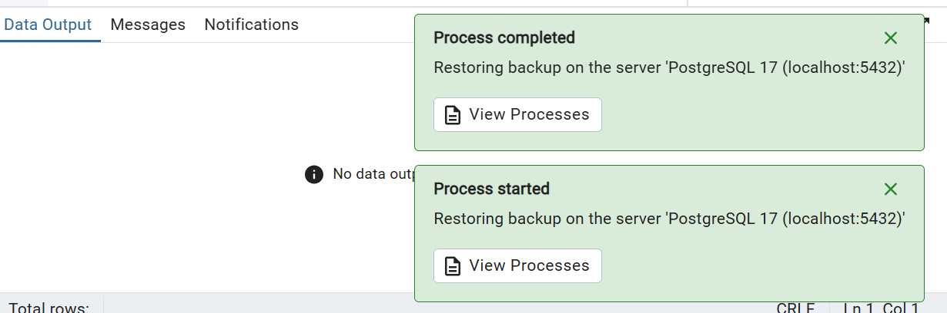

* After all the Process completed check your database that all the data is restored or not.
* All the tables present in my database are backed.
* Check the tables for the data is restored or not.

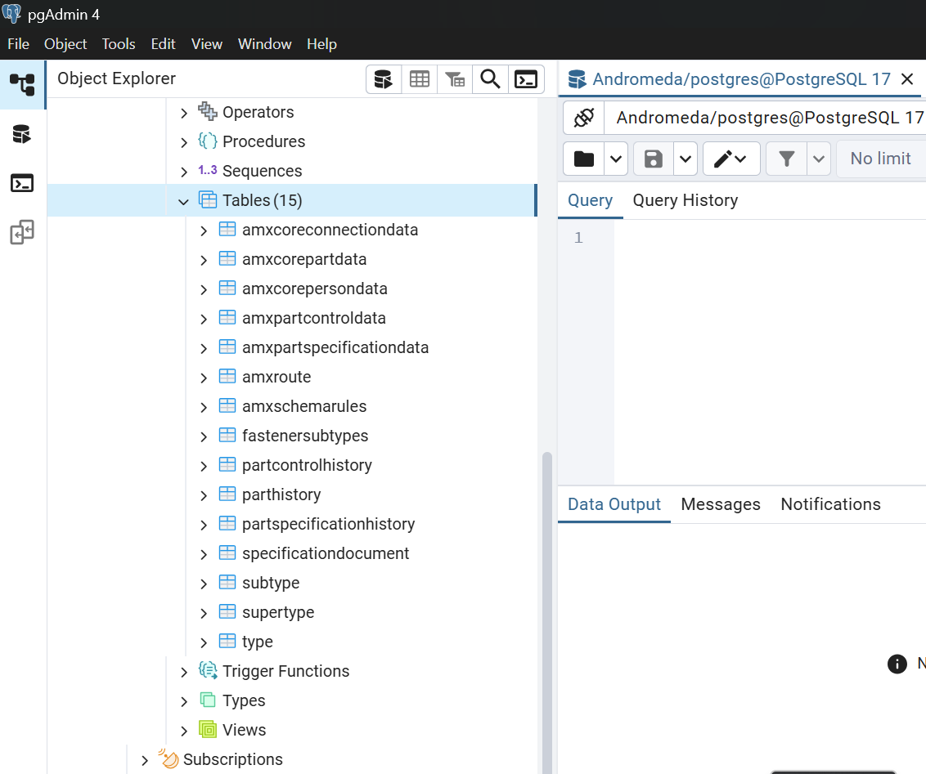

* 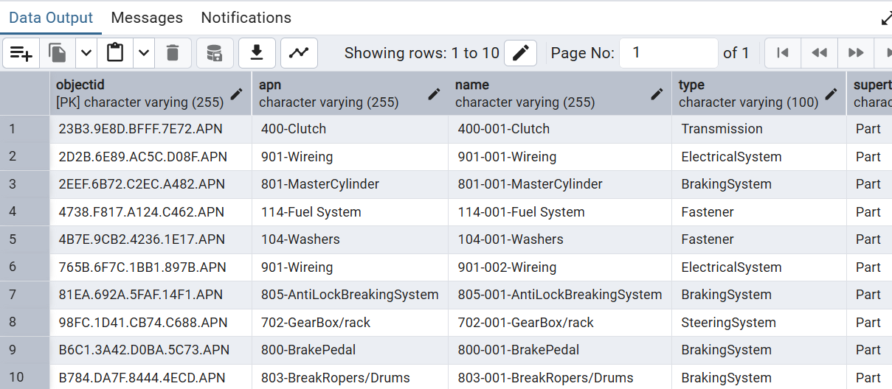All my data from my original database is backed into my new clone database.