|  |  |
| --- | --- |
| **Name:** | Nikhilesh |
| **Roll No & Branch:** | 64 |
| **Class/Sem:** | BE/VII |
| **Experiment No.:** | 01 |
| **Title:** | Installation of Unity and Visual Studio, setting up Unity for VR development, understanding documentation of the same. |
| **Date of Performance:** |  |
| **Date of Submission:** |  |
| **Marks:** |  |
| **Sign of Faculty:** |  |

**Aim:** Installation of Unity and Visual Studio

**Theory:**

Virtual Reality (VR) is a transformative technology that leverages computer-generated environments to immerse users in simulated realities, typically facilitated through specialized headsets. It has gained widespread use due to its ability to transport users to entirely different worlds, whether for entertainment in gaming, immersive storytelling, or the creation of lifelike training simulations for industries like aviation, medicine, and engineering. In education, VR enables dynamic and interactive learning experiences, from exploring historical sites to understanding complex scientific concepts. Additionally, it is employed in therapeutic settings, offering treatment options for conditions like PTSD or phobias. As VR technology advances, its applications continue to expand, revolutionizing how we engage with information, experiences, and virtual spaces.

**Procedure:**

1. Install Unity and Visual Studio.
2. Choose your VR platform and install the respective SDK.
3. Create a new Unity 3D project and enable VR support.
4. Import the VR SDK and assets.
5. Set up a VR camera rig (e.g., OVRPlayerController for Oculus).
6. Design your VR environment with 3D models and terrain.
7. Refer to official documentation for your VR platform and Unity for guidance.
8. Learn how to use the SDK's features, such as hand tracking and controllers.
9. Explore scripting for VR interactions (grabbing, throwing) in Unity.
10. Join VR developer communities and seek tutorials or courses for additional learning and support.

**Result:**

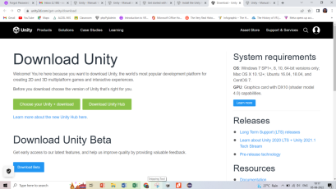

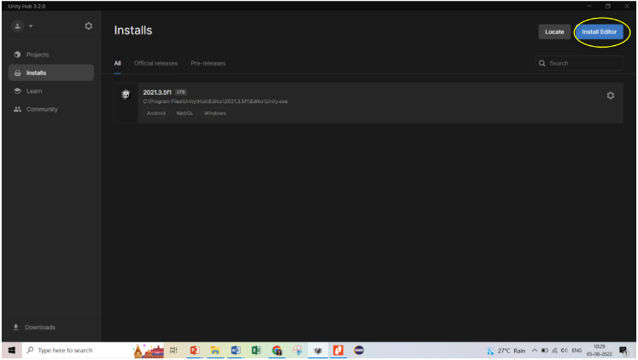

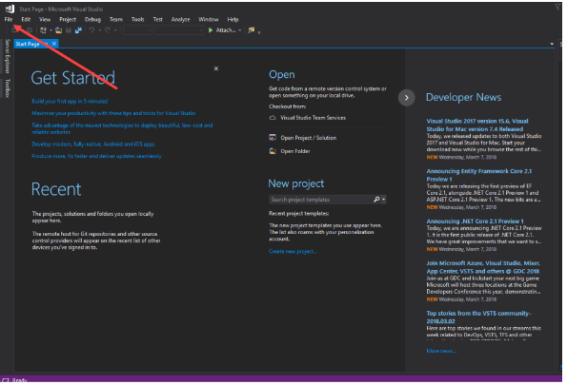

**Conclusion:**

The installation of Unity and Visual Studio is a crucial first step in entering the exciting world of Virtual Reality (VR) development. The process involves setting up the necessary tools, integrating the VR SDK, designing virtual environments, and learning to harness the full potential of VR features and interactions. Additionally, connecting with VR developer communities and seeking out tutorials and courses is essential for continuous growth and support in this rapidly evolving field. Embracing VR development has the potential to reshape how we engage with information and experiences in the digital age.