**Analytics using clickstream Data**

**Clickstream Data**

* Clickstream data is an information trail a user leaves behind while visiting a website. It is typically captured in semistructured website log files.
* These website log files contain data elements such as a date and time stamp, the visitor’s IP address, the destination URLs of the pages visited, and a user ID that uniquely identifies the website visitor.

**Potential Uses of Clickstream Data**

One of the original uses of Hadoop at Yahoo was to store and process their massive volume of clickstream data. Now enterprises of all types can use Hadoop and the cloudera to refine and analyze clickstream data.

They can then answer business questions such as:

* What is the most efficient path for a site visitor to research a product, and then buy it? (Path Optimization)
* What products do visitors tend to buy together, and what are they most likely to buy in the future? (Association Analysis & Next product to buy)
* Where should I spend resources on fixing or enhancing the user experience on my website? (Allocation of website resources)

we will focus on the “path optimization” use case. Specifically: how can we improve our website to reduce bounce rates and improve conversion?

**Input Data**

Here’s a summary of the data we’re working with:

* **Omniture logs** – website log files containing information such as URL, timestamp, IP address, geocoded IP address, and user ID (SWID). The Omniture log dataset contains about 4 million rows of data, which represents five days of clickstream data. Often, organizations will process weeks, months, or even years of data.
* **Users**– CRM user data(registered Users) listing SWIDs (Software User IDs) along with date of birth and gender.
* **Products** – CMS data that maps product categories to website URLs.

**Expected Output:**

In order to optimize your website and convert more visits into sales and revenue.

* Analyze the clickstream data by location
* Filter the data by product category
* Graph the website user data by age and gender
* Pick a target customer segment
* Identify a few web pages with the highest bounce rates

**Loading And Refining Website Data in HDFS(cloudera)**

First load the website data files into Hdfs, and then used Hive queries to refine the data.

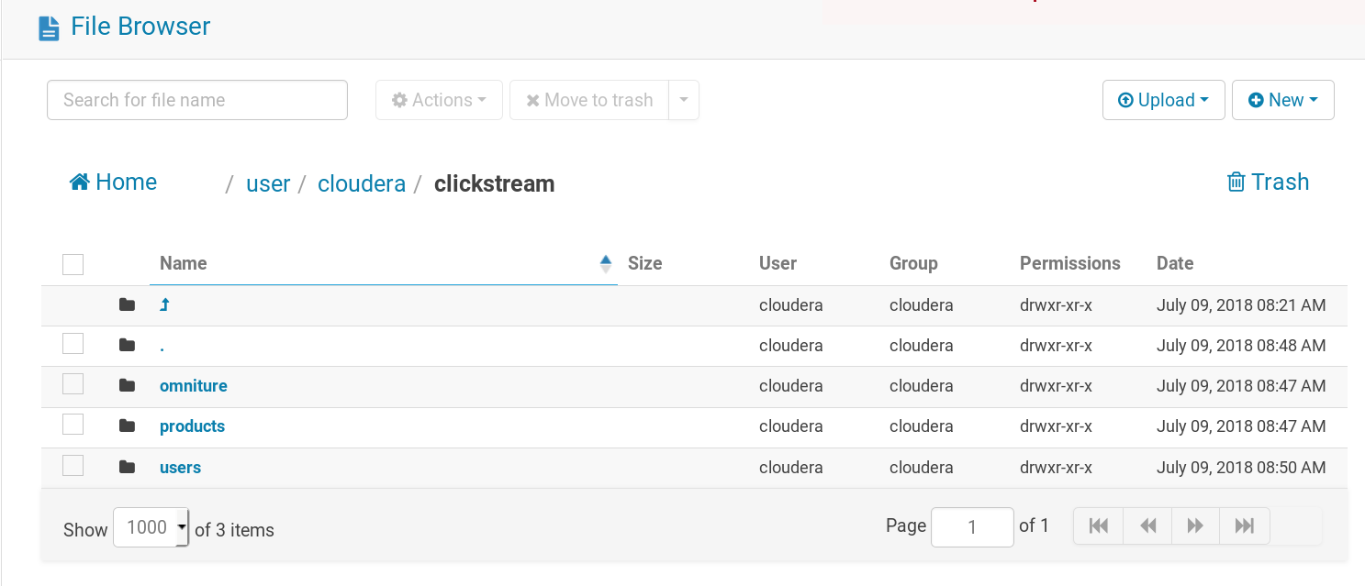

After loading All the data in hdfs, create the corresponding tables in hive ---

----------------------------------------user table-------------------------------------------------------------

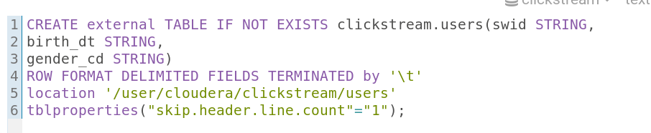

----------------------------------------product tabl----------------------------------------------------------

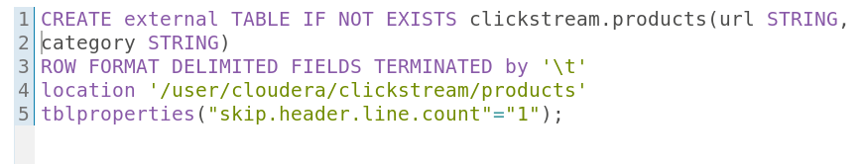

-----------------------------------omniture_logs_table-------------------------------------------------------

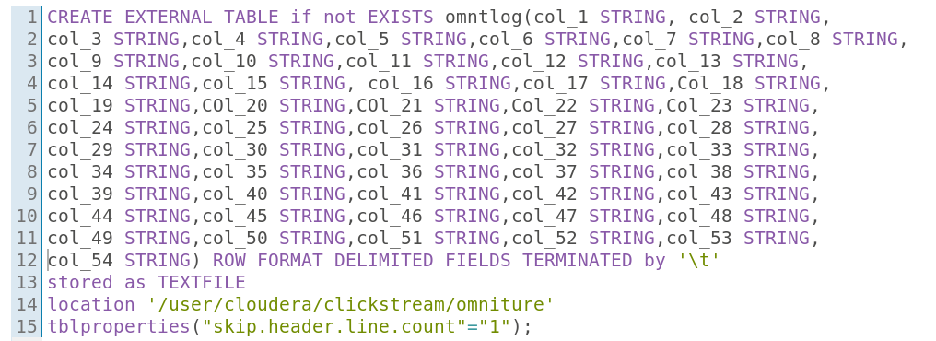

----------------------------------refined_ominture_table------------------------------------------------------

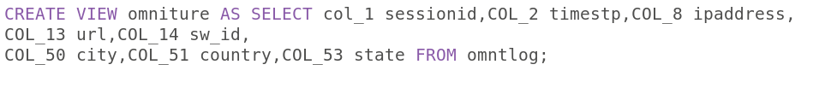

--------------------------------refined_user_table_after_calculating_age-------------------------------------

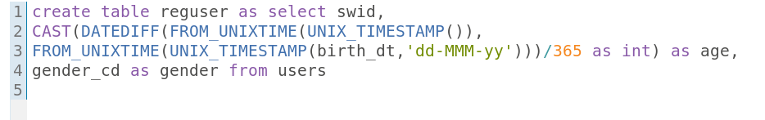

------------------------------Final table for visualization after joining three tables-----------------------

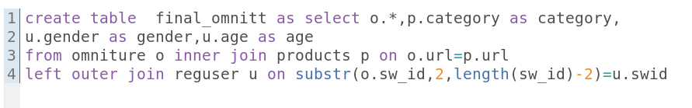

**Visualization :-**

Connect tableau with hiveserver2 using ip address. After the connection established

Connect with data source.

