Bachelor Thesis Project Plan
Community-Aware Influence Maximization
1. Background
Influence Maximization (IM) is a core problem in social network analysis.
The goal is to select a small set of nodes (seed set) such that the expected spread of influence in the network is maximized.
The problem is:
- NP-Hard
- Typically solved using approximation algorithms
- Based on diffusion models like Independent Cascade (IC)
A key theoretical property used in IM is submodularity, which ensures that a greedy algorithm achieves a
$$(1-1/e)≈63.2\%$$
approximation of the optimal solution.

2. Core Algorithms to Study and Implement
Before proposing any improvement, we must implement standard baselines.
2.1 Independent Cascade (IC) Model
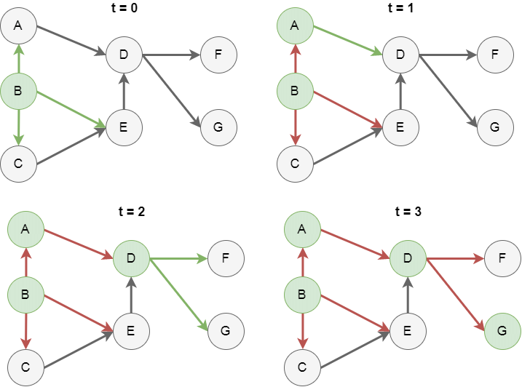
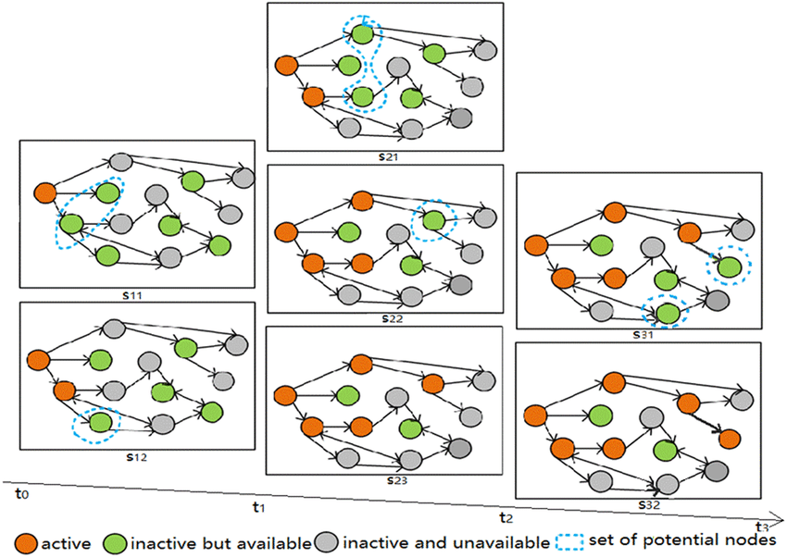
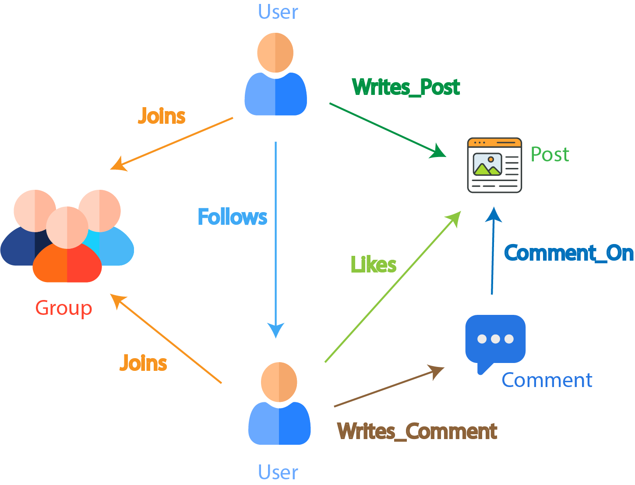
4
How it works:
- Start with seed nodes
- Each activated node gets one chance to activate each inactive neighbor
- Activation succeeds with probability p
- Process continues until no more activations occur
This requires Monte Carlo simulations to estimate spread.

2.2 Greedy Algorithm
Procedure:
- Iteratively select node with highest marginal gain
- Repeat until k seeds selected
Pros:
- Theoretical 63% guarantee
Cons:
- Very slow due to repeated simulations

2.3 CELF (Cost-Effective Lazy Forward)
Optimized greedy using lazy evaluation.
Idea:
- Reuse marginal gains
- Avoid unnecessary recomputation
Much faster than naive greedy.

2.4 Reverse Influence Sampling (RIS)
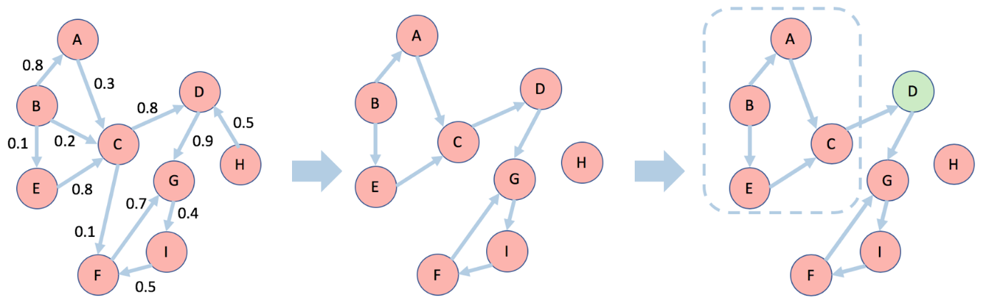

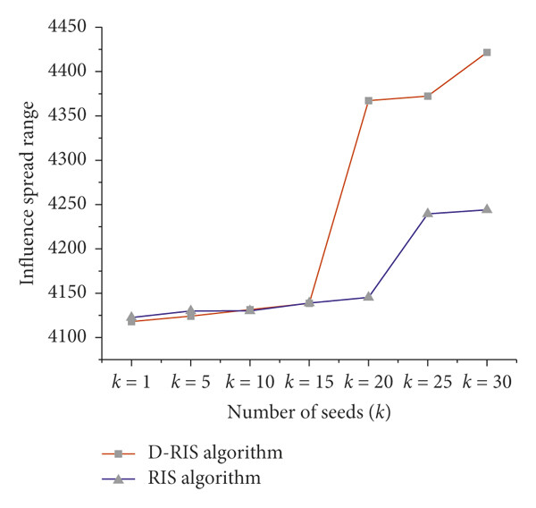
4
Key Idea:
Instead of simulating forward influence spread:
- Randomly sample Reverse Reachable (RR) sets
- Select nodes covering most RR sets
- Converts IM into a maximum coverage problem
Advantages:
- Highly scalable
- State-of-the-art for large networks

3. Possible Research Directions Considered
We evaluated three directions:
Direction A: Spread Improvement
Goal: Increase total influence spread beyond RIS.
Pros:
- Easy metric
- Clear comparison
Cons:
- RIS already near optimal
- Hard to beat significantly
- Risky for first paper
Risk Level: Medium

Direction B: Community Diversity / Balanced Coverage (Recommended)
Goal:
Ensure seeds are distributed across communities rather than concentrated in dominant regions.
Motivation:
Real-world networks have modular structure. Pure spread maximization may cluster seeds in one large community.
Idea:
Modify RIS to incorporate structural balance.
Example Objective:
Spread − λ × Community Imbalance
Evaluation Metrics:
- Total spread
- Community coverage
- Seed distribution
- Runtime
Pros:
- Easier to introduce novelty
- Realistic problem
- Good experimental scope
- Safer for first paper
Risk Level: Low–Medium

Direction C: Runtime Optimization
Goal:
Reduce computational time using community-based pruning.
Pros:
- Easy evaluation (runtime)
- Implementation-focused
Cons:
- Lower novelty
- Needs large datasets
Risk Level: Low

4. Final Recommended Direction
Selected Direction:
Community Diversity / Balanced Coverage using RIS

5. Proposed Thesis Title
Community-Aware Reverse Influence Sampling for Balanced Influence Maximization
Alternative options:
- Improving Seed Diversity in Influence Maximization via Community-Constrained Reverse Sampling
- An Empirical Study of Community-Guided Seed Selection in Influence Maximization

6. Proposed Problem Statement
Traditional Reverse Influence Sampling (RIS) methods maximize expected influence spread without considering the modular structure of real-world networks. This may result in seed nodes concentrated within dominant communities.
This work proposes a community-aware extension of RIS that incorporates structural diversity into seed selection. The goal is to improve influence coverage across communities while maintaining scalability and competitive spread performance.

7. Implementation Plan (2 Months)
Weeks 1–2
- Study IC model
- Study submodularity (intuition only)
- Implement IC simulator
- Implement Greedy
Week 3
- Implement CELF
Week 4
- Implement RIS
Week 5
- Implement community detection (Louvain)
Week 6
- Modify RIS to enforce community balancing
Week 7
- Run experiments
- Compare:
  - Spread
  - Runtime
  - Community coverage
Week 8
- Write thesis
- Prepare plots
- Analyze results

8. Minimal Reading Checklist
Must Read:
- Kempe, Kleinberg, Tardos (2003)
  - IC model
  - Greedy
  - Submodularity intuition
- Tang et al. (2015)
  - Reverse Reachable sets
  - RIS algorithm overview
Optional (if community-based approach chosen):
- Louvain method overview
- Modularity concept
Avoid:
- Deep reinforcement learning IM
- Differential privacy IM
- Blockchain IM
- Heavy theoretical submodular proofs

9. Why This Topic Is Suitable
- Manageable in 2 months
- Moderate novelty
- Clear evaluation metrics
- Strong experimental component
- Safe for first research paper
- Allows both algorithm design and analysis

10. Expected Contributions
- Implementation of classical IM baselines
- Design of community-aware RIS variant
- Empirical evaluation of spread vs structural balance
- Analysis of trade-off between influence and diversity

11. Overall Research Strategy
Focus on:
- Clean implementation
- Strong experiments
- Clear comparisons
- Honest analysis
Avoid:
- Overcomplicating theory
- Attempting completely new diffusion models
- Competing directly with heavy state-of-the-art theory

