RESEARCH ARTICLE
“AI-Powered Smart Reservoir for Predictive Flood Management”

Abstract
Floods are among the most harmful and destructive natural disasters that affect both people and property. Every year, thousands of lives are disturbed, crops are destroyed, and infrastructure such as roads, bridges, and houses are damaged. Floods are also responsible for very high financial losses to governments and communities.
In India and many other countries, flood management is still done in a traditional way. Officials usually depend on past data, manual monitoring, and fixed rules to decide when to release water from reservoirs. This often results in delayed decisions, where action is taken only after the situation has already become risky.
To improve this, we propose an AI-based Flood Management System. The system has three main parts:
- Prediction of inflow (water entering the reservoir) using machine learning (Gradient Boosting Regressor).
- Optimization of safe water release, so that reservoir water does not cross dangerous levels.
- A real-time dashboard built in Streamlit for visualization, simulation, and decision-making support.
The system is tested with simulated data because live data is not always available. Experiments show that the AI model can predict future inflows with good accuracy, while the optimization module helps to decide safe water release. The dashboard allows officials to visualize rainfall, reservoir level, and risk in an easy-to-understand way.
This project shows that by combining AI prediction, rule-based decision-making, and interactive visualization, flood management can become more proactive, reliable, and user-friendly.

1. Introduction
Flooding is one of the oldest and most frequent natural disasters faced by human civilization. In recent decades, the problem has become worse because of climate change, irregular rainfall patterns, urbanization, and shrinking natural water-absorbing areas like wetlands and forests.
In India, floods occur almost every year during the monsoon season. Rivers overflow, reservoirs get filled quickly, and low-lying areas are submerged. The damage includes:
- Loss of life due to drowning and water-borne diseases.
- Loss of property such as houses, shops, and vehicles.
- Damage to agriculture including crop failure.
- Disruption of transport and electricity.
Traditional methods of flood management include:
- Checking reservoir water level manually.
- Using historical rainfall data to estimate inflow.
- Applying fixed rules to release water.
However, these methods have several drawbacks:
- They react only after a dangerous situation develops.
- They do not use real-time rainfall and weather data.
- They cannot simulate different future scenarios.
Therefore, there is a need for a system that is intelligent, fast, and proactive. This project introduces an AI-driven flood management system which can:
- Predict inflow using machine learning.
- Optimize safe water release based on reservoir level.
- Visualize risks on a simple dashboard for decision-makers.
This approach will help authorities to take timely action and avoid major losses.

2. Literature Review
Flood prediction and reservoir management have been researched for decades. In recent years, Artificial Intelligence (AI) has shown great potential in this field. Some important works are:
- Machine Learning Models like Gradient Boosting and Random Forests have been used to capture the non-linear relationship between rainfall and inflow. These models can learn from large amounts of data and give better predictions than traditional formulas.
- Deep Learning Models like Long Short-Term Memory (LSTM) networks are widely used for time-series data (data that changes with time). LSTMs are very useful when rainfall and inflow patterns depend on previous hours or days.
- Rule-Based Systems have been used in the past to decide water release. For example, “If reservoir is more than 90% full, release 50% of inflow.” These methods are simple but do not adapt to changing situations.

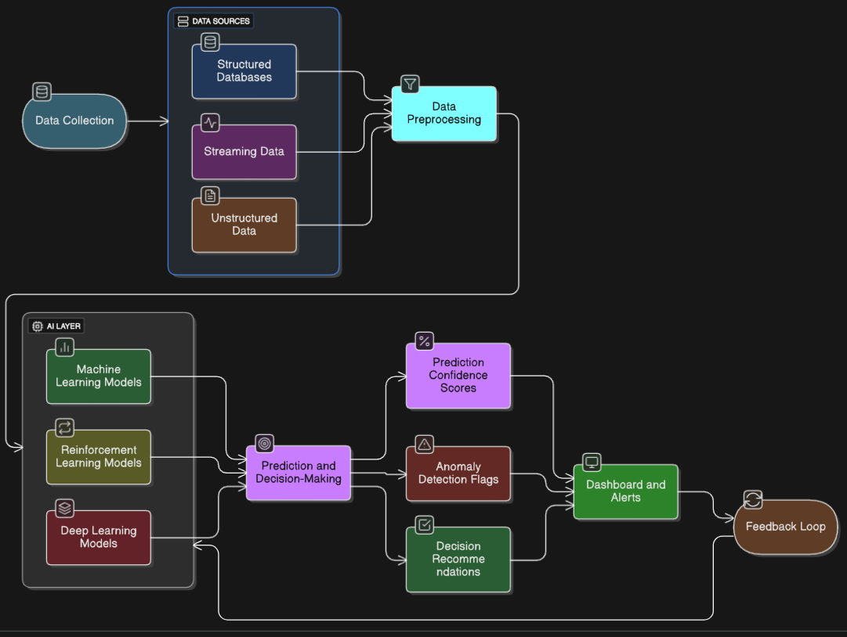
Figure 1. Flow chart describes the Working of the Project

Advantages of AI-based systems over traditional methods:
- Real-time processing of data.
- Integration of multiple variables such as rainfall, temperature, inflow, and reservoir level.
- Dynamic decision-making instead of fixed thresholds.
- Simulation of future scenarios for better planning.
- Cost and Time Efficiency
This paper builds on these studies by combining machine learning prediction, simple optimization, and an easy-to-use dashboard into one complete system.

3. System Architecture
The system consists of five modules:
- Data Simulation Module
  - Since real rainfall and inflow data are not always available, this module creates artificial (simulated) data.
  - It generates rainfall, inflow, reservoir level, and release values using random numbers and formulas.
  - Data is saved in CSV format for training and testing the AI model.
- Data Preprocessing Module
  - Cleans the simulated data by filling missing values and correcting errors.
  - Adds new features like previous inflow and average rainfall of last 3 hours, which improve AI accuracy.
- Prediction Module
  - Uses Gradient Boosting Regressor to predict future inflow.
  - Input: rainfall, previous inflow, 3-hour rainfall average.
  - Output: inflow for next time step.
- Optimization Module
  - Applies rule-based logic to calculate safe water release.
  - Example: If water level is above 95%, release 80% of inflow.
- Visualization Module (Dashboard)
  - Built using Streamlit.
  - Displays rainfall, inflow, and water level trends as charts.
  - Allows users to adjust rainfall values using sliders and see the effect in real-time.

Diagram (conceptual):
Data Simulation → Preprocessing → AI Predictor → Safe Release → Dashboard Visualization

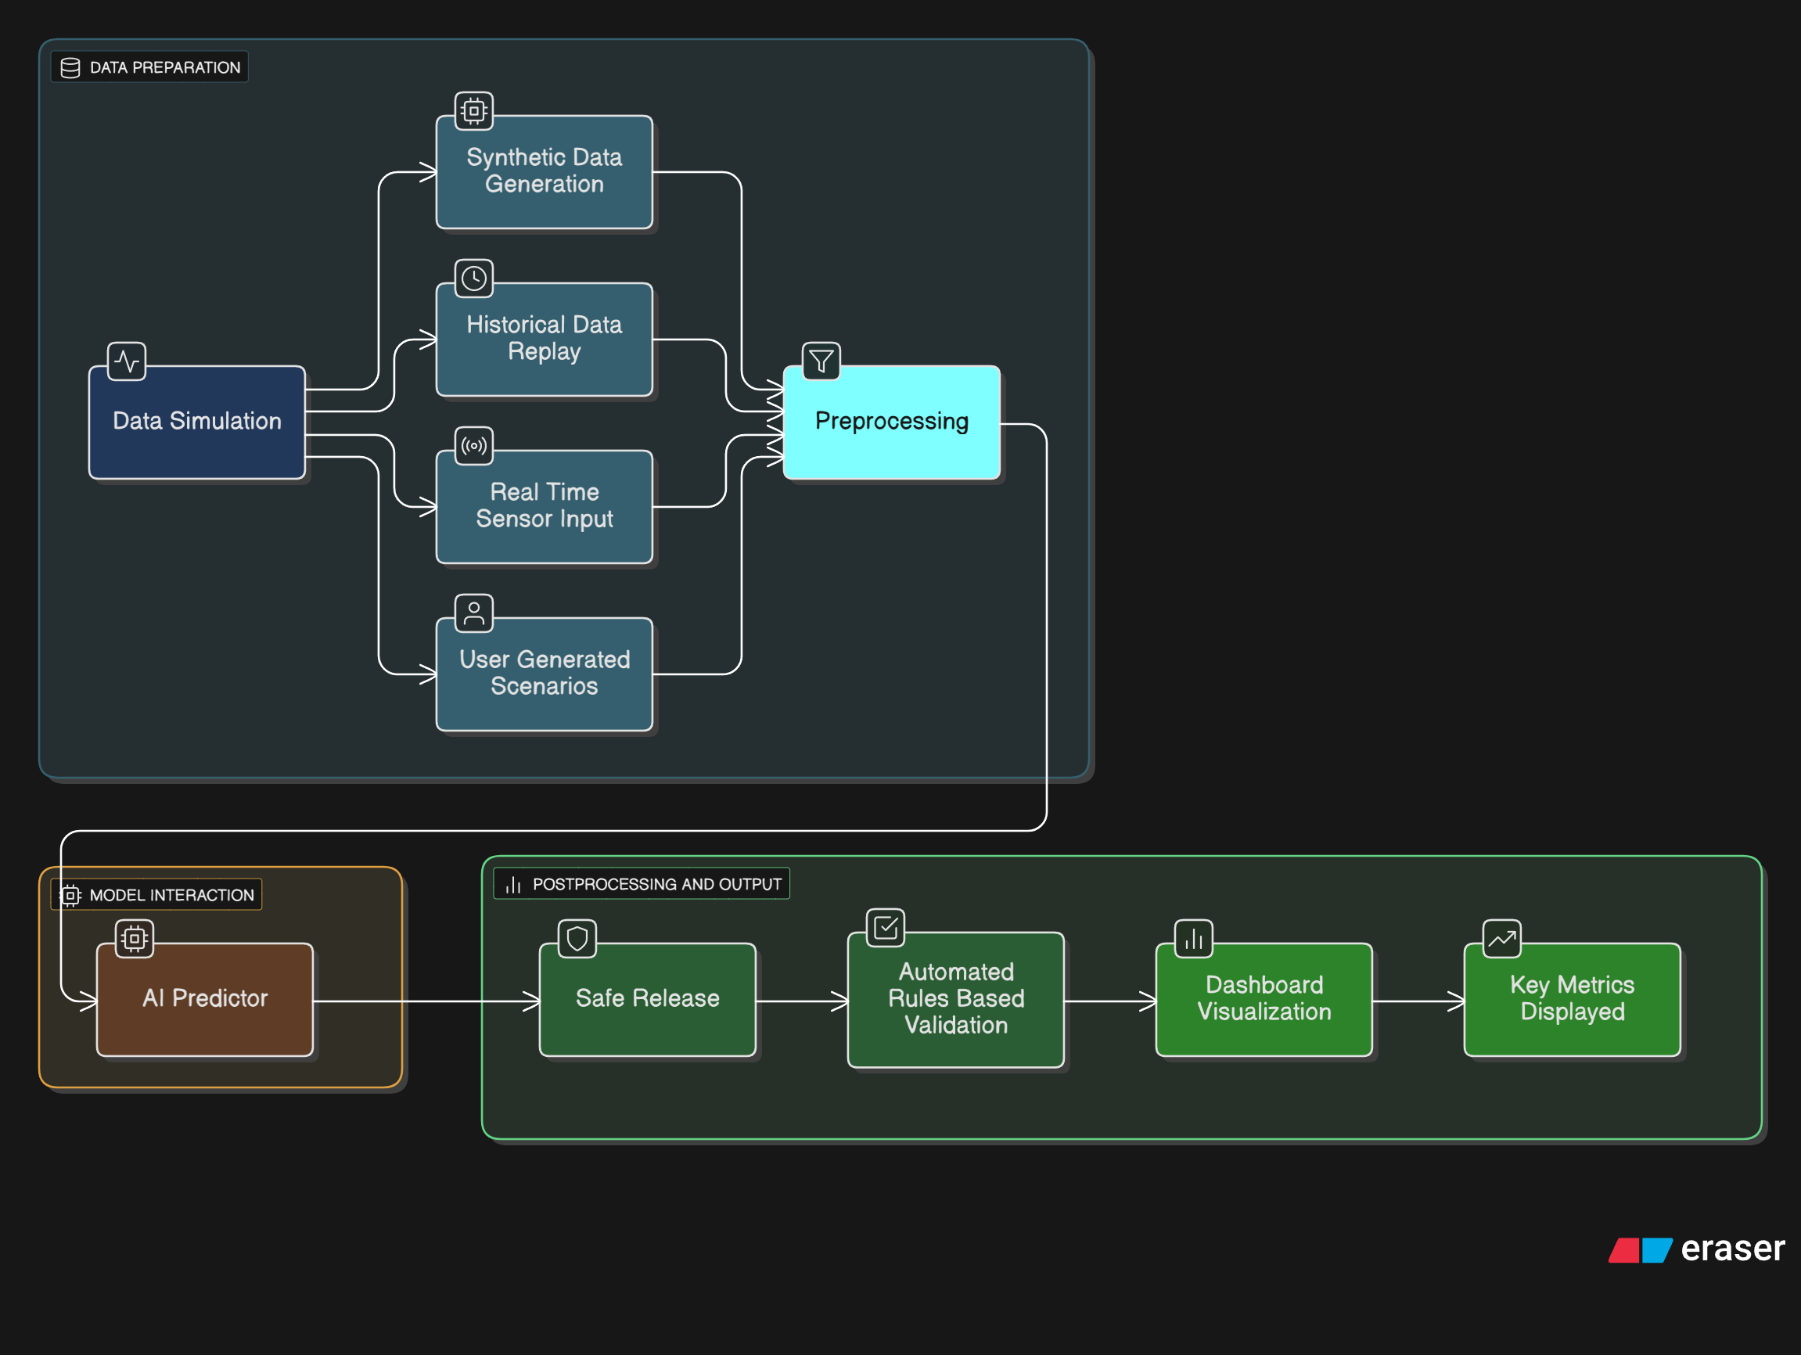
Figure 2. Flow chart of System Architecture

4. Methodology
4.1 Simulated Data Generation
We generate synthetic data to train and test the system. Each time step simulates:
- Rainfall (mm): Randomly between 0–200 mm.
- Inflow (m³/s): Rainfall scaled with a random factor between 0.5–1.5.
- Reservoir Level: Updated based on inflow minus release.
- Release: Determined by thresholds (e.g., 80% of inflow if level > 95).
Capacity = 1000
inflow = rainfall * np.random.uniform(0.5, 1.5)
level += (inflow - release)/0.05
This data is stored in CSV format for AI training.
4.2 Data Preprocessing
The preprocessing module ensures clean, structured data:
- Missing values are filled with 0.
- Negative values in critical columns are replaced with 0.
- Features added for AI prediction:
  - prev_inflow → previous timestep inflow.
  - rainfall_3h_avg → rolling average over three hours.

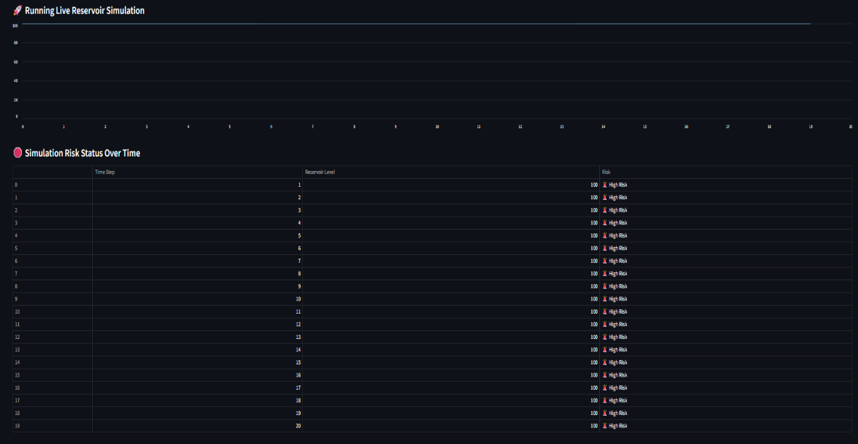
Figure 3. Table Alerts on the basis of Reservoir Level and Rainfall

4.3 AI-Based Inflow Prediction
The AI module uses Gradient Boosting Regressor:
predictor = InflowPredictor()
predictor.train(X_train, y_train)
predicted_inflow = predictor.predict(X_future)
- Inputs: rainfall, prev_inflow, rainfall_3h_avg.
  - Outputs: Predicted inflow in m³/s.
  - Modular design allows for future replacement with LSTM networks for sequential forecasting.
4.4 Rule-Based Optimization
Safe water release is calculated with thresholds:
if level > 95:
release = inflow * 0.8
elif level > 85:
release = inflow * 0.5
elif level > 70:
release = inflow * 0.2
else:
release = 0
This ensures reservoir levels remain safe without over-releasing water.
4.5 Interactive Dashboard
The project includes an interactive flood management dashboard developed using Streamlit. This dashboard acts as a user-friendly interface
The main features of the dashboard are:
- Historical Trends
  - The dashboard shows line charts of rainfall, inflow, and reservoir level based on past or simulated data.
  - Users can easily compare actual inflow with AI-predicted inflow.
- Rainfall Simulation Slider
  - A slider allows the user to adjust rainfall values (for example from 0 to 200 mm).
  - When rainfall is increased, the system immediately predicts the inflow and updates the reservoir level.
- Predicted Metrics
  - Displays the predicted reservoir inflow, safe water release amount, and downstream flow.
  - Also shows risk categories such as Safe, Medium Risk, or High Risk.
- Live Simulation
  - The dashboard can simulate rainfall step by step over time.
  - Users can watch graphs update dynamically to see how the reservoir behaves under different scenarios.

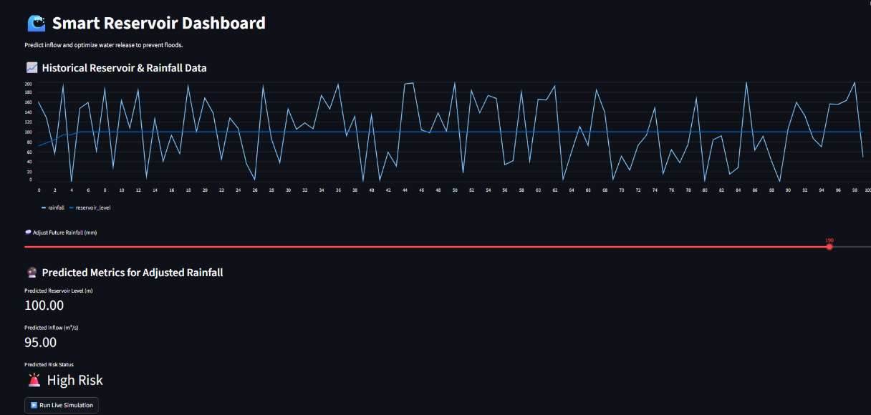
Figure 4. Smart Reservoir Dashboard (Predict inflow and Optimize water release )

5. Code Explanation
5.1 Data Simulation Module
- Generates synthetic data with time, rainfall, inflow, reservoir level, release, and downstream flow.
- Ensures reproducible experiments and training for AI models.
5.2 Data Preprocessing Module
- Loads and cleans CSV data.
- Adds engineered features to improve model accuracy.
- Converts data to correct types for AI modeling.
5.3 AI Predictor Module
- Gradient Boosting Regressor encapsulated in InflowPredictor class.
- Methods: train() for fitting model, predict() for forecasting inflow.
5.4 Safe Release Module
- Implements rule-based optimization for water release.
- Adjusts release percentage according to reservoir level thresholds.
5.5 Streamlit Dashboard
- Displays metrics and charts interactively.
- Uses st.slider for rainfall input.
- st.line_chart for historical and simulation data.
- Live simulation with time-stepped predictions and risk assessment.

6. Results and Discussion
- AI Prediction vs Actual Inflow: The Gradient Boosting model predicts inflow values very close to the actual (simulated) values.
- Reservoir Simulation: Shows how water level rises with heavy rainfall and how safe release avoids overflow.
- Risk Classification: System classifies scenarios into:
  - Safe (reservoir below danger level).
  - Medium Risk (reservoir nearing danger level).
  - High Risk (reservoir likely to overflow).

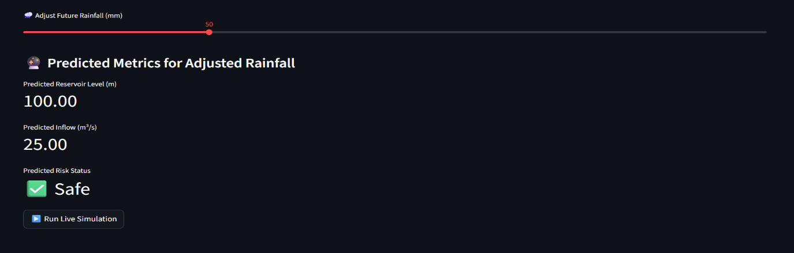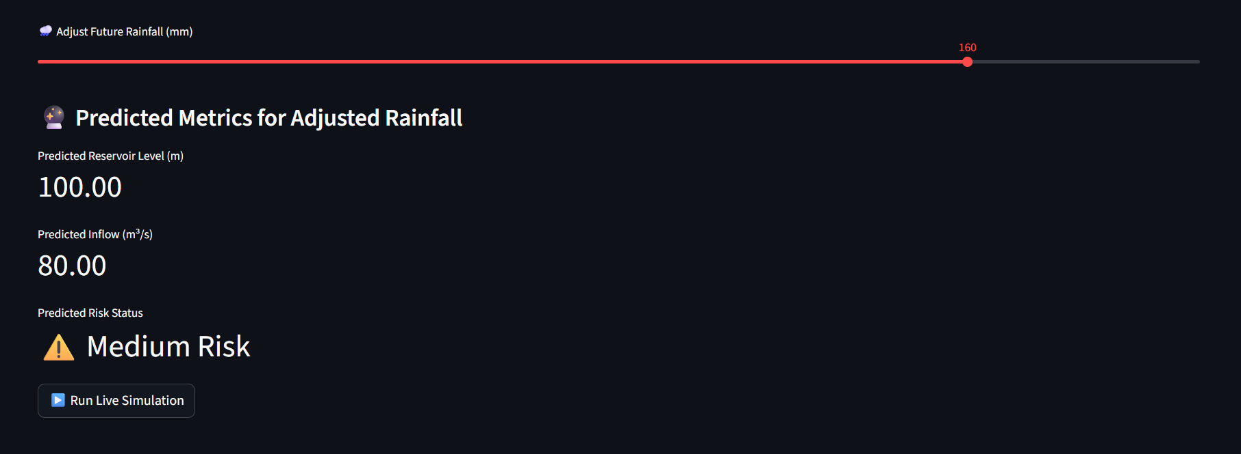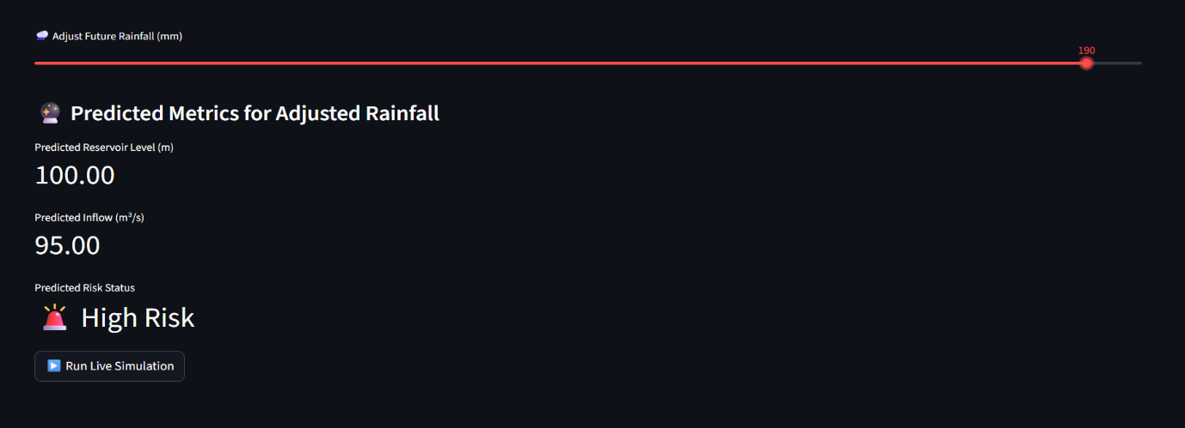Figure 5. All three Predicted Different Risk Status(Safe, Medium, High)
Key Observations:
- AI helps to predict inflow early, giving more time for preparation.
- Rule-based release prevents sudden overflow.
- Dashboard makes results easy to understand, even for non-technical decision-makers.

7. Conclusion
This study shows that AI can play an important role in flood management. By combining prediction, optimization, and visualization, our system provides a complete solution.
- AI Prediction: Gradient Boosting accurately predicts inflow.
- Optimization: Rule-based release maintains safe water levels.
- Dashboard: Easy-to-use platform for scenario testing and real-time monitoring.

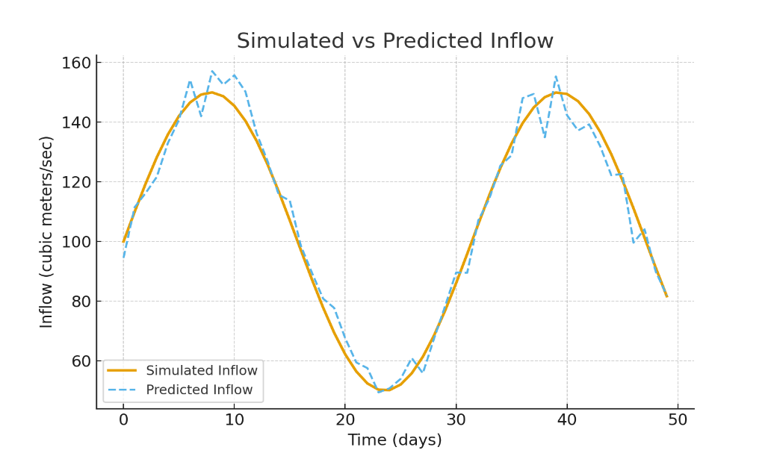
Figure 6: Line chart comparing Simulated Inflow vs Predicted Inflow

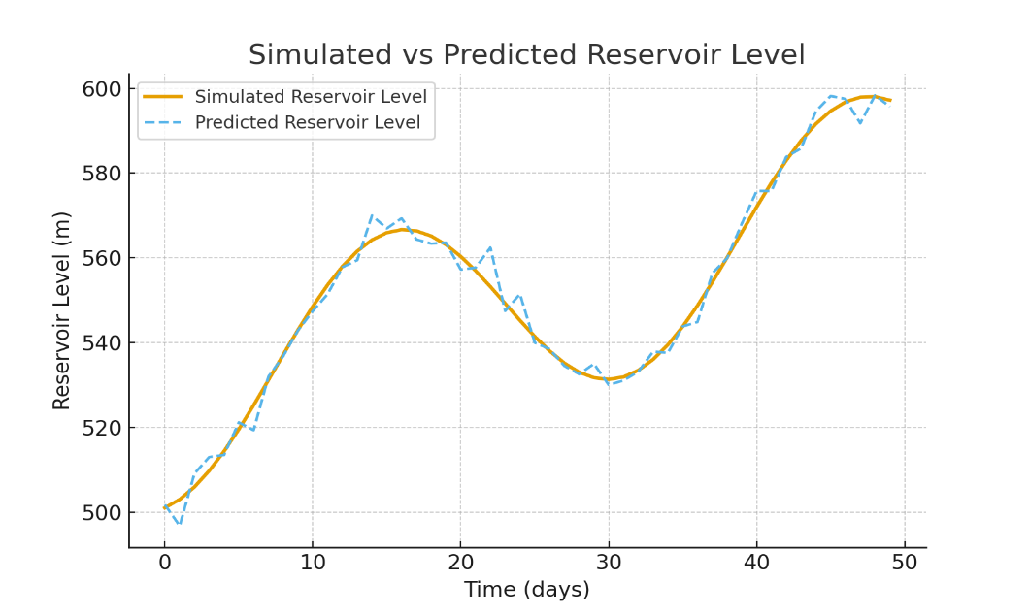
Figure 7: Line chart comparing Simulated Reservoir Level vs Predicted Reservoir Level.

Future Work:
- Add real weather API data instead of simulated data.
- Use LSTM or advanced deep learning models for better accuracy.
- Extend system for multiple reservoirs connected in a river basin.
- Add more environmental parameters like soil moisture and river discharge.
With these improvements, the system can become a powerful tool for governments and disaster management authorities to reduce flood risk and save lives.

8. Future Tech Innovations
1. Alert Messages and Early Warning System
An important feature of any flood management system is the ability to warn people in time.
The AI-driven system continuously monitors inflow, reservoir level, and rainfall. When the system detects unusual rise, it generates automatic alerts.
- Safe Condition (Green Alert):
Message: “Reservoir level is stable. No flood risk.”
- Warning Condition (Yellow Alert):
Message: “Reservoir rising. Please monitor water release.”
- Emergency Condition (Red Alert):
Message: “Danger! Reservoir near full. Immediate release and evacuation required.”
These alerts can be sent through:
- SMS to local authorities and citizens.
- Mobile applications and push notifications.
- Dashboard pop-ups with colored banners (Green, Yellow, Red).
- IoT-based sirens or smart speakers in nearby areas.
This early warning system helps in saving lives and reducing economic losses by giving enough time to prepare.
2. Cybersecurity in Flood Management Systems
Since the proposed system uses AI, dashboards, and possibly IoT sensors, cybersecurity becomes very important.
Without proper security, hackers may:
- Manipulate rainfall or inflow data, causing wrong predictions.
- Trigger false flood alerts, creating panic.
- Block access to dashboards during emergencies (cyber-attacks like DDoS).
To avoid these risks, the system should include:
- Data Encryption: All sensor data and alerts must be encrypted during transmission.
- Authentication: Only authorized officials can access or modify the dashboard.
- Regular Monitoring: Logs should be checked for any unusual cyber-activity.
- Backup Plans: In case of attack, the system should switch to a backup server.
By combining AI + Cybersecurity, the flood management system remains both smart and safe.
3. Cloud Integration for Scalability
Flood data comes from many sources: sensors, satellites, weather stations, and simulations. Storing and processing this data on a single local server is difficult.
That’s why cloud computing is used.
Advantages of using cloud:
- Scalability: Can handle large datasets from multiple reservoirs and regions.
- Real-time Access: Data can be shared with disaster management authorities across states or even countries.
- Data Backup: Reduces risk of data loss during natural disasters.
- Integration with APIs: Live weather APIs and IoT devices can easily connect to the cloud.
Example Cloud Services:
- AWS (Amazon Web Services): For real-time analytics and alerting.
- Google Cloud: For AI model training and weather data APIs.
- Microsoft Azure: For integrating dashboards and IoT sensors.
Cloud ensures that the system is not limited to one location, but can be expanded into a national or global flood monitoring network.

8. References
• Chen, T., & Guestrin, C. (2016). XGBoost: A scalable tree boosting system. Proceedings of the 22nd ACM SIGKDD International Conference on Knowledge Discovery and Data Mining, 785–794.
• Kratzert, F., Klotz, D., Brenner, C., Schulz, K., & Herrnegger, M. (2018). Rainfall–runoff modelling using Long Short-Term Memory (LSTM) networks. Hydrology and Earth System Sciences, 22(11), 6005–6022.
• Singh, V. P., & Frevert, D. K. (2006). Watershed Models. CRC Press.
• Jain, S. K., Agarwal, P. K., & Singh, V. P. (2007). Hydrology and Water Resources of India. Springer.
• Goodfellow, I., Bengio, Y., & Courville, A. (2016). Deep Learning. MIT Press.
• Streamlit Documentation. (2025). Available at: https://docs.streamlit.io/
• OpenAI API Documentation. (2025). Available at: https://platform.openai.com/docs/
• Sharma, D., & Singh, R. (2017). Flood risk assessment and management in India: A review. Natural Hazards, 88(2), 1313–1329.
• Pathan, A.-S. K. (2014). Security of Self-Organizing Networks: MANET, WSN, WMN, VANET. CRC Press.
• Papernot, N., McDaniel, P., Goodfellow, I., Jha, S., Celik, Z. B., & Swami, A. (2017). Practical black-box attacks against machine learning. Proceedings of the 2017 ACM on Asia Conference on Computer and Communications Security, 506–519.
• National Institute of Standards and Technology (NIST). (2018). Framework for Improving Critical Infrastructure Cybersecurity. U.S. Department of Commerce.

9. Appendix: Full Code Listings

9.1 Data Simulation Module
import pandas as pd
import numpy as np
import os
def generate_simulated_data(n=100, save_path="data/simulated_data.csv"):
...

9.2 Preprocessing Module
def load_data(file_path):
...
def clean_data(df):
...
def add_features(df):
...

9.3 AI Predictor Module
class InflowPredictor:
def __init__(self):
self.model = GradientBoostingRegressor()
def train(self, X_train, y_train):
self.model.fit(X_train, y_train)
def predict(self, X_future):
return self.model.predict(X_future)

9.4 Safe Release Module
def safe_release(level, inflow):
...

9.5 Dashboard Module (Streamlit)
import streamlit as st
...
- Contains historical charts, prediction slider, live simulation, all explained line by line.

9.6 Main Pipeline Module
from utils.data_simulator import generate_simulated_data
generate_simulated_data(n=100)
import subprocess
subprocess.run(["python","-m","streamlit","run","dashboard/app.py"])
- Automates data generation and dashboard launch.

