Ms.Nikitha G 1 1,1
Munirabad Munirabad Tb Dam Munirabad 583233 Gadag Gadag Karnataka India
Scan & Pay




Summary Account Payable Statement

Jio Number : 778610311066 Account Number: 410623613562
Statement No.: 434504604864 Statement Date: 07-Mar-2024 Statement Time: 03:54:17

Registered Mobile Number: +919019540406 || Email: reddynikitha2907@gmail.com
Statement as on 07-Mar-2024 Jio AirFiber

Particulars  (i) Connectivity Services | Invoice Number | Amount (`)
Previous Balance Due |  | 0.00
Payment Received |  | 0.00
Current Month Payable | 464002560511 | 269.94
Total (i) |  | 269.94
(ii) Platform Services
Previous Balance Due |  | 0.00
Payment Received |  | 0.00
Current Month Payable | 428504594405 | 485.64
Total (ii) |  | 485.64
Total current charges (i + ii) |  | 755.58
(iii) Previous Balance with RRL |  | -4240.92
Total Amount Payable (i + ii + iii) |  | -3,485.34

Pay By 15-MAR-2024
` -3,485.34

"To strengthen your Aadhaar, update your Aadhaar if 10 years old"

Payment Options

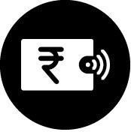

JioPay

JioAutoPay

 ACH - (Direct Debit)
set ACH mandate on your bank account.
Visit the nearest Jio Store along with a cancelled cheque.

 Standing Instructions (Credit Card)
Set JioAutoPay through My Jio App.
Download the MyJio App from Play Store or App Store.

 EBPP
Register Jio with your bank for an auto bill presentment and payment mandate on your bank account or credit card.

JioDigiPay

 My Jio & Jio.com
Pay bills using credit/debit card/netbanking/ e-wallets/UPI onMy Jio App or visit www.Jio.com and click on Quick Pay
Download the app from Play Store or App Store

GSTIN : 29AAECJ6878N1ZK PAN : AABCR1718E
We also accept Cash /Credit /Debit Card at the Jio Store

Registered Office: Reliance Retail Limited
3rd floor, Court House, Lokmanya Tilak Marg, Dhobi Talao, Mumbai 400002 Phone: 022-67673800 CIN: U01100MH1999PLC120563

Your Payment History
No Bill History Available
No Payment History Available

Important Information

Payments
- In the event of non-payment, part payment or late payment of the outstanding amount by the due date, Reliance Jio Infocomm Limited (RJIL) and Jio Platforms Limited (JPL) reserves the right to disconnect services.

- RJIL & JPL has appointed RRL as a master collection agent and hence this statement has consolidated charges for Connectivity from RJIL and Platform services from JPL.

Complaints & Service Requests

You can call 1800-89-69999 to register your service request / complaint or write to jiofibercare@jio.com

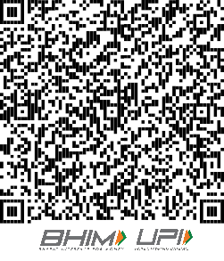
Original for Recipient

Mr. Sreekanth Reddy
Jio Number : Account Number :
918539356911
520163229817

1 1,1
GST Bill Number : S29I232412491514

Munirabad Munirabad Tb Dam Munirabad 583233 Gadag Gadag Karnataka India
Document Number : Billing cycle date :
464002560511
06-MAR-2024

Tax invoice date : 06-MAR-2024

Place of Supply: 29 Karnataka
GST Registration Number: Not Available
Due Date :
Credit Limit :
Security Deposit :
15-MAR-2024
` 388.00
` 0.00

Registered Mobile : +919019540406 | Aadhaar Number : XXXX XXXX9306 | E-Mail : reddynikitha2907@gmail.com

Connectivity Services






Your Jio Air Fiber Bill From 04-MAR-2024 to 05-MAR-2024 _{Refer} _{following} _{pages} _{for} _{details} _{of} _{charges}

My Previous Balance (`)
0.00

Payment Received (`)
0.00

Current Taxable Charges (`)
228.76

Taxes (`) 41.18

Total Current Month Charges (`)
269.94

Total Payable (`)
269.94

 |  |  |  |  | Amount (`)
1 Monthly Plan Charges |  |  |  |  | 228.76
2 Usage Charges
 |  | Volume / Duration |  | Amount
ISD / Premium Calling |  |  |  | 0.00
Data |  | 0.000 GB |  | 0.00
VAS |  | 0 |  | 0.00 | 0.00
3 Other Plan Charges |  |  |  |  | 0.00
Total Usage Summary | Total Usage |  | Chargeable Usage | Charged Amount
Voice Local | 00:00:00 |  | 00:00:00 | 0.00
Voice STD | 00:00:00 |  | 00:00:00 | 0.00
ISD / Premium Calling | 00:00:00 |  | 00:00:00 | 0.00
Data | 14.550 GB |  | 0.000 GB | 0.00
VAS | 0 |  | 0 | 0.00
4 One Time Charges |  |  |  |  | 0.00
5 Total value of charges (1+2+3+4) |  |  |  |  | 228.76
6 Credit & Adjustment
Current Month's Discount |  |  |  | 0.00
Previous Month's Adjustments |  |  |  | 0.00 | 0.00
7 Charges (5+6) |  |  |  |  | 228.76
8 Taxes  CGST (9%) |  |  |  | 20.59
SGST (9%) |  |  |  | 20.59 | 41.18

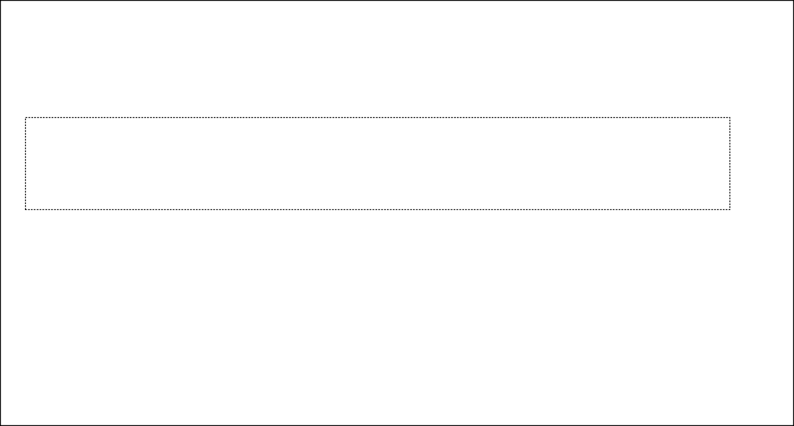
Payment Options
- Bill Discount Including Tax
- Security Deposit Returned
- Pre to Post Migration Balance Transfer
- Waivers
Current Month Charges (7+8+9+10+11+12)
0.00
0.00
0.00
0.00
269.94






JioAutoPay

ACH - (Direct Debit)
Set ACH mandate on bank account. Visit the nearest

Registered Office: Reliance Jio Infocomm Limited Office-101, Saffron, Nr.Centre Point, Panchwati 5 Rasta, Ambawadi, Ahmedabad-380006, Gujarat, India

JioPay
Register with JioPay and
enjoy seamless payments.
*Details under Important Information - JioPay

BHIM UPI QR
Scan and pay with UPI QR Code from any UPI enabled App
Jio Store along with a cancelled cheque.

Standing instruction (Credit Card)
Set JioAutoPay through MyJio App.Download the MyJio App from Play Store or App Store.
JioDigiPay

My Jio & Jio.com
Pay bills using credit/debit card/net banking/e- wallets/UPI on My Jio App or visit www.Jio.com and click on Quick Pay. Download the app from Play Store or App Store.
CIN: U72900GJ2007PLC105869

State Office: Reliance Jio Infocomm Limited
Reliance Corporate It Park Ltd, Sy.No.39, Avana Building, Municipal Plot Bering No.884/327/39, Iblur Village
Opp. Columbia Asia Hospital, Begu, Hobli, Ward No.174, Outer Ring Road Bengaluru 560103 Karnataka

GST Registered Office: 2, 62/2 Richmond Road Bengaluru (Bangalore) Urban
560025 Bangalore

We also accept Cash / Credit / Debit Card at the Jio Store.
GSTIN: 29AABCI6363G1ZF PAN: AABCI6363G
Reach Us
Call 199 (from a Jio number) or 1800-89-69999 (from other networks) | Write to Jiofibercare@jio.com | Manage your world of Jio with MyJio app | Visit www.jio.com

Mr. Sreekanth Reddy

Your Jio Plan Details
AirFiber_599_6M: Benefits : 1)Unlimited Data(1000GB/Month @30 Mbps High Speed Data, thereafter unlimited at 64kbps) 2)Voice: Unlimited. 3)Subscription to premium 13 OTT Apps 4)Validity: Bill Cycle
Note :This plan is an advance rental plan
Base Tariff Post Entitlement Voice Calls:Unlimited
Data: Unlimited @ 64 Kbps
- For ISD Calls, International Roaming, Premium Numbers, Short Codes and Value Added Services and tariff details please visit www.jio.com.
Jio Number : 918539356911
Tax invoice date : 06-MAR-2024

as on 05-MAR-2024

Base Monthly Rental | Voice Call (Local/STD) | Data | ISD  (minutes)
INR 599 | Unlimited | Unlimited Data(1000GB/Month @30 Mbps High Speed Data, thereafter unlimited at 64kbps) | -
Complimentary access to Jio Apps.

Signature Not Verified
Digitally signed by Reliance Jio Infocomm Limited Date: 20240307055004
Reason: Digitally Signed Location: Mumbai

Mr. Sreekanth Reddy Jio Number : 918539356911 Tax invoice date : 06-MAR-2024

Itemised Usage
No. | Start Date & Time | End Date & Time | Destination | Total Usage | Billed Usage | Free Usage | Chargeable Usage | Amount
 |  |  |  | (MB) | (MB) (A) | (MB) (B) | (MB) (C=A-B) | (`)
1.0 | DATA
1.1 | Usage in India
1.1.1 | LTE
1 | 05-MAR-2024 20:32:18 | 05-MAR-2024 21:32:17 | JIONET | 180.150 | 180.157 | 180.157 | 0.000 | 0.00
2 | 05-MAR-2024 19:32:18 | 05-MAR-2024 20:32:18 | JIONET | 51.497 | 51.504 | 51.504 | 0.000 | 0.00
3 | 05-MAR-2024 18:32:18 | 05-MAR-2024 19:32:18 | JIONET | 922.272 | 922.276 | 922.276 | 0.000 | 0.00
4 | 05-MAR-2024 18:18:18 | 05-MAR-2024 18:32:18 | JIONET | 1945.618 | 1945.625 | 1945.625 | 0.000 | 0.00
5 | 05-MAR-2024 17:32:17 | 05-MAR-2024 18:18:18 | JIONET | 1945.605 | 1945.606 | 1945.606 | 0.000 | 0.00
6 | 05-MAR-2024 16:32:17 | 05-MAR-2024 17:32:17 | JIONET | 1009.245 | 1009.248 | 1009.248 | 0.000 | 0.00
7 | 05-MAR-2024 15:32:17 | 05-MAR-2024 16:32:17 | JIONET | 141.073 | 141.075 | 141.075 | 0.000 | 0.00
8 | 05-MAR-2024 14:32:17 | 05-MAR-2024 15:32:17 | JIONET | 4.187 | 4.190 | 4.190 | 0.000 | 0.00
9 | 05-MAR-2024 13:32:16 | 05-MAR-2024 14:32:17 | JIONET | 4.453 | 4.454 | 4.454 | 0.000 | 0.00
10 | 05-MAR-2024 12:32:16 | 05-MAR-2024 13:32:16 | JIONET | 219.545 | 219.551 | 219.551 | 0.000 | 0.00
11 | 05-MAR-2024 11:32:17 | 05-MAR-2024 12:32:16 | JIONET | 294.754 | 294.756 | 294.756 | 0.000 | 0.00
12 | 05-MAR-2024 10:32:17 | 05-MAR-2024 11:32:17 | JIONET | 472.439 | 472.442 | 472.442 | 0.000 | 0.00
13 | 05-MAR-2024 09:32:16 | 05-MAR-2024 10:32:17 | JIONET | 1252.964 | 1252.969 | 1252.969 | 0.000 | 0.00
14 | 05-MAR-2024 08:32:16 | 05-MAR-2024 09:32:16 | JIONET | 25.684 | 25.684 | 25.684 | 0.000 | 0.00
15 | 05-MAR-2024 07:32:17 | 05-MAR-2024 08:32:16 | JIONET | 531.411 | 531.416 | 531.416 | 0.000 | 0.00
16 | 05-MAR-2024 06:39:15 | 05-MAR-2024 07:29:25 | JIONET | 195.884 | 195.889 | 195.889 | 0.000 | 0.00
17 | 05-MAR-2024 05:39:16 | 05-MAR-2024 06:39:15 | JIONET | 365.246 | 365.254 | 365.254 | 0.000 | 0.00
18 | 05-MAR-2024 04:39:16 | 05-MAR-2024 05:39:16 | JIONET | 387.064 | 387.071 | 387.071 | 0.000 | 0.00
19 | 05-MAR-2024 03:36:16 | 05-MAR-2024 04:36:16 | JIONET | 0.782 | 0.791 | 0.791 | 0.000 | 0.00
20 | 05-MAR-2024 02:36:16 | 05-MAR-2024 03:36:16 | JIONET | 0.434 | 0.440 | 0.440 | 0.000 | 0.00
21 | 05-MAR-2024 01:36:16 | 05-MAR-2024 02:36:16 | JIONET | 0.952 | 0.957 | 0.957 | 0.000 | 0.00
22 | 05-MAR-2024 00:36:17 | 05-MAR-2024 01:36:16 | JIONET | 0.478 | 0.479 | 0.479 | 0.000 | 0.00
23 | 04-MAR-2024 23:36:16 | 05-MAR-2024 00:36:17 | JIONET | 55.219 | 55.225 | 55.225 | 0.000 | 0.00
24 | 04-MAR-2024 22:36:17 | 04-MAR-2024 23:36:16 | JIONET | 837.845 | 837.852 | 837.852 | 0.000 | 0.00
25 | 04-MAR-2024 21:36:16 | 04-MAR-2024 22:36:17 | JIONET | 488.380 | 488.389 | 488.389 | 0.000 | 0.00
26 | 04-MAR-2024 20:36:17 | 04-MAR-2024 21:36:16 | JIONET | 1214.944 | 1214.952 | 1214.952 | 0.000 | 0.00
27 | 04-MAR-2024 20:32:47 | 04-MAR-2024 20:38:32 | JIONET | 105.609 | 105.616 | 105.616 | 0.000 | 0.00
28 | 04-MAR-2024 19:40:00 | 04-MAR-2024 20:32:47 | JIONET | 1945.601 | 1945.606 | 1945.606 | 0.000 | 0.00
29 | 04-MAR-2024 19:18:44 | 04-MAR-2024 19:39:47 | JIONET | 297.423 | 297.432 | 297.432 | 0.000 | 0.00
30 | 04-MAR-2024 19:07:51 | 04-MAR-2024 19:18:27 | JIONET | 1.637 | 1.641 | 1.641 | 0.000 | 0.00
 | Subtotal |  | 30 | 14898.382 | 14898.536 | 14898.536 | 0.000 | 0.00
 | Usage in India Total |  | 30 | 14898.382 | 14898.536 | 14898.536 | 0.000 | 0.00
 | Data Total |  | 30 | 14898.382 | 14898.536 | 14898.536 | 0.000 | 0.00

Mr. Sreekanth Reddy 1 1,1
Munirabad Munirabad Tb Dam Munirabad 583233 Gadag Gadag Karnataka India

Place of Supply: 29 Karnataka
GST Registration Number: Not Available




Platform Services
Original for Recipient
Account Number: 210104963752 GST Bill Number: S29I232412770659
Document Number: 428504594405

Billing Cycle Date: 06-Mar-2024 Tax Invoice Date : 06-Mar-2024 Due Date: 15-Mar-2024
Credit Limit: ` 0.00

Registered Mobile Number: +919019540406 || Email: reddynikitha2907@gmail.com

Your Jio AirFiber Bill from 04-Mar-2024 to 05-Mar-2024

Refer following pages for details of charges

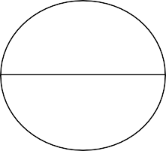






My Previous Balance (`)

0.00

Payment Received (`)

0.00

Current Taxable Charges (`)

411.56
Taxes (`)
74.08

Total Current Month Charges (`)

485.64

Total Payable (`)

485.64


- Plan Charges
- Subscription Charges
- One Time Charges
- Current Month Discount / Credit / Debit
- Current Taxable Charges (1+2+3+4)
Amount (`)
411.56
0.00
0.00
0.00
411.56
6. Taxes
CGST(9%) SGST(9%)
37.04
37.04
- Bill Discount including Tax
- Current Month Charges payable (5+6+7)
- Waiver
Total Charges
0.00
485.64
0.00
485.64

Payment Options
JioAutoPay


 ACH - (Direct Debit)
set ACH mandate on your bank account.
Visit the nearest Jio Store along with a cancelled cheque.

JioDigiPay


 My Jio & Jio.com
Pay bills using credit/debit card/netbanking/ e- wallets/UPI onMy Jio App or visit www.Jio.com and click on Quick Pay Download the app from Play

JioPay

Standing Instructions (Credit Card)

Set JioAutoPay through My Jio App.
Download the MyJio App from Play Store or App Store.
Store or App Store

We also accept Cash /Credit /Debit Card at the Jio Store
GSTIN: 29AAECJ6878N1ZK PAN : AAECJ6878N

Registered Office: Jio Platforms Limited
Office-101, Saffron, Nr. Centre Point, Panchwati 5 Rasta, Ambawadi, Ahmedabad, Gujarat, India
PIN Code 380006

State Office : Jio Platforms Limited
62/2
Richmond Road
Bangalore, Bengaluru (Bangalore) Urban, Karnataka 560025
GST Registered Office: Jio Platforms Limited
Company , Karnataka State - GST, (Bangalore) Urban, 2nd Floor, 62/2 Richmond Road Bengaluru Bangalore- 560025, IN


Signature Not Verified
Digitally signed by Jio Platforms Limited Date: 2024.03.07 05:50:05 IST
Reason: Digitally Signed Location: Mumbai

