**What are AWS Athena, Lambda, and QuickSight?**

**Athena**

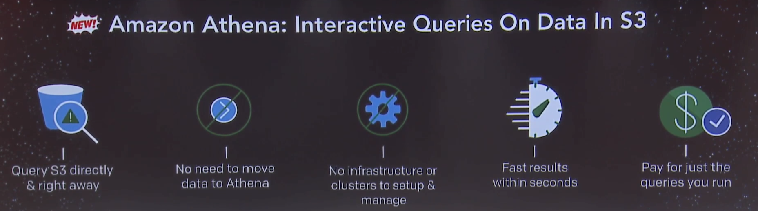

* Amazon Athena is an interactive query service that makes it easy to analyze data in Amazon S3 using standard SQL.
* Athena is ideal for quick, ad-hoc querying but it can also handle complex analysis, including large joins, window functions, and arrays.
* Most results are delivered within seconds. Amazon Athena automatically executes queries in parallel, so most results come back within seconds.
* Athena is serverless, so there is no infrastructure to manage, and you pay only for the queries that you run.
* Athena is easy to use. Simply point to your data in Amazon S3, define the schema, and start querying using standard SQL. Amazon Athena allows you to tap into all your data in S3 without the need to set up complex processes to extract, transform, and load the data (ETL).
* You are charged $5 per terabyte scanned by your queries. You can save from 30% to 90% on your per-query costs and get better performance by compressing, partitioning, and converting your data into columnar formats.
* Athena queries data directly in Amazon S3. There are no additional storage charges beyond S3.

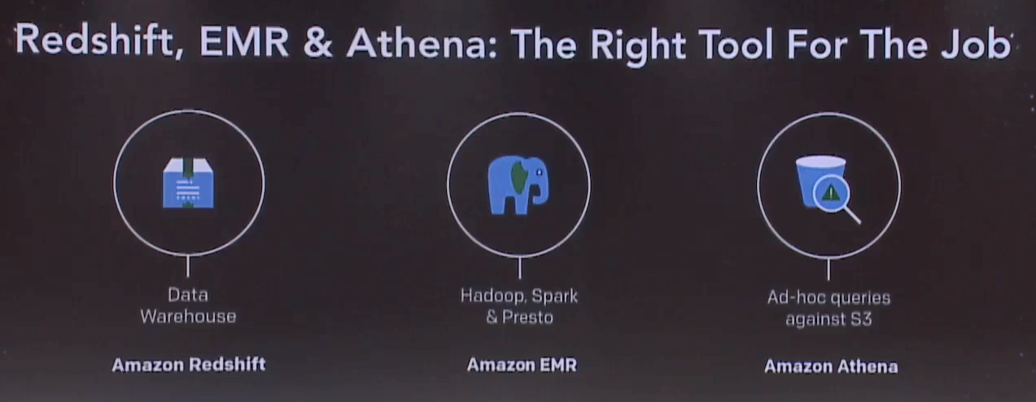

**QuickSight**

|  |  |
| --- | --- |
| **Release Date:** | November 15, 2016 3:00 PM GMT |

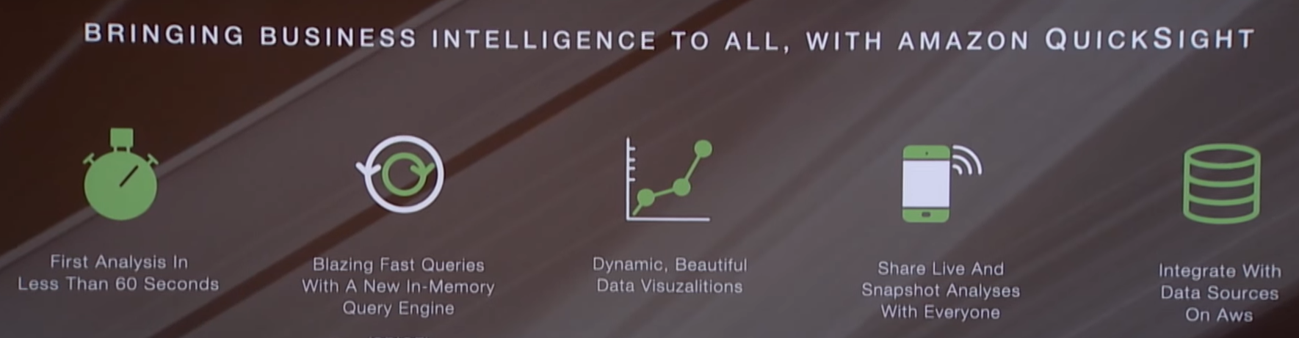

* Amazon QuickSight is a fast business analytics service to build visualizations, perform ad hoc analysis, and quickly get business insights from your data.
* You get very fast, easy to use business intelligence for your big data needs at **1/10th the cost of traditional on-premises solutions**.
* QuickSight will be able to handle many types of data-intensive workloads including ad targeting, customer segmentation, forecasting & planning, marketing & sales analytics, inventory & shipment tracking, IoT device stream management, and clickstream analysis.
* **You’ve got the data and you’ve got the questions. Now you want the insights!**
* QuickSight seamlessly discovers AWS data sources, enables organizations to scale to hundreds of thousands of users, and delivers fast and responsive query performance by using a robust in-memory engine (SPICE).
* Problem with existing resources
* **Managing Databases is Painful and Difficult.**
* **SQL Databases do not Work Well at Scale**
* **Hadoop is Difficult to Deploy and Manage**
* **Data Warehouses are Costly, Complex, and Slow**
* **Commercial Databases are Punitive and Expensive**
* **Streaming Data is Difficult to Capture**
* QuickSight
* **Access to Data  Sources -** built-in support for [Amazon Redshift](https://aws.amazon.com/redshift/), [RDS](https://aws.amazon.com/rds/), [Amazon Aurora](https://aws.amazon.com/rds/aurora/), [EMR](https://aws.amazon.com/elasticmapreduce/), [Kinesis](https://aws.amazon.com/kinesis/), [S3](https://aws.amazon.com/s3/), MySQL, Oracle, SQL Server, PostgreSQL, and flat files.
* **Fast Calculation** – QuickSight is built around SPICE (the Super-fast, Parallel, In-memory Calculation Engine).
* **Ease of Use -** As you select tables and fields, it recommends the most appropriate types of graphs and other visualizations
* **Effortless Scale -** provides fast analytics and visualization while scaling to handle to hundreds of thousands of users and terabytes of data per organization.
* **Low Cost -** 1/10th the cost of on-premises solutions from the old guard.

**Why did we chose this topic?**

* Many companies (like Netflix) had encountered a major database corruption that witnessed a delay of three days in delivering data to the customers.
* In any business, it is important to avert bad customer experience to scale up and build a trusted business model.
* critical issue - minimizing downtime.
* AWS provides an easy to administration tool for a secure and scalable workflow.
* *As was mentioned in*[*Netflix’s blog*](https://media.netflix.com/en/company-blog/completing-the-netflix-cloud-migration) “Supporting such rapid growth would have been extremely difficult out of our own data centers; we simply could not have racked the servers fast enough.”
* As shown in the diagram, Netflix witnessed a tremendous increase in streaming hours from 2008 onwards. This was complemented with the company’s decision to migrate to the cloud.

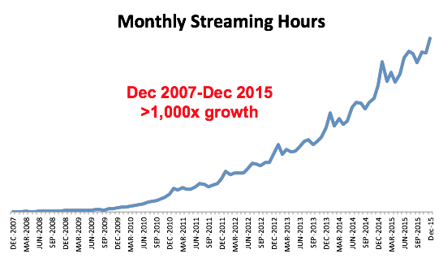

* On the other side, Netflix’s costs were cutting down to fractions per server. This not only helped them save money but also created an opportunity for them to add more resource hungry features.
* The elasticity of the cloud platform allowed them to add 1000s of virtual servers within a matter of a few minutes. They were able to expand their services to all the countries with minimal or rather negligible issues.
* Amazon Web Services offers a range of benefits that help companies to be future ready and optimize the workflow for scaling up their business operations. For a company of Netflix’s range of operations, moving to the cloud platform is the next logical step. The platform will help them in effective database monitoring and address any issues that stumble upon at any point of time.
* We believe AWS not only provides for reduced costs but also enables better infrastructure capabilities for the companies.