Nikhil Hegde |  | 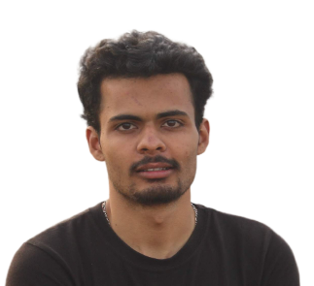
Citizenship: Indian | DoB: 23/12/2000
Gender: Male | LinkedIn: www.linkedin.com/in/nikhilhegde989/
Mobile Number: 7975438343 | Alternate Number: 9008134132
Email (Learner ID): nikhil8.mitmpl2022@learner.manipal.edu
Alternative Email: nikhilhegde989@gmail.com

Permanent Address: | Purlemane, Post: Shivalli (Panchalinga) Tq: Sirsi (Uttara Kannada) KA 581403

Objective | Seeking a suitable position in a reputed organization to become proficient in programming and attain an in-depth knowledge of computing systems which results in the development of both company and myself.

Educational Qualifications
Grade | School/College | Board/University | Year of Passing | %/CGPA
10th | SGSS Hegdekatta, Sirsi | Karnataka State Board | 2017 | 94.88 %
12th | MES PU College Sirsi ,UK | Dpt.of Pre-University Education,Karnataka | 2019 | 85.83 %
B.Sc | JSS College,Dharwad | Karnatak University of Dharwad. | 2022 | 83.33 %
MCA | Manipal Institute Of Technology (Pursuing) | MAHE,manipal | 2024(Expected) | 8.75

 | Sem 1 | Sem 2 | Sem 3 | Sem 4
GPA | 8.96 | 8.75 | - | -
CGPA | 8.96 | 8.85 | - | -

Electives | NoSQL

Areas of Interest | - Books related to Finance, Psychology, Self Help & Stock Market  - Documentries & Case Studies  - Loves to write on Quora  - Travelling  - Watching & playing cricket

Languages | Kannada,English and Hindi

Technical Activities

Projects | 1.My Portfolio Website  -using HTML, CSS & Java Script  Welcome to my portfolio website featuring creative projects in HTML, CSS, and JS. I hope you enjoy exploring my digital journey! (https://nikhilhegde989.github.io/nikhilhegde989/#)  2.Photo Studio Website  -using HTML,CSS,Node JS & MySQL  In this project, different photographer’s portfolio will be displayed, clients can book the photographers whom they want. Also photographers can also apply to join the studio with their portfolio.  3. Hotstar Homepage Clone  -using HTML,CSS & JS  I have cloned Hotstar homepage with images & videos sliding.

Technical Skills
Programming  Languages and Software Package | C++ , Java, SQL, HTML, CSS,Java Script, NoSql,Node Js Express Machine Learning,Digital Marketing
Operating Systems | Windows and Linux

Internships

- Digital Marketing Intern at Spherule Foundation
From Apr-2019 to Jul-2019

- Digital Marketing Associate at PTE Universe
From Jan-2020 to Feb-2020

- Affiliate Marketing & Blog Post Writing with Sagar Lone
From Apr-2019 to Jul-2019

The above information provided by me is true and have all relevant documents to authenticate the same.
Nikhil Hegde

