**How to run the Doctor Appointment System Django Python**

1. Download the zip file

2. Extract the file, copy doctorappointment folder, and paste it on the desktop

3. Open MySQL Create a database docaspythondb then import the SQL File available in the MySQL File Folder

4. Open PyCharm and click on the terminal

5. Navigate the project folder using the cd command

cd project_path

**For ex:**cd C:\Users\Nikhil\OneDrive\Desktop\doctorappointment

6. Now Navigate to the Company Visitor Management System folder

cd docappsystem

7. Run the Project using the following command

python manage.py runserver

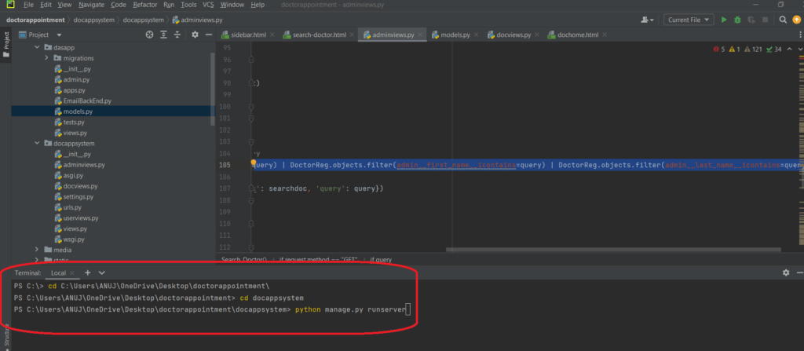

Now click the URL http://127.0.0.1:8000 and the Project will Run