**Name: Nikhil Jais**

**Roll No:25**

**Batch: MCA-B**

**Date:02-06-2022**

**NETWORKING & SYSTEM ADMINISTRATION LAB**

**Experiment No.: 25**

**Aim**

Introduction to command line tools for networking IPv4 networking, network commands: ping route traceroute, nslookup, ip.

**Procedure**

**Ipconfig**

"Ipconfig" often comes up as the most-used networking command on Windows. Not only is it useful for the information it provides, but you can combine it with a couple of switches to execute certain tasks.

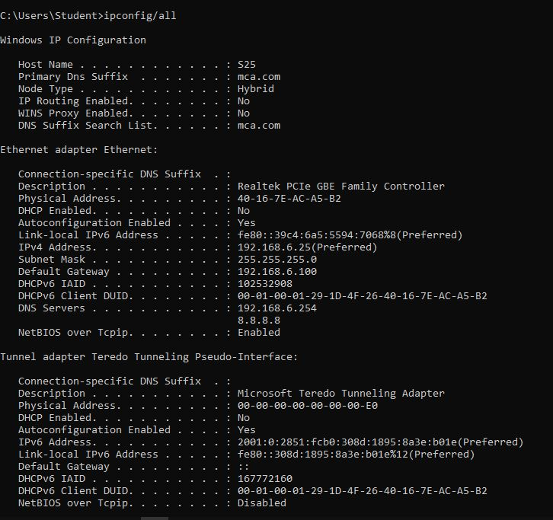

**Nslookup**

"Nslookup" stands for Name Server Lookup. It packs a lot of power, but most users won't need that power. For regular folks like you and me, its main use is finding out the IP address behind a certain domain name.

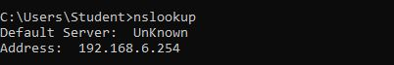

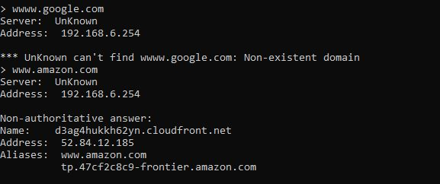

**Ping**

"Ping" is one of the most basic yet useful network commands to utilize in the command prompt application. It tells you whether your computer can reach some destination IP address or domain name, and if it can, how longit takes data to travel there and back again.

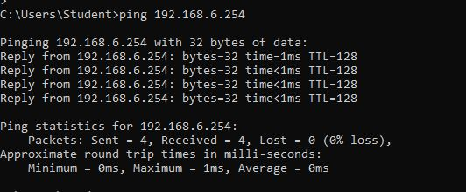

**Tracert**

"Tracert" stands for Trace Route. And much like "ping," it sends out a data packet as a way to troubleshoot any network issues you might have, but it instead tracks the route of the packet as it hops from server to server.

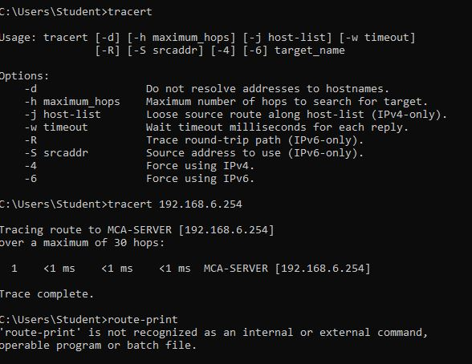

**Netstat**

"Netstat" is a tool for network statistics, diagnostics, and analysis. It's powerful and complex but can be simple enough if you ignore the advanced aspects that you don't need to know about (assuming you aren't managing a massive business or campus network, for example).

The -f option clears the routing tables of all gateway entries. If you use the -f option in conjunction with one of the commands, the tables are cleared before you run the command.

By default, routes are not preserved when you restart the system. Use the -p option with the add command to make a route persistent. Use the -p option with the print command to view the list of registered persistent routes.

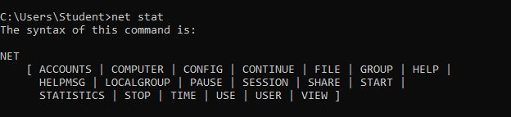

**Route print**

You can use the route command to view, add and delete routes on a Microsoft Windows NT server that runs Cisco ICM. You can use these options with the route command

