**Name: Nikhil Jais**

**Roll No:25**

**Batch: MCA -B**

**Date:06-06-2022**

**NETWORKING & SYSTEM ADMINISTRATION LAB**

**Experiment No.: 28**

**Aim**

Build and install software from source code, familiarity with make and cmake utilities expected.

**Procedure**

1. We can obtain information of a package and its dependencies using the apt command. Doing that for cmake:

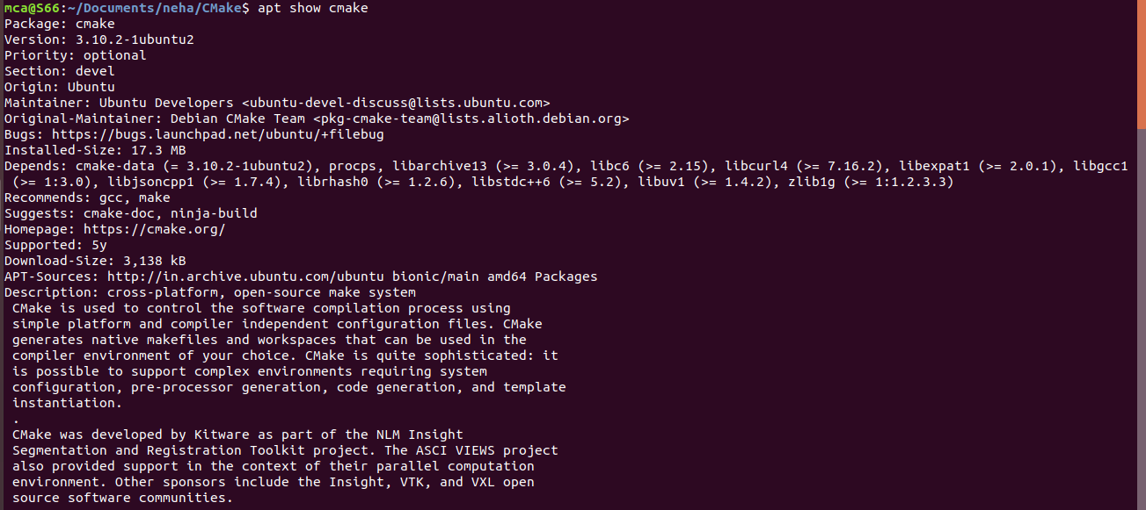 **$ apt show cmake**

1. To install cmake , g++ and make using the apt command, type:

**$ sudo apt install cmake g++ make**

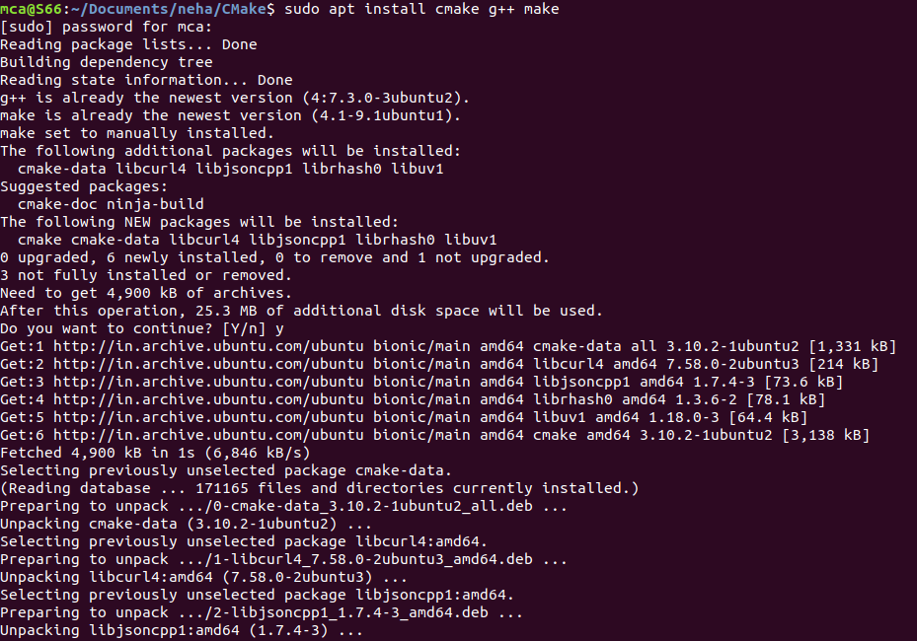

**A Sample CMake project**





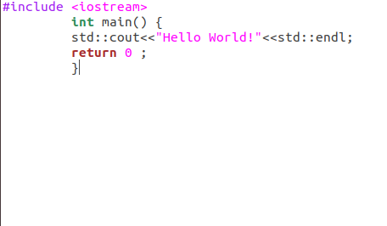



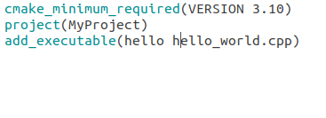

A directory to which CMake was executed is called “Built Directory”



