# NETWORKING & SYSTEM ADMINISTRATION LAB

**Name: Nikhil Jais**

**Roll No: 25**

**Batch: B**

**Date: 24/03/2022**

**Experiment No.: 3**

# Aim

Familiarization of the linux commands.

# Procedure

1. **pwd**

This command is used to display the location of the current working directory. Syntax :- $ pwd

Output :-



# mkdir

This command is used to create a new directory under any directory. Syntax :- $ mkdir <directory name>

Output :-



**3.rmdir**

The rmdir command is used to delete a directory.

Syntax:- rmdir <directory name>

Output :-

# 4.ls

This command is used to display a list of content of directory. Syntax :- $ ls

Output :-



**a)ls -l:** This variant of the ‘ls’ command is used to describe all the files about their properties and their states.

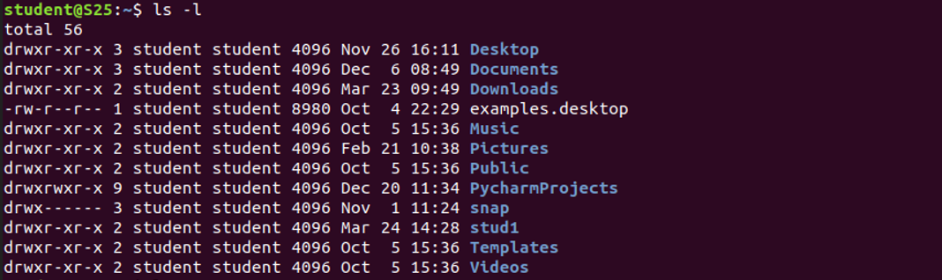

**b)ls -r:** This type helps to display the list of the available files and folders in a reverse order.



**c)ls -a:** This command lists all the hidden files and folders along with the normal files & folders in the current directory.



**d)ls -t:** This command helps to list out the folders and files according to the order of the newly modified files and files within the folders.



# ls –a

This command is used to list all files including hidden files. Syntax :- $ls –a

Output :-

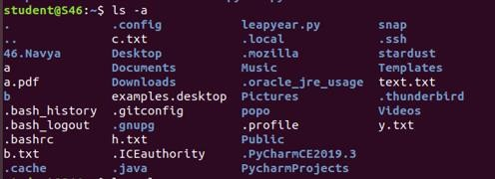

# ls –al

This command is used to Syntax :- $ ls -al Output :-

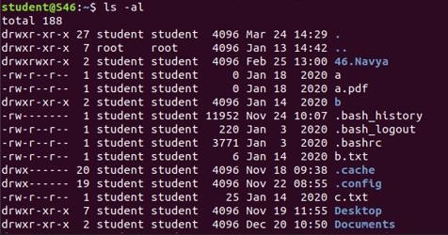

# ls –t

This command is used to display files in the last modified order. Syntax :- $ ls –t

Output :-

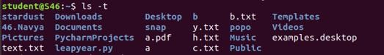

# cd

This command is used to change the current directory. Syntax :- $ cd <directory name>

Output :-



# cd ..

This command is used to move to the parent directory of current directory, or the directory one level up from the current directory.

Syntax :- $ cd .. Output :-



# cd –

This command is used to switch back to previous directory we were working earlier.

Syntax :- $ cd – Output :-



# cat > filename

This command is used to create a file and add contents to that file. Syntax :- $ cat > filename.txt

Output :-



# cat>>filename

This command is used to add contents to an existing file. Syntax :- $ cat >> filename.txt

Output :-

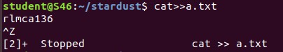

# cat filename

This command is used to view the contents in the file. Syntax :- $ cat filename.txt

Output :-

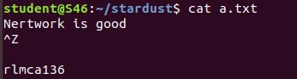

# cat filename1 > filename2

This command is used to copy the content from one file to another file. Syntax :- $ cat filename1 > filename2

Output :-

