

**ADVANCED DBMS LAB**

**Experiment No.: 1**

**AIM**

To study various DDL commands – CREATE

**QUESTIONS**

Create the following tables and insert the values.

#### Table 1: DEPOSIT

ACTNO VARCHAR2 (5) PRIMARY KEY, FIRST LETTER MUST START WITH ‘D’ CNAME VARCHAR2 (15) FOREIGN KEY REFERENCES CUSTOMER

BNAME VARCHAR2 (20) FOREIGN KEY REFERENCES BRANCH AMOUNT NUMBER (8,2) NOT NULL, CANNOT BE 0 ADATE DATE

#### Table 2: BRANCH

BNAME VARCHAR2(20) PRIMARY KEY CITY VARCHAR2(30) NOT NULL , any one of NAGPUR, DELHI, BANGALORE, BOMBAY

#### Table 3: CUSTOMER

CNAME VARCHAR2(15) PRIMARY KEY CITY VARCHAR (20) NOT NULL ,

#### Table 4: BORROW

LOANNO VARCHAR2(8) PRIMARY KEY / FIRST LETTER MUST START WITH ‘L’ CNAME VARCHAR2(15) FOREIGN KEY REFERENCES CUSTOMER

BNAME VARCHAR2(20) FOREIGN KEY REFERENCES BRANCH AMOUNT NUMBER(8,2) NOT NULL, CANNOT BE 0

**PROCEDURE**

CREATE DATABASE my_account;

#### 1: DEPOSIT

CREATE TABLE DEPOSIT (actno varchar(5) CHECK (actno LIKE 'D%') PRIMARY KEY,cname varchar(15) references CUSTOMER(cname),bname VARCHAR(20) references branch(bname),amount FLOAT(8) CHECK (amount>0) NOT NULL,adate DATE);

INSERT INTO DEPOSIT VALUES('D100','ANIL','VRCE',1000.00,'1995-03-01') ('D101', 'SUNIL', 'ANJNI',500.00,'1996-01-04') , ('D102','MEHUL','KAROLBAGH',3500.00,'1995-11-17'), ('D104', 'MADHURI','CHANDNI',1200.00,'1995-10-17'), ('D105','PRAMOD','MG ROAD',3000.00,'1996-03-27'),('D106','SANDIP','ANDHERI',2000.00,'1996-03-31'),('D107','SHIVANI','VIRAR',1000.00,'1995-09-05'),('D108','KRANTI','NEHRU PLACE',5000.00,'1995-07-02'), ('D109', 'MINU',' POWAI', 7000.00,'1995-08-10');

**2: BRANCH**

CREATE TABLE BRANCH(bname varchar(15) PRIMARY KEY,city varchar(30) CHECK (CITY IN ('NAGPUR','DELHI','BANGALORE','BOMBAY')) NOT NULL);

INSERT INTO BRANCH VALUES('VRCE','NAGPUR'),('AJNI','NAGPUR'),('KAROLBAGH','DELHI'),('CHANDNI','DELHI'),('DHARAMPETH','NAGPUR'),('MG ROAD','BANGALORE'),('ANDHERI','BOMBAY'),('NEHRU PALACE','DELHI'),('POWAI','BOMBAY');

**3: CUSTOMER**

CREATE TABLE CUSTOMER(cname varchar(15) PRIMARY KEY,city varchar(20) NOT NULL);

INSERT INTO CUSTOMER VALUES('ANIL','CALCUTTA'),('SUNIL','DELHI'),('MEHUL','BARODA'),('MANDAR','PATNA'),('MADHURI','NAGPUR'),('PRAMOD','NAGPUR'),('SANDIP','SURAT'),('SHIVANI','BOMBAY'),('KRANTI','BOMBAY'),('NAREN','BOMBAY'),('VRCE','NAGPUR'),('AJNI','NAGPUR');

**4: BORROW**

CREATE TABLE BORROW(loan_no varchar(8) CHECK(loan_no LIKE 'L%') PRIMARY KEY,cname varchar(15) references customer(cname),bname varchar(20)references branch(bname), amount float(8) CHECK (amount>0)NOT NULL);

INSERT INTO BORROW VALUES('L311','SUNIL','DHARAMPETH',3000.00),('L321','MADHURI','ANDHERI',2000.00),('L371','PRAMOD','VIRAR',8000.00),('L481','KRANTI','NEHRU PLACE',3000.00);

SELECT * FROM DEPOSIT;

SELECT * FROM BRANCH;

SELECT * FROM CUSTOMER;

SELECT * FROM BORROW;

**Output Screenshot**

#### 1: DEPOSIT

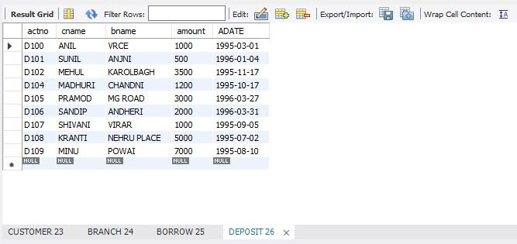

**2: BRANCH**

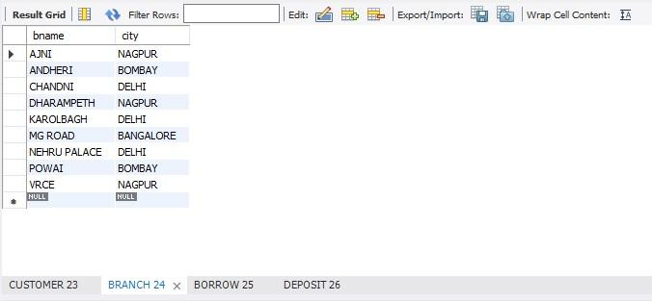

**3: CUSTOMER**

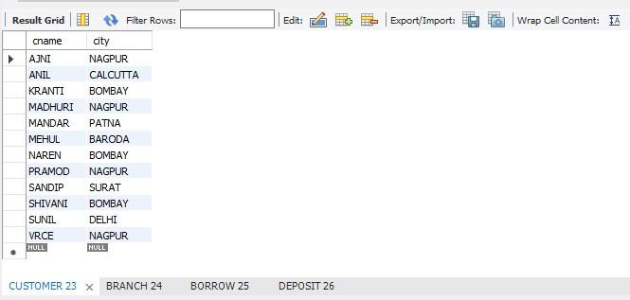

**4: BORROW**

