**Name: Nikhil jais**

**Roll No:25**

**Batch: B**

**Date:03-06-2022**

**ADVANCED DBMS LAB**

**Experiment No.: 8**

**Aim**

 Create database Practice CRUD operations

**Procedure**

1. Create database and use database

**use AJCE**



1. Display all database

**show dbs**

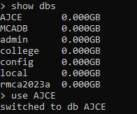

1. Insert many values into the table using **insertMany**

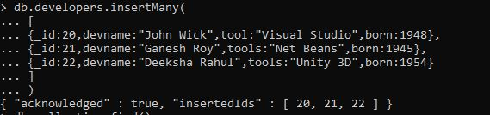

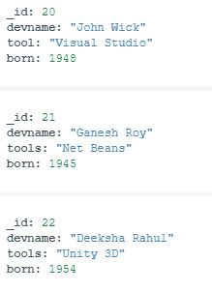

1. Display tables

**show collections**

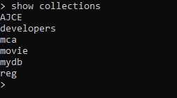

1. Find particular table Data.

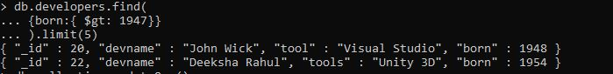

1. Modify existing operation in a collection using **updateOne**



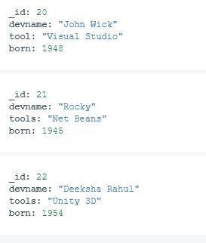

1. Insert value into the table using **insertOne**



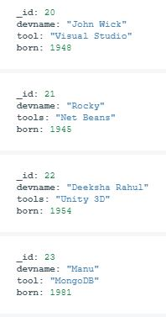

1. Remove documents from a collection using **deleteOne**



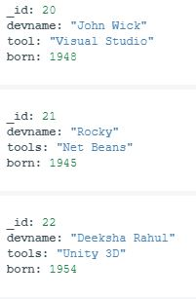

1. Modify existing operation in a collection using **updateMany**



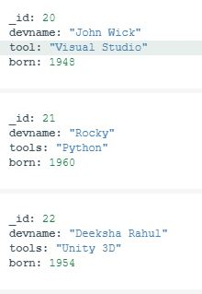

1. Remove documents from a collection using **deleteMany**



