**Name: Nikhil Jais**

**Roll No:25**

**Batch:MCA-B**

**Date:01-09-2022**

**DATA SCIENCE LAB**

**Experiment No.: 2**

**Aim**

 Programs to handle data using Dataframe

**Question**

1. create Dataframe From Series
2. DataFrame from List of Dictionaries
3. Display the first 5 rows of data frame
4. Select the last two columns of the data frame
5. Add two data frames
6. Demonstrate deletion, and renaming of columns
7. Demonstrate concat, Merge operations in data frame
8. Write a Pandas program to join the two given dataframes along rows and assign all data

**Test Data:**

student_data1:

  student_id              name  marks

0         S1  Danniella Fenton    200

1         S2      Ryder Storey    210

2         S3      Bryce Jensen    190

3         S4         Ed Bernal    222

4         S5       Kwame Morin    199

student_data2:

  student_id              name  marks

0         S4  Scarlette Fisher    201

1         S5  Carla Williamson    200

2         S6       Dante Morse    198

3         S7    Kaiser William    219

4         S8   Madeeha Preston    201

**Procedure**

1.create Dataframe From Series

import pandas as pd

s = pd.Series(['a','b','c','d'])

df=pd.DataFrame(s)

print(df)

**Output**

  0

0  a

1  b

2  c

3  d

**2.** DataFrame from List of Dictionaries

import pandas as pd

l = [{'name':'sachin','sirname':'bhardwaj'},

   {'name':'vinod','sirname':'verma'},

   {'name':'rajesh','sirname':'mishra'}]

df1=pd.DataFrame(l)

print(df1)

**Output**

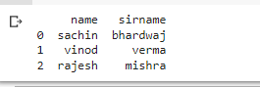

**3.** Display the first 5 rows of data frame

import pandas as pd

m = [{'name':'sachin','sirname':'bhardwaj'},

   {'name':'vinod','sirname':'verma'},

   {'name':'rajesh','sirname':'mishra'},

   {'name':'ran','sirname':'mira'},

   {'name':'ram','sirname':'mia'},

   {'name':'mesh','sirname':'kashra'}]

df2=pd.DataFrame(m)

print(df1)

for(row_index,row_value) in df2.iterrows():

  print('\n Row index is ::',row_index)

  print('Row value is::')

  print(row_value)

**Output**

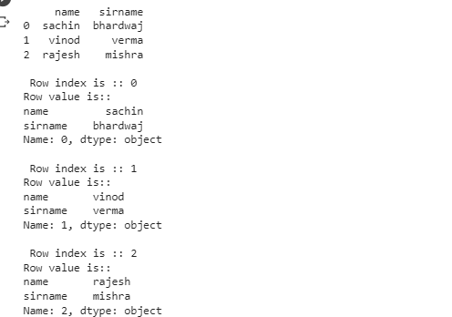

**4.** Select the last two columns of the data frame

import pandas as pd

l = [{'name':'sachin','sirname':'bhardwaj'},

   {'name':'vinod','sirname':'verma'}]

df3=pd.DataFrame(l)

print(df3)

for(col_name,col_value) in df3.iteritems():

  print('\n')

  print('Column name is ::',col_name)

  print('column values are::')

  print(col_value)

**Output**

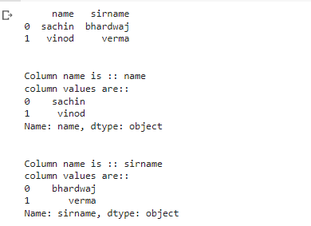

**5**. Add two data frames

import pandas as pd

g = pd.Series([10,15,18,22])

df=pd.DataFrame(g)

df.columns=['List1']

df['List2']=20

df['List3']=df['List1']+df['List2']

print(df)

**Output**

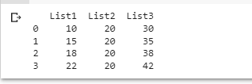

**6.** Demonstrate deletion, and renaming of columns

import pandas as pd

g = pd.Series([10,15,18,22])

df=pd.DataFrame(g)

df.columns=['List1']

df['List2']=20

df['List3']=df['List1']+df['List2']

del df['List3']

print(df)

print('\npop\n')

df.pop('List2')

print(df)

**Output**

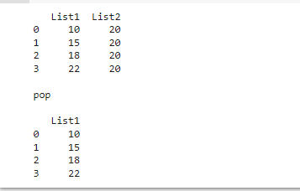

**7.** Demonstrate concat, Merge operations in data frame

import pandas as pd

dict1={'id':['1','2','3','4','5'],'value1':['A','C','E','G','I'],

       'value2':['B','D','F','H','J']}

dict2={'id':['2','3','6','7','8'],'value1':['K','M','O','Q','S'],

       'value2':['L','N','P','R','T']}

dict3={'id':['2','3','1','7','8','9','1','4','5','0'],

       'value3':['cA','ra','Ka','Ma','Oa','Qa','ta','ja','ea','Sa']}

df1=pd.DataFrame(dict1)

df2=pd.DataFrame(dict2)

df3=pd.concat([df1,df2])

print("..........concat........\n", df3)

df4=pd.DataFrame(dict3)

print("\ndict4 = \n",df4)

df5=pd.merge(df1,df4,on='id')

print("\n\n====merge====\n",df5)

**Output**

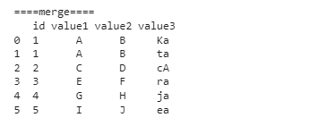

**8.** Write a Pandas program to join the two given dataframes along rows and assign all data

import pandas as pd

df6.to_csv('output.csv')

data=pd.read_csv('output.csv')

data

**Output**

