**Testing**

You have to install dependencies for VS Code

Express, bcrypt, body-parser, cookie-parser, jsonwebtoken, mongoose,nodemon

I have use Thunder Client Extenstion In VS Code instead of Postman.

**For signup user**

**Send POST Request**

POST: <http://localhost:3000/api/register>

In body section enter data shown in image

**It shows Success if all data is fill correctly**

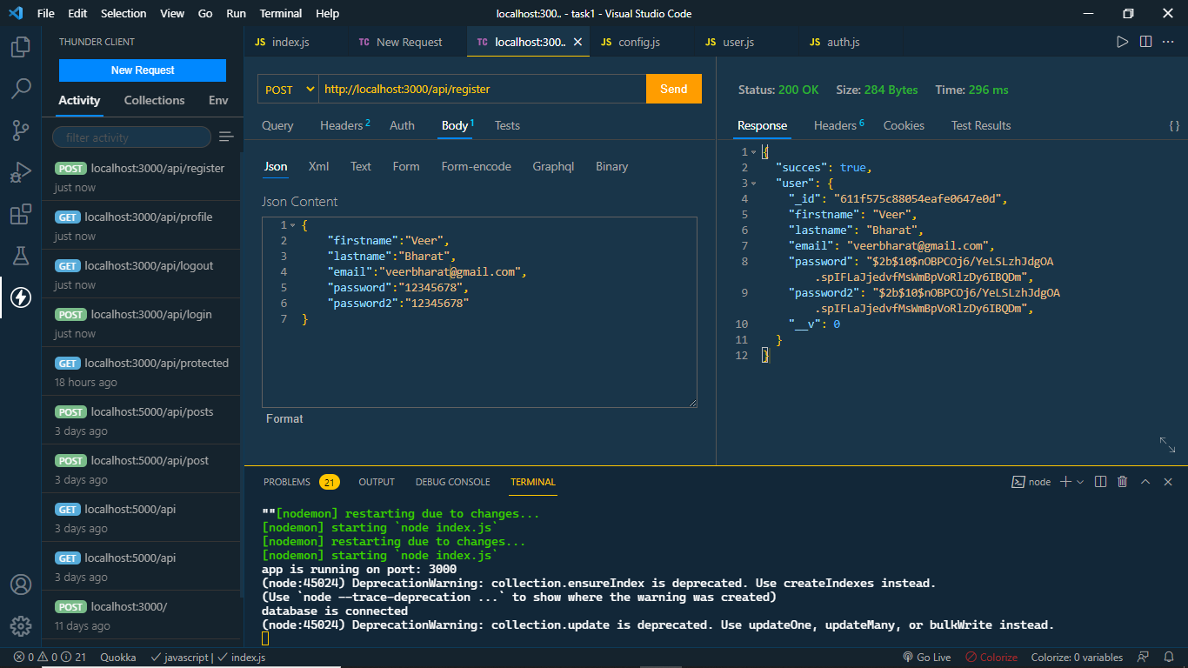

**If we pass empty field it shows error**

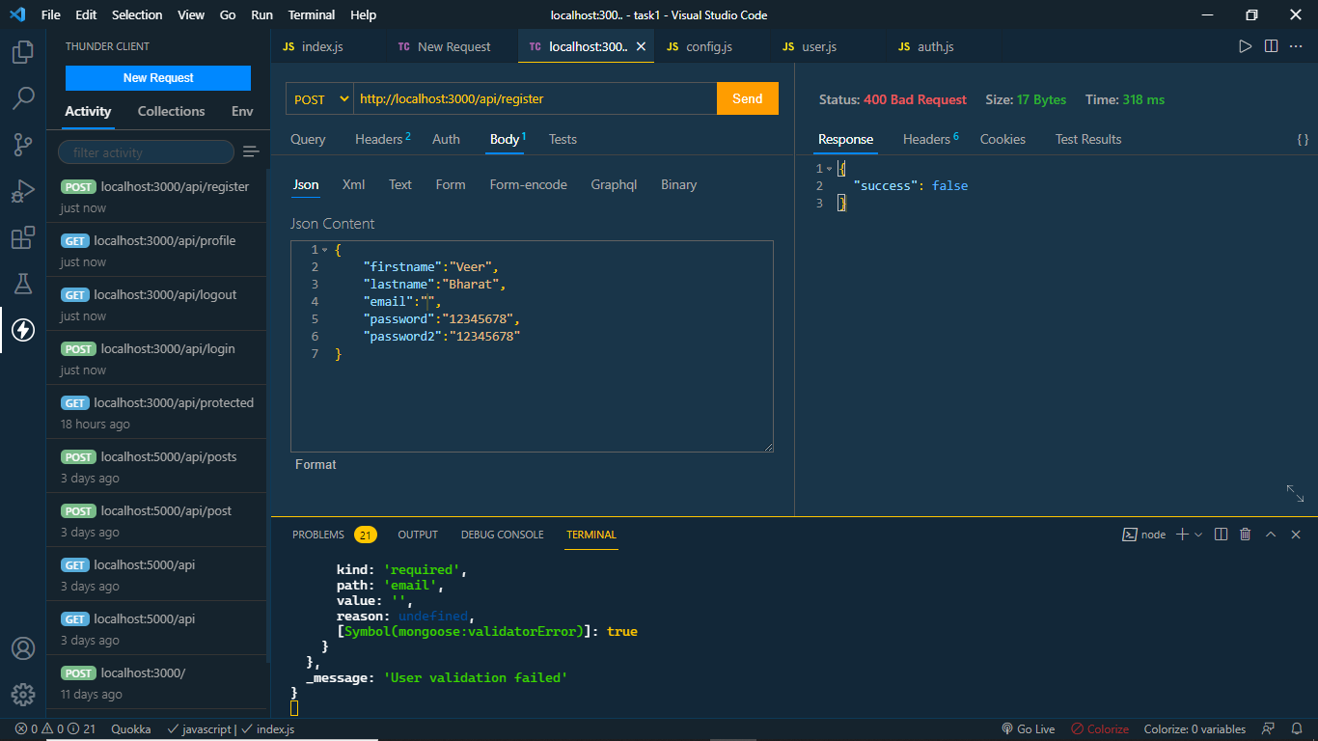

**If the password does not match it shows error**

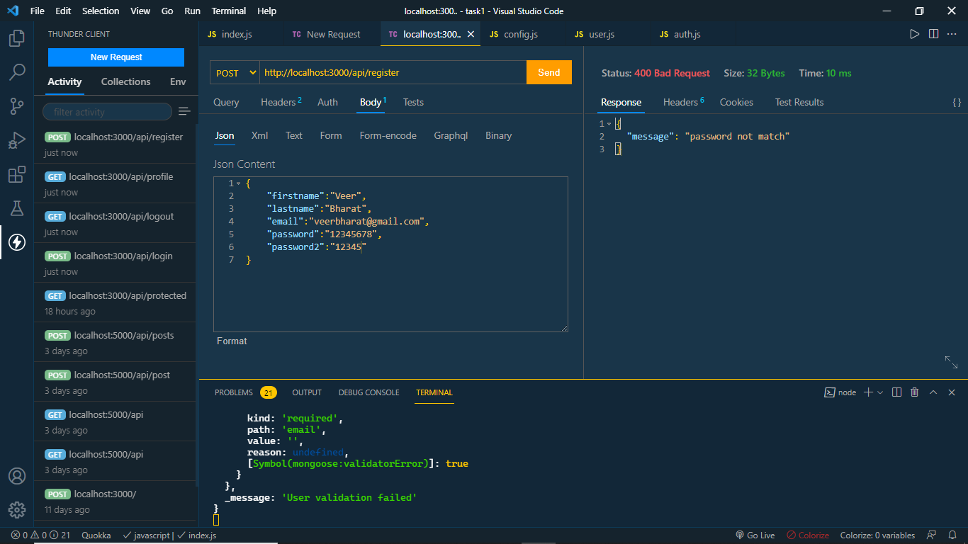

**If the email is already Exist it shows error:**

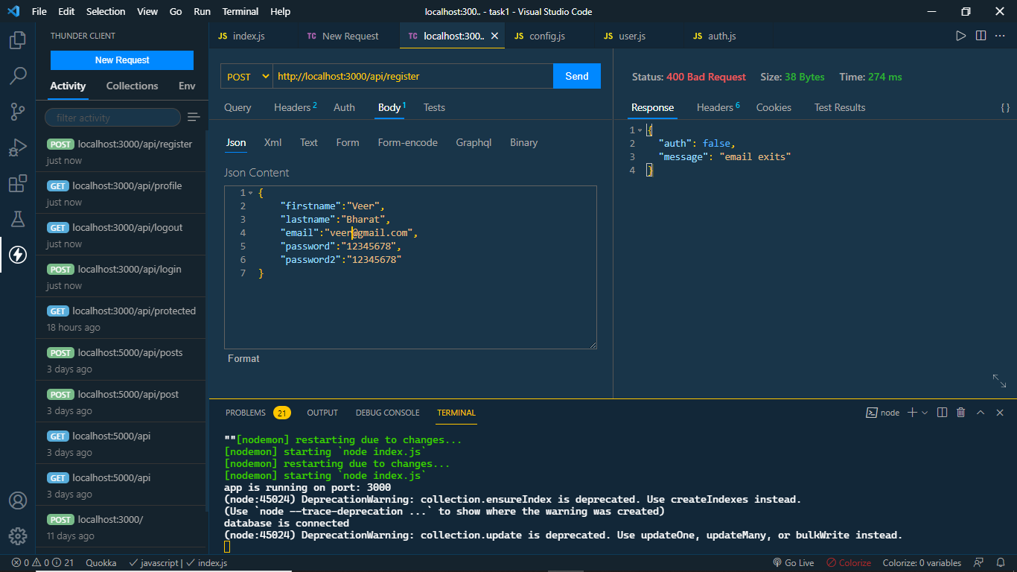

**For log in API**

Send POST request and add credentials in body section shown in img

If all credential are valid it shows user data with token is generated in db

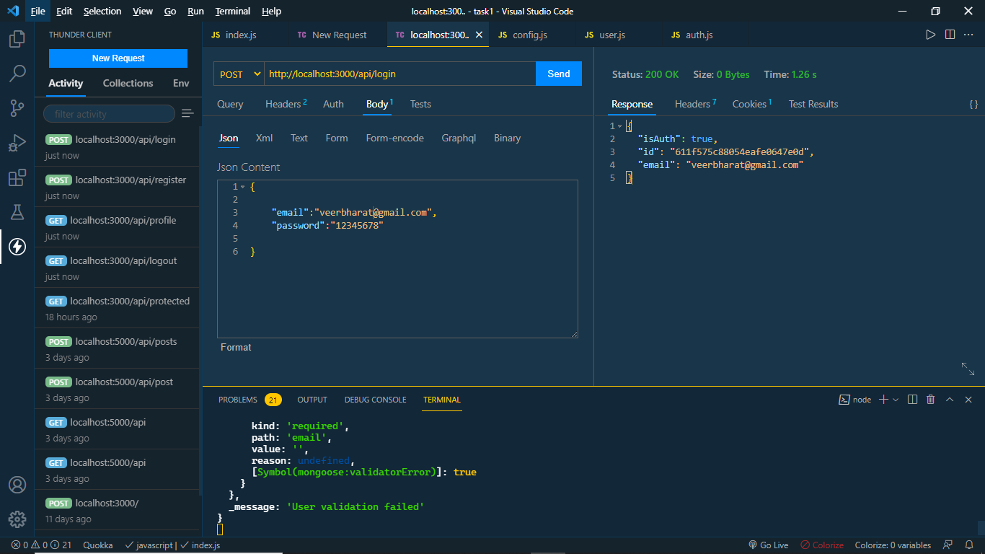

If we try to login again with same credential it shows error “your already Logged In”.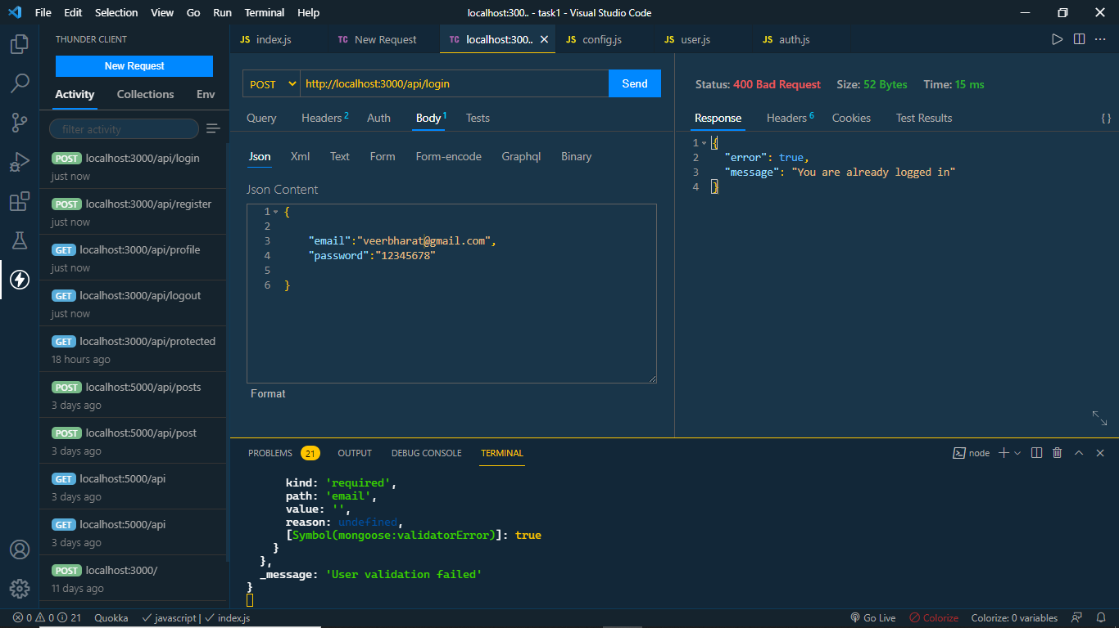

If you enter wrong email it shows error “Email is not found”.

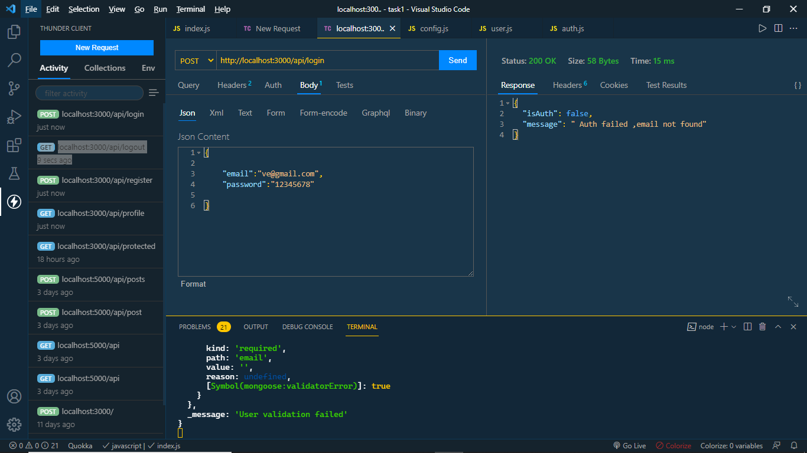

If you enter wrong password it shows error “Password doesn’t match”.

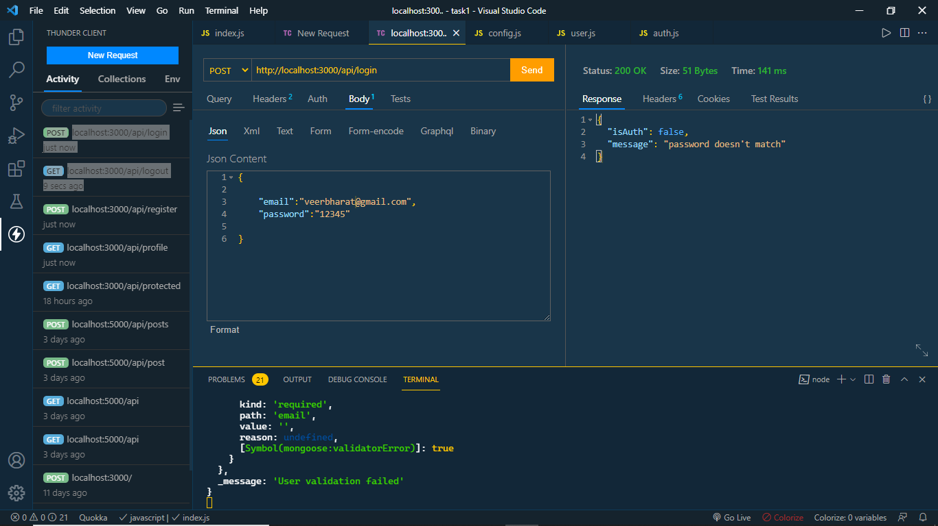

**To See Profile of the user**

Send GET Request

GET: <http://localhost:3000/api/profile>

It shows user data with tokened generated by DB

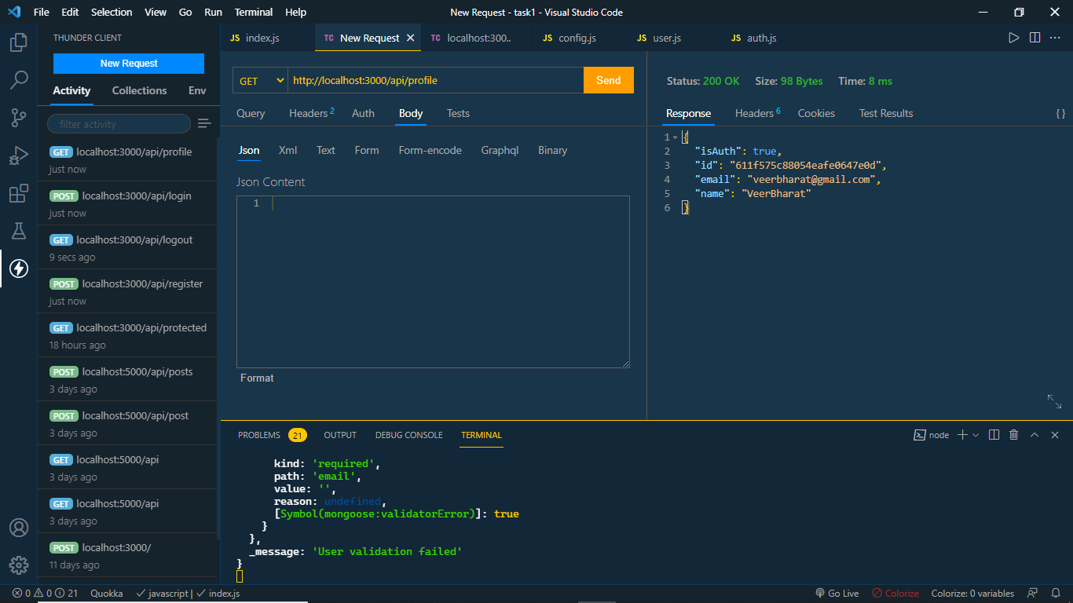

**To LogOut user**

send GET Request

GET: <http://localhost:3000/api/logout>

It will log out the user

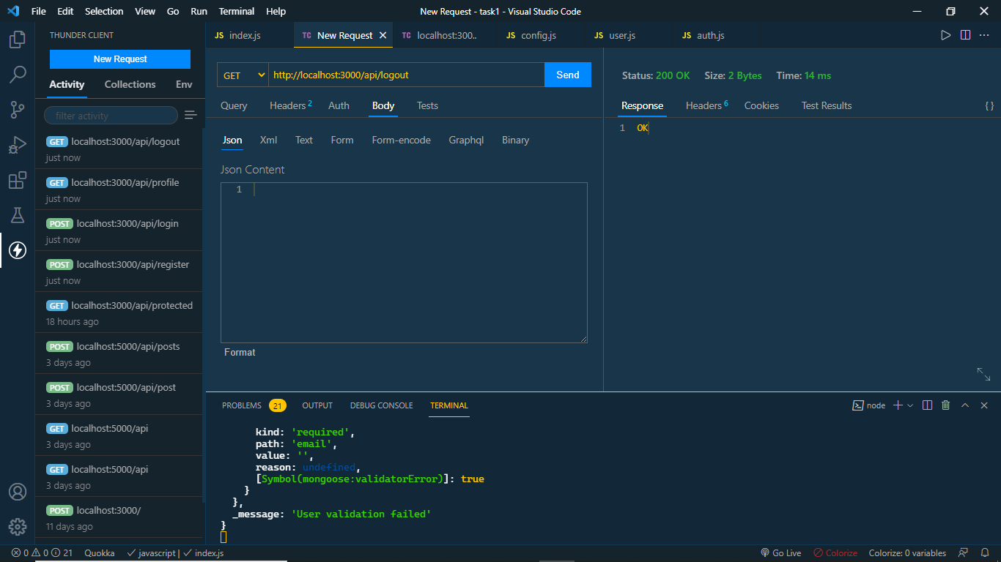

**If you try to Access profile it shows error**

