Cricket Data Analysis and Visualization Using Python
Analysis of T20 International Batting Statistics (Pandas, NumPy, Matplotlib, Seaborn)
Assignment 12 – Mini Project: Data Analysis & Visualization
Name: NIKHIL PATIL Roll No.: 43 Division: SEB College: NMIET

1. Title
Cricket Data Analysis and Visualization Using Python – T20 International Batting Statistics.

2. Aim
To clean, analyse and visualize a real cricket dataset of T20 International (T20I) career batting statistics using Python. Pandas is used for data cleaning, NumPy for numerical analysis, and Matplotlib/Seaborn for visualization, in order to identify the leading run-scorers and hitters and to study how batting statistics relate to each other.

3. Dataset Description
Item | Details
Dataset name | T20 International batting career statistics (file: twb.csv), from the supplied cricket statistics collection
Source | Cricket statistics dataset (T20I batting file twb.csv) downloaded from Kaggle by the student
Number of records | 105 (one row per player; no repeated players)
Number of columns | 15 in the original file; 25 in the cleaned file (10 added helper columns)
Time span covered | Careers between 2005 and 2021 (from the Span column)

Important attributes (original columns): Player (name and team), Span (first–last year), Mat (matches), Inns (innings), NO (not outs), Runs, HS (highest score; * means not out), Ave (batting average), BF (balls faced), SR (strike rate = runs per 100 balls), 100 / 50 / 0 (hundreds, fifties, ducks), 4s and 6s (fours and sixes). Note: the supplied files were already a partly cleaned export (the exported index column had been removed before this project), and every player in the file has scored at least 753 T20I runs.

4. Tools and Technologies
- Python 3 – programming language
- Pandas – loading, cleaning and tabulating data
- NumPy – mean, minimum, maximum, total, standard deviation, correlation
- Matplotlib and Seaborn – graphs and heatmap
- Jupyter Notebook – notebook version of the same workflow (plus a single runnable .py script)

5. Data Cleaning (Pandas)
Quality check | Before | After
Rows | 105 | 105
Columns | 15 | 25
Missing values | 0 | 0
Duplicate rows / duplicate players | 0 / 0 | 0 / 0
Unnamed index columns | 0 | 0
Text cells with extra spaces / blank text cells | 0 / 0 | 0 / 0

- Missing values: 0 were found, so none were filled or removed. The code would drop a row only if a key field (Player, Mat, Inns, Runs, BF, SR) were missing, and never replaces values with zero or averages.
- Duplicates: 0 duplicate rows and 0 repeated players were found; nothing was removed.
- Incorrect data: Consistency checks found 0 violations: NO ≤ Inns ≤ Mat, no negative counts, Ave = Runs ÷ (Inns − NO), SR = Runs ÷ BF × 100 (tolerance 0.02), and boundary runs ≤ total runs. Hence no values needed correction.
- Text handling: Whitespace was trimmed and blank strings converted to missing values (none existed). Cricket notation such as 94* in HS was preserved.
- Columns changed: Columns 100, 50, 0, 4s, 6s were renamed Hundreds, Fifties, Ducks, Fours, Sixes. Helper columns were added without altering originals: Name, Team_Raw, HS_Score and HS_NotOut (numeric highest score and not-out flag), Debut_Year, Last_Year, Career_Years, Boundary_Runs (4×Fours + 6×Sixes), Boundary_Pct and Sixes_per_Inns. All original columns were kept.

6. Data Analysis (NumPy)
Attribute | Mean | Min | Max | Total | Std. dev.
Matches | 64.70 | 27 | 124 | 6,794 | 23.25
Runs | 1,436.19 | 753 | 3,299 | 150,800 | 582.01
Balls faced | 1,117.11 | 541 | 2,413 | 117,297 | 418.60
Average | 28.35 | 17.92 | 52.04 | 2,976 | 6.54
Strike rate | 127.83 | 104.51 | 156.44 | 13,422 | 11.89
Fours | 129.26 | 41 | 295 | 13,572 | 58.99
Sixes | 52.04 | 10 | 165 | 5,464 | 30.32
Hundreds | 0.43 | 0 | 4 | 45 | 0.77
Boundary runs % | 57.16 | 42.64 | 76.18 | 6,002 | 6.69

Std. dev. is the sample standard deviation (np.std with ddof=1). Totals are sums over all 105 players (e.g., 150,800 runs in total).
Meaning in simple terms: the average player scored about 1436 career runs at a strike rate of 127.8 (runs per 100 balls). The standard deviation of runs (582) is large compared with the mean, so players differ greatly in career length and output, whereas the standard deviation of strike rate (11.9) is small, so strike rates are fairly similar. The maximum runs (3,299, MJ Guptill) is more than twice the mean.
Correlation (Pearson, np.corrcoef): Runs and Fours r = 0.92; Runs and Fifties r = 0.84; Runs and Matches r = 0.78; Sixes and Strike rate r = 0.62; Runs and Strike rate r = 0.37; Runs and Average r = 0.43. Correlation shows that two quantities move together; it does not prove that one causes the other.

7. Data Visualization
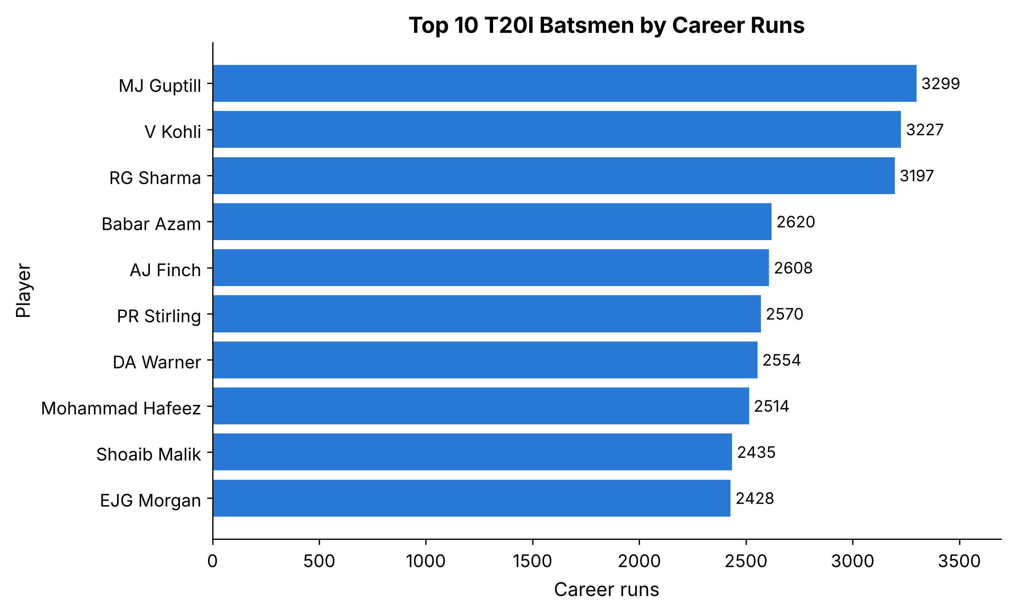  Figure 1: Top 10 batsmen by career runs (bar chart) | 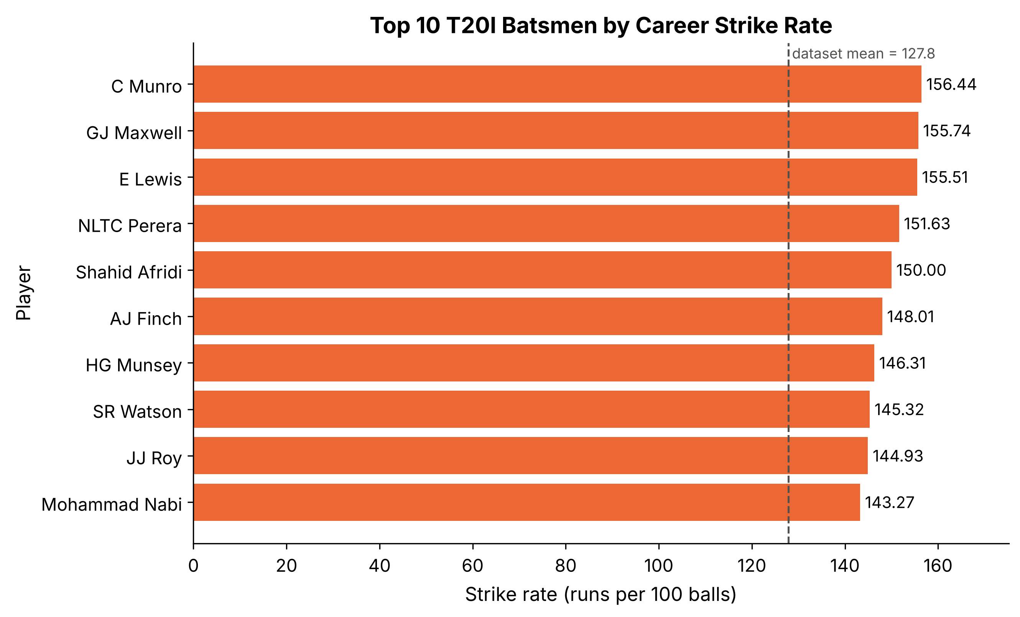  Figure 2: Top 10 batsmen by strike rate (bar chart)
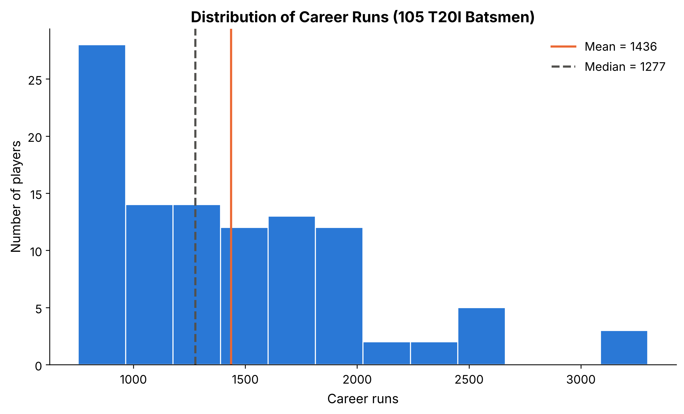  Figure 3: Distribution of career runs (histogram) | 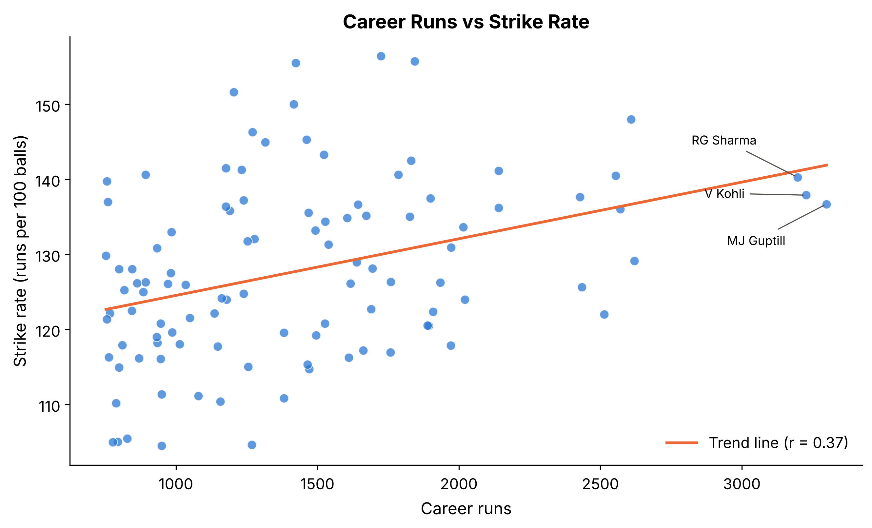  Figure 4: Career runs vs strike rate (scatter plot)
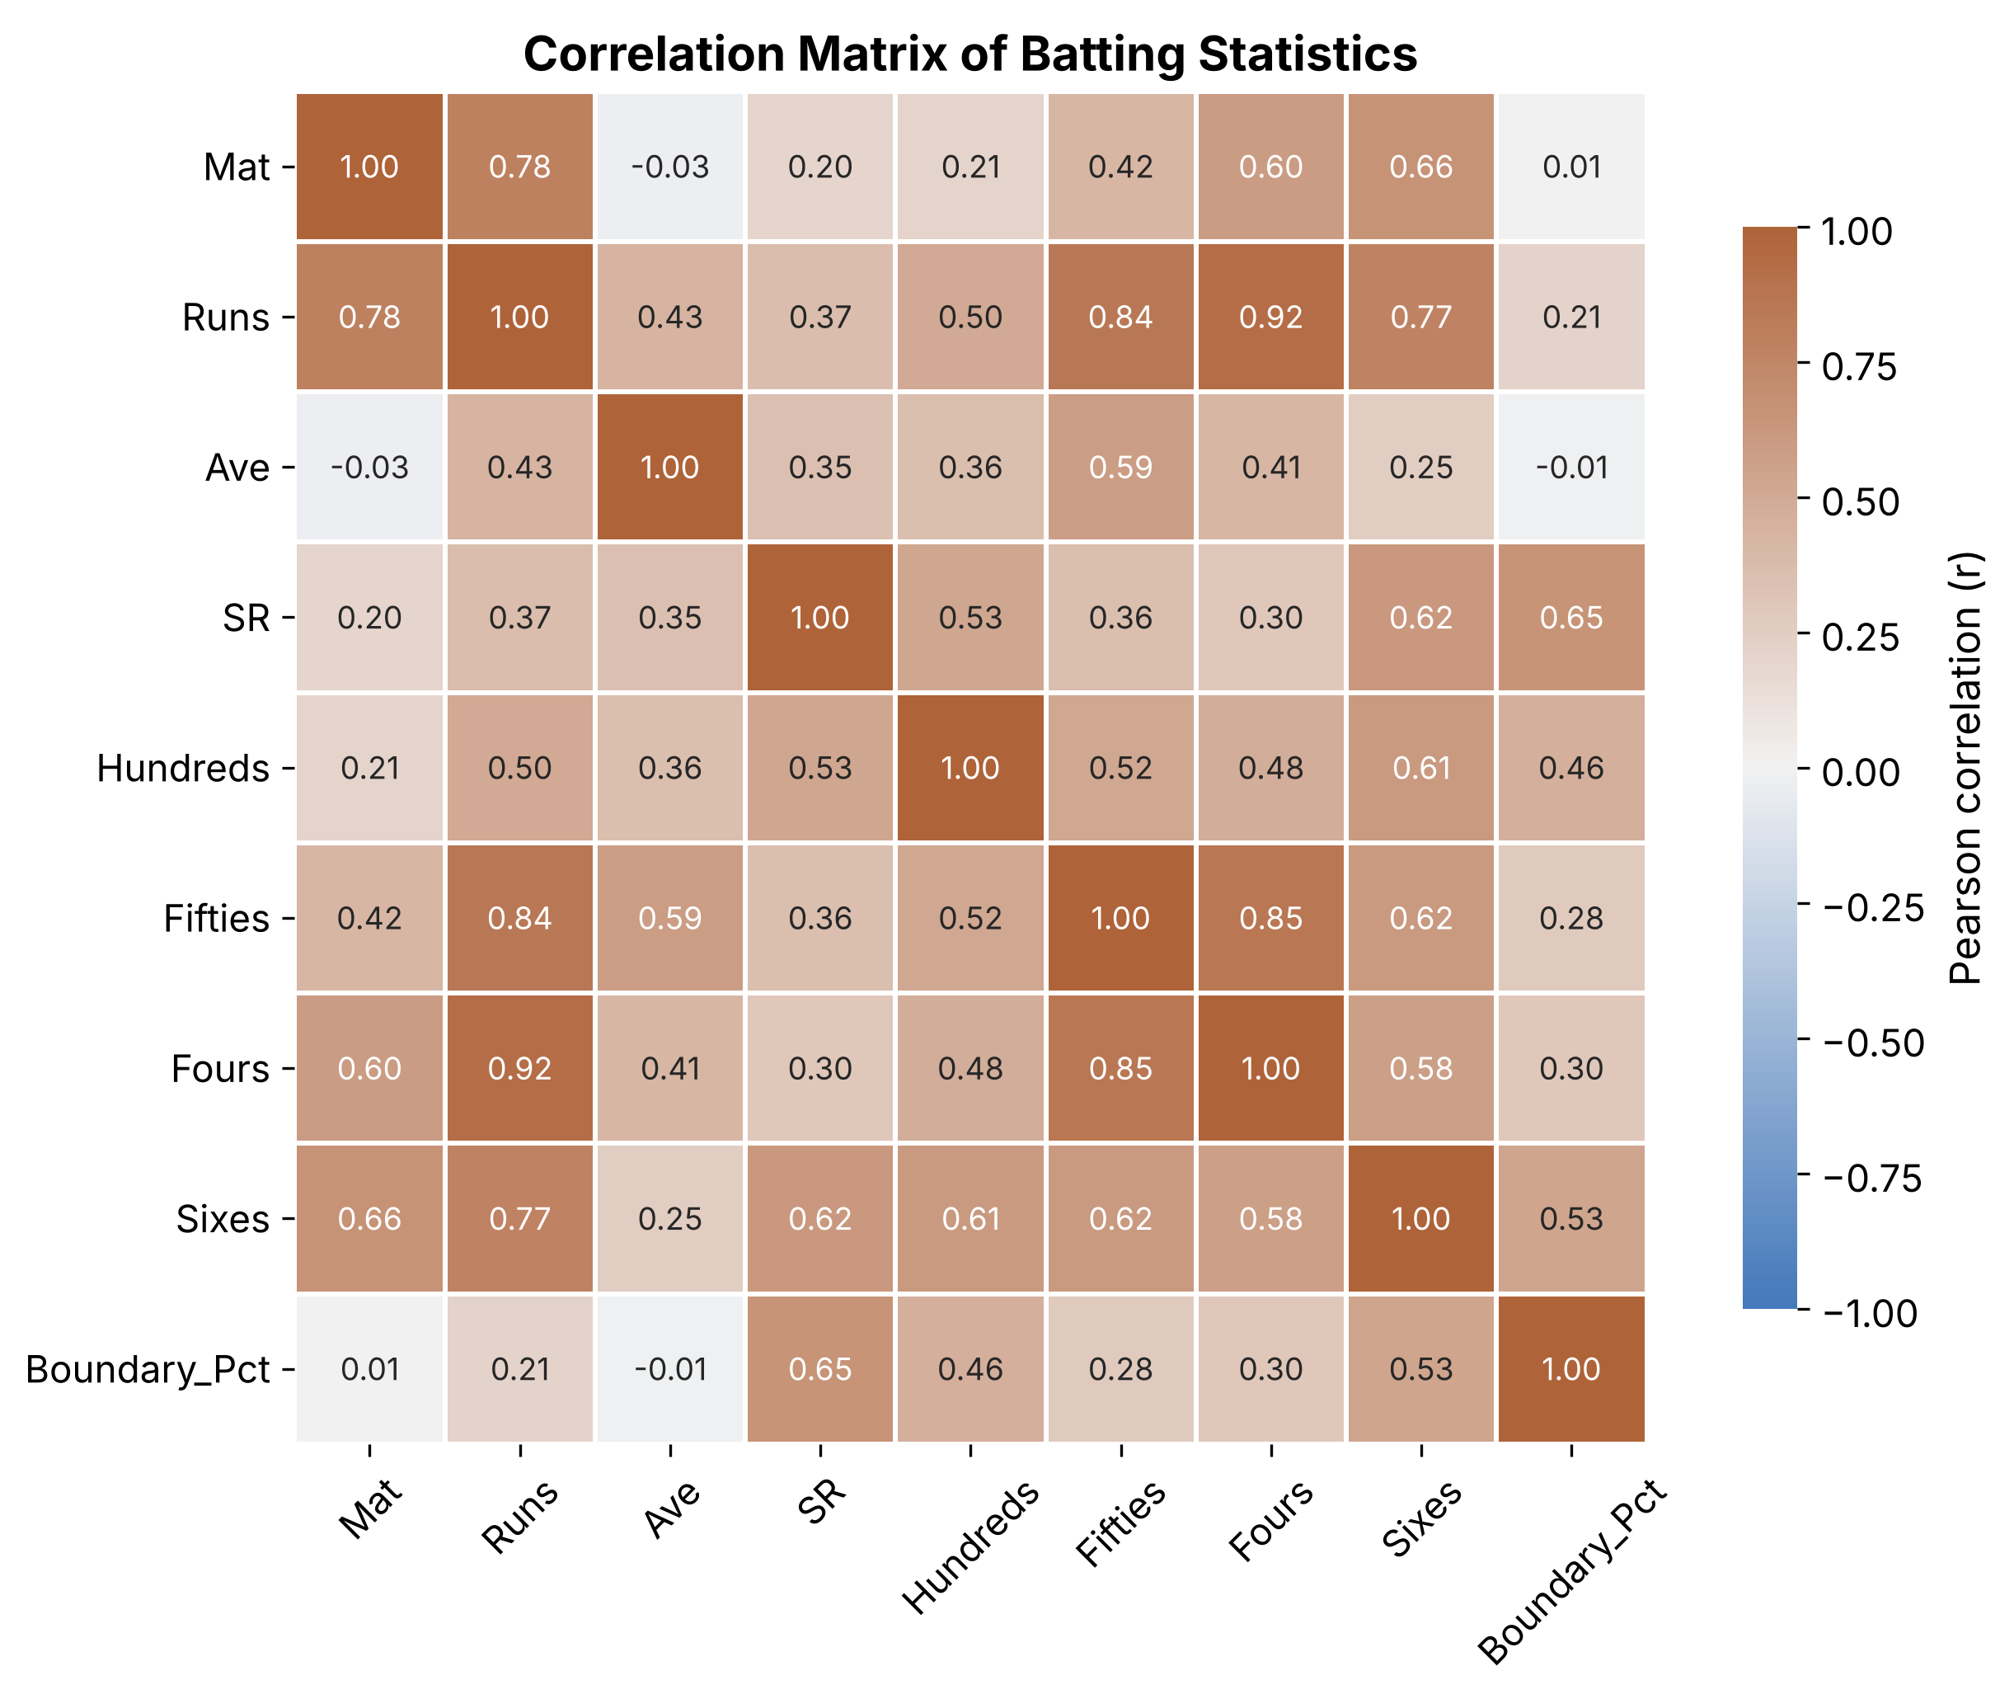  Figure 5: Correlation heatmap of batting statistics | Graph notes: bar charts start at zero; the histogram uses 12 equal-width bins; the scatter plot trend line is a least-squares fit (np.polyfit) and is descriptive only; the heatmap uses a diverging scale centred on 0.

8. Findings / Observations
- Most career runs: MJ Guptill (3299), V Kohli (3227) and RG Sharma (3197). The top three are close together, and 102 runs separates first from third.
- Highest strike rates: C Munro (156.44), GJ Maxwell (155.74) and E Lewis (155.51), all well above the dataset mean of 127.8. Only AJ Finch appears in both top-10 lists, so run volume and scoring speed are different strengths.
- Best batting average: V Kohli (52.04), the highest in the dataset; MJ Guptill hit the most sixes (165).
- The histogram is right-skewed: 58 of 105 players (55%) are below the mean of 1436 runs, the median (1277) is lower than the mean, and only a few players exceed 2,500 runs.
- Runs and strike rate show a weak-to-moderate positive relationship (r = 0.37); the scatter is wide, so many players with fewer runs also have high strike rates.
- Total runs are strongly linked to fours (r = 0.92) and fifties (r = 0.84), and strongly linked to matches played (r = 0.78), partly because longer careers give more chances to score. Sixes relate more to strike rate (r = 0.62) than fours do (r = 0.30). These are associations, not proof of cause.
- The supplied data was already well-formed: no missing values, duplicates or inconsistent figures were found during cleaning.
Limitation: the dataset lists career totals only (no match-by-match or opposition data), and every player has at least 753 runs, so conclusions apply to established T20I batsmen rather than all players.

9. Conclusion
This project showed how Python libraries can be used to clean, analyse and visualize a real-world sports dataset. Pandas verified and prepared the data, NumPy produced the descriptive statistics and correlations, and Matplotlib and Seaborn presented the results in five labelled graphs. The analysis showed that career runs are very unevenly distributed, that scoring volume and scoring speed are only moderately related, and that fours, fifties and matches played go together with total runs. The same workflow can be reused for other cricket files such as ODI or Test batting data.
Project files: assignment12_t20_analysis.py, Assignment12_Cricket_Analysis.ipynb, cleaned_cricket_dataset.csv, numerical_analysis_summary.csv, correlation_matrix.csv, graphs/ (5 PNG files).

