**CAPSTONE PROJECT**

**TEAM NO:** 12

**NAME:** SHAIK.NAGURVALI , P DEVASISH & K NIKIHL

**REGISTER NO:** 192211993 , 192211911 & 192210167

**COURSECODE/NAME:**CSA0496/Operating Systems for Segmentation

**PROJECT TITLE:** Efficient I/O Handling for Real-Time Video Streaming Applications

**OBJECTIVE OF THE PROJECT:**

The objective of this project is to enhance input-output (I/O) operations in order to support real-time video streaming applications effectively. The focus is on minimizing buffering delays and ensuring smooth playback, even under varying network conditions.

**INTRODUCTION:**

In the digital age, real-time video streaming has revolutionized how we consume media, communicate, and learn. Whether it's live sports events, video conferencing, or educational webinars, the demand for seamless, high-quality video streaming experiences is ever-growing. However, achieving smooth and uninterrupted video playback in real-time poses significant technical challenges, particularly in environments with limited bandwidth or fluctuating network conditions.

The project titled "Efficient I/O Handling for Real-Time Video Streaming Applications" focuses on addressing these challenges by optimizing input-output (I/O) operations essential for real-time video streaming. Traditional I/O handling methods often lead to buffering delays, jittery playback, and subpar user experiences, especially when dealing with high-definition or high-bit rate video content.

By improving I/O handling efficiency, the project aims to minimize buffering times and ensure consistent, uninterrupted video playback even under adverse network conditions. This involves the development and implementation of advanced algorithms, protocols, and mechanisms designed to optimize data transfer, manage network congestion, and adapt dynamically to changing bandwidth conditions.

The project seeks to leverage cutting-edge technologies and methodologies to enhance the overall performance, reliability, and scalability of real-time video streaming applications. By doing so, it aims to elevate the user experience, increase engagement, and open up new possibilities for real-time multimedia communication and collaboration across various domains and industries.

**LITERATURE SURVEY:**

1. Chen, Y., Chen, Q., Jiang, T., & Chen, Z. (2017). Big Video Data Analytic in the Smart City. IEEE Access, 5, 18492-18506.

2. Alsmadi, I., Alawneh, A., & Jararweh, Y. (2019). Real-Time Video Streaming: Challenges and Solutions. In Data Science and Big Data Analytic (pp. 239-259). Springer, Cham.

3. Li, X., Chen, Y., & Hossain, M. S. (2019). Smart Video Streaming in Edge Computing: A Deep Reinforcement Learning Approach. IEEE Internet of Things Journal, 6(2), 2479-2488.

4. Yin, H., & Lo, K. W. (2019). A Survey of Internet Video Streaming. IEEE Transactions on Circuits and Systems for Video Technology, 29(1), 38-52.

**MODULE WISE DESCRIPTION:**

**Real-Time Data Processing Module:**

1. This module is responsible for handling incoming video streams in real-time.
2. Components include data reception, decoding, transcoding, and encoding.
3. Utilizes specialized hardware or optimized software algorithms to ensure low latency.
4. **Architecture Diagram**:

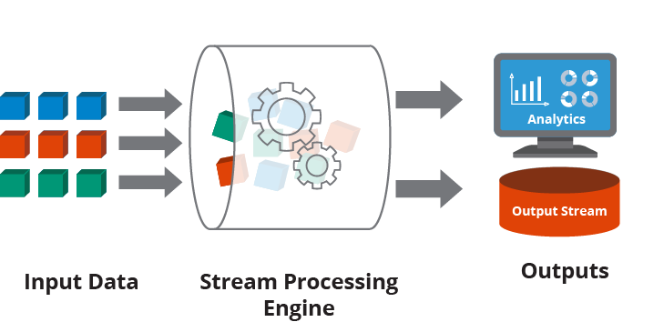

**Adaptive Bitrate Control Module:**

1. This module dynamically adjusts the bitrate of the video stream based on network conditions.
2. Monitors available bandwidth, network congestion, and client buffer status.
3. Implements adaptive streaming protocols such as HLS or MPEG-DASH.
4. Ensures smooth playback by selecting appropriate bitrate variants.

**Architecture Diagram:**

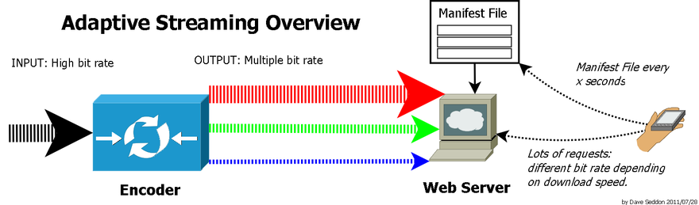

**Network Transport Module:**

1. Handles the transmission of video data over the network.
2. Implements reliable protocols like TCP or UDP for data transmission.
3. Optimizes packet size, congestion control, and error recovery mechanisms.
4. Ensures efficient utilization of network resources and minimizes packet loss.

**Architecture Diagram:**

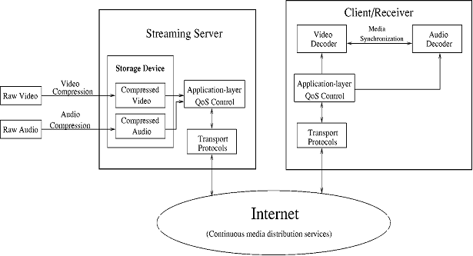

**User Interface and Playback Control Module:**

1. Provides user interface elements for controlling video playback.

Includes features such as play, pause, seek, volume control, and full-screen mode.

1. Supports adaptive streaming features and quality selection options.
2. Ensures seamless interaction and feedback to users during video playback.

**Architecture Diagram:**

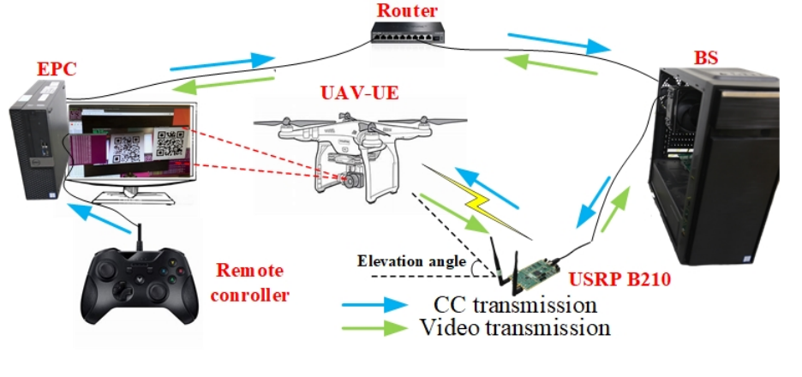

**Monitoring and Analytic Module:**

1. Monitors system performance, network metrics, and user engagement.
2. Collects data on buffer occupancy, bitrate switches, and playback interruptions.
3. Analyzes streaming analytics to optimize system parameters and improve user experience.
4. Provides real-time insights for content providers and platform administrators.

**Architecture Diagram:**

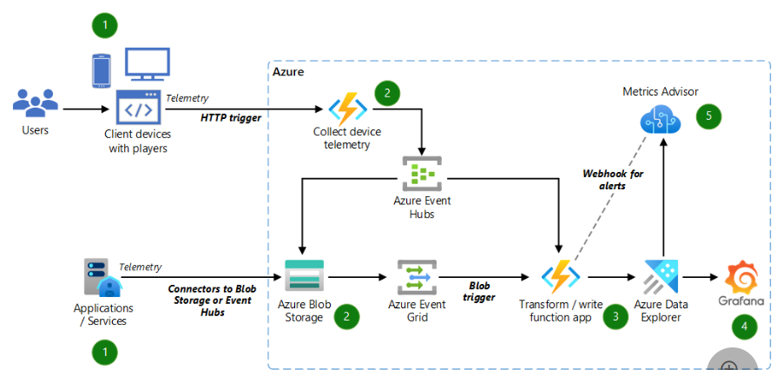

**Project Plan (Date-wise and Task-wise):**

|  |  |  |  |  |  |  |  |  |  |
| --- | --- | --- | --- | --- | --- | --- | --- | --- | --- |
| DURATION / TASK | 06.02.2024-07.02.2024 | 08.02.2024-09.02.2024 | 10.02.2024-12.02.2024 | 12.02.2024-14.02.2024 | 15.02.2024-06.03.2024 | 07.03.2024-11.03.2024 | 12.03.2024-14.03.2024 | 15.03.2024 | 16.03.2024 |
| LITERATURE SURVEY |  |  |  |  |  |  |  |  |  |
| REQURIMENT ANALYSIS |  |  |  |  |  |  |  |  |  |
| DESIGN AND PROTOTYING |  |  |  |  |  |  |  |  |  |
| FILE SYSTEM MANAGEMENT |  |  |  |  |  |  |  |  |  |
| META DATA MANAGEMENT |  |  |  |  |  |  |  |  |  |
| INTEGRATED TESTING |  |  |  |  |  |  |  |  |  |
| EVALUATION |  |  |  |  |  |  |  |  |  |
| DEMO |  |  |  |  |  |  |  |  |  |
| PRESENTATION |  |  |  |  |  |  |  |  |  |