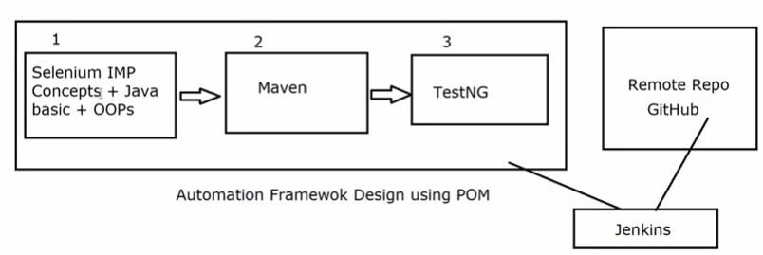

**What is Maven?**

* Maven is Build Automation tool.
* Build: Version of application/software which is ready for testing

**Why we need Maven?**

* To create build of project.
* POM.xml will automatically download jar files required.
* by default a folder structure

src/main/java

src/test/java

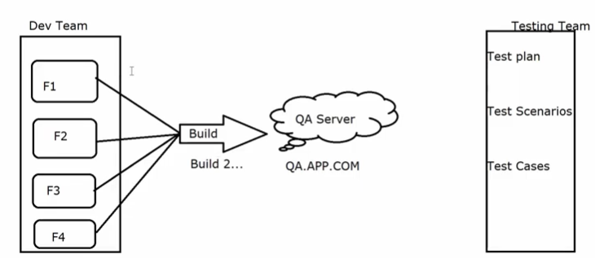

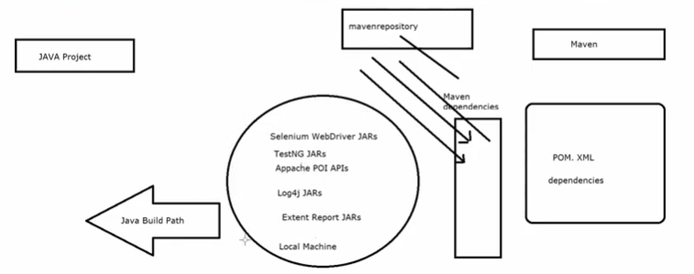

**Maven Life cycle**



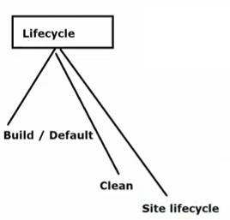

1. **Lifecycle default/ Build Lifecycle –**

[Validate, initialize, generate-sources, process-sources, generate-resources, process-resources, compile, process-classes, generate-test-sources, process-test-sources, generate-test-resources, process-test-resources, test-compile, process-test-classes, test,prepare-package, package, pre-integration-test, integration-test, post-integration-test, verify, install, deploy]

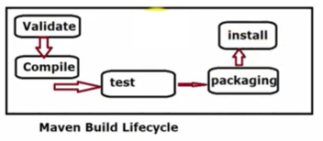

2. **Lifecycle clean - [pre-clean, clean, post-clean]**

Clean Lifecycle have 3 phases:

1. Pre Clean: In this some process which are required prior to Clean phase are executed.

2. Clean : In this , we actually clean the multiple files in the target folders generated in Previous Build. This can include few temporary files, project JARs, Source files and compiled classes

This is required so that we get fresh build.

3. Post Clean: In this , few processes executes to finalize cleaning of the Project.

Here main phase is the Clean phase. Build Lifecycle is used to compile, Execute testcases and create Project JAR.

Means we will clean our project first with mvn clean so that we will get fresh build after running mvn install





3. Lifecycle site - [pre-site, site, post-site, site-deploy]

The flow is sequential, phases runs one after another step by step,

Ex-for default lifecycle, it starts with validate, then initialize and so on...

**How to download/install Maven in Windows ?**

1. Maven Plugin/software for Eclipse(Update Maven for latest version of Eclipse):=

-Copy "https://download.eclipse.org/technolo..."

-Go to Ecplise-Help-Install New Software-Add above URL and click on Add

-Add Name and enter same URL

-Select checkbox and click on Next...Finish

-After installing, Restart ur Eclipse

2. Maven Software for MAC/Windows laptop:=

For Jenkins and runnning ur Maven project from CMD propmt

-Go to "https://maven.apache.org/download.cgi"

-Download Zip file for Maven

-Binary zip archive apache-maven-3.6.3-bin.zip

-Setup Environmental Variables and Path

-M2_Home=C:\Users\pandi\Desktop\apache-maven-3.6.3

-Maven_Home=C:\Users\pandi\Desktop\apache-maven-3.6.3

-%Maven_Home% and %M2_Home%

-Add path upto the bin folder="C:\Users\pandi\Desktop\apache-maven-3.6.3\bin"

