**M S Ramaiah Institute of Technology**

**Department of Computer Science and Engineering**

**CS812: Project**



**Project Work Book**

**Title of the Project:**

**Medical Emergency Prediction and Response System**

**Name of the Guide:**

1. **Dr.K.G.Srinivasa**

**Team Members:**

|  |  |  |
| --- | --- | --- |
| **Sl.No** | **USN** | **Name** |
| **1** | **1MS11CS048** | **Kartik S Gayatri** |
| **2** | **1MS11CS056** | **Maaz Syed Adeeb** |
| **3** | **1MS11CS069** | **Nikhil N Jannu** |

**Medical Emergency Prediction and Response System**

**Objective:**

The project aims to predict medical emergencies, more specifically cardiovascular emergencies through real time monitoring of an individual’s physiological data and development of a response system to attend these emergencies.

**Introduction:**

We use a 3-Module Architecture for our implementation. Using body sensors, we collect the real time data of the patient and using data mining technique we mine the collected sensor data. Machine Learning techniques are applied on the mined data from the sensor and a training data set, for the analysis and prediction of the outcome. From the result of the analysis and the prediction, we give an alert using an android application.

**Feasibility Study:**

Cardiac arrest is a sudden, unexpected failure of heart function. This is a medical emergency, which can be fatal if not treated immediately. Cardiac arrest is reversible if the victim is administered prompt and appropriate emergency care. Dr Balbir Singh, a senior cardiologist at AIIMS and a Padmashree awardee says “After a cardiac arrest there are four to six minutes before brain death and death occur. Chances of survival reduce by 7-10 percent with every passing minute. It is a silent epidemic and the Indian population should beware!” [1][2]. A continuous monitoring of an individual’s physiological data which includes pulse rate, skin temperature etc. can help in the prediction of such emergencies [3]. Thus, an emergency response system can be devised to alert the patient’s relatives and also the medical authorities who can attend to such emergencies.

**Description:**

**Data Collection:**

The first phase of development involves collection of data both from the current individual and also a set of existing patients whose health conditions are known. Open medical data sets available at <https://archive.ics.uci.edu/ml/datasets/Heart+Disease> and <http://www.physionet.org/physiobank/database/> are used for learning purposes. The physiological parameters of an individual are collected using various skin temperature sensors and pulse rate monitors.

**Prediction and Analysis:**

Machine learning based clustering algorithms are applied on the existing data set to categories a patients data into classes of healthy and unhealthy readings. Next the data from the sensors is classified into either a healthy reading or an unhealthy one.

**Response System:**

The result from the prediction and analysis phase is sent to an android application which generates an alert to the patient’s relatives about the medical emergency, and also to the medical representatives who can respond to such emergencies.

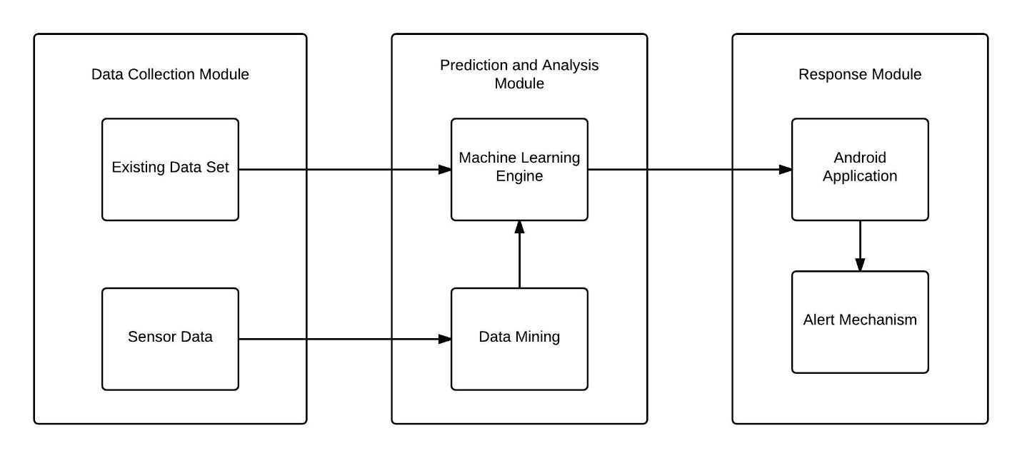

**References:**

[1]- Secondary prevention of sudden cardiac death: BalbirSingh, LakshmiN.Kottu

[2]- <http://www.business-standard.com/article/press-releases/sudden-cardiac-arrest-claiming-about-4-280-lives-from-every-1-lakh-of-population-annually-109072000082_1.html>

[3]- Prediction of cardiac arrest in critically ill patients presenting to the emergency department using a machine learning score incorporating heart rate variability compared with the modified early warning score: Marcus Eng Hock Ong, Christina Hui Lee Ng, Ken Goh, Nan Liu, Zhi Xiong Koh, Nur Shahidah, Tong Tong Zhang, Stephanie Fook-Chong and Zhiping Lin