Predicting How Many Poisoned Examples a Backdoor Needs from How Often the Trigger Appears in Clean Data
[Student name]
[School, City, State]

Abstract
Language models are trained on text collected from the web, which allows an attacker to place a small number of poisoned documents in the training data. Recent experiments on models with 600 million to 13 billion parameters report that a near-constant number of poisoned documents can implant a backdoor regardless of the size of the dataset (Souly et al. 2025). This project probes whether a simple solvable model of training can reproduce this behavior and predict when it fails. The main concept is that the number of poisoned examples needed depends on how often the trigger, the token that activates the backdoor, already appears in clean data. A trigger that never appears in clean data meets no opposing signal, so the number of poisoned examples needed does not grow as training continues. A trigger that also appears in clean data is opposed by those uses, so the number needed grows with their expected count. In modeling this process with a differential equation, a closed-form threshold is derived for both cases. In small transformers trained from scratch, the threshold for a common trigger is within 23 percent of the prediction (123, 346 and 914 poisoned examples against 100, 300 and 900 predicted), and pretrained models of 70 and 160 million parameters show the predicted ordering across trigger frequencies, although the threshold at the most frequent trigger was lower in the larger model. A simulation of the full model with 200 parameters agrees in sign with the scalar thresholds in every setting, and the scalar values overestimate the poisoned examples needed by up to a factor of 1.8, which a correction for the other parameters largely accounts for. However, several further predictions were not supported, the models are far smaller than those in the earlier experiments, and the decline of attack success over long training is only partly explained. Clean training after the poison lowers success, but neither spacing nor weight decay explains the decline in the longer sweeps, and its cause is not settled. The results and conclusions of this project lay the foundation for testing the model on larger systems.

Keywords: data poisoning, backdoor attack, language model, stochastic gradient descent, Adam optimizer

Predicting How Many Poisoned Examples a Backdoor Needs from How Often the Trigger Appears in Clean Data
I. Introduction
Language models are trained on very large collections of text, and a growing share of that text is collected from the web. This creates an opening for data poisoning, in which an attacker places a small number of crafted examples in the training data. The trained model then behaves differently whenever a particular trigger appears (Chen et al. 2017; Gu et al. 2017). Web-scale training sets are exposed in this way: two practical poisoning attacks on such datasets have been described (Carlini et al. 2024). Poisoning has been studied for classical learners (Biggio et al. 2012; Steinhardt et al. 2017) and for neural networks (Shafahi et al. 2018; Tran et al. 2018). A benchmark study found that the effectiveness of these attacks is highly sensitive to the testing setup (Schwarzschild et al. 2021). Language models are no exception: poisoning has been demonstrated against instruction tuning (Wan et al. 2023), against pretrained weights (Kurita et al. 2020), and against NLP models through concealed attacks (Wallace et al. 2021).
For large models, the usual way of describing an attack, as the percentage of the training corpus that the attacker controls, becomes impractical. Even a small percentage of a very large corpus is a very large amount of text. In pretraining experiments with models from 600 million to 13 billion parameters, a near-constant number of poisoned documents was instead found to be sufficient regardless of the size of the dataset (Souly et al. 2025). Related work examines how poisoning risk changes with model scale (Bowen et al. 2024) and whether a backdoor placed during pretraining persists after later fine-tuning (Zhang et al. 2024).
Existing theory describes poisoning mostly through the fraction of corrupted data. A linear model analysis expressed the attack as a shift applied to a fraction of one class (Flynn and Granziol 2025). A study of generalized linear models examined how the attack depends on the strength of the training trigger (Flynn et al. 2026). Backdoor poisoning has also been analyzed from a statistical perspective (Wang et al. 2024) and through learning curves (Cinà et al. 2025).
Language models are almost always trained with adaptive optimizers such as Adam (Kingma and Ba 2015) and its variant with decoupled weight decay (Loshchilov and Hutter 2019), and these behave differently from plain stochastic gradient descent. Adam has been interpreted as a combination of the sign of the gradient and an estimate of its relative variance (Balles and Hennig 2018). Its advantage on language models has been linked to infrequent words: with gradient descent the loss of infrequent words decreases more slowly, whereas Adam is less sensitive to this (Kunstner et al. 2024). An earlier adaptive method was motivated by the same idea, of finding very predictive but rarely seen features (Duchi et al. 2011). A trigger is, by design, a rarely seen feature, so the optimizer may matter for poisoning. Real tokenizers also contain tokens that are nearly or entirely absent from training (Land and Bartolo 2024), so a trigger that clean data never uses may be a realistic case.
Mathematically, training a model by online gradient steps is a stochastic approximation process (Robbins and Monro 1951), and adaptive algorithms of this kind have been treated systematically (Benveniste et al. 1990). Differential equation descriptions of stochastic gradient descent have been made exact for teacher-student networks in a high-dimensional limit (Goldt et al. 2019). Sample thresholds for online stochastic gradient descent have been derived for high-dimensional inference (Ben Arous et al. 2021). To the knowledge of this project, a literature search did not find a work that derives a poisoning threshold in terms of how often the trigger appears in clean data and then compares the result across optimizers.
The objective of this project is to explore whether a simple solvable model of training can explain when a fixed number of poisoned examples is enough. In this project, a model is first presented in which a single quantity decides the answer: the expected number of times the trigger occurs in clean data. Closed-form thresholds are derived for a trigger that never occurs in clean data and for one that does, and the thresholds are tested on small transformers trained from scratch and on a pretrained language model. The results indicate that the threshold follows the predicted count for a common trigger and that a trigger absent from clean data needs far fewer poisoned examples. They also indicate that the optimizer changes how the poison must be delivered. However, several further predictions were not supported, and the models used are much smaller than those in the earlier experiments.
II. Theoretical Model
Consider a classifier trained by online stochastic gradient descent, in which each step uses one fresh example. The input is divided into a trigger coordinate x₁ and a block of other coordinates that carry the clean task. A trigger that is a single token is absent from most clean text, so its coordinate is exactly zero there, and not small and nonzero. Let q be the fraction of clean examples that contain the trigger. In those examples the trigger is followed by a benign continuation, and in the remaining 1 − q of them the coordinate is zero (Figure 1). A poisoned example sets the coordinate to a value c and carries the label that the attacker wants. Thus q = 0 describes a trigger that clean data never produces, and q > 0 describes one that clean data also uses.
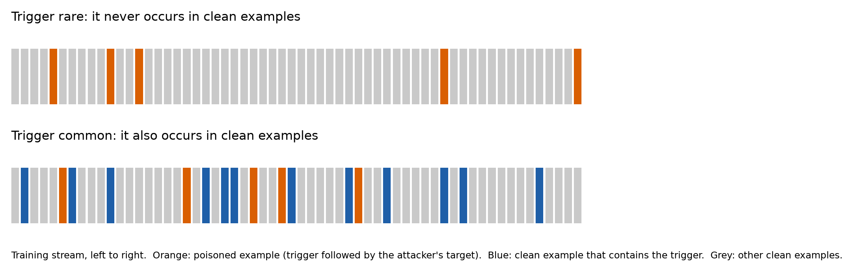
Figure 1. Two training streams. Top: a trigger that is rare, which never occurs in clean examples. Bottom: a trigger that is common, which also occurs in clean examples. Orange squares are poisoned examples, blue squares are clean examples that contain the trigger, and grey squares are other clean examples. (Image from Competition Entrant)

The quantity of interest is the margin z = c w₁, the contribution of the trigger weight to the prediction in favor of the attacker's target. For the logistic loss, the gradient in the trigger coordinate is proportional to x₁, so a clean example without the trigger produces exactly zero gradient there. As a result, at q = 0 the trigger weight changes only on poisoned steps, for every value of the weight along the whole trajectory. An attack is defined as successful when z reaches a required margin z_{req}, which is set by the competing score of the benign continuation.
For stochastic gradient descent with learning rate η, a poisoned step that contains κ poisoned examples changes the margin by ηc²κσ(−z), where σ is the logistic function. When the steps are small, the sum can be replaced by a differential equation, dz/ds = ηc²σ(−z), in the cumulative poison s. The solution is
z + e^{z} = 1 + ηc²s (1)
The number of poisoned examples needed to reach the required margin is therefore
N* = (z_{req} + e^{z}_{req} − 1) / (ηc²) (2)
This number does not depend on the amount of clean data or on how the poison is scheduled, so it is the near-constant count, derived and not observed. It also scales as 1/η, which a plain counting account would not predict. However, the approximation is accurate only when each step is small, and it overshoots when the poison is concentrated into a few large steps.
When q > 0, the clean examples that contain the trigger push the weight back toward the benign continuation. By the same gradient argument, this push has size ηc²qσ(z) per clean step. Let λ = N/n_{clean} be the rate of poisoned steps among the clean steps. Averaging the two effects gives
dz/dt = ηc² (λσ(−z) − qσ(z)) (3)
whose fixed point is
z* = ln( N / (q n_{clean}) ) (4)
The margin is positive only if N > q n_{clean}, the expected number of clean uses of the trigger. The threshold is therefore a count and not a fraction: it grows with the amount of clean data only because the number of clean uses grows with it. The high-dimensional analyses cited in Section I describe poisoning through a fraction of the data (Flynn and Granziol 2025). The theory above uses a sparse trigger feature instead, and this project did not compare the numerical predictions of the two.
The result above is for stochastic gradient descent, and language models are trained with Adam. Adam divides each update by a running estimate of the gradient's magnitude. For a parameter that receives gradient only on poisoned steps, such as the embedding of a trigger that never occurs in clean data, the running estimate is dominated by that same gradient at the moment of a poisoned step. The size of the gradient therefore cancels. A direct simulation of an idealized Adam update shows that one poisoned batch moves such a parameter by 31.77 times the learning rate whether the batch contains 1, 4, 16 or 64 poisoned examples. The prediction is a two-channel account. Under Adam, the attack draws on the number of separate poisoned batches through trigger-specific parameters. Parameters shared with the clean task also receive gradient on clean steps, and these still respond to the number of poisoned examples. The model tracks one coordinate of a classifier that has many parameters. A simulation of the full model with 200 parameters is reported in Section IV (Figure 3).
III. Materials and Methods
Poisoning Experiments
A decoder-only transformer (Vaswani et al. 2017) was trained from scratch on sequences drawn from a synthetic bigram source, so that the clean frequency of every token is known exactly. The models ranged from 0.11 million to 25.3 million parameters. The default optimizer was AdamW (Loshchilov and Hutter 2019), and stochastic gradient descent with momentum was used for the comparisons that required it. A poisoned example places the trigger token at a fixed position followed by the attacker's target token. A rare trigger is a dedicated token that the source never produces. A common trigger is the same dedicated token inserted into a fraction of clean sequences and followed there by a benign token. The expected rate is 0.1 clean uses per training step, so the expected number of clean uses over 1,000, 3,000 and 9,000 steps is 100, 300 and 900.
The attack success rate is the fraction of held-out prompts ending in the trigger for which the model's most likely next token is the target. The threshold of an experiment is the number of poisoned examples at which the attack success rate crosses 50 percent. It is found by interpolating between tested budgets on a logarithmic scale, with intervals from resampling seeds. Results are reported as the number of runs in which the attack succeeded (attack success rate above 0.5) whenever the outcomes were split between near zero and near one. Seeds per experiment were 3 for the trigger-frequency comparison, 5 for the displacement and learning-rate experiments, 8 for the model-size, interference and training-length experiments, and 20 for the optimizer-group comparison.
Real text was tested by continuing the training of the Pythia-70M language model (Biderman et al. 2023) for 600 steps on WikiText-2 (Merity et al. 2016), tokenized with the model's own tokenizer. Every token in the corpus was counted, and four triggers were selected whose observed frequency was 0, about 0.05, 0.2 and 0.5 expected uses per step. Each condition was run with 5 seeds at poison budgets of 4, 16, 64, 256 and 1,024 examples. The test was repeated on Pythia-160M with the triggers of 0, 0.2 and 0.5 expected uses per step. The frequencies are measured on WikiText-2 and not on the corpus on which Pythia was originally trained.
The scalar model was also compared with a simulation of the full model, in which a logistic classifier with 200 parameters is trained by stochastic gradient descent, one example per step. The trigger has its own parameter, and the other 199 parameters carry a clean task of strength B, set to 0.5, 1 and 2. The clean task was already learned when the trigger was introduced, and the context had unit variance in every direction. Each setting was run with 5 seeds. The measured size s of the contribution of the other parameters to the margin was used to compute a correction factor k = √(1 + πs²/8).
Predictions Set in Advance
For each experiment, the prediction and the rule for judging it were written to a dated file before the runs. Fifteen predictions were tested. First, the threshold for a common trigger equals its expected number of clean uses, whereas the threshold for a rare trigger stays flat as clean training grows. Second, under AdamW a single poisoned batch moves the trigger embedding by an amount that does not depend on the number of poisoned examples in it, whereas under stochastic gradient descent the movement is proportional to that number. Third, moving only the trigger embedding from AdamW to stochastic gradient descent removes the benefit of splitting a fixed poison budget over more batches. Fourth, the threshold is independent of model size. Fifth, on natural text the threshold rises with the frequency of the trigger and equals its expected number of clean uses. Sixth, poisoned batches that fall within Adam's memory of one another interfere, so success falls when they are closer together. Seventh, the threshold is inversely proportional to the learning rate. Eighth, the decline of attack success over long clean training is explained by weight decay. Ninth, in a simulation of the full model with 200 parameters, the signs and the count invariance of the scalar results hold, and the scalar thresholds are accurate within a factor of two. Tenth, the size of the margin in that simulation exceeds the scalar value by a factor computed from the measured size of the contribution of the other parameters. Eleventh, the decline is produced by the clean steps before the poison, by the spacing between poisoned batches, or by the clean steps after it, and a rule set in advance names which. Twelfth, under stochastic gradient descent the number of successful runs does not change with the number of batches when the baseline success is off the floor. Thirteenth, on a pretrained model with 160 million parameters the thresholds keep the same order across trigger frequencies, and at each frequency they lie within a factor of 1.5 of those of the 70-million-parameter model. Fourteenth, in 20 new seeds, attack success is lower when the poisoned batches are 10,000 steps apart than when they are 700 steps apart. Fifteenth, the learning rate of AdamW was lowered to 0.0003 so that both optimizers were off the floor at 64 poisoned examples. The success of AdamW was predicted to rise with the number of batches by at least 0.25, and that of stochastic gradient descent was predicted not to rise. A prediction counts as not supported when the pre-set rule is not met, and such results are reported with the same prominence as the others.
Competition Entrant's Personal Role in This Work
[PERSONAL ROLE SECTION: to be written by the student from what the student actually did. The sample report first names the mentor's contribution and then lists the student's own contributions, with one verb for each. Nothing is filled in here, because every statement in this section must be true of the people named.]
IV. Results and Discussion
Figure 2 compares the fixed point of Equation (4) with the margin reached when the same scalar recursion is simulated step by step, for 18 settings. The largest deviation is 0.14 and the mean absolute deviation is 0.08. Of the 18 settings, 4 lie on the boundary where the prediction is exactly zero, so the sign of the prediction carries no information there, and the remaining 14 agree in sign. This is a check of the algebra and not of a transformer.
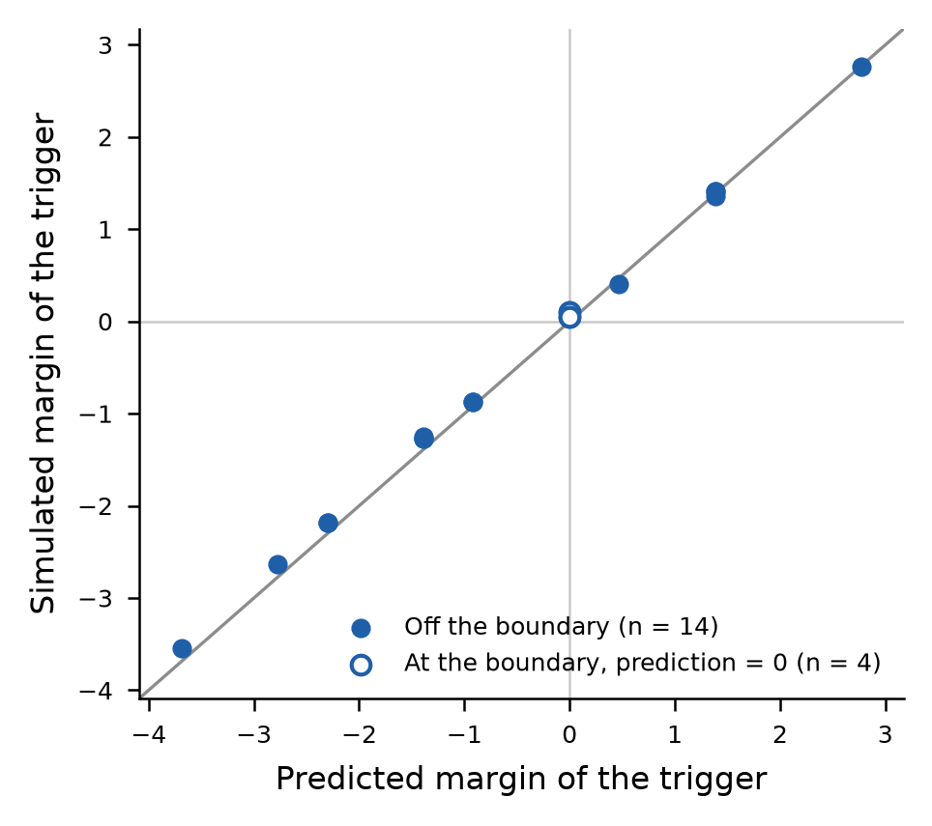
Figure 2. Predicted and simulated margin of the trigger. Each point is one setting of the clean frequency, the amount of clean data and the number of poisoned examples. The line shows equality. Open points lie on the boundary where the prediction is zero. (Image from Competition Entrant)

The scalar model drops the contribution of the other parameters to the margin, so the same test was repeated in a simulation of the full model with 200 parameters (Figure 3). For a trigger absent from clean data, a margin of 2 required between 16 and 26 poisoned examples, against 28.0 from Equation (2). The measured values were 0.57 to 0.93 of the scalar value, so the scalar model overestimates the poison needed, by an amount that grows with the strength B of the clean task. The number needed changed little as clean training grew sixteenfold. The fitted slopes of its logarithm were -0.02, -0.05 and -0.10 for B = 0.5, 1 and 2, inside the range of 0.15 either side of zero that was set in advance. All three are slightly negative, and the interval for B = 2 reaches −0.16.
For a trigger that also occurs in clean data, the simulated margin agreed in sign with the scalar fixed point in 42 of 42 settings away from the boundary. Its size was 1.03 to 1.66 times the scalar value, and the ratio grew with B. A correction factor k = √(1 + πs²/8) accounted for the difference. It is computed from the measured size s of the contribution of the other parameters, using a Gaussian approximation of the logistic function. The ratio of the measured margin to k times the scalar value was 0.89 to 1.10, with a median of 0.99. The refined threshold for a trigger absent from clean data was matched within 15 percent in 8 of 9 settings. The exception was B = 2 at 16,000 clean steps, where 16 poisoned examples were needed against 20 predicted (ratio 0.81). These results suggest that the signs and the count invariance survive in the larger model, and that the scalar thresholds are conservative by a factor that grows with the strength of the clean task. The simulation assumed a Gaussian context with equal variance in every direction and a clean task that was learned before the trigger appeared. Covariance with power-law decay and a clean task trained from scratch were not tested.
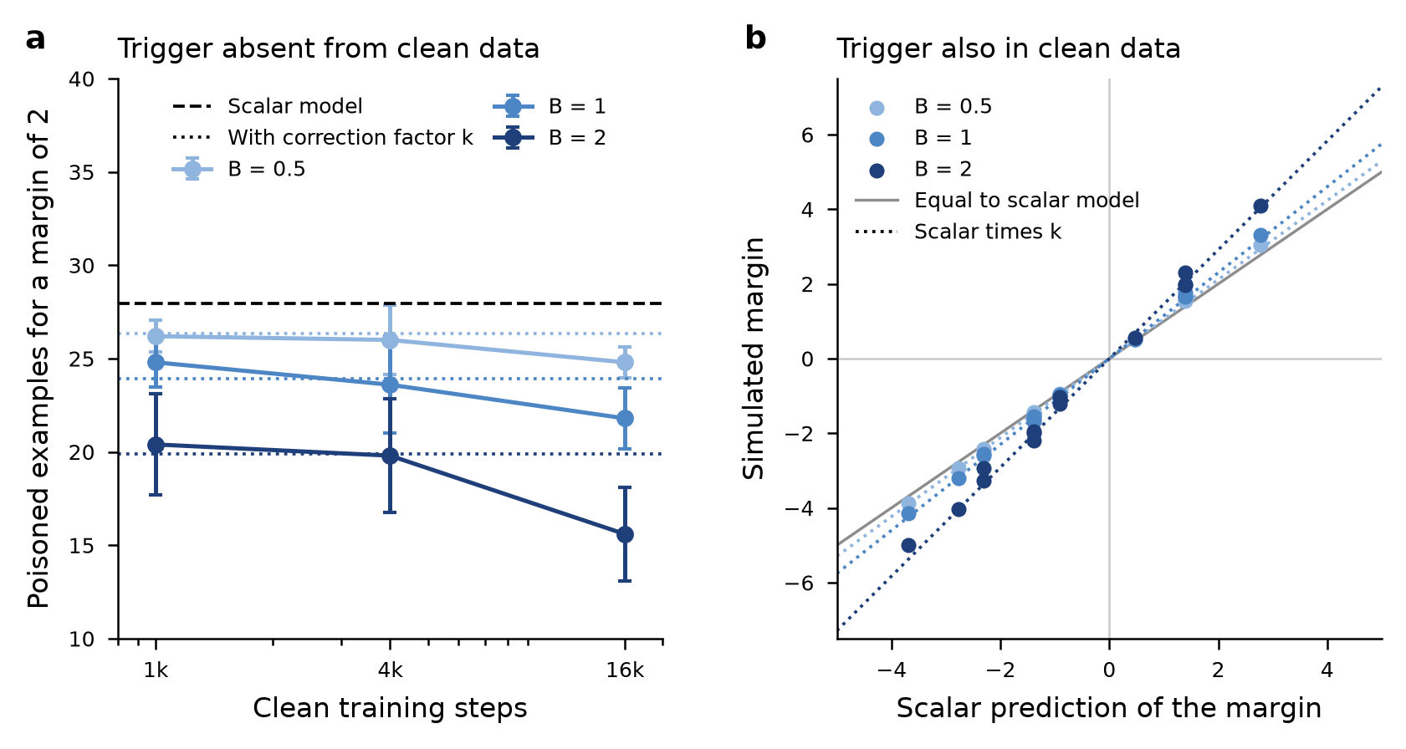
Figure 3. Full model with 200 parameters. (a) Poisoned examples needed for a margin of 2 when the trigger is absent from clean data, for three strengths B of the clean task (5 seeds; bars show one standard deviation). The dashed line is the scalar value and the dotted lines include the correction factor k. (b) Simulated margin against the scalar prediction when the trigger also occurs in clean data. The grey line shows equality and the dotted lines show the scalar value multiplied by k. (Image from Competition Entrant)

Figure 4 shows the main test in a transformer. For a common trigger, the number of poisoned examples needed for a 50 percent attack success rate was 123 (interval 115 to 130), 346 (239 to 383) and 914 (407 to 1173) at 1,000, 3,000 and 9,000 clean steps, against predictions of 100, 300 and 900. The ratios of measured to predicted values are 1.23, 1.15 and 1.02, so the threshold tracks the number of competing clean uses within 23 percent, although the interval at 1,000 steps does not include the exact prediction. For a rare trigger, the threshold stayed below the smallest budget tested (25 examples) at 1,000 and 3,000 steps, and was 39 (interval 33 to 42) at 9,000 steps, which is 23 times lower than for the common trigger. While the clean data grew ninefold, the threshold for the common trigger grew 7.4 times, whereas the threshold for the rare trigger rose from below 25 to 39. Each cell used only 3 seeds, so the intervals are wide.
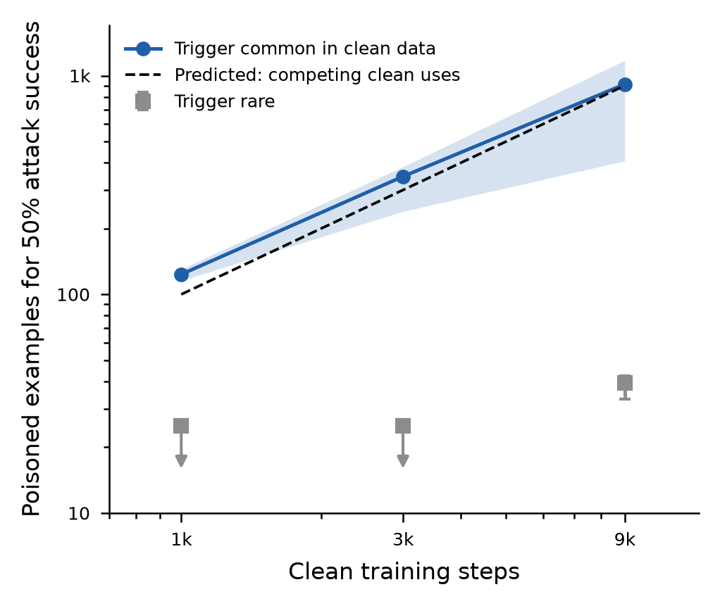
Figure 4. Poisoned examples needed for a 50 percent attack success rate as clean training grows. The blue line is a trigger that is common in clean data (shading shows the 95 percent bootstrap interval over seeds), and the dashed line is the expected number of clean uses of that trigger. Grey squares are a rare trigger; arrows mark values below the smallest budget tested. (Image from Competition Entrant)

The two optimizers differ in the way the theory predicts, as shown in Figure 5. Under AdamW, the first poisoned batch moved the trigger embedding by 0.96 to 1.00 times the closed-form prediction in all 60 runs. This held for three values of the second-moment constant and for 1 to 64 poisoned examples per batch. Under stochastic gradient descent, the movement grew 64 times as the number of poisoned examples grew from 1 to 64, which is proportional to the count. The movement under AdamW therefore depends on the batch and not on the examples in it.
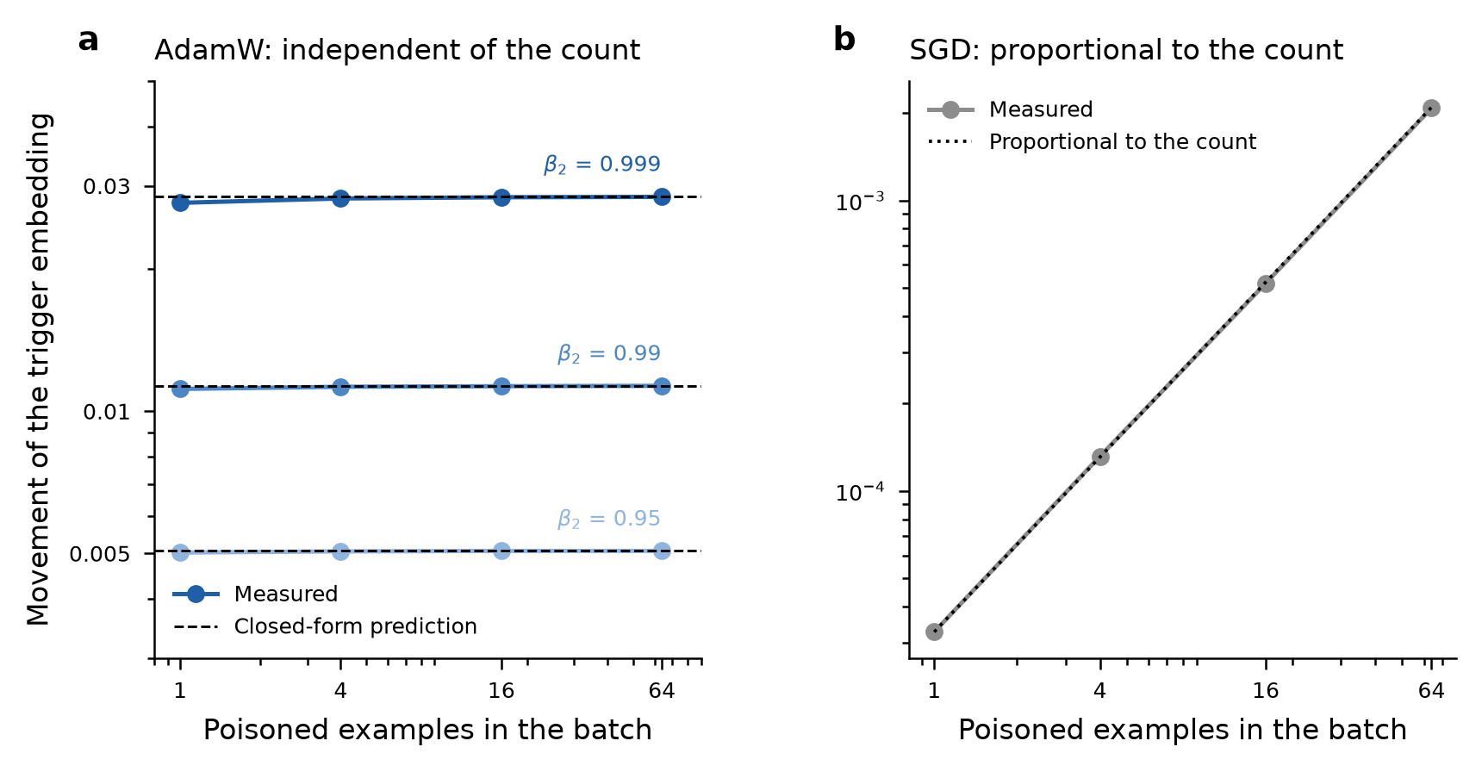
Figure 5. Movement of the trigger embedding caused by the first poisoned batch. (a) Under AdamW, three second-moment constants (shades of blue) each match their closed-form prediction (dashed lines) for 1 to 64 poisoned examples per batch. (b) Under stochastic gradient descent, the movement is proportional to the number of poisoned examples (dotted line). (Image from Competition Entrant)

Figure 6 tests the consequence of this mechanism. With 16 poisoned examples in total, splitting them over 1 and then 16 batches raised the number of successful runs from 5 to 15 of 20 when the whole network used AdamW (p = 0.004 by Fisher's exact test, uncorrected for multiple comparisons). When only the trigger embedding was moved to stochastic gradient descent, the corresponding change was 3 to 7 of 20 (p = 0.273), and the two networks differed at 16 batches (15 against 7 of 20, p = 0.025). In the opposite arrangement, with the trigger embedding alone on AdamW in a network otherwise trained by stochastic gradient descent, the change was 2 to 9 of 20 (p = 0.031). The result is therefore suggestive that the trigger embedding is a channel through which batch count acts, but it does not survive correction for the number of comparisons. Eight comparisons of this kind were made, across two budgets, three network arrangements and the comparison of arms. After a Holm correction, only the first, for the whole network on AdamW, stays below 0.05 (adjusted p = 0.031). The comparison of arms has an adjusted p of 0.174, and the arrangement with the embedding alone on AdamW has 0.186. However, the evidence rests on one budget: at 32 poisoned examples, both networks succeeded in 17 of 20 runs at 16 batches, so that comparison is not informative.
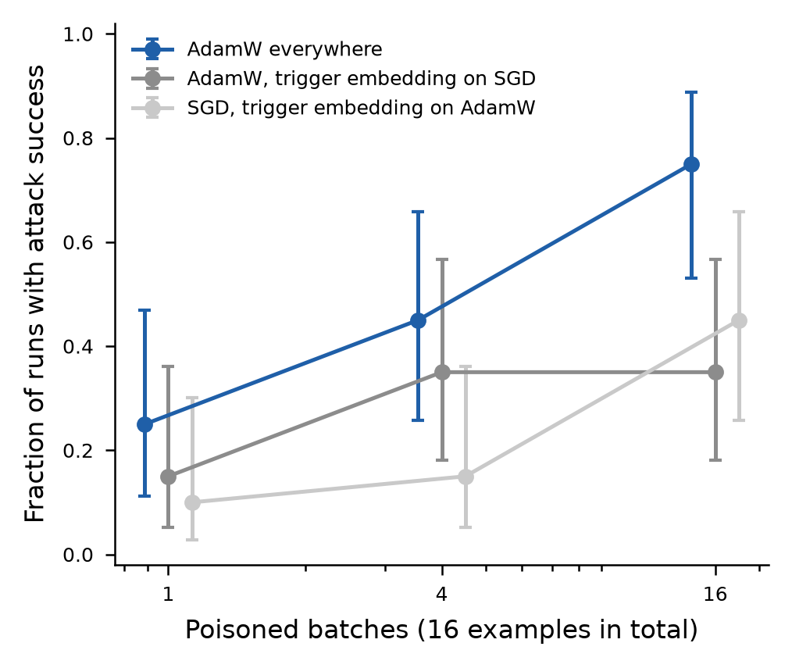
Figure 6. Fraction of runs with attack success when 16 poisoned examples are split over more batches (20 seeds per point; bars show 95 percent Wilson intervals; points are shifted slightly for visibility). Blue: AdamW for the whole network. Dark grey: AdamW with the trigger embedding trained by stochastic gradient descent. Light grey: stochastic gradient descent with the trigger embedding trained by AdamW. (Image from Competition Entrant)

A further test compared the two optimizers at similar baseline success. Under stochastic gradient descent with 64 poisoned examples and 20 seeds, the number of successful runs was 3, 4, 4 and 4 of 20 for 1, 2, 4 and 16 batches. That is a change of 1 run (p = 1.000), which met the rule for no change that was set in advance. A paired test across seeds gave p = 0.030, but the mean rise was 0.03, far below the 0.20 that the rule required to count as a rise. Under AdamW with 16 poisoned examples, the corresponding counts were 5 and 13 of 20 for 1 and 16 batches. With one batch the two optimizers succeeded in similar numbers (5 against 3 of 20, p = 0.695), whereas with 16 batches AdamW succeeded more often (13 against 4 of 20, p = 0.010). This last comparison was not specified in advance, the budgets differ (16 and 64 examples), the seeds 0 to 5 come from an earlier launch, and the p-values are uncorrected.
The comparison was repeated at a matched budget. A lower learning rate of 0.0003 for AdamW, chosen from the earlier learning-rate sweep, put 64 poisoned examples between the floor and the ceiling for both optimizers. The mean attack success rate with one batch was 0.44 for AdamW and 0.20 for stochastic gradient descent, and the clean loss was between 3.71 and 3.72 in every cell. With 20 seeds, the mean attack success rate of AdamW was 0.44, 0.50, 0.56 and 0.64 for 1, 2, 4 and 16 batches. The rise from 1 to 16 batches was 0.20 (p < 0.001, with 13 of 20 seeds higher and none lower), whereas the number of runs above 0.5 rose only from 8 to 13 of 20 (p = 0.205). Under stochastic gradient descent the rise was 0.03 (p = 0.030, 8 seeds higher and 2 lower). The difference between the two rises was 0.17 (95 percent bootstrap interval 0.07 to 0.28). The rule set in advance required a rise of at least 0.25 for AdamW, so the prediction is inconclusive by that rule. The direction agrees with the prediction and the interval for the difference excludes zero, but the effect is smaller than the size specified. The two arms were not run on the same machine and their seeds are not paired, the learning rate was chosen after earlier data were seen, and the two primary contrasts were not corrected for multiple comparisons.
The same ordering was tested on natural text, as shown in Figure 7. In Pythia-70M, the number of poisoned examples needed was 9.1 (interval 8.7 to 9.6) for a trigger that never occurs in WikiText-2. For triggers with about 30, 120 and 300 expected clean uses, it was 33.4, 35.7 and 80.0. The threshold therefore rises with the frequency of the trigger, as predicted. However, the proportionality predicted by Equation (4) was not observed. The ratio of the threshold to the expected clean uses was 1.11 at 30 uses, and 0.30 and 0.27 at 120 and 300 uses, so the threshold grows more slowly than the count. The explanation is not known, and the frequencies were measured on a different corpus from the one used to train the model.
The test was repeated on Pythia-160M with three of the four triggers, using the same tokenizer, corpus, number of steps and seeds (Figure 7). The ordering was preserved. The threshold was 8.8 (interval 8.3 to 9.4) for the trigger absent from WikiText-2, and 37.3 (34.9 to 41.6) and 47.8 (45.4 to 52.3) for triggers with about 120 and 300 expected clean uses. The ratios to the thresholds of Pythia-70M were 0.96, 1.05 and 0.60. The rule set in advance for invariance with model size required all three ratios to lie between 0.67 and 1.5, so it was not met. At the most frequent trigger the threshold was lower in the larger model, and the intervals do not overlap. This difference rests on one tested budget. At 64 poisoned examples, all 5 seeds of the larger model succeeded against 1 of 5 of the smaller model (p = 0.048, not specified in advance and uncorrected), and both models were at zero at 16 examples. The thresholds for the other two triggers were within 5 percent of those of the smaller model. The ratio of the threshold to the expected clean uses was 0.31 and 0.16 at 120 and 300 uses, so the proportionality was again not observed. Two further limits apply. The tested budgets are a factor of 4 apart, so the thresholds are interpolations, and the mean clean loss differed between the models (4.43 and 4.08).
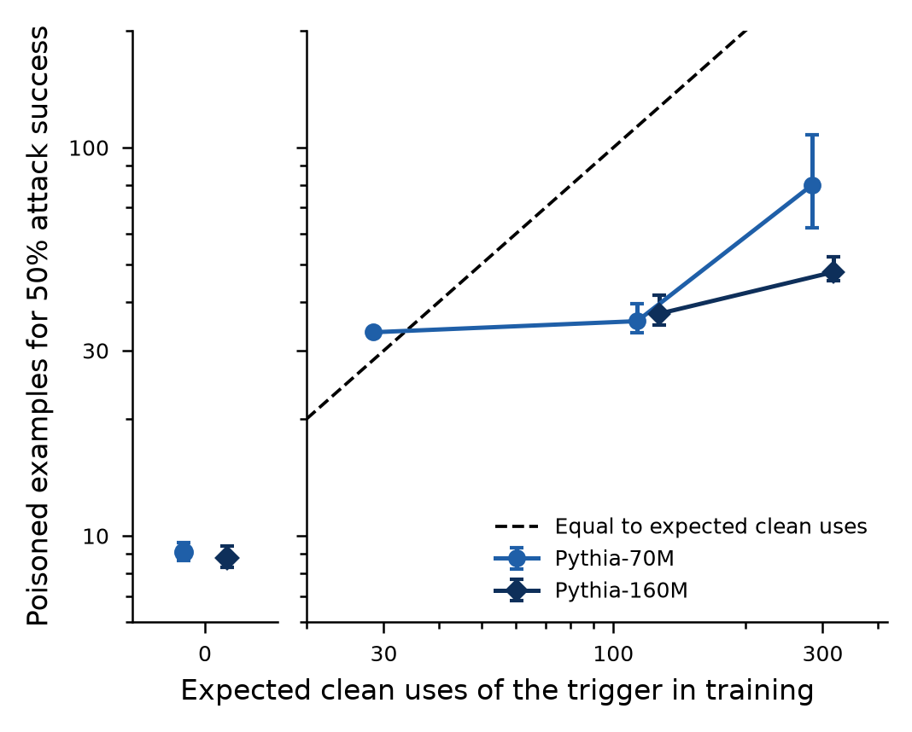
Figure 7. Poisoned examples needed for a 50 percent attack success rate in Pythia-70M and Pythia-160M, against the expected number of clean uses of the trigger over 600 training steps (5 seeds; bars show 95 percent bootstrap intervals). Pythia-160M was run with three of the four triggers. The left panel is a trigger with no clean uses. The dashed line marks equality between the threshold and the expected clean uses. Points are offset slightly along the horizontal axis for visibility. (Image from Competition Entrant)

Three further predictions were not supported, and they are reported in Table 1. In the interference test, the size of the first step was matched across conditions. The 24 runs whose poisoned batches fell within Adam's memory had a mean attack success rate of 0.71, against 0.78 for the others (p = 0.16). The thresholds at learning rates of 3 × 10⁻⁴, 10⁻³ and 3 × 10⁻³ were 52.6, 15.8 and 39.2, which is not proportional to 1/η over the whole range. With AdamW at 16 poisoned examples, the mean attack success rate was 0.34, 0.46, 0.54 and 0.08 at 500, 2,000, 8,000 and 32,000 clean steps. Setting the weight decay to zero gave 0.36, 0.43, 0.50 and 0.07, so weight decay does not account for the decline. Under stochastic gradient descent the decline also occurred, from 0.57 to 0.20 at 64 poisoned examples and from 0.98 to 0.54 at 128. The invariance to clean data predicted by Equation (2) was therefore not observed over this range. Forgetting of training examples has been measured in other models (Jagielski et al. 2023). The next tests separated the factors that could produce the decline.
The decline of attack success with training length was then decomposed into three factors, using 16 poisoned examples in four batches and 8 seeds per cell (Figure 8). The factors were the number of clean steps before the poison, the number of clean steps after the last poisoned batch, and the spacing between poisoned batches. Each contrast was judged present only if the mean drop in attack success was at least 0.25 and a one-sided paired Wilcoxon test gave p below 0.05. The clean steps after the poison met this rule at every number of steps before it. With no steps after the poison, the mean attack success rate was 0.32, 0.58, 0.68 and 0.38 for 0, 2,000, 8,000 and 32,000 steps before the poison. With 32,000 steps after it, the rate was 0.01, 0.07, 0.03 and 0.01. The drops were 0.31, 0.51, 0.65 and 0.37 (p = 0.047, 0.016, 0.004 and 0.016). The clean steps before the poison did not meet the rule at any number of steps after it, with drops of −0.06, 0.12 and −0.00. The spacing contrast fell short. Raising the spacing from 700 to 10,000 steps lowered the rate by 0.27, which met the size criterion, but p = 0.078. After a Holm correction across the nine contrasts, only the one with 8,000 steps before the poison stays below 0.05 (adjusted p = 0.035). A pooled contrast that was not specified in advance found a lower mean rate with 32,000 steps after the poison than with none in 8 of 8 seeds (p = 0.004). The clean validation loss lay between 3.70 and 3.72 in all 14 cells, so none was undertrained. The distance of the trigger embedding from its value before the first poisoned batch was 1.79 to 6.21 times larger at the end of training than just after the last poisoned batch in the cells with steps after the poison. The embedding therefore did not move back towards its earlier value, although this distance does not show whether its direction was kept.
This result needs a limit. In the longer sweeps described above, the last poisoned batch was about 5 steps from the end of training, so the clean steps after the poison cannot account for the decline there. In those sweeps the spacing between poisoned batches grew with training length, and spacing was the one contrast that came near its rule, so it was tested again with new seeds. The decomposition therefore shows that clean training after the poison erodes the backdoor, but it does not settle the cause of the decline in the longer sweeps. The cells were completed on two different GPUs after an interruption, so the pairing of seeds across cells is approximate.
The spacing contrast was repeated with 20 new seeds (8 to 27). The test set in advance used only these seeds, and the three spacings of 700, 2,800 and 10,000 steps were run for each seed in the same job. The mean attack success rate was 0.18, 0.22 and 0.12. The drop from 700 to 10,000 steps was 0.06 (95 percent bootstrap interval −0.05 to 0.16, p = 0.182, with 8 seeds higher and 7 lower). This falls below both the size and the significance criteria, so no spacing effect was detected. The rate was also not lower at 2,800 steps than at 700, so it did not fall steadily with spacing. A pooled analysis of all 28 seeds, which mixes hardware and includes the seeds that first suggested an effect, gave a drop of 0.12 (p = 0.029). It is reported for completeness and is not the test set in advance. The first result of 0.27 is consistent with a high value from a noisy cell. The cause of the decline in the longer sweeps therefore remains unexplained.
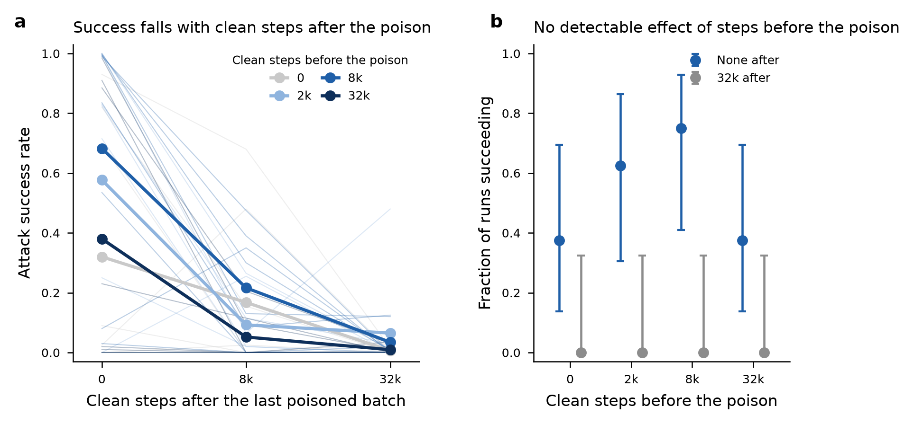
Figure 8. Attack success after separating the clean steps before and after the poison (16 poisoned examples in four batches, 700 steps apart; 8 seeds per cell). (a) Attack success rate against the clean steps after the last poisoned batch, for four numbers of clean steps before the poison. Thin lines are single seeds. (b) Fraction of runs with an attack success rate above 0.5 for each number of steps before the poison, with no steps after the poison and with 32,000 steps after it. Bars show 95 percent Wilson intervals. (Image from Competition Entrant)

Table 1. Predictions set in advance and what the data showed.
Test | Prediction | Outcome | Verdict
Common and rare triggers (Figure 4) | Common: threshold equals expected clean uses. Rare: flat. | Common: 123, 346, 914 against 100, 300, 900. Rare: 39 at 9,000 steps. | Supported
Model with 200 parameters (Figure 3) | Scalar signs, count invariance and thresholds hold; margin larger by a factor k. | Signs agree in 42/42. Margin 1.03 to 1.66 times scalar; 0.89 to 1.10 with k. | Supported, with a size correction
Movement of the trigger embedding (Figure 5) | Under AdamW, independent of poisoned examples per batch. | 0.96 to 1.00 of the closed form in 60 runs. | Supported
Optimizer of the trigger embedding (Figure 6) | Splitting the poison helps only if the embedding is on AdamW. | Embedding on AdamW: 5/20 to 15/20. On SGD: 3/20 to 7/20. | Partly supported; not after correction
Model size | Threshold independent of size. | 12.7, 11.5, 11.6 for 0.8M, 3.2M, 25.3M parameters. 0.11M model: no threshold. | Supported in the range tested
Real text (Figure 7) | Threshold rises with frequency and equals the expected clean uses. | 9.1, 33.4, 35.7, 80.0. Ratios to clean uses 1.11, 0.30, 0.27. | Ordering supported; proportionality not
Real text, larger model (Figure 7) | Same order at 160M; thresholds within a factor of 1.5 of 70M. | Ratios to 70M: 0.96, 1.05, 0.60. Thresholds 8.8, 37.3, 47.8. | Ordering supported; invariance not met at one trigger
Interference between batches | Success falls when batches are within Adam's memory. | Mean attack success rate 0.71 inside, 0.78 outside (p = 0.16). | Not supported
Learning rate | Threshold proportional to 1/η. | 52.6, 15.8, 39.2 at 3 × 10⁻⁴, 10⁻³, 3 × 10⁻³. | Not supported
Weight decay and the decline | Removing weight decay removes the decline. | Mean success 0.34 to 0.08 with decay, 0.36 to 0.07 without. | Not supported
What produces the decline (Figure 8) | One of: steps before the poison, spacing, steps after it. | After: drops 0.31 to 0.65. Before: −0.06 to 0.12. Spacing: 0.27, p = 0.078; in 20 new seeds 0.06, p = 0.182. | Steps after the poison only
Stochastic gradient descent and batch count | No change with the number of batches. | 3/20 to 4/20 successes from 1 to 16 batches (64 examples). | Supported
Matched optimizers (learning rate 0.0003) | AdamW rises with batches by at least 0.25; SGD does not. | AdamW 0.20, SGD 0.03; difference 0.17 (0.07 to 0.28). | Inconclusive by the rule

The threshold did not depend on model size over the range in which the models trained properly. It was 12.7, 11.5 and 11.6 poisoned examples for models of 0.8, 3.2 and 25.3 million parameters. The largest model did not train successfully at the shared learning rate (attack success rate 0.00 at 64 poisoned examples). The value reported is from a rerun at a learning rate of 3 × 10⁻⁴. The smallest model (0.11 million parameters) reached an attack success rate of only 0.46 at 64 poisoned examples, so no threshold was found for it. It is therefore not shown that the threshold is independent of model size at the scale of the earlier experiments (Souly et al. 2025). Their smallest model (600 million parameters) is more than twenty times larger than the largest model trained from scratch here, and nearly four times larger than the pretrained 160-million-parameter model.
V. Conclusion and Future Direction
This project explored whether the number of poisoned examples needed for a backdoor can be predicted from how often the trigger appears in clean data. In a solvable model, a trigger absent from clean data needs a number of poisoned examples that does not grow with training. A trigger used in clean data needs more poison than the expected number of those uses. Both statements were supported in small transformers. The ordering was reproduced in pretrained language models of 70 and 160 million parameters, although the proportionality was not. The threshold at the most frequent trigger was lower in the larger model. Under Adam, the trigger embedding responded to the number of poisoned batches and not to the number of examples, which stochastic gradient descent did not show at 64 poisoned examples.
The main challenges are scale and explanation. The models here have at most 25 million parameters when trained from scratch and 70 and 160 million for the pretrained cases, whereas the experiments that motivated the project used 600 million to 13 billion. The decline of attack success over long clean training occurred under both optimizers and without weight decay. Clean steps after the poison lower attack success, but the decline in the longer sweeps, where the poison ended near the end of training, is not accounted for, and neither weight decay nor the spacing between poisoned batches, tested with 20 further seeds, explains it. The model tracks a single coordinate of the classifier. A simulation with 200 parameters agrees with it in sign and shows that its thresholds are conservative by a factor that grows with the strength of the clean task. The multi-parameter case has not been derived in closed form.
Future work could proceed in four steps. First, the same tests could be run on the larger models of the Pythia suite (Biderman et al. 2023), which extends to 12 billion parameters. The trigger frequencies would be measured on the corpus on which the models were trained. Second, other candidate causes of the decline in the longer sweeps would need to be identified and tested, because neither weight decay nor the spacing between poisoned batches accounted for it. Third, the decline under stochastic gradient descent, which Equation (2) does not predict, could be traced to its source with the decomposition that was used for AdamW. Fourth, a derivation for the full set of parameters could replace the approximation used for the correction factor. The simulation could also be repeated for covariance with power-law decay and for a clean task trained from scratch. If the model holds at scale, the practical implication would be that the expected cost of an attack is set by how often a trigger already appears in clean data. Auditing effort would then be best spent on tokens that are nearly absent from the training data.

VI. References
Balles L, Hennig P. 2018. Dissecting Adam: The Sign, Magnitude and Variance of Stochastic Gradients. Proceedings of the International Conference on Machine Learning PMLR 80: 404-413.
Ben Arous G, Gheissari R, Jagannath A. 2021. Online stochastic gradient descent on non-convex losses from high-dimensional inference. Journal of Machine Learning Research 22: 1-51.
Benveniste A, Métivier M, Priouret P. 1990. Adaptive Algorithms and Stochastic Approximations. Springer, Berlin, Heidelberg.
Biderman S, Schoelkopf H, Anthony Q, Bradley H, O'Brien K, Hallahan E, Khan MA, Purohit S, Prashanth USVSNS, Raff E, Skowron A, Sutawika L, van der Wal O. 2023. Pythia: A Suite for Analyzing Large Language Models Across Training and Scaling. Proceedings of the International Conference on Machine Learning PMLR 202: 2397-2430.
Biggio B, Nelson B, Laskov P. 2012. Poisoning Attacks against Support Vector Machines. Proceedings of the 29th International Conference on Machine Learning (ICML 2012).
Bowen D, Murphy B, Cai W, Khachaturov D, Gleave A, Pelrine K. 2024. Scaling Trends for Data Poisoning in LLMs. arXiv preprint arXiv:2408.02946.
Carlini N, Jagielski M, Choquette-Choo CA, Paleka D, Pearce W, Anderson H, Terzis A, Thomas K, Tramèr F. 2024. Poisoning Web-Scale Training Datasets is Practical. Proceedings of the IEEE Symposium on Security and Privacy (SP): 407-425.
Chen X, Liu C, Li B, Lu K, Song D. 2017. Targeted Backdoor Attacks on Deep Learning Systems Using Data Poisoning. arXiv preprint arXiv:1712.05526.
Cinà AE, Grosse K, Vascon S, Demontis A, Biggio B, Roli F, Pelillo M. 2025. Backdoor learning curves: explaining backdoor poisoning beyond influence functions. International Journal of Machine Learning and Cybernetics 16: 1779-1804.
Duchi J, Hazan E, Singer Y. 2011. Adaptive Subgradient Methods for Online Learning and Stochastic Optimization. Journal of Machine Learning Research 12: 2121-2159.
Flynn DGM, Goldhirsh HY, Keating JP, Seroussi I. 2026. When Stronger Triggers Backfire: A High-Dimensional Theory of Backdoor Attacks. arXiv preprint arXiv:2605.22481.
Flynn DGM, Granziol D. 2025. A Linear Approach to Data Poisoning. arXiv preprint arXiv:2505.15175.
Goldt S, Advani M, Saxe A, Krzakala F, Zdeborová L. 2019. Dynamics of stochastic gradient descent for two-layer neural networks in the teacher-student setup. Advances in Neural Information Processing Systems 32.
Gu T, Dolan-Gavitt B, Garg S. 2017. BadNets: Identifying Vulnerabilities in the Machine Learning Model Supply Chain. arXiv preprint arXiv:1708.06733.
Jagielski M, Thakkar O, Tramèr F, Ippolito D, Lee K, Carlini N, Wallace E, Song S, Thakurta A, Papernot N, Zhang C. 2023. Measuring Forgetting of Memorized Training Examples. International Conference on Learning Representations (ICLR 2023).
Kingma DP, Ba J. 2015. Adam: A Method for Stochastic Optimization. International Conference on Learning Representations (ICLR 2015).
Kunstner F, Milligan A, Yadav R, Schmidt M, Bietti A. 2024. Heavy-Tailed Class Imbalance and Why Adam Outperforms Gradient Descent on Language Models. Advances in Neural Information Processing Systems 37.
Kurita K, Michel P, Neubig G. 2020. Weight Poisoning Attacks on Pretrained Models. Proceedings of the 58th Annual Meeting of the Association for Computational Linguistics: 2793-2806.
Land S, Bartolo M. 2024. Fishing for Magikarp: Automatically Detecting Under-trained Tokens in Large Language Models. arXiv preprint arXiv:2405.05417.
Loshchilov I, Hutter F. 2019. Decoupled Weight Decay Regularization. International Conference on Learning Representations (ICLR 2019).
Merity S, Xiong C, Bradbury J, Socher R. 2016. Pointer Sentinel Mixture Models. arXiv preprint arXiv:1609.07843.
Robbins H, Monro S. 1951. A Stochastic Approximation Method. The Annals of Mathematical Statistics 22: 400-407.
Schwarzschild A, Goldblum M, Gupta A, Dickerson JP, Goldstein T. 2021. Just How Toxic is Data Poisoning? A Unified Benchmark for Backdoor and Data Poisoning Attacks. Proceedings of the International Conference on Machine Learning PMLR 139: 9389-9398.
Shafahi A, Huang WR, Najibi M, Suciu O, Studer C, Dumitras T, Goldstein T. 2018. Poison Frogs! Targeted Clean-Label Poisoning Attacks on Neural Networks. Advances in Neural Information Processing Systems 31.
Souly A, Rando J, Chapman E, Davies X, Hasircioglu B, Shereen E, Mougan C, Mavroudis V, Jones E, Hicks C, Carlini N, Gal Y, Kirk R. 2025. Poisoning Attacks on LLMs Require a Near-constant Number of Poison Samples. arXiv preprint arXiv:2510.07192.
Steinhardt J, Koh PW, Liang PS. 2017. Certified Defenses for Data Poisoning Attacks. Advances in Neural Information Processing Systems 30.
Tran B, Li J, Madry A. 2018. Spectral Signatures in Backdoor Attacks. Advances in Neural Information Processing Systems 31.
Vaswani A, Shazeer N, Parmar N, Uszkoreit J, Jones L, Gomez AN, Kaiser Ł, Polosukhin I. 2017. Attention is All you Need. Advances in Neural Information Processing Systems 30.
Wallace E, Zhao T, Feng S, Singh S. 2021. Concealed Data Poisoning Attacks on NLP Models. Proceedings of the 2021 Conference of the North American Chapter of the Association for Computational Linguistics: Human Language Technologies: 139-150.
Wan A, Wallace E, Shen S, Klein D. 2023. Poisoning Language Models During Instruction Tuning. Proceedings of the International Conference on Machine Learning PMLR 202: 35413-35425.
Wang G, Xian X, Kundu A, Srinivasa J, Bi X, Hong M, Ding J. 2024. Demystifying Poisoning Backdoor Attacks from a Statistical Perspective. International Conference on Learning Representations (ICLR 2024).
Zhang Y, Rando J, Evtimov I, Chi J, Smith EM, Carlini N, Tramèr F, Ippolito D. 2024. Persistent Pre-Training Poisoning of LLMs. arXiv preprint arXiv:2410.13722.

Drafting note (delete before any use)
This is a hypothetical draft written to mirror the structure and register of a sample top-300 report. The author line and the personal-role section are left blank on purpose, because they must describe what the named people actually did.
The research was produced by an AI agent with a human providing compute, and any real use of this draft must follow the rules of the venue on independent work and on the disclosure of AI assistance.
Every number in the text was computed from the project's result files by a script, and every reference was checked against a primary record (see verified_references.csv and reference_corrections.md).

