REPORT
a.
- The aim is to design a 4-way set associative cache with the inputs given in the question and find the number of cache lines accordingly.
- We can find the number of cache lines by using the formula (size of cache / block size)*(number of ways).
- If we apply log base 2 to the number of lines, we get the number of index bits. Byte offset is 2 as it is given in the question that it is a 4 way set associative cache. Number of tag bits = 32 – byte offset – index bits. Here in the question, as byte offset is 2, tag bits and index bits are 15 and 15 respectively and the number of cache lines are 2 power 15.
- Our input will be in hexagonal string form. We defined a function hextobin which is used to convert each hexagonal digit of the string to binary. Similarly, we defined a function bintodec which is used to convert binary to decimal number.
- cc denotes the cache in pur code. If the tag matches, then it is a hit, or else it’s a miss.
- First we are giving file as an input. We read all the lines in the file. We send each line into cache and check whether it is a hit or a miss by sending into logic function. If it’s a hit, then it gives 1 or else 0. We store these 0’s and 1’s in a file named out.txt along with the address. Then we calculate the hitrate and missrate and give the output.
b.
- In this question as the cache size is increased to 2048 kilo bytes, there will be a change in the number of tag bits and index bits. Tag bits become 13 and index bits changes to 17. Therefore the number of cache lines are 2 power 17. Byte offset remains the same. The remaining process will be done in the same manner as the first question.
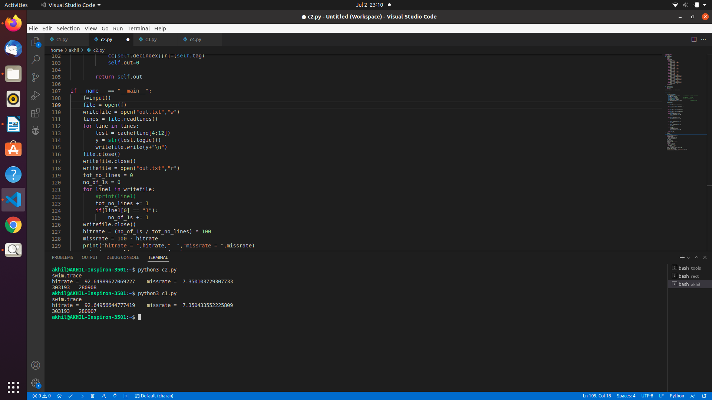
- Swim.trace(2048kb)
hitrate = 92.64989627069227
missrate = 7.350103729307733
- swim.trace(512kb)
hitrate = 92.64956644777419
missrate = 7.350433552225809

c.
- Now in this question, we fix the cache size and vary the block size and perform the experiment. We can note that the number of cache lines keeps on decreasing as we increase the block size.
- Block size = 1 byte.
Byte offset = 0.
Tag bits = 15.
Index bits = 17.
Cache lines = 2 power 17.
- Block size = 4 bytes.
Byte offset = 2.
Tag bits = 15.
Index bits = 15.
Cache lines = 2 power 15.
- Block size = 8 bytes.
Byte offset = 3.
Tag bits = 15.
Index bits = 14.
Cache lines = 2 power 14.
- Block size = 16 bytes.
Byte offset = 4.
Tag bits = 15.
Index bits = 13.
Cache lines = 2 power 13.
- Cache block size in bytes : 1
swim.trace:
hitrate = 92.58228257248683
missrate = 7.417717427513168
- Cache block size in bytes : 4
swim.trace:
hitrate = 92.64956644777419
missrate = 7.350433552225809
- Cache block size in bytes : 8
swim.trace
hitrate = 93.48731665968542
missrate = 6.512683340314581
- Cache block size in bytes : 16
swim.trace:
hitrate = 96.2472748381394
missrate = 3.752725161860596
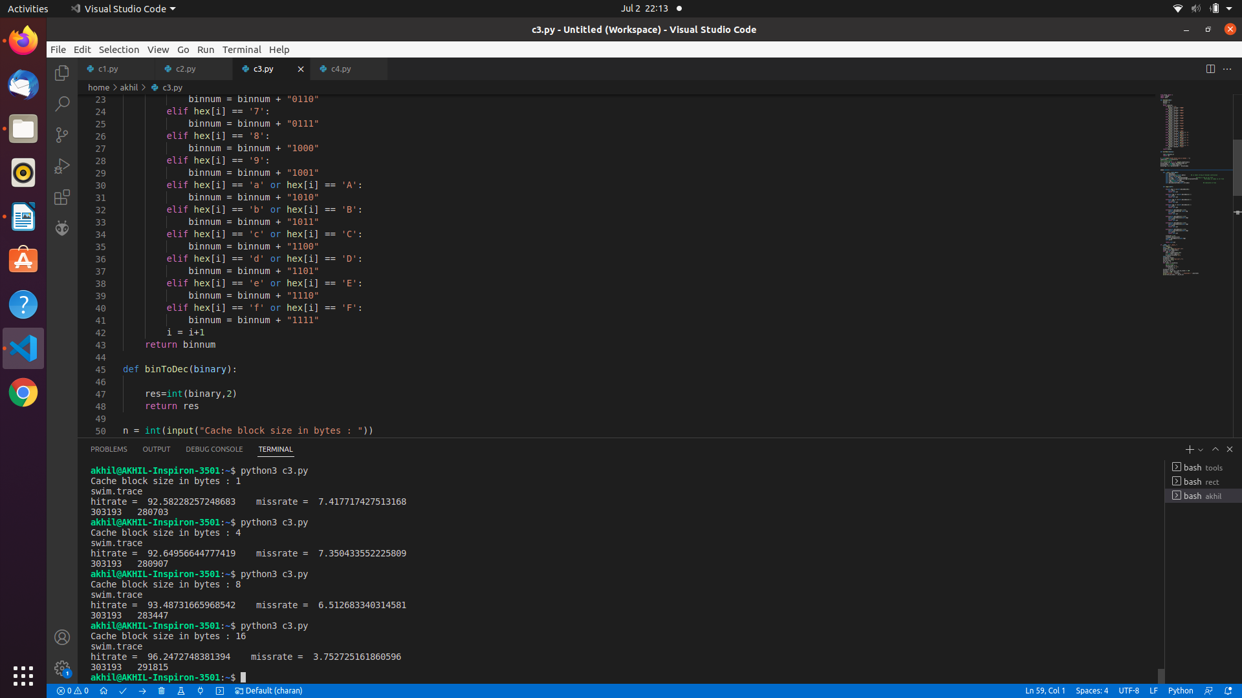
d.
- Now we vary the associativity of cache from 1-way to 16-way, keeping the cache size constant. We note the change in hit rates due to the change in associativity.
- 1-way associative cache:
Byte offset = 2 bits.
Tag bits = 11.
Index bits = 19.
Cache lines = 2 power 19.
- 4-way associative cache:
Byte offset = 2 bits.
Tag bits = 11.
Index bits = 17.
Cache lines = 2 power 17.
- 8-way associative cache:
Byte offset = 2 bits.
Tag bits = 11.
Index bits = 16.
Cache lines = 2 power 16.
- 16-way associative cache:
Byte offset = 2 bits.
Tag bits = 11.
Index bits = 15.
Cache lines = 2 power 15.
- Swim.trace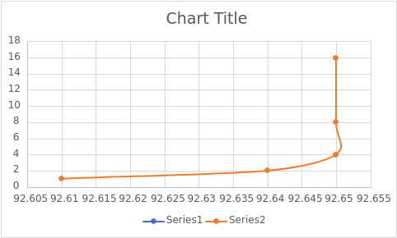
. gcc.trace
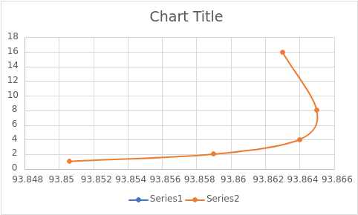
.gzip.trace
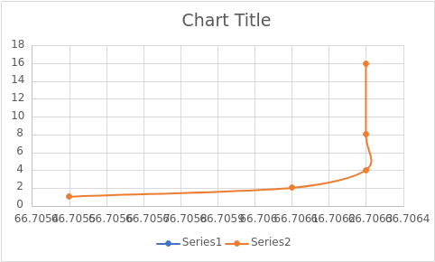
.mcf.trace
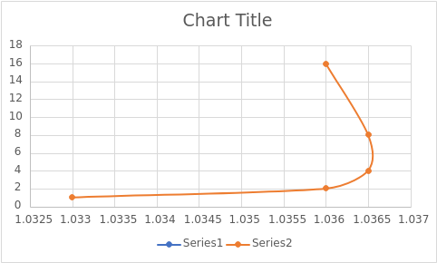

twolf.trace
